Enclosure 2: Pictures of Texas Township Wetland Comparisons.

The 20 acre wetlands that are recipients of the Eagle/Crooked Lake pumping discharge is shown below. EGLE decision is based on this wetland property showing stress.

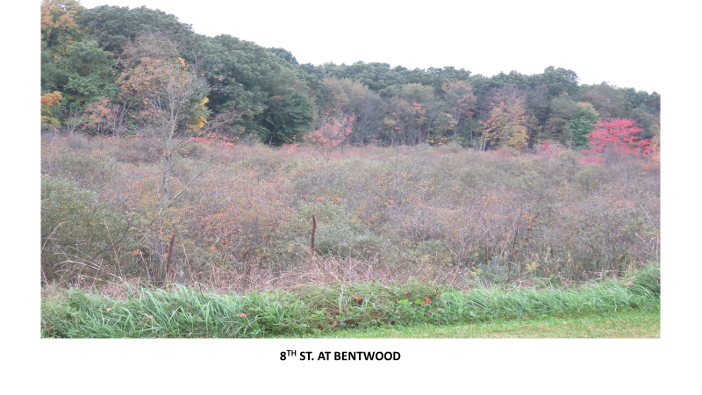

Other wetlands in Texas Township that have been impacted by flooding are shown on the following pages. The stress on these wetlands is evident in these photos, as well as showing large trees being impacted.

