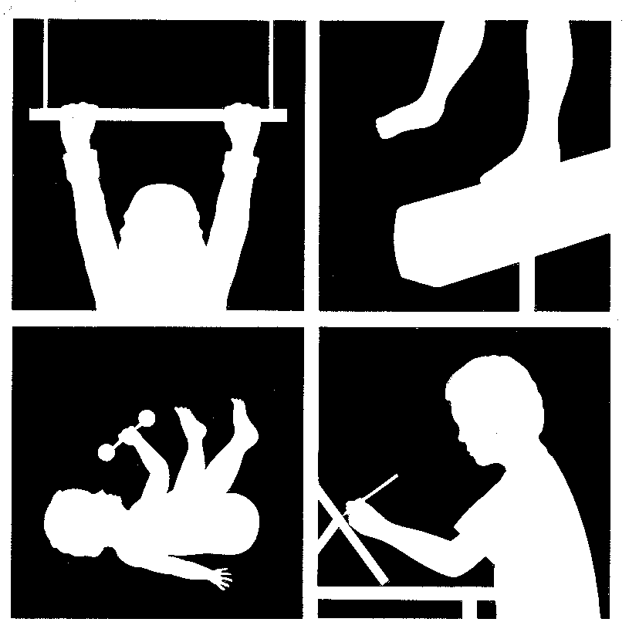
Therapy Rita Patterson OTR/L & Associates

Solutions 836 Ritchie Hwy, Suite 6 For Severna Park, Maryland 21146

Children 410-421-8920 / Fax 410-421-8923
Inc.

CONSENT FORM

I, ____________________________________ give permission to Rita Patterson, OTR/L, subcontractors, and associates to speak with the following professionals regarding my son/daughter.

________________________________________ ____________________
Patient’s Name Date of Birth

________________________________________ ____________________
Signature of Parent or Legal Guardian Date

Name | Telephone Number
MEDICAL RECORDS RELEASE

I ___________________________________ hereby allow TSFC, Inc. to release records for my

child___________________________________ to:

____________________________________________

____________________________________________

____________________________________________

Signature:__________________________

Witness:___________________________ Date:_____________

I ________________________________ give TSFC, Inc. permission to request secure medical records for my

child___________________________ from the following:

_________________________________ ______________________________

_________________________________ ______________________________

_________________________________ ______________________________

_________________________________ ______________________________

Parent Signature:______________________________

Witness:_____________________________________ Date:___________________

