RSAI Legislative Update
Jan. 16, 2019

In this Jan. 16, 2019 RSAI Report of the first week of the 2019 Legislative Session, find information about:
- Education Highlights from Governor Reynolds Condition of the State
- The Governor’s Budget Recommendation for FY 2019, FY 2020, and FY 2021
- Specifics about State School Aid in the Recommendation
- New Bills Introduced
- Finding Biographical and Contact Information for your Legislators
- Links to members of Key Legislative Committees
- Advocacy Resources

Governor’s 2020 Condition of the State: Governor Reynolds delivered her condition of the state address on Jan. 15. Find the complete text of her address on her web site here: https://governor.iowa.gov/2019/01/gov-reynolds-to-deliver-condition-of-the-state-address
Gov. Reynolds shared the successes of the 2018 Session and expressed themes of second chances, proposing constitutional amendments to both restore felon’s voting rights and protect victim’s rights, investing in children’s mental health, funding the Future-ready Workforce, and the Empower Rural Iowa Initiative including investments in Broad Band connectivity. Her comments included the following references to education:
- “Of course, the road to finding a rewarding career doesn’t start after high school. A strong K-12 education system is the foundation of any state, and Iowa has a solid foundation to build upon.” She mentioned TLC, a nationally recognized STEM initiative, and making progress toward third grade reading proficiency.
- “Kids today are growing up immersed in a world of digital technology. The workforce is continually impacted by innovation and globalization. And we need an education system that adapts to those changes.” Gov. Reynolds continued her advocacy for STEM, apprenticeships, work-based learning and computer science, including the new program, Computer Science is Elementary, a public-private partnership that will transform 6 high-poverty elementary schools by weaving computer coding into class lessons. She acknowledged innovative programs in several school districts including Clear Lake, Kingsley-Pierson, Indianola and Des Moines.
- “The budget I’m submitting today proposes over $93 million in additional funding for preschool through high school education, which includes a 2.3% increase in per pupil funding.” She also is requesting $11.2 million for disproportionate transportation costs and a $1 million increase in STEM funding,” . . .bringing the total preK-12 investment to almost $3.4 billion this year.”
Governor’s Budget: The following information is found in the Legislative Services Agency’s Preliminary Summary of the Governor’s Budget Recommendation, Jan. 15, 2019, found on their web site here: https://www.legis.iowa.gov/docs/publications/LAGRP/1033690.pdf
Governor Reynolds Budget Recommendation covers three fiscal years:

- FY 2019 is based on the REC December estimate, which has an estimated growth rate of 4.7% and carry forward balance of $71.0 million from FY 2018 and supplemental (mid-year) appropriations of $144.5 million for several state programs, the largest share of which is for Medicaid ($141.1 million).
- FY 2020 includes total General Fund resources of $7.959 billion based on the December REC growth estimate of 1.8%, and includes $93.3 million in surplus carry forward dollars from FY 2019. Governor Reynolds is recommending total FY 2020 General Fund expenditures of $7.659 billion, which is $222.2 million below the 99% Expenditure Limitation. This budget recommendation estimates a carry forward surplus of $305.9 million going into FY 2021.
- FY 2021 budget recommendation assumes an increase of 2.7% compared to the FY 2020 recommendation, but there is no REC estimate yet for FY 2021 and the legislature is not required to set a budget for FY 2021.
State School Aid: The largest appropriation increase in either FY 2020 or FY 2021 is state school aid. The Governor’s recommendation of 2.3% increase in the State Supplemental Assistance (state cost per pupil formerly known as allowable growth) is an increase of $89.6 million in FY 2020. The Governor’s FY 2021 Budget Recommendation indicates an increase of $79.9 million for that year. However, the supplemental appropriation of $141.1 million for Medicaid in FY 2019 increases the FY 2019 base for the comparison, so the $72.1 million increase for FY 2020 is in addition to the supplemental appropriation.
The LSA notes that the State Aid Budget recommendation sets a per pupil growth rate of 2.3%, continues the $15.0 million reduction to the AEAs, increases the Property Tax Replacement Payment (PTRP) funding per student from $92 to $111. The FY 2021 recommendation includes the same assumptions (2.3% increase per pupil, continuation of $15 million AEA reduction and increased PRTP.)
Medicaid: The Governor’s Medicaid recommendation includes an increase of $1.2 million to eliminate the waiting list for the Children’s Mental Health Home and Community-Based Services Waiver (to eliminate long waiting lists for mental health treatment for children)
Children’s Health Insurance: The recommendation includes an increase of $12.3 million in FY 2020 and another $18.9 million in FY 2021 to pick up more of a state share to continue the Children’s Health Insurance Program (CHIP) (also known in Iowa as HAWK-I) due to a lowering of the federal contribution to the program in FY 2020 and eliminating the federal share in FY 2021.
Broadband Grants: The recommendation includes an annual $10.0 million appropriation for broadband grants in FY 2020 and continued in FY 2021 as part of the Empower Rural Iowa Initiative. (For background, the FY 2019 appropriation of $1.3 million was provided from the Rebuild Iowa Infrastructure Fund for broadband grants and these new appropriations are from the General Fund.)
Regents Institutions: The Governor is recommending a total increase of $21.9 million for FY 2020 and $12.2 million for FY 2021 for the Board of Regents, primarily to provide a 3.3% General Aid increase ($7.0 million for FY 2020) for the University of Iowa, a 4.1% General Aid increase ($7.0 million for FY 2020) for Iowa State University, a 4.2% General Aid increase ($4.0 million for FY 2020) for the University of Northern Iowa, and an increase of $1.0 million for the Governor’s STEM Advisory Council to increase K-12 student interest and achievement in science, technology, engineering, and mathematics.
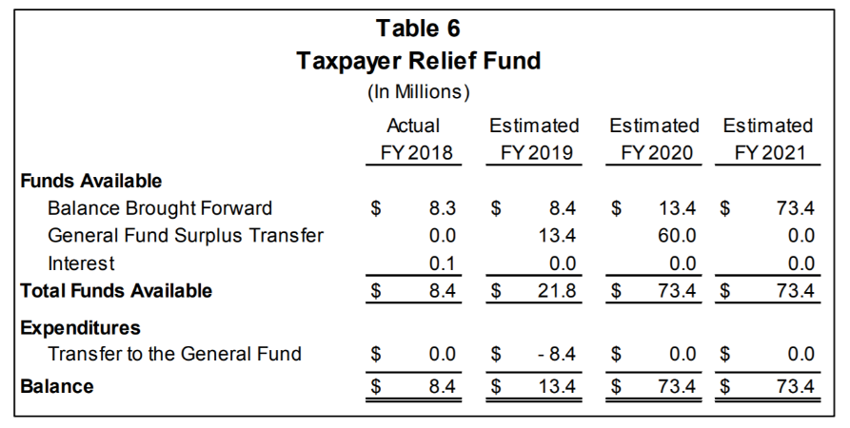
The Taxpayer Relief Fund was changed through SF 2417 tax reform in the 2018 session, removing the $60 million cap of surplus funds that can be transferred to the state’s general fund, beginning July 1, 2020. Iowa Code section 8.57E, as amended by SF 2417, requires the moneys in the Taxpayer Relief Fund to only be used for tax relief pursuant to an appropriation by the General Assembly. This chart from the LSA analysis shows the estimated surplus that will be directed to the fund annually from FY 2018 to FY 2021 based on the Governor’s Budget Recommendation.
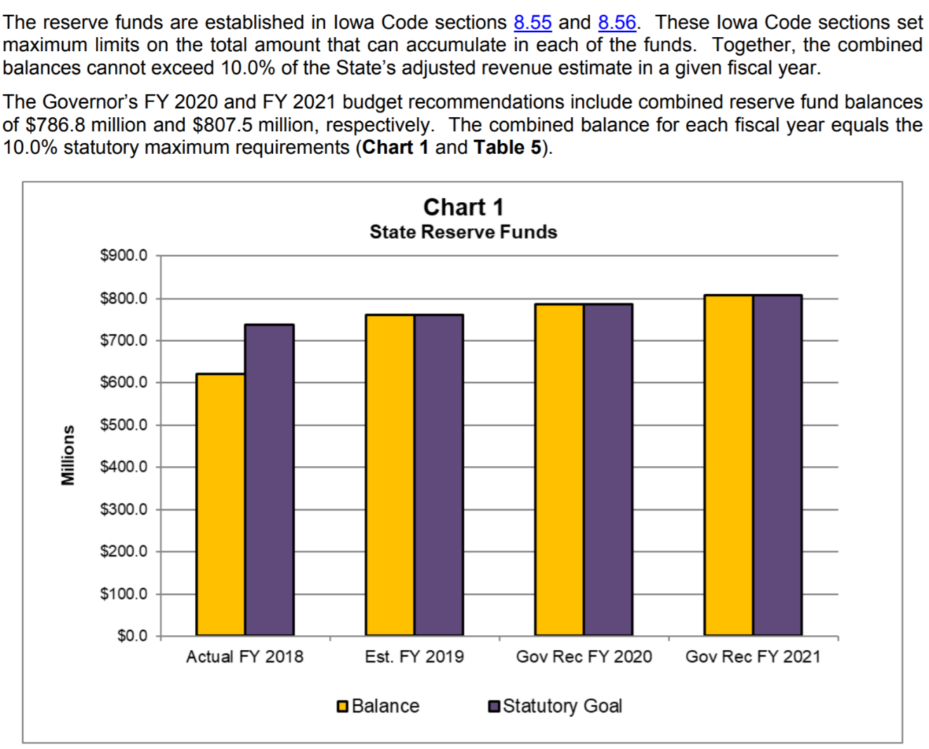

State of the State Budget:
This chart shows the status of Iowa’s combined cash reserve and economic emergency fund combined balances:

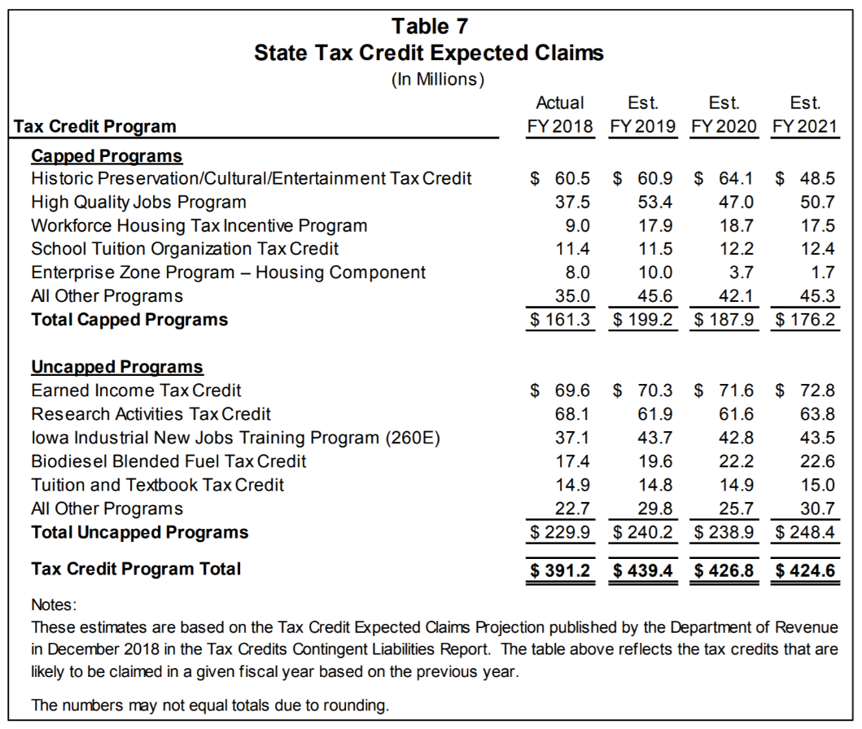
State Tax Credit Expected Claims:
The Iowa Department of Revenue publishes an annual report that was quoted as the source for the tax credit expected claims included in the LSA publication. Last year’s report showed $332 million as the total tax credit program actual expenditures for FY 2017, growing to an estimated $439.4 million by FY 2019. This reflects a two-year growth of over 32% and over $100 million. The growth rate in tax credits has outpaced the growth in the state’s general fund or investments in education over that same time, although is estimated to taper off slightly in the Governor’s FY 2020 and FY 2021 budget recommendation.
This table shows the impact of the largest tax credits annually, including the School Tuition Organization Tax Credit (STO) which was expanded to a cap of $13 million in SF 2417 in the 2018 Session.
School Aid Long Term Trends: State School Aid comprises the largest portion of the General Fund budget at nearly 44.0%, and therefore accounts for the largest dollar increase from FY 2009 to FY 2018. State School Aid increased by a total of $746.3 million from FY 2009 to FY 2018, representing an average annual increase of 3.0%. The Supplemental State Aid growth rate for FY 2019 was set at 1.0%, resulting in an estimated appropriations increase of $28.0 million (0.9%) compared to FY 2018. For FY 2020, the Governor is recommending an increase of $89.6 million for State School Aid, which represents a Supplemental State Aid growth rate of 2.30% and includes an additional $15.0 million reduction to AEAs. Under the Governor’s FY 2020 budget recommendation, the appropriations for State School Aid and Medicaid make up a combined 61.5% of the total recommended appropriations (Compared to a combined total for State School Aid and Medicaid of 53.6% of all General Fund appropriations in FY 2009).
Education Appropriations Budget Detail: The Governor’s recommendation includes three major increases within the College Student Aid Commission including an increase of $1.1 million for the Tuition Grant Program standing appropriation, and new $17.2 million appropriation for the Future-Ready Iowa Last-Dollar Scholarship Program (to assist students pursuing a postsecondary credential up to an associate’s degree in a high-demand occupation at a community college or private postsecondary institution in Iowa), and a new appropriation of $1.0 million for Future Ready Iowa Administration.
Within the Department of Education budget area, most line-items are status quo funding with no change compared to FY 2019, except for the following areas receiving an increase:
- A new appropriation of $500,000 for the Iowa Learning On-line Program
- An increase of $300,000 for the Statewide Assessment
- An increase of $4.7 million for Community Colleges General Aid (2.3% increase for FY 2020.)
- A new appropriation of $3.0 million for Children’s Mental Health Training
School Transportation Equity: The recommendation includes a new standing appropriation request of $11.2 million to the Department of Management for the Transportation Equity Fund for school districts experiencing disproportionate transportation costs. A standing appropriation would be more secure for district budgeting plans than a line-item grant appropriation, as it would take agreement of the House, Senate and Governor to eliminate a standing appropriation down the road.
Next Steps: The Joint Education Appropriations Subcommittee is scheduled to hold their first meeting of the Session on Thursday, Jan. 17, to hear explanation of the Governor’s budget recommendations by LSA staff. The combined House and Senate Appropriations Subcommittees will craft their own budgets which may or may not reflect the Governor’s budget recommendations yet are required to live within the 99% expenditure limitations according to the December REC estimate (or the March estimate if that is lower than December). Those bills will work their way to agreement between the two chambers, then to the Governor’s desk for her signature or veto. The Governor has line-item veto authority for appropriations bills.
Stay tuned for more detail as the budget and tax bills progress through the chambers.

Bills Introduced:
The following bills have already been introduced and assigned to committees. If RSAI Legislative Priorities address our registration, you’ll see a registration already declared as in support, undecided or opposed. For those issues not addressed in our legislative platform, we encourage your feedback on what our registration should be, but in the meantime, will indicate an undecided registration.
SF 1 by Sen. Chapman, Repeal of the Inheritance Tax and SF 39 by Sen. Zaun, State Inheritance Tax Repeal II: These bills would repeal the inheritance tax, with SF 1 beginning July 1, 2019 through July 1, 2029 and SF 39 phasing in the elimination over a nine-year period. The impact would be a loss of state General Fund revenue between $80 and $100 million annually. The bill has been assigned a subcommittee of Sens. Feenstra, Chapman and Quirmbach in the Senate Ways and Means Committee. Registered opposed.
SJR 1 by Sen. Zaun, Home Rule Authority for Schools Constitutional Amendment. This resolution would start the process of a vote of Iowa to grant constitutional Home Rule to school districts. The process requires a supportive both in two consecutive legislative biennium session, so first in 2019 or 2020 Session and again in the same form in 2021 or 2022, then a statewide ballot referendum. Registered in support.
SSB 1017 by Judiciary Chair Sen. Zaun, Firearms and School Transports: This bill would allow individuals with a valid nonprofessional permit to carry a firearm may go armed with, carry or transport a firearm on school grounds when the person is on the grounds of the school for the purpose of transporting another person to or from school or delivering an item to or from the school, and if the person remains in a parking area or driveway designed for a motor vehicle. The bill has been assigned a subcommittee of Sens. Kinney, Chapman and Sinclair as is in the Judiciary Committee. Registered undecided.
SF 7 by Sen. Kinney, Carrying on School Grounds: This bill allows a peace officer or reserve peace officer, whether certified or not, and federal peace officers whose duties include carrying a gun, to carry a gun on school grounds, whether the officer is in performance of official duties or not. The bill has been assigned a subcommittee of Sens. Kinney, Chapman and Sinclair as is in the Judiciary Committee. Registered undecided.
SF 21 by Sen. Zaun, School Tuition Tax Cap: This bill would increase the cap of the school tuition organization tax credit from $13 million to $20 million for the tax year starting Jan. 1, 2020. The Subcommittee of Sens. Feenstra, Smith and Jochum has been assigned and the bill is in the Senate Ways and Means Committee. Registered opposed.
Other Bills sponsored by Sen. Zaun all assigned to the Senate Education Committee:
SF 28 DE Repeal – repeals the DE and assigns necessary duties to other state or regional entities and establishes an education savings grant program (vouchers) and fund and makes appropriations. Registered opposed.
SF 29 ESL Supplemental Weighting increases the weighting to .39 (currently .22 weighting) and extends the years of state weighting to seven (currently five.) Registered in support.
SF 30 Core Curriculum References eliminates references to the Iowa Common Core and Core Curriculum. Registered opposed.
SF 31 School Administrative Costs limits school district administrative costs to 5% and requires the DE to define such costs (assuming SF 38 doesn’t move forward to eliminate the DE.) Registered undecided.
SF 32 School District Rules requires the DE to repeal or amend an administrative rule is a school district petitions for changes to the rule and the ED finds the rule lacks the necessary support in statute. Registered undecided.
SF 43 by Sen. Breitbach, School Bus Exception excludes certain 11-passenger vehicles as school buses and limits the use of such vehicles to transporting students to events or transportation a student home due to illness in an emergency. Registered undecided.
Connecting with Legislators: Find biographical information about legislators gleaned from their election web sites on the ISFIS site here: http://www.iowaschoolfinance.com/legislative_bios Learn about your new representatives and senators or find out something you don’t know about incumbents.
Find out who your legislators are through the interactive map or address search posted on the Legislative Website here: https://www.legis.iowa.gov/legislators/find
You can click on any Senator or Representative within the Legislative website to find their office phone and email address or search the Iowa Secretary of State’s general election candidate list for all House members and those Senators who were elected in November of 2018 to see their home address, local phone or cell phone number and email address. That list is found here: https://sos.iowa.gov/elections/pdf/candidates/generalcandidatelist.pdf
To call and leave a message at the statehouse during session, the House switchboard operator number is 515.281.3221 and the Senate switchboard operator number is 515.281.3371. You can ask if they are available or leave a message for them to call you back.
Key Committee Contacts (every name is linked to their legislative email address within the table):
Senate Education Committee Members:  Amy Sinclair (R, District 14), Chair  Chris Cournoyer (R, District 49), Vice Chair  Herman C. Quirmbach (D, District 23), Ranking Member  Jerry Behn (R, District 24)  Claire Celsi (D, District 21)  Jeff Danielson (D, District 30)  Jeff Edler (R, District 36)  Craig Johnson (R, District 32)  Tim Kraayenbrink (R, District 5)  Mark S. Lofgren (R, District 46)  Ken Rozenboom (R, District 40)  Jackie Smith (D, District 7)  Annette Sweeney (R, District 25)  Zach Wahls (D, District 37)  Brad Zaun (R, District 20) | Senate Ways and Means Committee Members:  Randy Feenstra (R, District 2), Chair  Dan Dawson (R, District 8), Vice Chair  Pam Jochum (D, District 50), Ranking Member  Jerry Behn (R, District 24)  Joe Bolkcom (D, District 43)  Waylon Brown (R, District 26)  Jim Carlin (R, District 3)  Jake Chapman (R, District 10)  Jeff Danielson (D, District 30)  William A. Dotzler Jr. (D, District 31)  Jeff Edler (R, District 36)  Zach Nunn (R, District 15)  Herman C. Quirmbach (D, District 23)  Jason Schultz (R, District 9)  Roby Smith (R, District 47)  Annette Sweeney (R, District 25)  Zach Wahls (D, District 37) | Senate Appropriations Committee Members:  Michael Breitbach (R, District 28), Chair  Tim Kraayenbrink (R, District 5), Vice Chair  Joe Bolkcom (D, District 43), Ranking Member  Claire Celsi (D, District 21)  Mark Costello (R, District 12)  William A. Dotzler Jr. (D, District 31)  Julian B. Garrett (R, District 13)  Thomas A. Greene (R, District 44)  Dennis Guth (R, District 4)  Craig Johnson (R, District 32)  Carrie Koelker (R, District 29)  Mark S. Lofgren (R, District 46)  Jim Lykam (D, District 45)  Liz Mathis (D, District 34)  Mariannette Miller-Meeks (R, District 41)  Amanda Ragan (D, District 27)  Ken Rozenboom (R, District 40)  Charles Schneider (R, District 22)  Tom Shipley (R, District 11)  Todd E. Taylor (D, District 35)  Zach Wahls (D, District 37)
House Education Committee Members  Cecil Dolecheck (R, District 24), Chair  Tedd Gassman (R, District 7), Vice Chair  RasTafari I. Smith (D, District 62), Ranking Member  Holly Brink (R, District 80)  Molly Erin Donahue (D, District 68)  Tracy Ehlert (D, District 70)  Joel Fry (R, District 27)  Ruth Ann Gaines (D, District 32)  Mary Ann Hanusa (R, District 16)  Lindsay James (D, District 99)  David Kerr (R, District 88)  Monica Kurth (D, District 89)  Mary Mascher (D, District 86)  Heather Matson (D, District 38)  Ann Meyer (R, District 9)  Norlin G. Mommsen (R, District 97)  Tom Moore (R, District 21)  Sandy Salmon (R, District 63)  Jeff Shipley (R, District 82)  Art Staed (D, District 66)  Sharon S. Steckman (D, District 53)  Skyler Wheeler (R, District 4)  Cindy Winckler (D, District 90) | House Ways and Means Committee Members  Lee Hein (R, District 96), Chair  Jacob Bossman (R, District 6), Vice Chair  Dave Jacoby (D, District 74), Ranking Member  Jane Bloomingdale (R, District 51)  Timi Brown-Powers (D, District 61)  Gary L. Carlson (R, District 91)  John Forbes (D, District 40)  Mary A. Gaskill (D, District 81)  Dustin D. Hite (R, District 79)  Steven Holt (R, District 18)  Charles Isenhart (D, District 100)  Lindsay James (D, District 99)  Megan Jones (R, District 2)  Bobby Kaufmann (R, District 73)  Monica Kurth (D, District 89)  Jeff Kurtz (D, District 83)  Dave E. Maxwell (R, District 76)  Charlie McConkey (D, District 15)  Amy Nielsen (D, District 77)  Anne Osmundson (R, District 56)  David Sieck (R, District 23)  Skyler Wheeler (R, District 4)  Matt W. Windschitl (R, District 17)  Mary Lynn Wolfe (D, District 98)  Louie Zumbach (R, District 95) | House Appropriations Committee Members  Pat Grassley (R, District 50), Chair  Ray Sorensen (R, District 20), Vice Chair  Chris Hall (D, District 13), Ranking Member  Bruce Bearinger (D, District 64)  Liz Bennett (D, District 65)  Brian Best (R, District 12)  Wes Breckenridge (D, District 29)  Holly Brink (R, District 80)  Dave Deyoe (R, District 49)  Joel Fry (R, District 27)  Lisa Heddens (D, District 46)  Ashley Hinson (R, District 67)  David Kerr (R, District 88)  John Landon (R, District 37)  Mary Mascher (D, District 86)  Gary M. Mohr (R, District 94)  Norlin G. Mommsen (R, District 97)  Jo Oldson (D, District 41)  Kirsten Running-Marquardt (D, District 69)  Mike Sexton (R, District 10)  Phyllis Thede (D, District 93)  Dave Williams (D, District 60)  John H. Wills (R, District 1)  Cindy Winckler (D, District 90)  Gary Worthan (R, District 11)

Advocacy Resources:
To find Advocacy Resources such as Position Papers, RSAI Weekly Legislative Reports and video updates, RSAI Calls to Action when immediate advocacy action is required, testimony presented to the State Board of Education, the DE or any legislative committee or public hearing, and links to fiscal information that may inform your work, visit the RSAI legislative web page here: http://www.rsaia.org/legislative.html

Contact us with any questions, feedback or suggestions to better prepare your advocacy work:
Margaret Buckton, RSAI Professional Advocate
margaret@iowaschoolfinance.com
515.201.3755 Cell

