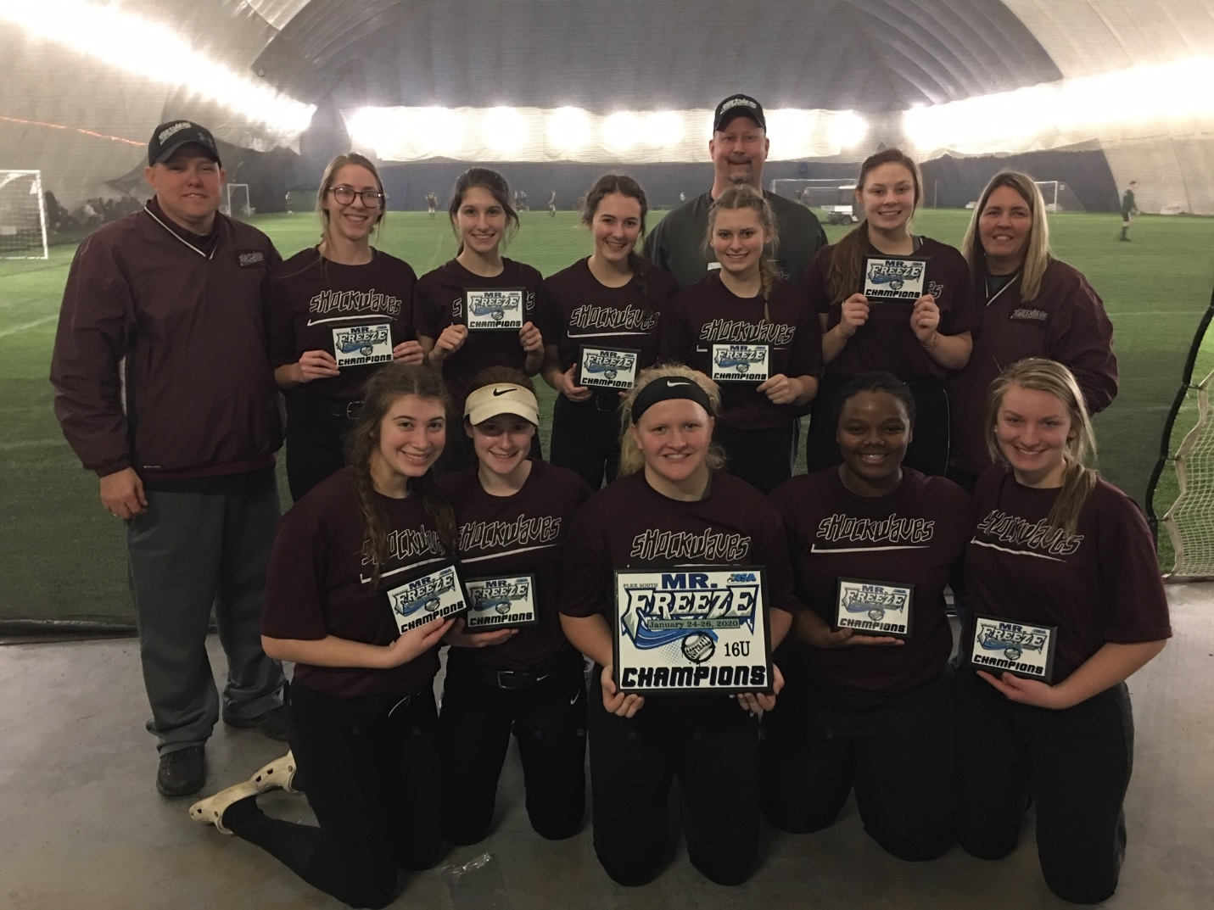
16u Champions Indiana Shockwaves (Kleinbub)

