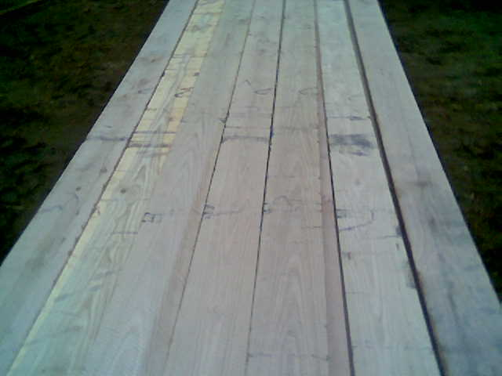

Horse Fence Oak 1x 6 x 16

