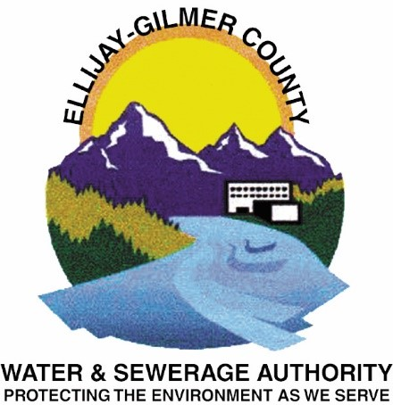

Authorization for Direct Payment via ACH
Direct Payment via ACH is the transfer of funds from an account for the purpose of making a payment.
Check one: ☐ Begin Payment ☐ Change Information

I (we) authorize Ellijay-Gilmer County Water & Sewerage Authority(“EGCWSA”) to electronically debit my (our) account and, if necessary, to electronically credit my (our) account to correct erroneous debits as follows:
- Checking Account / ☐ Savings Account (select one) at the depository Financial Institution named below (“Bank”). I (we) agree that ACH transactions I (we) authorize comply with all applicable law.

Bank name:

Routing number: Account number:

Name(s) on the account:

Debit transaction frequency:

  - One-Time Draft Authorized Amount $____________
  - Monthly Draft of Account Balance (entries that recur at substantially regular intervals, without further affirmative action by the Receiver)

Payment Date/ Payment Start Date:

I (we) understand that this authorization will remain in full force and effect until I (we) notify EGCWSA in writing that I (we) wish to revoke this authorization. I (we) understand that EGCWSA requires at least 10 days prior notice in order to cancel this authorization.

Name(s):
(Please Print)
Water Account Number: _______________________ Service Address: ___________________________

Date: Signature(s):

PLEASE ATTACH VOIDED CHECK/ SAVINGS DEPOSIT SLIP

COMPLETED FORM MAY BE EMAILED TO customerservice@egcwsa.com

