Mars UP Church

Apostles’ Creed
I believe in God the Father Almighty, Maker of heaven and earth; and in Jesus Christ His only Son our Lord; who was conceived by the Holy Ghost, born of the Virgin Mary, suffered under Pontius Pilate, was crucified, dead and buried; He descended into hell; the third day He rose again from the dead; He ascended into heaven, and sitteth on the right hand of God the Father Almighty; from thence He shall come to judge the quick and the dead. I believe in the Holy Ghost, the holy catholic church; the communion of saints; the forgiveness of sins; the resurrection of the body; and the life everlasting. Amen.

Gloria Patri
Glory be to the Father, and to the Son, and to the Holy Ghost. As it was in the beginning, is now and ever shall be,
world without end.
Amen. Amen.

Come Holy Spirit, Come
Before the Service – Speak to God!
During the Service – Let God speak to you!
After the Service – Speak to each other!

(*Please stand, if able)
Welcome and Mars Messages

Prelude

Call to Worship (adapted from Psalm 139:1-12, 23-24)
Leader: If God is for us, who is against us?
People: He who gave us his son, now gives us the Spirit in power!

Leader: The Holy One is in our midst:

People: equipping us for life in the service of Christ.

Leader: In Christ we are more than conquerors,

People: for nothing in creation can separate us from the love of God!

Leader: May the all surpassing grace of our Lord Jesus Christ be with you.

People: And the unshakable love of God be with you.
Leader: The joyous communion of the Holy Spirit be with you.

People: And Also with you!

Opening Prayer

*Hymn 3
“Holy, Holy, Holy! Lord God Almighty”

Scripture Romans 8:31-39

Children’s Chat
The
Lord’s Prayer

Our Father,
who art in heaven,

hallowed be Thy
name,

Thy kingdom come,
Thy will be done,
on earth
as it is in heaven.

Give us this day
our daily bread;

and forgive us
our debts,
as we forgive
our debtors;

and lead us not
into temptation,
but deliver us
from evil.

For Thine
is the kingdom,
and the power,
and the glory,
forever. Amen.

The Doxology

Praise God
from whom
all blessings flow;
praise Him
all creatures
here below;
praise Him above,
ye heavenly host;
praise Father, Son,
and Holy Ghost.
Amen.

*Hymn 630
“What a Friend”

Morning Message Rev. Brian Hauser
“The Confidence of Faith”

Prayers of the People and Lord’s Prayer

Offertory
Doxology
Prayer of Dedication

Affirmation of Faith Apostles Creed

*Hymn 327
“The Old Rugged Cross”

*Benediction

*Postlude

MUP Session
Church Staff
Rev. Brian Hauser
Pastor
pastor@mars-up.org
724-689-3412

Mrs. Shelly Bocheff
Administrative Assistant
marsup@mars-up.org

AV TEAM
Alma Staskiewicz, Lisa Barbour, Marie Matthews, Bill Guesman, John Ivory, Mike Bocheff, Herb Wellman

Mars United Presbyterian Church

232 Crowe Ave
PO Box 805
Mars, Pennsylvania 16046
724-625-1365
www.mars-up.org
marsup@mars-up.org

Church Office Hours:
Mon -Thurs from 9 a.m. -2:30 p.m.

Class of 2025 Class of 2024 Class of 2023
John Ivory Alma Staskiewicz Lisa Barbour
Susan Cox Louise Fox Mary Ann Croop
Jay Wilson Marie Matthews Don Lewis
Herb Wellman

Clerk of Session: Herb Wellman
Morning Worship:
10:00 am

8th Sunday after Pentecost

Prayer of Preparation
Lord, we come to you today with so many things on our hearts.

You call us to be in relationship of trust and love with you and you offer healing to us for those portions of our lives that are broken and injured.

Help us to be open to your mercy and healing love. For we ask this in Jesus’ Name.
AMEN.

MUP Deacons

Class of 2025 Class of 2024 Class of 2023
Jill Cooper Steve Martin Sharon Gibb
Robyn Beckwith Marge Nicklas Carol Kopar
Missy Wells Pat Auld Alice Leonberg

Moderator: Steve Martin

MUP Music Committee
Keith Nichols – Chair
Sally Olsen – Clerk
Alma Staskiewicz
John Ivory
Linda Lees
Karl Kennedy

Mars United Presbyterian Church
Welcome!

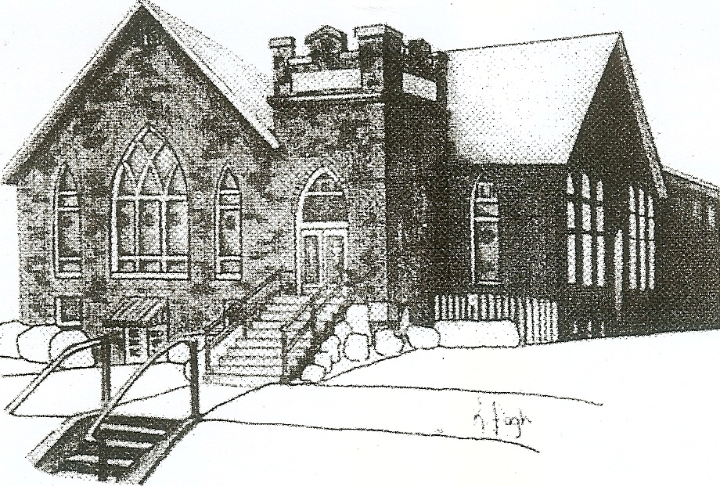
We are your hometown church: Faithful to Tradition, Loving in Fellowship, & Reaching for Tomorrow!

July 30, 2023

We welcome you and we are glad you’ve chosen to Worship with us today!

CALENDAR: July 30th – August 6th

Church Office Hours: Monday -Thursday from 9 a.m. – 2:30 p.m.

Today, July 30, 2023
VOLUNTEERS☺

LAST SUNDAY’S In-House ATTENDANCE:

LAST SUNDAY’S OFFERING:
Operating Funds:
Kindness:
Mission:
Total:

Tarry N Talk Hosts
Deacons

10:00 a.m. THE MORNING WORSHIP SERVICE
Monday, July 31, 2023
Tuesday, August 1, 2023
9:00 am Ateam
7:00 pm AA Meeting
Wednesday, August 2, 2023
9:00 am Material Girls
Thursday, August 3, 2023
Friday, August 4, 2023
Saturday, August 5, 2023
Sunday, August 6, 2023
10:00 am THE MORNING WORSHIP SERVICE

Welcome to all who are Worshiping with us today!

Guests
We sincerely hope our service is a blessing to you. We ask that our guests please take a few minutes to complete one of the Connect Cards found in the pew holder.

Should you have questions regarding any aspect of our church, including membership, please contact Pastor Brian or the church office during the week at 724-625-1365. Thank you for being with us today.

PRAYER – JOYS & CONCERNS
Lou Beckwith Paige Lauten
Paige Barbour (daughter of Andrew and Steph Barbour) Sandy Wahl
Reid Christopher Hall (June Stirling’s nephew)
Lindy McCartney (Lisa Barbour’s Sister)

ANNOUNCEMENTS
Bulletins are printed Thursday mornings; let us know if you have an announcement…

VBS REUNION We had so much fun at VBS, we can’t wait until next year! Join us for a VBS REUNION to have a bonus day of VBS! SUNDAY, AUGUST 13TH at Mars UP Church 1-3pm

GRIEFSHARE SUMMER MEETINGS Griefshare will continue to hold one monthly meeting during the summer. Meetings will be held on July 17th, and August 21st. The fall session will resume on September 18th at 6:30 For more information, please contact Denise @ ddemarco5@yahoo.com

VOLUNTEER OPPORTUNITIES Please join other MUP friends as we volunteer at one of our mission partners this summer --- Pine Valley Bible Camp (near Ellwood City) On Wednesday August 9 from 5:30-7:30 pm we will be serving dinner and dessert to the campers. Anyone volunteering is invited to stay for dinner at the camp if interested, we just need to let them know how many are staying. Ask a friend and let’s send lots of folks to help…pretty sure car pools can be arranged, too.
Sign-up sheets are in the Tarry ‘n Talk area or see Rev. Brian or any Christian Ed/ Mission & Outreach committee member (John Ivory, Susan Cox, Lisa Barbour, Herb Wellman, Carol Kopar, Jill Cooper) to volunteer or for questions.
COMING THIS FALL Mothers of Preschoolers (MOP) group starting at Mars UP Church. To register or questions contact church office or Ashley Hauser at 814-270-9101. More details to follow!!
SAVE THE DATE Mars UP church annual picnic will be held Sunday, September 10th at Adams Township Park. We will also be celebrating Rally Day this Sunday. More Details to Follow!!

