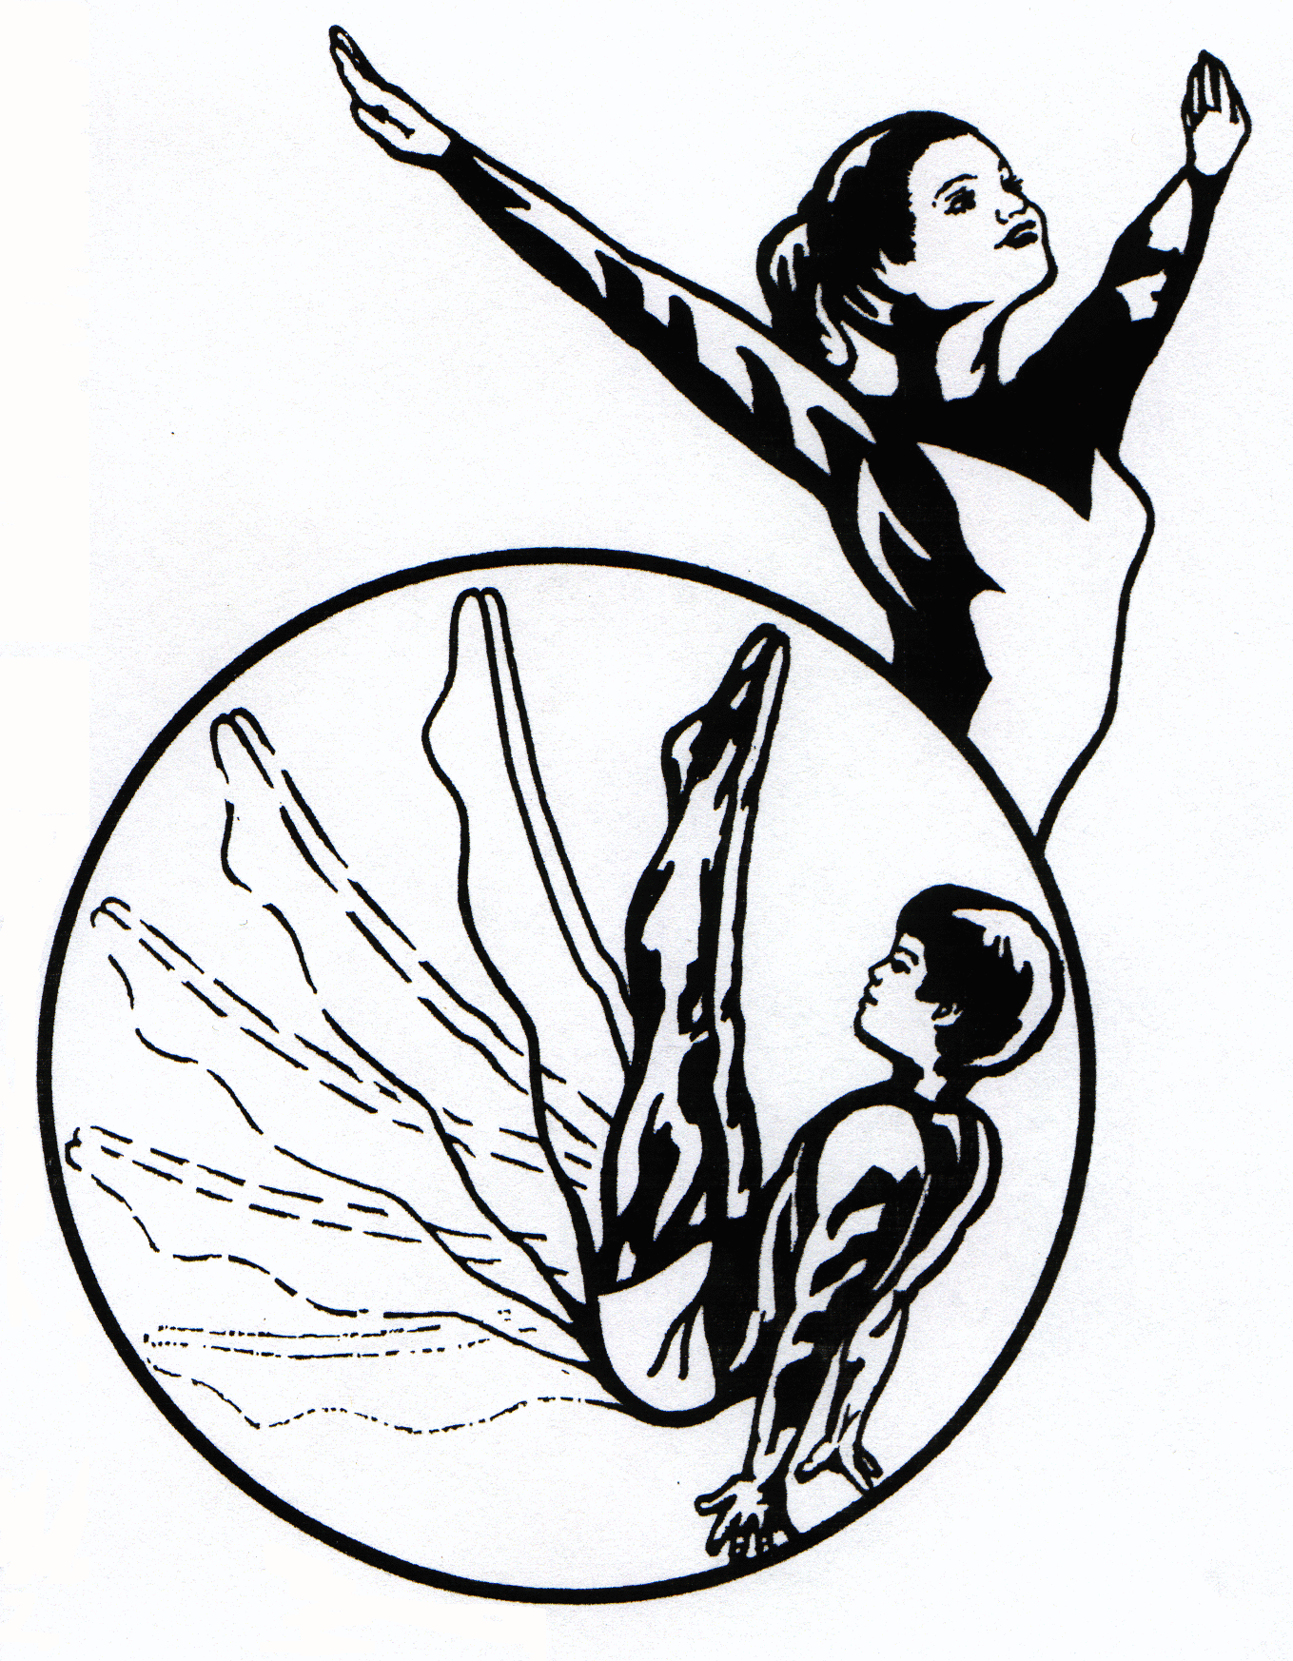
The Ohio Gymnastics Institute, Inc.
5701 West Webb Rd., Austintown Ohio 44515
330-652-4386 / MyTeamOGI.com

Build-a-Birthday Party at OGI!
OGI Birthday Party Packages give parents the option of doing as little or as much as they choose. Each package has available add-on options to create a unique experience for everyone at the party. From decorations to food and drinks, OGI has the party for you!

All activities will be based on the age of the birthday child, who will be the star of the party!

Standard Party Premium Party
$215 for up to 8 children $275 for up to 8 children
$290 for up to 16 children $350 for up to 16 children
1.5 hour total party 2 hours total party
1 hour in the Gym 1 hour in the Gym
½ hour in the Party Room 1 hour in the Party Room
Free Participant Open Gym Passes Free Participant Open Gym Passes

Both party options have available add-ons. The premium party includes a premium bonus of one free add-on and lots of extras!
A $75.00 deposit is required when you pick up your invitations.
Please see the office for additional information.

*Reminder: No crockpots or other cooking devices at parties. No alcoholic beverages on OGI property.

Sunday parties must be scheduled 1 month in advance and have a 10% surcharge.

