**March Members Meeting & Program**

**March 10, 2025**

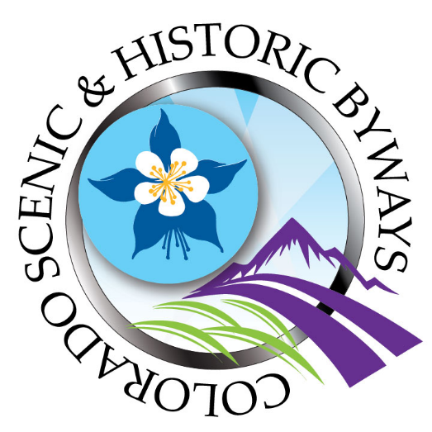

**WHAT: March 2025 RMGA MEMBERS MEETING & PROGRAM**

**WHEN: March** 10, 2025

6:00 pm – Networking

6:30 pm – Business Meeting – Nominations for Board of Directors

6:45 pm – Program: Colorado’s Scenic and Historic Byways

Lenore Bates, Colorado Byways Program Manager, CDOT, will tell us about the Scenic and Historic Byways of Colorado program and each Byway.



Colorado’s Scenic and Historic Byways program provides a system of 26 spectacular touring routes throughout rural Colorado. The Byways Commission is a partnership to maintain and improve this Colorado system of 2,565 miles of outstanding roadways, located in 48 of Colorado’s 65 counties. Thirteen byways have been awarded the national designation of America’s Byways® and the Colorado Byways program established in 1989 has the largest number of nationally designated scenic byways

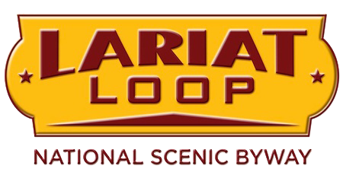

**WHERE: Via Zoom**

Rocky Mountain Guides is inviting you to a scheduled Zoom meeting.

Join Zoom Meeting:

<https://us06web.zoom.us/j/84614004864>

**GUESTS:**  **Members are encouraged to invite potential members as guests to the meeting.**

**GUEST FEES: 1st and 2nd Time Guest:** Free, **Third thru Fifth Time, Same Guest Visit is** $10 each time**. Succeeding Times, Same Guest** Must Join RMGA.

**MEETING NIGHT CONTACT**: Mike Pearl (303) 868-0023 voice & text or Tom Jensen (303) 968-0515l