August 2015 Volume 26 #8

AUGUST
As has been noted previously, August is our only month without a major holiday (I don’t think International Left-handers Day on August 13th qualifies, do you?). Lefty or Righty, everyone have a very happy month!

BOARD MEETING

There is no Board Meeting in August. The next Board Meeting will be on Tuesday, September 15th.

TGIF PARTY
The TGIF this month is on Friday, August 7th starting at 5:45 p.m. All residents are invited and we look forward to seeing you there. There is no admission charge, just bring a beverage of your choice and a small item of food to share.

ANNUAL BARBEQUE
The Annual Poolside Barbeque will be on Saturday, August 15th. The party will begin at 5pm and dinner will be served at 5:45. A reservation form will be delivered to your tube. Completed forms must be returned by Monday, August 10th.

MOVIE NIGHT
The movie for August will be Woman in Gold starring Helen Mirren. Plot summary: An octogenarian Jewish refugee takes on the government of Austria to recover artwork she believes rightfully belongs to her family. The movie will begin at 7 p.m. on Wed., August 19th in the Clubhouse.

PLEASE NOTE

On collection days, garbage & recycling cans must be placed on sidewalks, not in the street.

PRESIDENT’S REMARKS
At the last HOA meeting there was considerable discussion regarding: pool rules, home-owner parking, tree root situations, fence/noise barriers, and HOA monthly delinquent fees. Some of these issues are complicated and will require further discussion and consideration. In other cases, just a few reminders are in order regarding our community rules and regulations listed in the CC&R’s.
The pool rules state that from 2-4PM is reserved for solely adult swim time, so prior to 2PM and after 4PM children would have ample opportunity to swim. This particular pool rule has not been followed by all residents and guests. Also please be reminded that glass bottles and containers are off limits in the immediate pool area, for the safety of everyone.
The HOA meeting discussion also centered around too many keys floating around the community. No decision was reached, but suggestions were offered for consideration, including:
* New locks and keys being issued to homeowners
* Making the pool gate higher
* Improving gate security so that reaching over the gate to open it will not be possible
* Using a swipe card similar to Creekside’s system
The pool season is half over; so new procedures would likely be instituted next year. In the mean-time, we ask all residents to abide by the rules when using the pool.
Homeowner parking was raised again. Ideally, cars should be garaged when not in use. Regarding cars left in driveways, the neighbor-to-neighbor approach seems to work more often than not. All Chantarelle residents have chosen to live here and agreed to abide by the CC&R’s. Homes here are in demand and sell quickly. Part of the appeal is the tranquil look and feel of Chantarelle. Our cooperation in these matters will ensure a positive future.
The letter from our attorney regarding the HOA tree responsibility has been under Board discussion and a few more meetings should clarify what we do from now on. When these decisions are finalized, the procedures and forms needed will be made clear to all homeowners. These procedures will include, for example, application forms, timelines, estimates, budgetary considerations and approval protocols. So you can see it is complex and I hope that the next HOA meeting will point us in the right direction to start this process.
Fence/noise barriers for homes that border Arnold Drive were also discussed. Paul Strong and I will do some research and report back at the September HOA meeting.
We received a report from the Finance Committee and we as a community are in very good shape as per our yearly budget. The Board moved to approve a lien for one homeowner who is in arrears and per the CCR’S the HOA needs to move ahead with legal action. This is no easy task from a humanistic point of view, but at this point, from a financial standpoint affecting the community, we must proceed. Let’s hope an optimal solution can be realized for both parties.
We are looking for volunteers to visit our neighbors who are in hospital. While this is often done by family and friends, there are some who may not have family nearby. Volunteers could bridge the communication gap for a short period of time. Please join me in forming a list of volunteers for this project.
You may have noticed our new Chantarelle Clubhouse sign. Thanks to Carl Hofman for doing the finishing work, and to Charlie Berry for his original California quail design. I am grateful for all of our helping hands in Chantarelle.
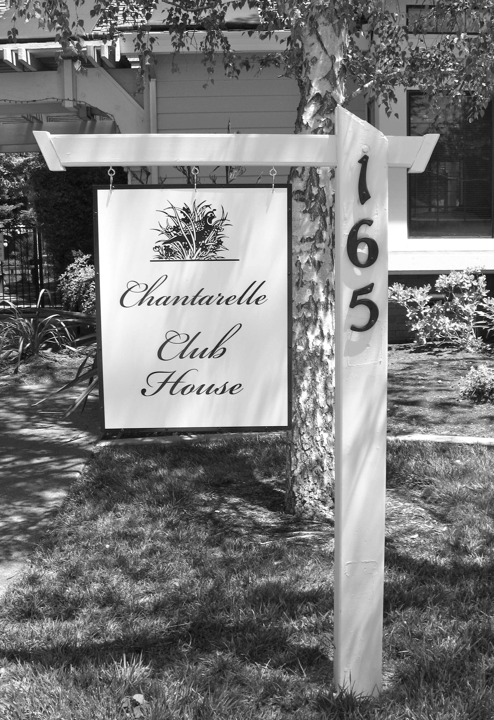
Security: Please make sure when you leave your home that all doors are locked and secured. A break-in occurred at the home of an attendee at the last HOA meeting while the meeting was in progress. The neighborhood needs to be on watch as well so that each of us is safe. We can help one another by noting anything that seems out of place. If you see something, say something. The more eyes looking will help to deter any wrongdoing.
At the Health and Safety committee meeting in the clubhouse on July 27th, Hans Steuck, our H/S chairperson, made us aware of many health and safety concerns. Some are highlighted here, and the information will be distributed at the September HOA meeting. The Chantarelle community is laid out in 8 Zones with 15-17 homes in each zone. The ideal would be to have 1-2 team members for each zone to prepare for emergencies. In case of emergency in the community each zone reports to a command center and then the command center reports to the Fire Dept. We now have 8 walkie-talkies available for zone communication.
For your home safety, having important telephone numbers and health information written on a magnetic strip on the refrigerator is the first place that the fire department looks when they arrive at a home. As you know, it is now one year since our last earthquake so these tips are important. A grab and go case is recommended in the event of evacuation. Have important papers in place along with any health needs so that you can maintain your health for a period of time. If still at home a water supply is vital. Water can be purchased that will last for up to 5 years from a specific company. More details to follow in September. Keep a bike for transportation, have a helmet, safety goggles, a knife, vest, dust mask, flashlight and a whistle. Any and all of these items may help when an emergency occurs. Hans also has available brochures on various safety and security topics, including telemarketing scams, home and personal safety and security, vehicle security, privacy protection and crime prevention.
If you have a streetlight that is not working properly, PG&E’s telephone number is on the pole for reporting the outage.
At the Sept. HOA meeting I will have orange signs, which can be used in an emergency. They state ”I’m OK” or “I Need Help “ and would be placed in a front window during the emergency or event. We will also distribute a list surveying “homeowner strengths” which will allow us to call on you to aid the community in an emergency. We all have the ability to help one another in a crisis. Thank you, Hans, for your efforts to keep us safe and secure. Volunteer to be a Zone Team Member. A list will be distrib-uted at the Sept. HOA meeting.
In the meantime, I hope to see you all at the Community BBQ on August 15th. Dave Owens

LANDSCAPE NOTES
Here is your summertime Landscape Committee summary...

Waldron Crew Increases Chantarelle Days. You'll be seeing a bit more of the Waldron crew these days. The crew will now be here on these days: Tuesdays: 8 am - 2 pm, Thursdays: 10 am - 4 pm, Fridays: 8 am - 2 pm. Please note that the days of the week are firm but the hours are approximate. The head of the crew is now Rojelio Sanchez, assisted by Arnulfo Rojas, and sometimes additional crew, depending on the need.
Ground Beautification. We are now in the midst of a major mulching project. Rojelio and Arnulfo are progressing through the neighborhood with fresh mulch on Fridays, covering ground areas that are either bare or have old mulch. Those of you who have had fresh mulch placed within the last year won't be receiving mulch this time around, but the rest of the community will be completed by the end of August, if not sooner.
Drip Irrigation Conversion. When we start to move into cooler weather and the Waldron crew isn't quite so busy, we are going to start converting spray irrigation for the shrubs in front of our homes to much more efficient drip irrigation. This will ensure that our precious resource of water will go straight to the roots of the plants rather than coating the leaves and then either evaporating or simply not pene-trating into the ground. Drip irrigation will greatly enhance our water conservation as well as help our beautiful plants thrive. One more item about irrigation: please inform us if you notice any irregularities in the irrigation around your home. Since the irrigation goes on at night, we can't always keep tabs on where leaks or problems might be occurring.
A Little Help For Our Friends
Until this drip irrigation conversion begins, we wish to ask a bit of assistance from you -- particularly during the height of the summer heat. Please check plants in front of your home to see if they appear to be receiving enough water. If not, please give your leafy friends a nice dose of water at the roots ever few days. If you can’t do this for any reason, then please inform either Debbie or myself so that we can make sure that the plants in front of your home do receive enough water. Thank you so much for your help!
Tree Removal Project Scheduled for September
Sadly, it is time to say good bye to a few of our tree friends in the neighborhood. Some of the Ornamental Pear trees are too damaged by the Blight to be saved, so they will be removed. And there are a few others scattered about that need to go. Please know that the decision to remove any tree in our community is made with a great deal of forethought and is aided by the recommendations given to us by Ryan Garrison, our tree expert from Art & Science Tree Service. Not only is this quite an expense for our landscape budget to bear but, even more importantly, the beauty of our trees is a very important aspect of the overall loveliness of our neighborhood. So we never take a tree removal decision lightly! The dates we have scheduled are Tuesday, September 8 - Thursday, September 10. Be prepared to experience the sound of saws and wood-chipping on those days.
A Different Kind of Movie Night! In the month of September, we are going to schedule the showing of a locally made documentary called "The Russian River: All Rivers" at the Chantarelle Clubhouse for our residents. Here is a summary of the movie: "Rivers are among Earth's most enduring features. Even when threatened or in decline, they, and the habitat they nourish, can appear deceptively beautiful. The Russian River and its water-shed have always provided. Those with access to this gift have always taken what they've wanted. The story of the Russian River is, in many ways, the story of all rivers."
~ Debbie and Susan

SUNSHINE COMMITTEE
If you know of anyone at Chantarelle who is sick or if you have a new neighbor, please let Willy Hoekstra know, so that she can contact them. Willy’s number is 996-0661.

CLUBHOUSE NOTES
To reserve the clubhouse for an event, please call Liz Wardimon at 343-1132.

SAFETY & WELFARE
The Safety & Welfare Committee still needs additional volunteers. Interested residents should call Hans Steuck at 939-1103.
The following page contains valuable tips about what to do during and after an earthquake.

BOARD OF DIRECTORS & COMMITTEE MEMBERS
Please refer to your 2015 Directory for a list of our Board of Directors and Committee Members.

CHANTARELLE WEBSITE

Check out the Chantarelle website at Chantarelle.org. The website is now maintained by John Dodgshon and Mary Howland. Please submit suggestions to John & Mary at news@chantarelle.org.

NEWSLETTER

Please submit items for the newsletter to John Dodgshon, 933-8395 or email him at: John_Dodgshon@hotmail.com.
Our thanks to Cecilia Angel for her continued dedication to delivering the newsletter.

A REMINDER ABOUT EARTHQUAKES…

DURING THE EARTHQUAKE…

- Remain calm
- Avoid windows
- Stand in door frame or duck under desk/table near exit

AFTER THE SHAKING IS OVER…

* Survey damage
* Shut off utilities in case of gas smell or severe structural damage
* Be alert for possible aftershocks
* Locate emergency supplies
* Survey neighborhood for those who may need help

WHAT YOU CAN DO NOW…

* Make sure you know the location of shutoff valves for gas, electricity & water (see below)
* Start assembling emergency supplies
* Identify and locate important items to take in the event evacuation is required

GAS
When- You smell gas or have substantial damage to your house
Where- Next to gas meter on side of garage
What- Turn lever with wrench ¼ turn (across flow)
NEVER TURN THE GAS BACK ON… LET PG&E DO IT

ELECTRICITY
When- You smell burning insulation or have substantial damage to your house
Where- Next to electric meter on side of house (main breaker panel) or
Laundry room wall (individual breaker panel)
What- Turn main or individual breakers off

WATER
When- You have a severe leak in, or substantial damage to, your house
Where- Next to sidewalk under WATER METER plate (water district shutoff) or vertical pipe
on house in line with water meter (outside water shutoff)
What- Turn water meter lever ¼ turn (across flow) or turn outside water shutoff wheel
clockwise

CHANTARELLE WEEKLY CALENDAR
Monday | Tuesday | Wednesday | Thursday | Friday
Art Club 1pm |  | Mah Jongg 9:30 Bridge 12:30pm | Rummikub 1:30 | Mah Jongg 9am
Water Aerobics 1-2pm | Water Aerobics 1-2pm | Water Aerobics 1-2pm | Water Aerobics 1-2pm | Water Aerobics 1-2pm
AUGUST 2015
Sun | Mon | Tue | Wed | Thu | Fri | Sat
 |  |  |  |  |  | 1
2 | 3 | 4  Bunco  1-4pm | 5 | 6 | 7  TGIF  5:45pm | 8
9  Clubhouse closed for private party  (all day) | 10 | 11  MexicanTrain Dominoes  12:30-4pm | 12 | 13 | 14 | 15
16 | 17 | 18 | 19  Movie  Night 7pm | 20  Clubhouse closed for private party  (in evening) | 21 | 22  Clubhouse closed for private party  (all day)
23 | 24 | 25  MexicanTrain Dominoes  12:30-4pm | 26 | 27 | 28 | 29
30 | 31

Waldron Landscaping is now here on Tuesday 8am-2pm, Thursday 10am-4pm and Friday 8am-2pm.
Garbage, recycling and garden trash pickup is every Monday.

