The Four Tavs

The Meaning of the Tav

The Tav is the last letter in the Hebrew alphabet. The Messiah Himself gives us the meaning of the Tav in the book of Revelation when He identifies Himself as the Alpha and the Omega, the Beginning and the End. The Greek letter "Alpha" corresponds to the English letter "A" and the Hebrew letter "Aleph", the first letter in each alphabet. The Greek letter "Omega" corresponds to the English letter "Z" and the Hebrew letter "Tav", each being the last letter in their alphabets.

Although the book of Revelation was written in Greek, the Messiah probably spoke to John in Hebrew during the giving of His revelation.

In ancient Hebrew the meaning of the Tav was "a mark", and was signified in the earliest ancient pictorial Hebrew as crossed sticks. Crossed sticks were placed at the end of the field and were used as a guide to help the farmer plow a straight furrow. The Tav is a "marker of the end" and a part of the alphabet used by Israel during King David's reign 3000 years ago. The Hebrew Tav today looks entirely different because the Jews adopted an entirely different alphabet during the Babylonian captivity about 2500 years ago around 550 BC.


The Paleo Hebrew Tav The modern Hebrew Tav

The Four Tavs at the End of the Age

There are a series of 4 pairs of solar eclipses which began in 1999. Each pair paints an ancient Paleo Hebrew X “Tav”, or “End Mark” on a particular region of the earth. The series of 4 eclipse pairs ends in the year 2034. These Tavs were placed on the earth by the Creator at the time of the creation of the heavens and the earth.

In each of the 4 Tavs the first eclipse in each pair occurs in the month of August. Each August eclipse suddenly reveals the King star Regulus, signifying Israel’s King the Messiah, and the constellation Leo signifying the Lion of Judah, to the observers in the path of eclipse totality.

The second eclipse in each pair occurs exactly 2422 days later, and marks the precise beginning of the first Hebrew month, Aviv 1, in each case.

Here’s a list of the eclipse pairs and the regions marked by the eclipses:

1. 8/11/1999 – 3/29/2006 …Turkey, Ezekiel 38 & 39

2. 8/01/2008 – 3/20/2015 …Russia, The Extreme North

3. 8/21/2017 – 4/08/2024 …United States, Babylon the Great

4. 8/02/2027 – 3/20/2034 …Islam, The Beast

These four Tavs don't necessarily mean that Israel's Moshiach can't come until after 2034. The Tavs were revealed to me November 21-29, 2014. Moshiach's coming will be at the Father's appointed time. We can know the general time by watching world events and studying the bible. We need to be prepared. The unimaginable is coming.

The First Tav

Here is the first “Tav” in ancient Paleo Hebrew painted on the earth by the first pair of solar eclipses:

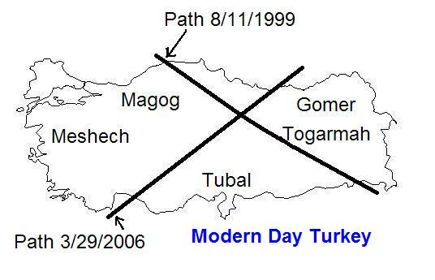

This “Tav” from the Creator may be indicative of the coming fulfillment of Ezekiel chapters 38 & 39.
2
Ezekiel 38:1 And the word of YaHuWaH came unto me, saying,
2 Son of man, set thy face against Gog, the land of Magog, the chief prince of Meshech and Tubal, and prophesy against him,
3 And say, Thus saith the Master YaHuWaH ; Behold, I am against thee, O Gog, the chief prince of Meshech and Tubal:
4 And I will turn thee back, and put hooks into thy jaws, and I will bring thee forth, and all thine army, horses and horsemen, all of them clothed with all sorts of armor, even a great company with bucklers and shields, all of them handling swords:
5 Persia, Ethiopia, and Libya with them; all of them with shield and helmet:
6 Gomer, and all his bands; the house of Togarmah of the north quarters, and all his bands: and many people with thee.

Ezekiel 39:1 Therefore, thou son of man, prophesy against Gog, and say, Thus saith the Master YaHuWaH ; Behold, I am against thee, O Gog, the chief prince of Meshech and Tubal:
2 And I will turn thee back, and leave but the sixth part of thee, and will cause thee to come up from the north parts, and will bring thee upon the mountains of Israel:
3 And I will smite thy bow out of thy left hand, and will cause thine arrows to fall out of thy right hand.
4 Thou shalt fall upon the mountains of Israel, thou, and all thy bands, and the people that is with thee: I will give thee unto the ravenous birds of every sort, and to the beasts of the field to be devoured.
5 Thou shalt fall upon the open field: for I have spoken it, saith the Master YaHuWaH.
6 And I will send a fire on Magog, and among them that dwell carelessly in the isles: and they shall know that I am YaHuWaH.
7 So will I make My holy Name known in the midst of My people Israel; and I will not let them pollute My holy Name any more: and the heathen shall know that I am YaHuWaH, the Holy One in Israel.

3

The Second Tav

Here are the paths of the second pair of eclipses in the sequence:

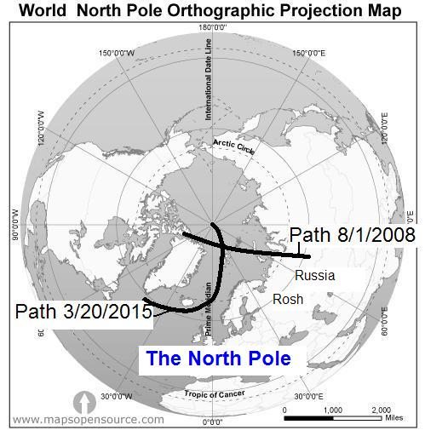

Above: The "Tav" intersects at approximately 82 N and 28 E In the Berents Sea in the image above.

The eclipse of 3/20/2015 on the map directly above describes a "cup" as it passes over the Faroe and Svalbard Island Groups. The Messiah will press grapes into "Faroe's" cup and give it to him to drink.

4
Joseph's Interpretations of the Dreams of the Butler (Cup Bearer) and the Baker from the book of Genesis chapter 40

Similarities:

The Presser of Grapes:
The Cup Bearer (Messiah) will return alive after being imprisoned (crucified) to press (tribulation, a time of pressure) the grapes (blood) into Pharaoh's (Faroe's) cup. By this time the "woman who rides the beast" described in the book of Revelation has already drunk the blood of the saints in the inquisitions.

The Baker:
Pharaoh's Baker had his head lifted, he was beheaded. Elijah went alive into heaven (his head was lifted alive), John the Baptist (Elijah) was beheaded. The End Time Bakers (Elijah's) who bring the Bread of Life are now being beheaded by Islam. Perhaps some will have their heads lifted in another way and they will be taken alive into heaven.

We're invited to the end times wedding feast. Elijah brings the bread, Moshiach will provide the wine.

The eclipse on 3/20/2015 in the graphic above, again marking Aviv 1, passes over the Faeroe Islands and ends precisely at the North Pole. The North Pole points to the star Polaris signifying the “lesser sheepfold” and Isaiah chapter 63, and Micah 2:12-13 the “Breaker” who is Messiah.

Isaiah 63:1 Who is this that cometh from Edom, with dyed garments from Bozrah? this that is glorious in His apparel, traveling in the greatness of His strength? I that speak in righteousness, mighty to save.
2 Wherefore art Thou red in thine apparel, and Thy garments like him that treadeth in the wine vat?
3 I have trodden the wine press alone; and of the people there was none with Me: for I will tread them in Mine anger, and trample them in My fury; and their blood shall be sprinkled upon My garments, and I will stain all My raiment.
4 For the day of vengeance is in Mine heart, and the year of My redeemed is come.

Micah 2:12 I will surely assemble, O Jacob, all of thee; I will surely gather the remnant of Israel; I will put them together as the sheep of Bozrah, as the flock in the midst of their fold: they shall make great noise by reason of the multitude of men.
13 The Breaker is come up before them: they have broken up, and have passed through the gate, and are gone out by it: and their King shall pass before them, and YaHuWaH on the head of them.
5
The path of the 8/1/2008 eclipse on the image above passed directly over this item on display in a building on an island north of Siberia in the Berents sea:


57 million tons of TNT

The Eclipse of Regulus by the Asteroid 163 Erigone on 03/20/2014

On 03/20/2014 at 6:06 AM UT (2:06 AM EDT New York Time) precisely 1 year to the day before the total solar eclipse of 03/20/2015 mentioned above, the asteroid 163 Erigone blocked the light from the star Regulus (the King star, the sign of Messiah, in the constellation of Leo the Lion) as seen from New York City. To an observer in New York City the star Regulus appeared to vanish for about 20 seconds and then reappear at about 2:06 AM EDT as the asteroid moved between Regulus and the earth and blocked the light from the star.

6
Below: A graphic that illustrates the 40 km wide ground path of this occurrence. Anyone along this path was able to see Regulus disappear and then reappear at the UT times indicated. Those people outside the path didn't notice any change in the star.

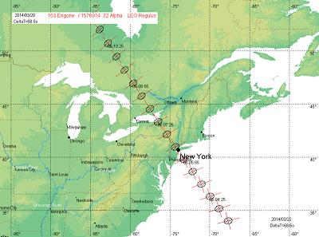

Illustration courtesy Aldo Vitagliano

Above: New York City was marked on 3/20/2014, precisely one year after President Obama arrived in Israel for talks on 3/20/2013, and precisely one year before the solar eclipse of 3/20/2015.

The Creator appears to have targeted New York City for this warning. Could it be that the Manhattan project of WWII was prophetically named? Could it be that President Obama has a major part in the biblical end times?

The Manhattan Project

Isaiah 46:9 ...I am Elohim, and there is none like Me,
10 Declaring the end from the beginning,...

Because YaHuWaH declares the end from the beginning, the end result of the secret "Manhattan Project" of World War II to develop nuclear energy might be the literal destruction of Manhattan by a nuclear device.

Manhattan is currently the economic center of the world.

The book of Revelation declares the destruction of Babylon the Great, the economic center of the world in the end times, in one hour by burning:

Revelation 18:9 and the kings of the earth, who have committed lewdness and lived deliciously with her, shall bewail her, and lament for her, when they shall see the smoke of her burning,
10 standing afar off for the fear of her torment, saying, alas, alas, that great city Babylon, that mighty city! for in one hour is thy judgment come.

The Third Tav

Below: The Tav painted by the third pair of solar eclipses:

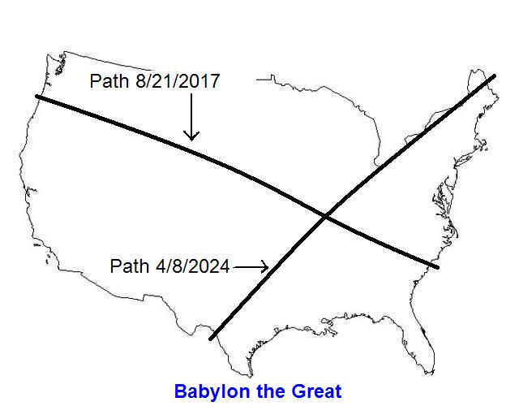

The United States of America

Above: The intersection point of the above eclipses is just south of Carbondale, Illinois. It's a region of the nation known locally as "Little Egypt".

Revelation 18:8 Therefore shall her plagues come in one day, death, and mourning, and famine; and she shall be utterly burned with fire: for strong is YaHuWaH Elohim who judgeth her.
9 And the kings of the earth, who have committed fornication and lived deliciously with her, shall bewail her, and lament for her, when they shall see the smoke of her burning,
10 Standing afar off for the fear of her torment, saying, Alas, alas, that great city Babylon, that mighty city! for in one hour is thy judgment come.
11 And the merchants of the earth shall weep and mourn over her; for no man buyeth their merchandise any more:

The Fourth Tav

The fourth Tav of the solar eclipse sequence:

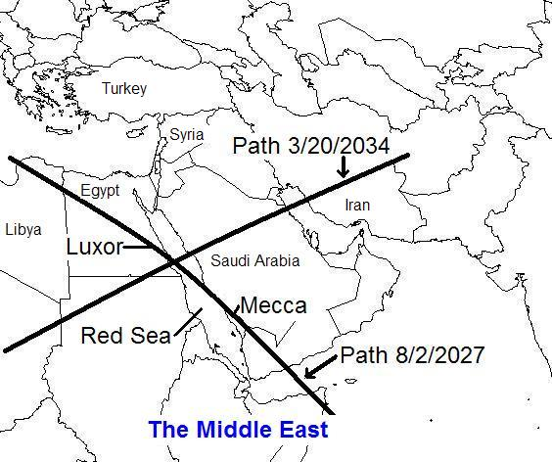

Above: A Tav is placed on the Red Sea directly in line between Luxor and Mecca.
Below: The eclipse of 8/2/2027 passes directly over the Kaaba in Mecca:

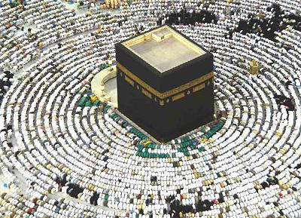

Above: Muslims bowing in prayer around the Kaaba in Mecca, Saudi Arabia

Below:The Kaaba Stone, a meteorite, symbolic of a fallen angel, mounted on the east corner of the Kaaba:

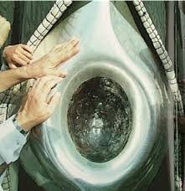

Above: The Muslim faithful reverence and kiss the Kaaba Stone, an act of idolatry.

10
Revelation 21:6 And He said unto me, It is done. I am Aleph and Tav, the beginning and the end. I will give unto him that is athirst of the fountain of the water of life freely.
7 He that overcometh shall inherit all things; and I will be his Elohim, and he shall be My son.
8 But the fearful, and unbelieving, and the abominable, and murderers, and whoremongers, and sorcerers, and idolaters, and all liars, shall have their part in the lake which burneth with fire and brimstone: which is the second death.

Below: The stars in the image below suddenly appear directly overhead in the daytime to eclipse observers in Mecca on 8/2/2027:

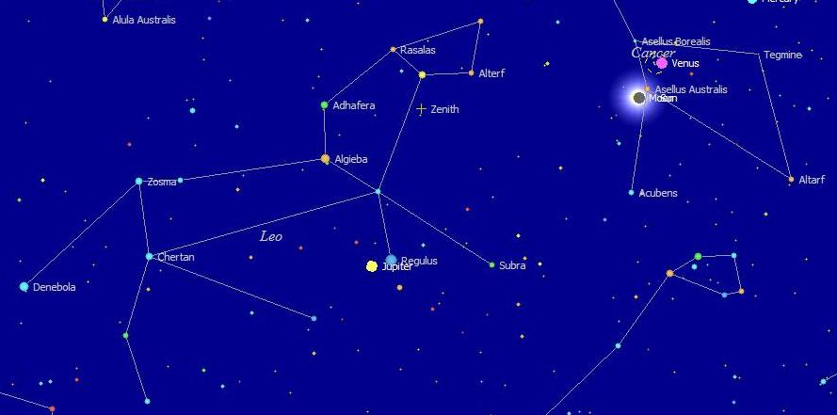

Above: The symbol of the Lion of Yahudah appears overhead with Jupiter next to Regulus.

The other August eclipses listed previously on this page reveal a sky similar to the picture above, except for the positions, or lack, of various planets.

I believe these four Tavs serve as a warning from YaHuWaH Elohim to all the governments of the earth, and as a sign of the end times to YaHuWaH 's people.

11

The Chiasm Structure of the Four Tavs

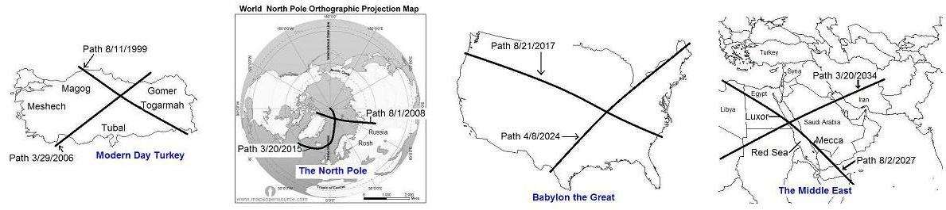

The Chiasm is a structure that mirrors itself. It's found quite often in the Bible in the way that bible verses and chapters were written. The sentence structure itself, of the literature, enhances the meaning of the literature and points to a theme usually located at the center of the Chiasm.

Here's a cut and paste link to a video explaining Chiastic structure: https://youtu.be/6YNcueVysHg

The four Tavs exhibit overall chiastic structure in their formation. The chiasm is found in the beginning Tav of 8/11/1999-3/29/2006 which crosses Turkey, a mainly Islamic country. The last Tav 8/2/2027-3/20/2034 crosses Egypt and Saudi Arabia, both mainly Islamic societies. So the First and Last Tavs have equal "topics", Islam.

The second Tav of 8/1/2008-3/20/2015 crosses the extreme north near Russia. The third Tav of 8/21/2017-4/8/2024 crosses the United States. These two central Tavs of the four Tav sequence are mirrors of each other. Russia and the United States are the two world superpowers, at least in the nuclear weapons category. So these two inner Tavs have equal topics, Global Nuclear Superpower.

12

The Central Date of the Outer Two Tavs

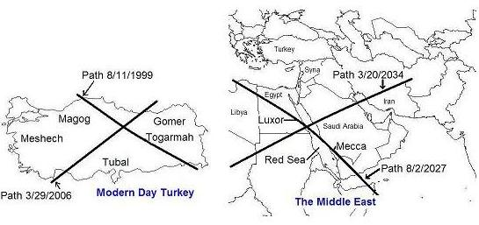

The Chiastic Structure of the Outer Tavs of the Eclipse Sequence:

A - Turkey
B - November 29, 2016 Central Date of the two outer Tavs
A' - Islam

The central date of the outer Tavs is calculated using the date of first eclipse of Tav #1 on 8/11/1999 and the date of the last eclipse of Tav #4 on 3/20/2034. The central date is found to be November 29, 2016.

November 29, 2016 will be exactly 69 complete years (and the beginning of the 70th year) since the United Nations passed a resolution to partition Palestine into Arab and Jewish sections on November 29, 1947.

13

The Central Date of the Inner Two Tavs

Now let's look at the central date of the two inner Tavs, Tav # 2 and Tav #3. Those two inner tavs concern Russia and the United States, the two world nuclear superpowers.

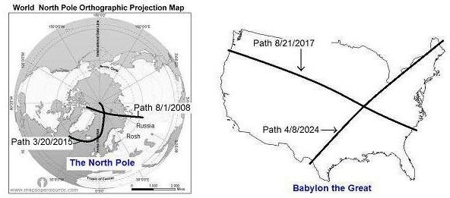

Chiastic Structure of the Two Inner Tavs of the Eclipse Sequence:

A - Russia
B - June 5, 2016 Central Date of the two inner Tavs
A' - United States

The center date of the two inner Tavs is different from the center date of the two outer Tavs because the spacing between each set of Tavs increases with time. The spacing isn't linear.

The space from the end of the 1st Tav to the beginning of the second Tav is 856 days. The space from the end of the second Tav to the beginning of the third Tav is 885 days, and the space between the end of the 3rd Tav to the beginning of the 4th Tav is 1211 days.

Although the spacing inside each Tav remains constant at 2422 days, the spacing between adjacent Tavs increases with time and isn't linear. This will cause a different central theme date to be issued by Tavs #2 and #3 from the central date issued by the outer Tavs #1 and #4.

The central date pointed to by Tavs #2 and #3 is 6/5/2016. Tavs #2 and #3 both concern the nuclear superpowers, Russia and the United States.

The Chiastic Structure of the Entire Eclipse Sequence

A - Turkey
B - Russia
C - June 5, 2016 Central date of the two inner Tavs, Russia and the United States
C' - November 29, 2016 Central date of the two outer Tavs, Turkey and Islam
B' - United States
A' - Islam

The above information is a scientific investigation and is NOT a prophecy, or any attempt to set dates.

Other Information from the Four Tavs

There is also another extremely important piece of information conveyed to us by the Chiastic structure of the four Tavs. That is, that an intelligent being has written this sequence of solar eclipses. I believe the four Tav sequence is intentionally Chiastic and not a random or accidental happenstance of nature. The information revealed in the four Tav sequence is completely in agreement with major bible prophecy and is timely, being revealed at a time in history when it's needed.

Intelligence is conveyed to us by coherent, orderly communications. The message relayed to us by these four Tavs indicate the existence of a Being who has not only intelligence, but the ability to determine the precise orbits and movements of the earth, moon, sun, and stars. This is an indication of an extremely sophisticated extraterrestrial being whose existence mankind would, and should, fear greatly. NASA will probably find this information unacceptable, although it fits precisely the model that NASA and others have used while searching for life in the universe. Coherence does not arise from chaos without the intervention of an intelligent being, and the people of SETI know this. It was the foundational truth applied in their years of searching for radio signals from the universe.

Science has a Problem

Science currently has a problem. The science of Quantum Mechanics indicates a basic structure to the universe that appears to be extremely chaotic at the subatomic level. The bible has the answer. In Genesis 1:2 we find the Spirit of Elohim hovering over the face of the waters. The symbol for water in ancient pictorial Hebrew, mem, is the same symbol for chaos.

The word picture of Genesis 1:2 is the Spirit of Elohim bringing order out of chaos. It's also a picture of Noah's Ark riding the flood. The earth may be likened to an ark of life riding the chaos (waters) of subatomic quantum physics. When the Spirit of Elohim departs in the near future, the fountains of the deep may be broken up and subatomic chaos might be openly manifest. The universe may begin to do strange things, like appear to roll up like a scroll. It's our Creator who currently keeps the subatomic chaos at bay, allowing order, life, and coherent information to exist. Eventually the subatomic chaos will subside, as the waters of Noah's flood subsided, and we will inhabit a new heavens and new earth with no underlying chaos. The old universe will be gone. No more sea = no more chaos.

Revelation 21:1 And I saw a new heaven and a new earth: for the first heaven and the first earth were passed away; and there was no more sea.

Now we know who's coming to visit. He's announced His arrival in the bible and in the heavens. His abilities and powers are unimaginable. It's time to repent of sin and get ready. An eternity of existence awaits the righteous.

The Solar Eclipse of 3/20/2015 Examined

Below: An image of the four Tav's solar eclipse sequence:

The second Tav crosses over the Berents Sea and is different from the other eclipses in the sequence, although it's timing is exactly the same with 2422 days between it's two components.

I was impressed to examine the 3/20/2015 eclipse more closely. The really odd thing about it at first sight is that it ends precisely at the North Pole.

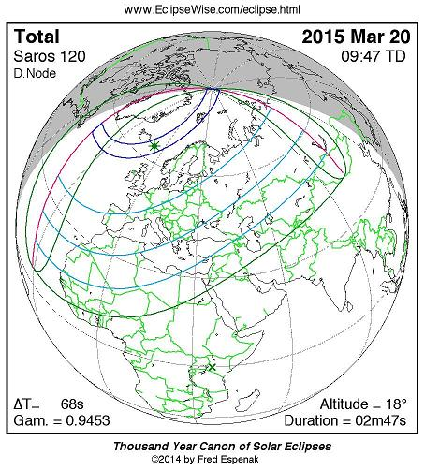

"Eclipse Predictions by Fred Espenak, www.EclipseWise.com

One Day = One Year

Something exists at the North and South Poles that doesn't exist anywhere else on earth. At the North and South Poles, one day is equal to one year. This fact has biblical prophetic implications as will be explained further down the page. At the North Pole the sun rises in the sky around March 21th each year and just circles around and around in the sky for the next 6 months. There is daylight continually at the North Pole for these 6 months.

The sun reaches it's highest point in the sky at about June 21. Then it begins a gradual descent toward the horizon, touching the horizon about September 21. It then descends lower below the horizon and twilight lasts for several weeks continually. Then the sky is completely dark and night lasts for about 5 months until twilight begins around March 1. The sun then appears again on the horizon at daybreak on about March 20 the next year.

I have a computer program that can be used to observe the heavens from various cities on the earth and also the North and South Poles. It's a very accurate program showing the precise position of the sun, moon, planets, and stars at any time of day accurate to one second in time. Using the program I positioned the observer at the North Pole to see what the solar eclipse of 3/20/2015 would look like. I was very surprised.

Here's an image of the sun as it appears on 3/19/2015 exactly one day before the solar eclipse of 3/20/2015. The blue part is the sky, the gray part is the earth at the horizon. You can see that the sun appears to be beginning to rise above the horizon after being below the horizon for the preceding 6 months. Although the sun is presented in it's entirety in the graphic, the part below the horizon wouldn't be visible to an actual observer. The sun completely circles the horizon in a 24 hour period, very gradually getting higher. The image below is the same point on the local meridian where the eclipse will occur one day later. The local meridian is a term that astronomers use to locate objects in the sky. Also the sun is actually entirely below the horizon at this point in time, but atmospheric bending make it appear higher on the horizon.

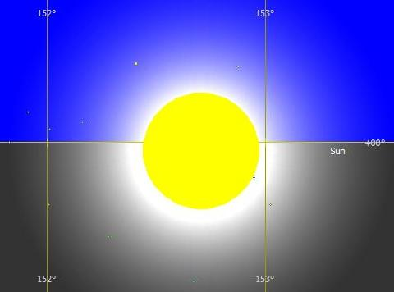

Below is an image of the eclipse on 3/20/2015 at it's final stage just before light appears again from the sun. These images are corrected for atmospheric refraction to show what an actual person would see who is observing the eclipse. In actuality the eclipsed sun is partly below the horizon at this point in time but atmospheric bending makes it appear to an observer to be entirely above the horizon.

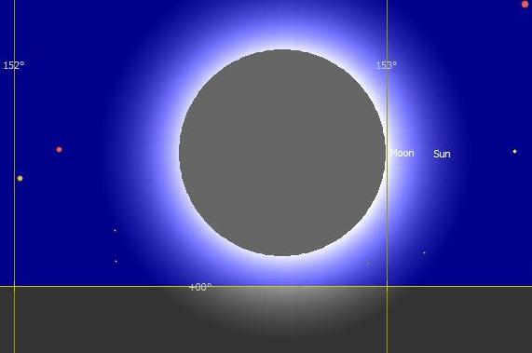

Above: The total solar eclipse in the image above enters totality at about 152 degrees 25 minutes and just touches 153 degrees at 10:18:29 UT as it emerges from totality.

19
Below is an image of the solar eclipse at 10:18:30 UT, one second after the image above, the sun flashes around the limb of the moon as it precisely touches the 153 degree mark.

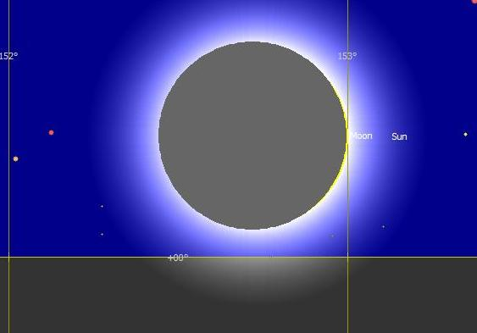

The 153 degree marker is significant, as it's the number of fish mentioned in John 21:11 in the following passage:

John 21:1 After these things YAHUSHUA shewed Himself again to the disciples at the sea of Tiberias; and on this wise shewed He Himself.
2 There were together Simon Peter, and Thomas called Didymus, and Nathanael of Cana in Galilee, and the sons of Zebedee, and two other of His taught ones.
3 Simon Peter saith unto them, I go a fishing. They say unto him, We also go with thee. They went forth, and entered into a ship immediately; and that night they caught nothing.
4 But when the morning was now come, YAHUSHUA stood on the shore: but the disciples knew not that it was YAHUSHUA.
5 Then YAHUSHUA saith unto them, Children, have ye any meat? They answered him, No.
6 And He said unto them, Cast the net on the right side of the ship, and ye shall find. They cast therefore, and now they were not able to draw it for the multitude of fishes.
7 Therefore that disciple whom YAHUSHUA loved saith unto Peter, It is the Master. Now when Simon Peter heard that it was the Master, he girt his fisher’s coat unto him, (for he was naked,) and did cast himself into the sea.
8 And the other disciples came in a little ship; (for they were not far from land, but as it were two hundred cubits,) dragging the net with fishes.
9 As soon then as they were come to land, they saw a fire of coals there, and fish laid thereon, and bread.
10 YAHUSHUA saith unto them, Bring of the fish which ye have now caught.
11 Simon Peter went up, and drew the net to land full of great fishes, an hundred and fifty and three: and for all there were so many, yet was not the net broken.
12 YAHUSHUA saith unto them, Come and dine. And none of the disciples durst ask Him, Who art Thou? knowing that it was the Master.
13 YAHUSHUA then cometh, and taketh bread, and giveth them, and fish likewise.
14 This is now the third time that YAHUSHUA shewed Himself to His disciples, after that He was risen from the dead.

But that's not all...

At the very time the sun is in total eclipse at the North Pole, the sky darkens and reveals the constellation Pisces, the two fish. Here's what the sky will look like:

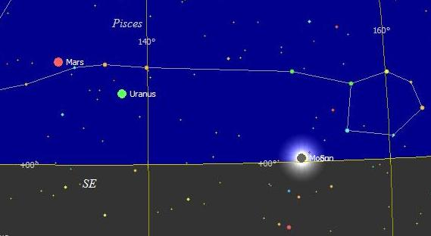

The sun is being eclipsed at 153 degrees in the constellation of Pisces the fish. It's a confirmation that this particular solar eclipse is biblically relevant to John 21 and the 153 fish in the net.

But that's not all...

Ten seconds after the sun touches 153 degrees and just begins to emerge from eclipse totality, the 0 degree local meridian passes precisely over Regulus the King star in the constellation of Leo, significant of YAHUSHUA the Lion of Yahudah. This occurs on the opposite side of the sky from the eclipse, 153 degrees away. This is shown in the image below.

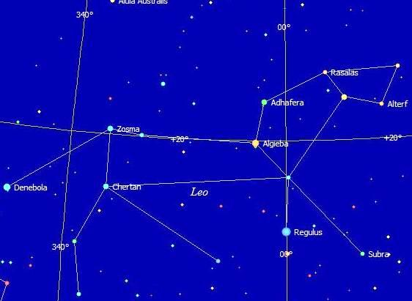

Above: This solar eclipse is confirmed to be relevant to John chapter 21.

But that's not all...

Remember, for a person standing at the North or South Poles there is only one day per year. Sunrise is around March 21 and sunset is around September 21 at the North Pole. That brings us to a very ominous time, considering the interpretation of the four Tav eclipses.

On October 11, 539 BC, the king of Babylon was having a party with his provincial governors. They were drinking wine. The king called for the holy vessels that his grandfather had taken from the Temple in Jerusalem to be brought. The king and his friends drank wine from the holy cups and praised their foreign gods. Immediately the form of a man's hand appeared and wrote a message on the wall in a language that no one could understand. The king became so frightened at the sight that his knees began to knock together. He called for his astrologers and wise men, but no one could read the strange language.

Here's what the handwriting on the wall may have looked like:

The message above says "mna mna tkl uprsn" in ancient pictorial Hebrew. It's the Hebrew alphabet that was in use when Moshe received the Ten Commandments at Mt. Sinai. This alphabet may have been unknown to the Babylonians, but not to the Hebrew scholars like Daniel from Jerusalem.

Daniel, a Hebrew, was called and he immediately read the message. No problem.

The handwriting on the wall was a notice of judgment from YaHuWaH, the Elohim of the Hebrews. The king of Babylon would loose his kingdom. He had publicly defiled the vessels that had been consecrated to YaHuWaH. That very night, Ugbary, a representative of Cyrus (Hebrew "Koresh", meaning "the sun") King of Persia entered Babylon without a fight and took control. The king of Babylon was killed by his own servants that very night. Koresh, the Persian King himself, entered ancient Babylon on October 29, 539 BC.

The problem with this 3/20/2015 North Pole eclipse and its position in the sky indicating biblical relevance is this: at the North Pole exactly 7 complete years will have passed from the handwriting on the wall on October 11, 539 BC, to about June 16, 2019 AD. Remember that one day at the North or South Pole = one year everywhere else on earth south of the arctic circle and north of the antarctic circle.

365.2422 days (years) x 7 = 2556.6954 years = 7 years at the North Pole.

October 11, 539 BC + 2556.6954 years = approximately June 16, 2019 AD

October 29, 539 BC + 2556.6954 years = approximately July 2, 2019 AD

Seven is a biblical complete number. We are currently at the end of the age, whether anyone wants to face it or not.

The king of ancient Babylon drinking wine from YaHuWaH 's set apart vessels is a picture of the king of modern Babylon the Great drinking the blood of YaHuWaH 's set apart saints.

Matthew 24:7 For nation shall rise against nation, and kingdom against kingdom: and there shall be famines, and pestilences, and earthquakes, in divers places.
8 All these are the beginning of sorrows.
9 Then shall they deliver you up to be afflicted, and shall kill you: and ye shall be hated of all nations for My Name’s sake.

August 21, 2017 the first solar eclipse of a "Tav" crosses the United States, Babylon the Great. The "handwriting on the wall" event comes to a 7 "year" completion around June 16, 2019. The entrance of Koresh, King of Persia, plus 7 "years" calculates to about July 2, 2019.

In 1986 I was attending an Assembly of God church in Beacon, NY. One Sunday afternoon a word came to me, the word "Interpreter". I wondered why that word had just popped into my head. That evening our family went to church and a person seated directly across the isle from me gave the shortest message in tongues that I had ever heard. It was just 3 or 4 words. I immediately knew the meaning of the message. It was "I want a Jericho march". I didn't say anything. I had never given an interpretation of tongues before. I was surprised. After a short period someone else gave an interpretation that had nothing to do with a Jericho march. So I remained silent and didn't say anything. About 20 minutes later the Pastor went to the pulpit and began to preach about the walls of Jericho coming down. Then I wished I had spoken up. But it was too late. The confirmation of YaHuWaH 's workings needed by the congregation was missed because I didn't speak up.

That being said, today I interpret and show what our Father shows me. I didn't make myself an interpreter, YaHuWaH did. We are now involved in a Jericho march at the end of the age.

There are indications that agreements have been made in secret between the leaders nations. The time is very late. Please prepare by turning from sin. Just bow before our heavenly Father privately, if just for a few seconds each day, and acknowledge Him.

John 10:27 My sheep hear My voice, and I know them, and they follow Me:
28 And I give unto them eternal life; and they shall never perish, neither shall any man pluck them out of My hand.
29 My Father, which gave them Me, is greater than all and no man is able to pluck them out of My Father’s hand.

