Mars UP Church

Apostles’ Creed
I believe in God the Father Almighty, Maker of heaven and earth; and in Jesus Christ His only Son our Lord; who was conceived by the Holy Ghost, born of the Virgin Mary, suffered under Pontius Pilate, was crucified, dead and buried; He descended into hell; the third day He rose again from the dead; He ascended into heaven, and sitteth on the right hand of God the Father Almighty; from thence He shall come to judge the quick and the dead. I believe in the Holy Ghost, the holy catholic church; the communion of saints; the forgiveness of sins; the resurrection of the body; and the life everlasting. Amen.

Gloria Patri
Glory be to the Father, and to the Son, and to the Holy Ghost. As it was in the beginning, is now and ever shall be,
world without end.
Amen. Amen.

Come Holy Spirit, Come
Before the Service – Speak to God!
During the Service – Let God speak to you!
After the Service – Speak to each other!

(*Please stand, if able)
Welcome and Mars Messages

Prelude

*The Call to Worship adapted from Psalm 116
Leader: Love the Lord; call upon the Lord as long as you
live.
People: We will call on the name of the LORD:
Leader: O LORD, we are your servants;
People: We offer to you a thanksgiving sacrifice as we
call on the name of the LORD.
Leader: Praise the Lord!
People: In the presence of all God’s people, we praise
the Lord!

*Hymn Jonah Smeltzer
“Good, Good Father”

Thanksgiving for Baptism
Leader: Blessed be the holy Trinity, one God, by whose hand
we are given new birth, by whose speaking we are
given new life.

People: Amen.

Leader: Water! We praise you, O God, for water: for oceans

and lakes, for rivers and streams. We praise you for waters that wash us clean, quench our thirst, and nurture your whole creation. Praise to you for the life-giving water of baptism, the outpouring of the Spirit of the new creation. Satisfy the world’s need through this living water. Where drought dries the earth, bring refreshment. Where despair prevails, grant hope. Where chaos reigns, bring peace. We ask this through Christ, who with you and the Spirit reigns forever.

People: Amen.

Leader: Let us give thanks for the gift of baptism. Holy God, holy and merciful, holy and mighty, you are the river of life, you are the everlasting wellspring. In mercy and might you have freed us from death and raised us with Jesus. In baptismal waters our old life is washed away, and in them we are born anew.

People: Wash away our sin and all that separates us
from you. Empower our witness to your
resurrection. Strengthen our resolve in seeking
justice for all.

Sharing the Peace of Christ

Leader: We are reconciled to God through the waters of baptism, let us now be reconciled to one another. May the peace of our Lord Jesus Christ, the love of God, and the fellowship of the Holy Spirit be with you all.

People: And also with you.

Scripture Acts 2:14a, 36-41
1 Peter 1:17-23
The
Lord’s Prayer

Our Father,
who art in heaven,

hallowed be Thy
name,

Thy kingdom come,
Thy will be done,
on earth
as it is in heaven.

Give us this day
our daily bread;

and forgive us
our debts,
as we forgive
our debtors;

and lead us not
into temptation,
but deliver us
from evil.

For Thine
is the kingdom,
and the power,
and the glory,
forever. Amen.

The Doxology

Praise God
from whom
all blessings flow;
praise Him
all creatures
here below;
praise Him above,
ye heavenly host;
praise Father, Son,
and Holy Ghost.
Amen.

Kids Club Skit Luke 24:13-35
Children’s Chat

Homily Rev. Katie McNeal

*Hymn Jonah Smeltzer
“How Great is Our God”

The Joy of Kids Club/Youth Group

Prayers of the People/Lord’s Prayer
Leader: Hear us, O God
People: Your mercy is great

Communion Hymn 460
“Let Us Break Bread Together”

Communion
Leader: The Lord be with you.
People: And also with you.
Leader: Lift up your hearts.
People: We lift them to the Lord.
Leader: Let us give thanks to the Lord our God.
People: It is right to give our thanks and praise.

*Hymn 358
“Because He Lives”

*Benediction

*Postlude
Church Staff
Rev. Brian Hauser
Pastor
pastor@mars-up.org
724-689-3412

Mrs. Shelly Bocheff
Administrative Assistant
marsup@mars-up.org

AV TEAM
Alma Staskiewicz, Lisa Barbour, Marie Matthews, Bill Guesman, John Ivory, Mike Bocheff, Herb Wellman

Mars United Presbyterian Church

232 Crowe Ave
PO Box 805
Mars, Pennsylvania 16046
724-625-1365
www.mars-up.org
marsup@mars-up.org

Church Office Hours:
Mon -Thurs from 9 a.m. -2:30 p.m.

Morning Worship:
10:00 am

3rd Sunday of Easter

Prayer of Preparation
Lord, we come to you today with so many things on our hearts.

You call us to be in relationship of trust and love with you and you offer healing to us for those portions of our lives that are broken and injured.

Help us to be open to your mercy and healing love. For we ask this in Jesus’ Name.
AMEN.

Mars United Presbyterian Church
Welcome!

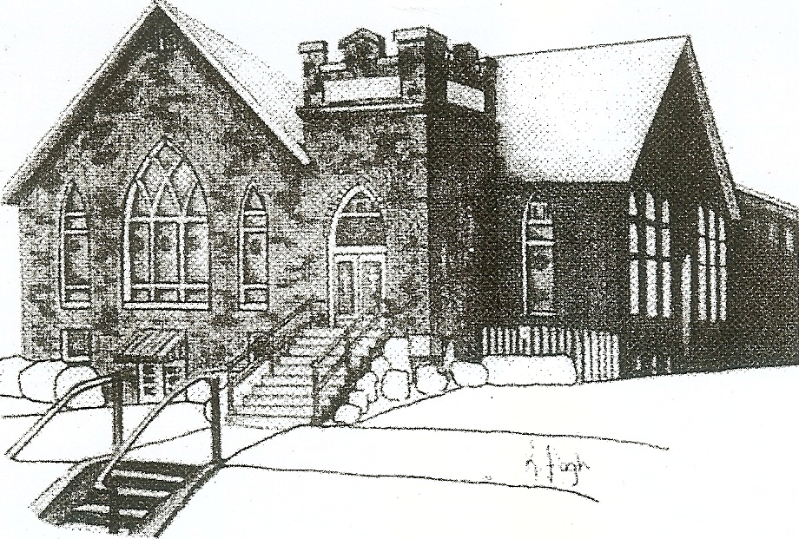
We are your hometown church: Faithful to Tradition, Loving in Fellowship, & Reaching for Tomorrow!

April 23, 2023

We welcome you and we are glad you’ve chosen to Worship with us today!

CALENDAR: April 23rd – April 30th

Church Office Hours: Monday -Thursday from 9 a.m. – 2:30 p.m.

Today, April 23, 2023
VOLUNTEERS☺

LAST SUNDAY’S In-House ATTENDANCE: 51

LAST SUNDAY’S OFFERING:
Operating Funds: $3780.00
Kindness: $120.00
Total: $3900.00

Tarry N Talk Hosts
Christian Ed/Mission Outreach

9:00 am Sunday School Hour
10:00 a.m. THE MORNING WORSHIP SERVICE
Monday, April 24, 2023
7:00 pm Boy Scouts
Tuesday, April 25, 2023
9:00 am A team
7:00 pm AA
Wednesday, April 26, 2023
9:00 am Material Girls
Thursday, April 27, 2023
6:00 pm Daisy Troop
Friday, April 28, 2023
Saturday, April 29, 2023
11:00 am Spaghetti Dinner Fundraiser
Sunday, April 30, 2023
9:00 am Sunday School Hour
10:00 am THE MORNING WORSHIP SERVICE
2:45 pm Girl Scouts
Welcome to all who are Worshiping with us today!

Guests
We sincerely hope our service is a blessing to you. We ask that our guests please take a few minutes to complete one of the Connect Cards found in the pew holder.

Should you have questions regarding any aspect of our church, including membership, please contact Pastor Brian or the church office during the week at 724-625-1365. Thank you for being with us today.

PRAYER – JOYS & CONCERNS
Lou Beckwith Paige Lauten
Paige Barbour (daughter of Andrew and Steph Barbour) Sandy Wahl
Reid Christopher Hall (June Stirling’s nephew) Sue Morris
Lindy McCartney (Lisa Barbour’s Sister)

ANNOUNCEMENTS
Bulletins are printed Thursday mornings; let us know if you have an announcement…

SPAGHETTI DINNER FUNDRAISER We will be holding a Spaghetti Dinner fundraiser on Saturday, April 29th from 11am until 7pm in the church Fellowship Hall. The fundraiser is for The Future Jimmy Ellis Fire Fighter Foundation. All proceeds go directly to the Adams Area Fire District Dept. for the Foundation. There will also be a basket raffle and 50/50 raffle. Any questions please contact the office or see Pastor Brian.

SPAGHETTI DINNER VOLUNTEER SIGN—UP If you would like to help with this fundraiser, please go to this site to pick a time to help. This will be a big event; many volunteers are needed. https://www.signupgenius.com/go/508084BA8AA2EABFF2-vfdmup
CALLING ALL GRADUATES If you or someone in our church that you know is graduating from high school, college or another post-high school program, please let us know in the church office. We would like to celebrate these graduates. More details to follow.
SAVE THE DATE- New To You Sale – June 3rd We will be accepting donations after April 29th. More info to follow
SAVE THE DATE – Vacation Bible School- July 9th thru July 13th
SAVE THE DATE Mars UP church annual picnic will be held Sunday, September 10th at Adams Township Park. More Details to Follow

