**Holiday-Decorated Yard of the Month**

Maybe the extended mild weather encouraged folks to go all-out this year with decorations, resulting in a plethora of decorated yards and homes in the neighborhood this year! This plentitude and diversity, from classic white lights along the roof line, to multicolor lights on yard trees, to kinetic laser lights, to inflatables, made it difficult to choose a winner. But we did pick a winner, and it was 2245 Barn Swallow Drive, belonging to Tom and Robin Trader. The house and yard displayed lots of color and an illuminated faux Christmas tree made entirely of lights that appeared to rotate. The first-floor roofline had white lights and an evergreen swag above the garage doors. An illuminated white star hung from the second story gable, and a red and green ?bell from the first- story gable. Bushes along the driveway, front of the house, and a small evergreen in the yard displayed multi-color lights. Red candy cane-appearing lights around the front porch pillars, a snowman guarding the mailbox, and an illuminated deer completed the scene. Tom and Robin say,”…”.

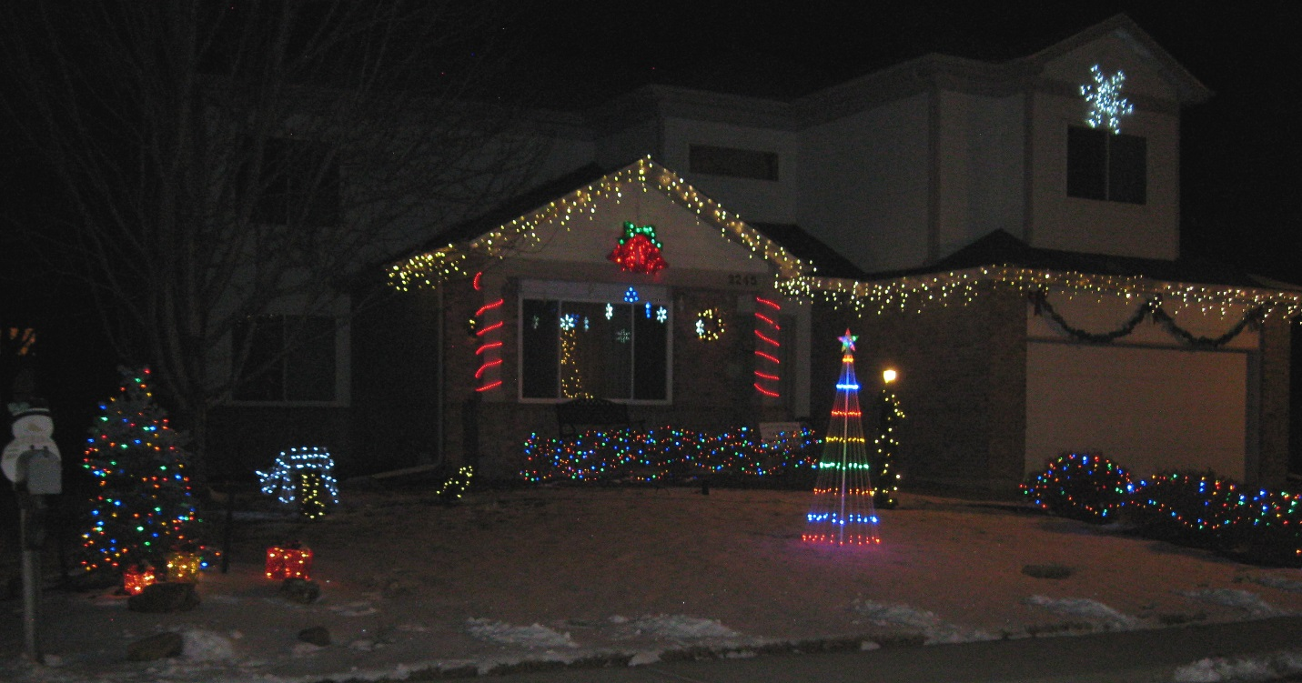

**Social Committee Volunteers Needed for Next Year**

The Social Committee of the HOA puts on the annual Easter egg hunt, July 4 parade, and neighborhood Oktoberfest that includes homebrew and chili contests. If you want these events to continue, please volunteer by emailing the board at hoa@fachoa.org and social committee at soc@fachoa.org.