When I heard it announced on TV a day or two ago that American Pharoah was going to be attempting the Triple Crown at Belmont Park on June 6, I said to my wife "I know what that means".

Spiritual signs are flying left and right. They're in the heavens, in the earth, in the media, and all around us. They're all saying "This is it. The end is approaching".

The American Pharaoh

Our American Pharaoh is Barak Obama who has been acting as a Monarch, not a lawful President, since assuming the Presidency in 2009. According to law, the President has to take the oath of office before noon on January 20. If he doesn't, he's not legally a president of the United States. On 1/20/2009 the oath being administered to Barak Obama was botched, and was not repeated correctly at that time. The oath was then re-administered the next day, 1/21/2009, in the White House. According to the Word of Law, Barak Obama was not legally the President of the United States during his first term in office.

Since 2009 Mr. Obama has continued to skirt Congress and implement mandates and laws against the will of the majority of the people of the United States. It's called Chicago gangland politics.

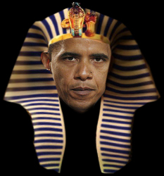
The American Pharaoh

The horse "American Pharoah" signifies the American Pharaoh, "President" Barak Obama.

The Triple Crown

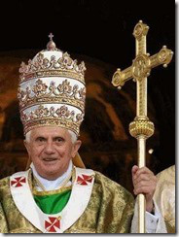
The Triple Crown Displayed

Popes are able to wear a triple crown. It signifies their authority in three realms.

The Belmont

Bel

American Pharoah won the Triple Crown at the Belmont race track.

Belmont is a name meaning "Bel Mountain" or " Mountain of Bel".

The information below is from http://shoebat.com/2014/12/19/new-discovery-antichrist-nation-turkey-now-reviving-mark-beast/ :

According to Dr. Arthur Jeffrey, professor of Islamic and Middle East Studies at Columbia University, “Allah is a pre-Islamic name corresponding to the Babylonian god known as Bel.”

“Bel bows down, Nebo stoops; Their idols were on the beasts and on the cattle.” (Isaiah 46:1)

Bel will bow down before YaHuWaH . This is none other than the image of Allah-Satan, the crescent-moon. In the purest form of poetic justice, the demonic god of Islam will bow low before YAHUSHUA , the Mighty One of Israel.

The ancient symbol of the god Bel is the crescent moon, the current symbol of Islam.

Mont

The meaning of mont is mountain. In the bible YaHuWaH 's appointed mountain is the symbol of His authority and His dwelling place. YaHuWaH 's appointed mountain is mount Zion in Jerusalem.

Bel Mont would signify Allah's (Bel's, Satan's) appointed mountain and his authority.

6/6/2015

American Pharoah won the Triple Crown at Belmont on 6/6/2015. There's a triple coincidence that occurs on 6/5/2016. The information is available here: http://www.joybysurprise.com/The_Four_Tavs.html

There's a possibility that 6/6/2016, one year after 6/6/2015, might also be known as "The Day After".

Summary

There's a three way spiritually significant bond between the American Pharaoh, the Triple Crown, and the Belmont.

On the Hebrew Day of Atonement, 9/23/2015, the wearer of the Triple Crown has an appointment to meet with the American Pharaoh in his dwelling place, the White House.

Global taxation is currently scheduled to be one of the topics.

Nothing good will come from that meeting! I fear the plagues of the Book of Revelation will soon be on the way from YAHUSHUA!

