**HOLY COMMUNION**

V. Communion here is pretty simple, and all who believe in Jesus Christ are

welcome at this very table.

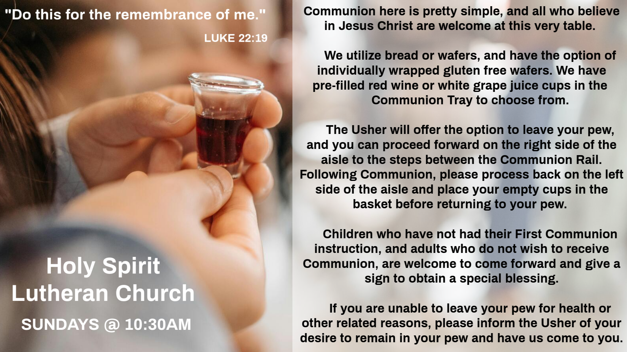

**INVITATION TO COMMUNION**

V. All who are hungry, come!

The feast of grace is spread.

**C. Amen.**

(Distribution of Holy Communion)



**COMMUNION HYMN**

(Please enjoy various music offered by our Organist during your

quiet time, prayer, and reflection following Holy Communion.)

(Vicar and Assistant remove Communion Vessels from the Altar.)

(We invite you to stand as you are able.)

**POST COMMUNION BLESSING**

V. May the body and blood of our Lord Jesus Christ strengthen us and keep us

always in His grace.

**C. Amen.**

**POST COMMUNION CANTICLE**

**C:\Users\Vince and Heather\Downloads\Lord, Now You Let Your Servant Go, LBW Setting Two (Melody).tif**



**THE LORD’S PRAYER**

(We ring the bell throughout the Lord’s Prayer at all services to

invite those in the community to join in praying the Lord’s Prayer.)

V. May we now join with one another and pray together as Jesus has taught us.

**C. Our Father, who art in heaven, hallowed be thy name, thy kingdom come,**

**thy will be done, on earth as it is in heaven. Give us this day our daily**

**bread; and forgive us our trespasses, as we forgive those who trespass**

**against us; and lead us not into temptation, but deliver us from evil. For**

**thine is the kingdom, and the power, and the glory, forever and ever.**

**Amen.**

**LAMB OF GOD**

**C:\Users\Vince and Heather\Downloads\Lamb of God, ELW Setting Four (Melody).tif**

(We invite you to be seated.)

**SANCTUS**

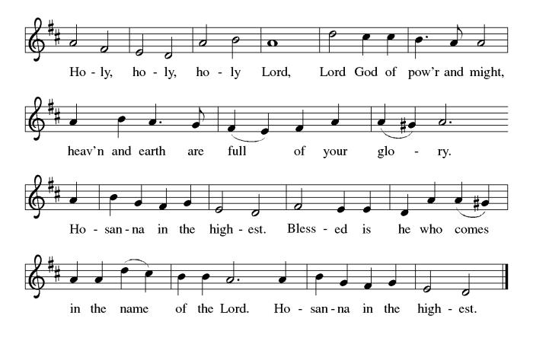

**THE EUCHARISTIC PRAYER**

V. Blessed are you, Lord of heaven and earth, in mercy for our fallen world you gave

your only Son, that all those who believe in Him should not perish, but have

eternal life. We give thanks to you for the salvation you have prepared for us

through Jesus Christ. Send now your Holy Spirit into our hearts that we may

receive our Lord with a living faith as He comes to us in His holy supper.

**C. Amen. Come, Lord Jesus.**

V. In the night in which he was betrayed our Lord Jesus took bread,

he gave thanks; broke it, and gave it to his disciples, saying:

*Take and eat; this is my body, given for you.*

*Do this for the remembrance of me.*

V. Again, after supper, He took the cup, he gave thanks,

and gave it for all to drink, saying:

*This cup is the new covenant in my blood,*

*shed for you and for all people for the forgiveness of sin.*

*Do this for the remembrance of me.*

**PRAYER AFTER COMMUNION**

A. Let us pray,

Generous Host,

you have shared your feast with us and made us new.

Send us now to set tables of love and grace in our communities,

that your liberating love might nourish the world into freedom,

in the name of the crucified one, Jesus Christ our Lord.

**C. Amen.**

**BLESSING**

V. God our tender parent,

God the crucified one,

God the reconciling Spirit,

**☩** bless you now and forever.

**C. Amen.**



**SENDING HYMN**

(We invite you to sing along with the music offered by our Organist.)

Lutheran Book of Worship—Green Book

**88—Oh, Love, How Deep**

(4 Verses)

(Assistant extinguishes the Altar Candles half way through the Sending Hymn.)

(Vicar processes out once the Altar Candles have been extinguished.)

(We invite you to be seated.)

**BIRTHDAYS, ANNIVERSARIES, & ANNOUNCEMENTS**

(Offered by Assistant and Congregation.)

**BIRTHDAYS**

12th Carly McGinn

13th Mary Pacher

15th Butch Poehler

**DISMISSAL**

A. Go in peace. Care for others as God cares for you.

**C. Thanks be to God.**

**POSTLUDE**

(Music offered by our Organist as we depart following our Worship Service.)

**O Jesus I Have Promised**

**OFFERING PRAYER**

V. Let us pray,

Gracious Provider,

you set your immense treasures among us,

opening your heart to the world.

As we prepare to feast on your bountiful love,

deepen our commitment to sharing those

treasures with others,

through our Savior, Jesus Christ.

**C. Amen.**

**GREAT THANKSGIVING**

V. The Lord be with you.

**C. And also with you.**

V. Lift up your hearts.

**C. We lift them to the Lord.**

V. Let us give thanks to the Lord our God.

**C. It is right to give him thanks and praise.**

V. It is indeed right and salutary that we should at all times and in all places offer

thanks and praise to you, O Lord, holy Father, through Christ our Lord; who rose

beyond the bounds of death and, as he promised, poured out your Spirit of life

and power upon the chosen disciples. At this the whole earth exults in boundless

joy. And so, with the Church on earth and the hosts of heaven, we praise your

name and join their unending hymn:

**OFFERING**

V. We now worship God with our tithes and offerings, wine and bread for use in holy

communion, and monetary gifts to support our ministry for service in God’s name.

Our Ushers will be around to your pews to pass the Offering Plates.

(Ushers come forward to get the Offering Plates from the Assistant.)

(Vicar and Assistant prepare the Altar for Communion.)

**OFFERING SONG**

(We invite you to sing along with the music offered by our Organist.)

Evangelical Lutheran Worship

**811—On My Heart Imprint Your Image**

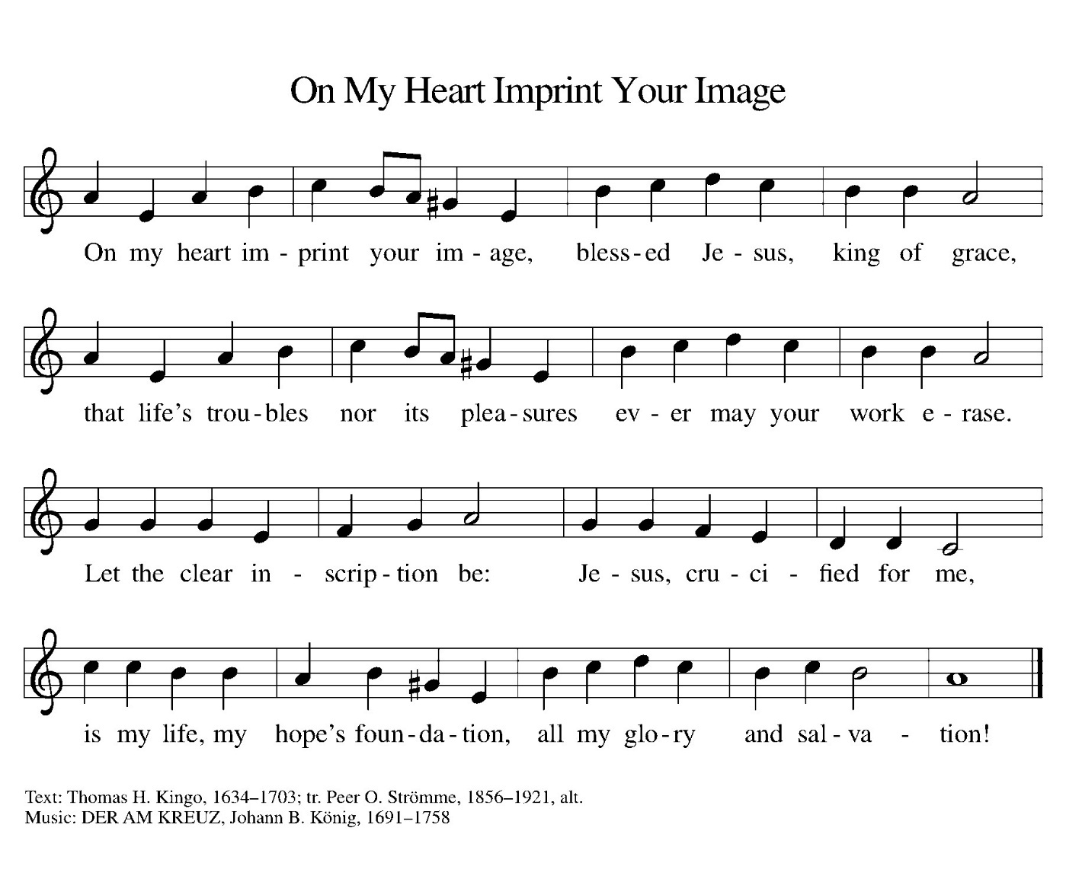

(Usher(s) brings the Tithes and Offerings up front to the Assistant.)

(We invite you to stand as you are able.)



**SUNDAY SCHOOL & CONFIRMATION**

“Here We Stand” is a program that allows our young folks to go through a 2-year process while focusing on the Bible and Luther’s Small Catechism. The program is on **Sundays from 9-10AM** with snacks, games, arts & crafts, and other fun things.

We are also exploring resuming regular Sunday School classes for children of all ages to attend. We are looking at various dates and times in this planning process.

See Heather, Bonnie, & Vicar Vince for more information.

**WORSHIP MINISTRY**

The most important thing we do each week is gather together as God's people to worship. God is the center and focus of everything we do. Participating in worship is active. Liturgy means the work and actions of the people gathered. Everything we do during the week to prepare for worship, and everything we do as we assist in leading worship is important. We are thankful for all the wonderful work being done. If you are interested in any position let Vicar Vince know so a training can be set-up.

Sign-up sheets are located on the bulletin board between the church offices.



**COFFEE HOUR**

The Women of the Church are hosting our monthly Coffee Hour **TODAY, Sunday, March 9th**, following our Worship Service. See Judy or Kathy for more info.

**40 DAYS – 40 ITEMS**

We will be joining True Deliverance Praise & Worship Center on this Lenten Challenge to support those in need in our communities. It is rather simple, for each day of Lent remove one item from your closet, drawers, chest, etc. that you no longer wear or need and place it in a trash bag. Brings the bags into the church on or before Easter Sunday, April 20th, 2025. All items will be donated to the Branches in Rio Grande and the Atlantic City Rescue Mission. Make sure you grab a trash bag and card from the church with directions for this Lenten Journey Challenge.

**BIBLE STUDY & FAITH DISCUSSIONS**

​​​​​Bible Study & Faith Discussions was started in order to focus on various readings,

books, Bible verses, people of faith, and other general topics. Group Members offer

various points of view while reviewing the Bible and various aspects of faith while

being respectful and supportive of each other. Join us on **Tuesdays at 6PM**.

**FOOD PANTRY & COMMUNITY DELIVERIES**

**Open every Thursday**, and the **last Saturday of every month**, from **10AM to 1PM**. 79 people were served in February. 164 people were served in 2025. Donations can be dropped in the basket in the Narthex, placed in the outdoor drop-box by the Church Office door, placed in the money jug in the back of the Church, mailed into the Church Office, or placed in the Offering Plate. Volunteers are needed each week. Sign-up sheets are located on the bulletin board between the church offices.

If you have questions or need training see Heather, Vicar Vince, or Bonnie.

|  |  |  |
| --- | --- | --- |
| **Thursday, 3/13** | **Thursday, 3/20** | **Thursday, 3/27** |
| Tori & Garnet | Cathie & Garnet | Cathie & Garnet |

Our local North Cape May Acme & Big Lots provide us with Expiring Soon, Recently Expired, and Slightly Damaged Foods & Items weekly. Kathy helps those in need by delivering items each Saturday in the community. Kathy then brings leftover items to the Church for church members in need, and those who visit the food pantry during the week. Additional items are then taken over to the Branches Outreach in Rio Grande. A special thanks to all who donate, pray, and help in any way!

​ The Family & Friends of Lou Marcucci (Wayne Rand's Friend)

Carla Krouse (Skip & Bonnie Millard's Friend)

(Additional Names Added Prior to the Worship Service.)

A. God, in your mercy,

**C. receive our prayer.**

A. Living God, we give thanks for all the faithful who have crossed the threshold from

death to life. Guide us who are living to learn from their wisdom and follow their

example. God, in your mercy,

**C. receive our prayer.**

(Here other intercessions may be offered.)

V. Watch over all of us who are worried and suffering, and especially those whose

names we now say aloud or hold within our hearts (extended pause). God, in

your mercy,

**C. receive our prayer.**

V. Receive the prayers of your people and draw all things together in your love, in

the name of Jesus, who leads us from death to life.

**C. Amen.**

**SHARING OF THE PEACE**

V. May the peace of the Lord be with you always.

**C. And also with you.**

V. Let us share God’s Peace with one another.

(Please remain in your pews and offer the sign of peace with a peace sign or wave.)

(Following the sharing of the peace, we invite you to be seated.)

**ANTHEM**

(Special Music for Everyone to Enjoy.)

**Count Your Blessings**

Ron Anderson (Bill Kelly's Friend)

Jerry P (Wanda Bryan's Friend)

Pat Labrae (Kathy Poehler's Friend)

Bud Brearey (Judy Brannan & Mary Melnicoff's Friend)

Mary Skain (Kathy Poehler's Friend)

Bill Rand (Wayne & Eleanor Rand's Family)

Kevin Naylor (Vicki Rinier's Friend)

Robert Chaplin (Mary Melnicoff's Friend)

Jack Wieckouski (Theresa & Kim McGinley's Family)

Rick (Carol Amundsen's Friend)

Vera (Carol Amundsen's Friend)

Carolyn Santarpio (Bob Fritsch's Friend)

Cathy Hines (Rose Lang's Friend)

Ken Mortensen (Del McKenna's Family)

Harry (Judy Brannan's Friend)

Janet K (Philomena Noak's Friend)

Michael Hart (Diana DeNote's Friend)

Rocco Leonard DeNote (Diana DeNote's Family)

Spencer Oditt (Butch Poehler's Family)

Julie Schlereth (Diana DeNote's Friend)

Al Singer & Family (Frank & Sharon Ford's Friends)

Sherri Lynn (Bob Fritsch's Friend)

John Bannco (Bob Fritsch's Friend)

Nancy Pazarinie (Bob Fritsch's Family)

Arthretta Crandell (Heather & Vicar Vince Piekarski's Friend)

Mary Pat Parsons (Vicki Rinier's Friend)

Jane & Paul Eiben (Rose Lang's Friend)

​ Jean Marcucci (Wayne Rand's Friend)

Joe DiMassimo (Judy Brannan & Mary Melnicoff's Friend)

Vivian (Mesher Family Member)

Tommy Stanford (Sue Waltz's Family)

Audrey McAlister (Sue Waltz's Family)

Joe Waltz (Sue Waltz's Family)

Sherrie Meenan (Jean Zimmerman's Friend)

Ronald Velli (Kathy Poehler's Friend)

Denny Papst (Rose Lang’s Friend)

Mike Rhoades (Rose Lang’s Friend)

Jannet Paynter (Leon Stitt’s Friend)

Chris (Judy Brannan's Friend)

**BULLETIN ENTRY DEADLINE**

The Bulletin is Printed on **Thursdays** during Church Office Hours. Changes need to be submitted to Vicar Vince or Heather no later than **Thursday by 4PM**. Thank you!

**CHURCH OFFICE**

Open **Thursdays from 6PM to 8PM** to serve the Congregation, the Community,

and to continue handling the business of the Church. Feel free to stop in to talk,

pick-up or drop off something, pray in the Sanctuary, or for whatever reason.

**SOUP & SCRIPTURES**

Did you ever look forward to sitting around a fire in the church yard hanging out with some folks, enjoying s’mores, and studying scripture? We will shift this Fellowship time to **Soup & Scripture** and be **indoors** following the holidays. **Join us on Saturday, March 15th, at 6PM**. Ask Heather or Vicar Vince for more information.

**ANNUAL RUMMAGE SALE**

It’s that time of year again that we begin our spring cleaning, and when we get our committee together and begin planning for our Annual Church Rummage Sale on **Saturday, May 31st, from 7AM to 12Noon**. Please start gathering items until we come up with a date to bring them in. We will plan to coordinate things before Whale of A Day so that all unsold items can be transported there to have a second chance in being sold to raise funds for the Property Owners Association of Townbank. We look forward to this event raising funds for a to be determined cause. Join us at our first Committee Meeting on **Sunday, March 16th, after our Worship Service**.

**NEWSLETTER**

Information, stories, pictures, and committee reports for our seasonal publication can be submitted to Vicar Vince in-person or via email at vpie8282@gmail.com. The deadline for all entries for the Spring Publication is **Sunday, March 16th**.

**CHURCH COUNCIL**

Share your comments, concerns, questions, or joys with one of our Church Council Members who can bring them back to our meetings. Visitors are always welcome to attend and listen to what is going on in and around the church. Join us In- Person or on our Conference Call at our next Meeting on **Tuesday, March 18th, at 6PM**.

**PREACHING AT BROOKDALE**

Vicar Vince will be Preaching at Brookdale Senior Living in Cape May Court House

on **Sunday, March 23rd, at 1PM**. Holy Communion will follow the service.

**MINISTERIUM DAY**

Vicar Vince will be attending the Social Hour with The Bishop, Assistants, Pastors, and Vicars on **Monday, March 24th, from 7 to 9PM** at Homewood Suites in Hamilton. Then, will be attending the lecture on **Tuesday, March 25th, from 8:30AM to 2:30PM,** at the Hibernian Club, led by Rev. Barbara Lundblad who will be preparing us to preach Easter in our current climate of political and social tension.



Our 75th Anniversary will be occurring this year! The Synod has been contacted, and we have been placed on the Bishop’s Calendar for **Sunday, October 19th**. This congregation is a legacy that we have all lived in and through over all of these years, or maybe just for a short time. However, it is a legacy that we hope and desire to continue to carry on and move forward for those people that will be able to gather and worship with us and following us as well. We are the church carries a strong mentality with it, and it does not just mean within these very walls. We need to celebrate those 75 years of being part of this community, and all that has led up to the very start of this church body as well. I encourage you all to start thinking how we are going to celebrate this legacy as we continue preparations at our second Committee Meeting on **Sunday, March 30th, after our Worship Service**.

**DONATION STATION**

Get on the train and place all purchased items in the specified project donation bins located on the counter by the front doors. See Heather for more information.



A. Steadfast God, speak words of courage to your people in the wilderness. Protect

migrants and refugees on perilous journeys, that they find safe refuge and a

portion in the bounty you have given humanity to share. God, in your mercy,

**C. receive our prayer.**

A. Loving God, speak gently to all who are alone. Bless lay ministers, home

communion teams, and others who attend to those who are overlooked,

vulnerable, or lonely, that all find belonging in your love. We pray for all who are

ill; especially:

BettyAnn Rich-White (Church Member)

Chip Hand (Church Member)

Lynn Bargstadt (Church Member)

Sharon Ford (Church Member)

Carol Amundsen (Church Member)

Kim McGinley (Church Member)

Marie Hand (Church Member)

Frank Ford (Church Member)

Blanche Cameron (Church Member)

Eric Dishman (Church Family)

Joan Sommerman (Church Family)

Arleen Kinka (Church Family)

Rick Lang (Church Family)

Suzie Clark (Rose Lang's Friend)

Francis Clock (Dianna DeNote’s Family)

Andrew Hudak (Rose Lang’s Friend)

Viena Murtha (Bob Fritsch’s Friend)

Sharon Waicus (Skip & Bonnie Millard's Friend)

Karen O'Brien (Paul Bowker's Friend)

Dustin Irizzary (Mary Melnicoff's Family)

The Bryan Family (Wanda Bryan's Family)

Ernie Kinzler (Marie Hand & Doreen Kinzler’s Family)

Craig Brearey (Judy Brannan & Mary Melnicoff's Friend)

Sarah Dutton (Frank & Sharon Ford's Family)

Christina McNasby (Fran Green’s Family)

The Kinkson Family (Judy Brannan's Friends)

Mark Stephen Dennis (Diana DeNote's Family)

Dellie Valcourt (Skip & Bonnie Millard's Family)

Bill Lodge (Skip & Bonnie Millard's Friend)

Patrick & Denise Brannan (Judy Brannan's Family)

**was crucified, died, and was buried;**

**he descended to the dead.**

**On the third day he rose again;**

**he ascended into heaven,**

**he is seated at the right hand of the Father,**

**and he will come to judge the living and the dead.**

**I believe in the Holy Spirit,**

**the holy catholic church,**

**the communion of saints,**

**the forgiveness of sins,**

**the resurrection of the body,**

**and the life everlasting. Amen.**

**PRAYERS OF INTERCESSION**

(The prayers are prepared locally for each occasion.)

V. Led by the Spirit, let us turn to God in prayer for the church, the world, and all

those in need.

(A brief silence.)

A. Gracious God, speak your word anew among your church. Strengthen it to

withstand the temptation to turn inward in fear or complacency. Embolden church

institutions to turn from self-preservation toward the self-giving love of Jesus.

God, in your mercy,

**C. receive our prayer.**

A. Mothering God, speak the word of life into wilderness places and fertile fields.

Grant wisdom to your people, that we may quell the urge to strip lands of their

resources and instead preserve first fruits for future generations. God, in your

mercy,

**C. receive our prayer.**

A. Almighty God, speak a word of wisdom to people in positions of power: mayors,

councils, and tribal leaders, legislators, judges and juries, presidents, and

monarchs. Help them discern your voice and follow your guidance, resisting the

temptations of the evil one. God, in your mercy,

**C. receive our prayer.**

**WOMEN OF THE CHURCH**

The Women of The Church will be taking time off during the Winter months and

their next monthly meeting will be held on **Monday, April 7th, at 6PM**.

New members are always welcome to attend! Contact Judy for more information.

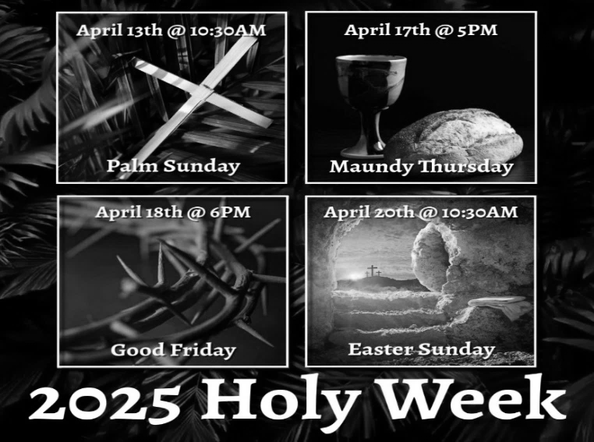

**HOLY WEEK INVITATION & EXTRA OPPORTUNITY**

Mother Allison and Father Marcel, together with their congregations, started celebrating Easter Vigil together a few years ago. Last year Father Marcel became aware that not all congregations celebrate the Easter Vigil. Since we - Episcopal Church and Lutheran Church (ELCA) - are in full communion, Father Marcel thought of reaching out to invite the Episcopal and Lutheran Congregations in the vicinity to join them. We have been invited to celebrate the **Easter Vigil at St. Simeon's By The Sea in North Wildwood, on, Saturday, April 19th, starting at 5:30pm**. We look forward to sharing in this Easter Liturgy together. Please see Vicar Vince with any questions, or inform Vicar Vince of your interest or intent in attending.

**37TH NJ SYNOD ASSEMBLY**

Behold! I Make All Things New. (Revelation 21:5) Assembly will transition from a one to a three-day event due to the election of a new Bishop, and other business. Vicar Vince is looking for two other church members to be able to attend the event. We will be at the Hilton East Brunswick Hotel - 3 Tower Center Blvd, East Brunswick, from **Thursday, June 5th to Saturday, June 7th**. Online registration opens in February, and the **deadline for registration is April 21st**. Synod Council has designated funds to cover most of the costs for attending with the hope that relieving the financial burden of attendance will prompt all congregations to send a full contingent of voting members. Voting Member: $25 (includes Friday evening banquet) / $50 (after April 21st). Rooms have been blocked for the NJ Synod. Rates are $179 per night. **Hotel deadline is May 22nd**. Reach out to Vicar Vince with any questions.



Vicar Vince was introduced to Milestones Ministries weekly guides for faith-filled studies and conversations through a Seminary class. A decision was made to pass these along to you. If you missed a week, or lost your insert, check our website for past issues. Feel free to ask questions and provide feedback to Vicar Vince.

**2025 CHURCH DIRECTORY**

Additional copies are by the Church Office on the bookshelves. We continue to keep it updated throughout the year. Undoubtedly, we probably miss a few changes, and have made a few errors. The printed church directories have spaces for changes in information, new people’s information, notes, and your favorite Bible verses. Please continue to make it a point to inform the Church Office of any changes or updates.

**PRAYER SHAWL MINISTRY**

Prayer Shawls, Lap Quilts, Scarves, and other items have been made with love. Blessed items are located in the Narthex, and are free for anyone. Members of the group continue working at home on new stitches and patterns. We are blessed to be able to continue collecting new items. We have a donation station of yarn and other items located in the Narthex. You can find some new supplies for your next creation!

here, 10 for it is written,

  ‘He will command his angels concerning you,

   to protect you,’

11 and

  ‘On their hands they will bear you up,

   so that you will not dash your foot against a stone.’ ”

12 Jesus answered him, “It is said, ‘Do not put the Lord your God to the test.’ ”

13 When the devil had finished every test, he departed from him until an

opportune time.

V. This is the Gospel of the Lord,

**C. Praise to you, O Christ.**

(We invite you to be seated.)

**SERMON**

(Delivered by Vicar Vince Piekarski.)

(Following the Sermon, we invite you to stand as you are able.)

**HYMN OF THE DAY**

(We invite you to sing along with the music offered by our Organist.)

Lutheran Book of Worship—Green Book

**99—O Lord, throughout These Forty Days**

**APOSTLES’ CREED**

V. God has made us his people through our Baptism into Christ. Living together in

trust and hope let us confess our faith together using the Apostles’ Creed.

**C. I believe in God, the Father almighty,**

**creator of heaven and earth.**

**I believe in Jesus Christ, God’s only Son, our Lord,**

**who was conceived by the Holy Spirit,**

**born of the Virgin Mary,**

**suffered under Pontius Pilate,**

no distinction between Jew and Greek; the same Lord is Lord of all and is

generous to all who call on him. 13 For “everyone who calls on the name of the

Lord shall be saved.”

R. This is the Word of the Lord.

**C. Thanks be to God.**

V. I invite you to stand as you are able, and I invite you to announce the Gospel

Acclamation with me.

**GOSPEL ACCLAMATION**

**C. One does not live by bread alone, but by every word that comes from the**

**mouth of God.** (Matt. 4:4)

**GOSPEL READING**

After being filled with the Holy Spirit at his baptism, Jesus is led in the wilderness.

Through his responses to the temptations of the devil, he defines what it means

to be called “the Son of God.”

V. The Holy Gospel According to Luke, the 4th Chapter (Verses 1-13).

**C. Glory to you, O Lord.**

V. 1 Jesus, full of the Holy Spirit, returned from the Jordan and was led by the Spirit

in the wilderness, 2 where for forty days he was tested by the devil. He ate

nothing at all during those days, and when they were over he was famished.

3 The devil said to him, “If you are the Son of God, command this stone to

become a loaf of bread.” 4 Jesus answered him, “It is written, ‘One does not live

by bread alone.’ ”

5 Then the devil led him up and showed him in an instant all the kingdoms of the

world. 6 And the devil said to him, “To you I will give all this authority and their

glory, for it has been given over to me, and I give it to anyone I please. 7 If you,

then, will worship me, it will all be yours.” 8 Jesus answered him, “It is written,

  ‘Worship the Lord your God,

   and serve only him.’ ”

9 Then the devil led him to Jerusalem and placed him on the pinnacle of the

temple and said to him, “If you are the Son of God, throw yourself down from



Our Prayer List continues to lengthen and we realize the important need for prayers and healing. Sometimes the unfortunate result is that someone has passed away, and the words “The Family & Friends of” appear before someone’s name. However, sometimes we forget names are still on the list and their health has improved or the they are no longer struggling, and they can be removed. Please share the good and bad stories as we continue to pray for strength and healing. Names can be added or removed from the list on the clipboard in the Narthex prior to the Worship Service, by calling the church office, or addressing it on the Conference Call. Please let us know the relation to the person(s) you listed so we can be more mindful with our prayers. Names will stay on the list until removed by the person(s) who requested prayer.

**HOME COMMUNION MINISTRY**

A Minister is available if you have a loved one, or if you desire services. We look forward in sharing the Word and Holy Communion! Please inform Vicar Vince, Kathy, or the Church Office so plans can be made for visits.

**INTERESTED IN BECOMING A NEW MEMBER**

Have you been attending our church for a while? Have you just recently returned to church after being away for a bit? Maybe you transitioned from another church,

or just started to recently attend our church. We are glad to have you, and would love to have you as a member of our Congregation. See Vicar Vince for more info.

**BAPTISM**

We are a church whose unity is in Jesus Christ, who gathers us around word and water, wine and bread. Baptism is a significant part of our faith journey as we come from the baptismal waters to live a new life as children of God. Our baptism sets us out on a lifelong journey that is characterized by our relationship to God, our relationship to our faith community, our relationships in our community and the wider world. Living our baptismal covenant means living a life of growth in the faith practices of discipleship. Please see Vicar Vince for more information.

**FIRST COMMUNION**

Although no particular age for first communion is prescribed by The Use of the Means of Grace, one guideline is offered. Because admission to the Sacrament is by invitation of the Lord to the baptized, "baptized children begin to commune on a regular basis at a time determined through mutual conversation that includes the pastor/vicar, the child, and the parents or sponsors involved, within the accepted practices of the congregation.” Each congregation is encouraged to ask the question of readiness for first communion, establish their own policies regarding age and practice, and accompany that practice with catechesis appropriate to the age of the communicant. If anyone has questions, please see Vicar Vince.

**LIBRARY**

New books are added to our library from time to time. Several are borrowed and read and exchanged. Who knows, you might find one particularly interesting and share that with someone as well. Reading is a great way to pass spare time, learn, and explore. You may find some fresh ideas for prayer, ways to grow more spiritually, ways to grow closer to God, or some opportunities to understand our faith more. Visit the library between the church offices and see what books are there!

We also have an extended library located in Vicar Vince’s office on the large green shelves. There are Bibles of various translations, books from his personal collection, books inherited from Pastor Leah, movies, past Bible Study Curriculums, and so much more. Feel free to ask Vicar Vince to be able to check things out!

**FAVORITE HYMNS**

Carol is willing to play some of your favorite hymns for the Prelude & Postlude each Sunday during our Worship Service. Feel free to let her know of your suggestions.

**TITHES, OFFERINGS, & ENVELOPES**

2025 Offering Envelopes are available. Please see Heather if you have not received yours, or would like to have some. For we do indeed worship God with our tithes and offerings. We hear this in scripture, “Each of you must give as you have made up your mind, not reluctantly or under compulsion, for God loves a cheerful giver.”

(2 Corinthians 9:7) Feel free to drop your envelopes in the offering plate, mail them to the church, or drop them off in the locked mailbox. Thanks for your continued support in the mission of our church, its ministries, the NJ Synod, and other needs!

**C. God will give the angels charge over you, to guard you in all your ways.**

(Ps. 91:11)

R. 9 Because you have made the Lord your refuge,

   and the Most High your habitation,

  10 no evil will befall you,

   nor shall affliction come near your dwelling.

  11 For God will give the angels charge over you,

   to guard you in all your ways.

  12 Upon their hands they will bear you up,

   lest you strike your foot against a stone.

**C. God will give the angels charge over you, to guard you in all your ways.**

(Ps. 91:11)

R. 13 You will tread upon the lion cub and viper;

   you will trample down the lion and the serpent.

  14 I will deliver those who cling to me;

   I will uphold them, because they know my name.

  15 They will call me, and I will answer them;

   I will be with them in trouble; I will rescue and honor them.

  16 With long life will I satisfy them,

   and show them my salvation.

**C. God will give the angels charge over you, to guard you in all your ways.**

(Ps. 91:11)

**SECOND READING**

Paul reminds the Christians at Rome of the foundation of their creed, the

confession of faith in the risen Christ as Lord.

R. Our Second Reading is from the 10th Chapters of Romans (Verses 8b-13).

R. 8b “The word is near you,

   in your mouth and in your heart”

(that is, the word of faith that we proclaim), 9 because if you confess with your

mouth that Jesus is Lord and believe in your heart that God raised him from the

dead, you will be saved. 10 For one believes with the heart, leading to

righteousness, and one confesses with the mouth, leading to salvation. 11 The

scripture says, “No one who believes in him will be put to shame.” 12 For there is

R. Our First Reading is from the 26th Chapter of Deuteronomy (Verses 1-11).

R. 1 “When you have come into the land that the Lord your God is giving you as an

inheritance to possess and you possess it and settle in it, 2 you shall take some o

of the first of all the fruit of the ground, which you harvest from the land that the

Lord your God is giving you, and you shall put it in a basket and go to the place

that the Lord your God will choose as a dwelling for his name. 3 You shall go to

the priest who is in office at that time and say to him, ‘Today I declare to the Lord

your God that I have come into the land that the Lord swore to our ancestors to

give us.’ 4 When the priest takes the basket from your hand and sets it down

before the altar of the Lord your God, 5 you shall make this response before the

Lord your God: ‘A wandering Aramean was my ancestor; he went down into

Egypt and lived there as an alien, few in number, and there he became a great

nation, mighty and populous. 6 When the Egyptians treated us harshly and

afflicted us, by imposing hard labor on us, 7 we cried to the Lord, the God of our

ancestors; the Lord heard our voice and saw our affliction, our toil, and our

oppression. 8 The Lord brought us out of Egypt with a mighty hand and an

outstretched arm, with a terrifying display of power, and with signs and wonders;

9 and he brought us into this place and gave us this land, a land flowing with milk

and honey. 10 So now I bring the first of the fruit of the ground that you, O Lord,

have given me.’ You shall set it down before the Lord your God and bow down

before the Lord your God. 11 Then you, together with the Levites and the aliens

who reside among you, shall celebrate with all the bounty that the Lord your God

has given to you and to your house.”

R. This is the Word of the Lord.

**C. Thanks be to God.**

**PSALM**

R. Our Responsorial Psalm is from the 91st Psalm (Verses 1-2, 9-16).

**C. God will give the angels charge over you, to guard you in all your ways.**

(Ps. 91:11)

R. 1 You who dwell in the shelter of the Most High,

   who abide in the shadow of the Almighty—

  2 you will say to the Lord, “My refuge and my stronghold,

   my God in whom I put my trust.”

**ED GREEN CAPITAL IMPROVEMENT FUND**

We continue raising money for unforeseen costs or repairs.Kathy sells Wawa Tickets for $6, the donation bin is in the back of the church, and we have our Annual Church Rummage Sale. Thanks for your continued donations, prayers, and support!

**PROPERTY USE**

​​​​​Do you know anyone interested in utilizing our Fellowship Hall for a Party or Event?

It is a suggested $50 refundable security deposit, and $250 for facility use. There is no alcohol or games of chance permitted due to ELCA policy. Please contact Vicar Vince or the Church Office with questions, for info, or to reserve a date and time.

**VICE PASTOR UPDATE**

Pastor William Hodgetts continues to attend our monthly Church Council Meetings. Pastor William continues to provide Supervision and Direction for Vicar Vince.

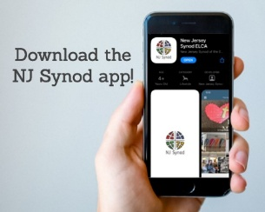

Jersey Jottings is a weekly e-newsletter that connects our synod together with weekly prayer, upcoming events, synod and churchwide activities, mission stories, congregational activities, and more. You can also sign up by going to https://www.njsynod.org/stay-connected and filling out the form! You can also get the app on your smartphone in the Apple App Store or on Google Play on your android.



**VICAR APPOINTMENT ON MARCH 19TH, 2023**

A Memorandum of Understanding on the Matter of Pastoral Appointment

In Theological Education for Emerging Ministries (TEEM) Candidacy

TO: Congregation Council, Holy Spirit Lutheran Church, Villas

FROM: The Rev. Tracie L. Bartholomew, Bishop, New Jersey Synod

Dear Brother and Sisters in Christ,

This memorandum is in support of your discussions with Vincent Piekarski as pastor of Holy Spirit, Villas. Because this is not the usual pattern for completing the educational and candidacy requirements for ordination, it is my hope that this memorandum will both provide guidelines and engage in conversation with those who are invested in this process.

I would say at the outset that because Vincent is an outstanding candidate for the Ministry of Word and Sacrament, we will all want to do whatever is necessary to assure that his placement serves the mission of the church in the best possible fashion.

The following notes reflect my own understanding of this matter:

(1) The appointment for Vincent will begin on April 1, 2023. At this time, Vincent

will assume all responsibilities of a regularly called pastor, including presiding at

the Sacrament of Holy Communion and Baptism at Holy Spirit, Villas.

(2) A pastoral appointment in the TEEM process is an option for completing

seminary educational requirements and the steps of the candidacy process.

Upon completion of the candidacy process and seminary education, the

candidate may receive and accept a call to ordained ministry from the

congregation where the appointment is being served.

**KYRIE**

V. In peace, let us pray to the Lord.

**C. Lord, have mercy.**

V. For the peace from above, and for our salvation, let us pray to the Lord.

**C. Lord, have mercy.**

V. For the peace of the whole world, for the well-being of the church of God,

and for the unity of all, let us pray to the Lord.

**C. Lord, have mercy.**

V. For this holy house, and for all who offer here their worship and praise,

let us pray to the Lord.

**C. Lord, have mercy.**

V. Help, save, comfort, and defend us, gracious Lord.

**C. Amen.**

**PRAYER OF THE DAY**

V. The Lord be with you.

**C. And also with you.**

V. Let us pray,

O Lord God, you led your people through the wilderness and brought them to the

promised land. Guide us now, so that, following your Son, we may walk safely

through the wilderness of this world toward the life you alone can give, through

Jesus Christ, our Savior and Lord, who lives and reigns with you and the Holy

Spirit, one God, now and forever.

**C. Amen.**

(We invite you to be seated for our Readings and Psalm.)

**FIRST READING**

The annual harvest festival, called the Feast of Weeks, provides the setting for

this reading. This festival celebrates the first fruits of the produce of the land

offered back to God in thanks. In this text, worshipers announce God’s gracious

acts on behalf of Israel.

V. Compassionate One,

**C. you are slow to anger and abounding in steadfast love,**

**but our lives do not always reflect you**

**and your love for the world.**

**We do not show others the tender compassion**

**you have shown to us.**

**We do not welcome others with the radical hospitality**

**you grant to all people.**

**We oppress others,**

**even though you have set us free again and again.**

**We squander the abundant gifts of the earth.**

**Transform our lives**

**and guide us again in the way of the cross.**

**Amen.**

V. Beloved in Christ,

God’s arms are always stretched open wide

to welcome the wandering ones home.

In **☩** Christ your sins are forgiven.

You have a place in God’s house forever.

**C. Amen.**

(We invite you to remain standing as you are able.)



**GATHERING HYMN**

(We invite you to sing along with the music offered by our Organist.)

With One Voice—Blue Book

**780—What a Fellowship, What a Joy Divine**

**APOSTOLIC GREETING**

V. May the grace of our Lord Jesus Christ, the love of God,

and the communion of the Holy Spirit be with you all.

**C. And also with you.**

(3) This appointment is jointly supervised by the Office of the Bishop and the TEEM

pastor’s seminary. A mentoring relationship with a local pastor is required for the

length of this appointment.

(4) The synod of candidacy origin will be responsible for the approval process.

(5) Upon approval for ordination, the congregation would be expected to extend a

call to the pastoral appointee.

(6) Compensation for the TEEM pastor will be according to the guidelines of the New

Jersey Synod. All normal forms of compensation should be in place for the term

of the appointment, including stipulation that base salary and housing shall be in

accord with synod guidelines for first call at time of ordination.

(7) The ELCA Portico benefit plan for lay persons in full-time church service should

be used for the pastoral appointee up to the time of ordination, whereupon the

benefit package is to be converted to the plan for ELCA clergy.

(8) A decision for Pastoral Appointment is made with the agreement of a synod and

its candidacy committee, and the ELCA, normally represented by the regional

staff person of each in consultation with the seminary and its Director for

Contextual Education.

(9) Pastoral Appointment in a TEEM Candidacy is an option that is to serve the

mission of the Church in a particular and vital way and is not to be viewed or

used as a means to circumvent the normal candidacy process and/or first call

placement process.

In the specific case of Vincent, the New Jersey Synod remains responsible for the candidacy and approval process, and has agreed to this proposal for Appointment at Holy Spirit, Villas.

Continued blessings to both Holy Spirit and Vincent Piekarski as you embark on this journey of mutual ministry. As partners in ministry, we walk with you and rejoice in this new relationship.

**VICAR VINCE’S DAY OF REST**

A day of rest can have physical, mental, and spiritual benefits. “Mittwoch,” German for mid-week, or Wednesday, is the day that Vicar Vince will use to recharge and do some other things. Please do not hesitate to reach out if there is an emergency!

**WHAT IS THE EVANGELICAL LUTHERAN**

**CHURCH IN AMERICA (ELCA)?**

The ELCA was formed in 1987 by the merger of three Lutheran Church bodies –

the ALC (American Lutheran Church), the LCA (Lutheran Church in America),

and the AELC (Association of Evangelical Lutheran Churches).

To learn more, go to the ELCA's website at www.elca.org.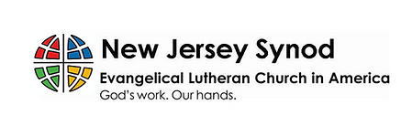

**WHAT IS THE NEW JERSEY SYNOD?**

The New Jersey Synod is a geographical grouping of Evangelical Lutheran Church in America (ELCA) congregations that share the mission and ministry of the Church on the New Jersey territory. It is one of 65 synods in the ELCA. The NJ Synod is comprised of 146 congregations, which include over 45,000 baptized members.

**TUESDAY SEWING CIRCLE**

**COFFEE, CHIPS, FELLOWSHIP, QUILTS!**

You all—men included—are warmly invited to join **Holy Trinity Lutheran Church in Wildwood on Tuesday morning at 10 AM**. No sewing skills required! We welcome anyone looking to be part of a friendly group that enjoys doing a variety of activities together. We meet in the front room of the Parish Hall at 2810 Atlantic Ave. There’s parking available behind the church, and you can enter through the rear door. Just bring a sandwich or snack for lunch! For more information, please contact: Louise McHugh at tillie26@verizon.net or Martha Neff at marthaneff1@yahoo.com

**TRUE DELIVERANCE PRAISE & WORSHIP CENTER**

Reverend Maria Brooks and True Deliverance Praise & Worship Center utilize our facilities from 1-4PM on Sundays. TDPWC helps with the Food Pantry and hosts or assists with other events throughout the year. TDPWC hosts a **Prayer Line** on **Mondays, Thursdays, & Fridays at 5PM** on the **Conference Call 1-657-390-7957**.

**CONFERENCE CALL CHECK-IN**

(Roll Call and Attendance)

**WELCOME & ANNOUNCEMENTS**

(Offered by Vicar, Assistant, and Congregation.)

**INTRODUCTION**

A. These forty days called Lent are like no other. It is our opportune time to return to

the God who rescues, to receive the gifts of God’s grace, to believe with the heart

and confess with the mouth the wonder of God’s love in Jesus, and to resist

temptation at every turn. This is no small pilgrimage on which we have just

embarked. It is a struggle Jesus knew. It is a struggle Jesus shares. The

nearness of the Lord, in bread and wine, water and word, will uphold and sustain

us.

**PRELUDE**

(Music offered by our Organist before the start of our Worship Service.)

**More Love To Thee O Christ**

**CHIMES**

(Music offered by our Organist before the start of our Worship Service.)

**Lord Jesus Think On Me**

(We invite you to stand as you are able.)

**CONFESSION & FORGIVENESS**

(All may make the sign of the cross, the sign that is marked at baptism.)

V. Blessed be the holy Trinity, **☩** one God,

who forgives all our sin,

whose mercy endures forever.

**C. Amen.**

V. Let us return to God, confessing our sin in the assurance of God’s abiding love.

(Silence is kept for reflection.)



We, the Evangelical Lutheran Church of the Holy Spirit, are People of God, who

are called by the Holy Spirit to pray, worship, joyfully proclaim Jesus Christ,

and compassionately witness and serve others in Christian Love.

**AN ESPECIALLY WARM WELCOME TO OUR VISITORS**

We are glad that you joined us for Worship today! Thank you for enriching our time together! We would like to get to know you better, and we would like for you to get to know us better too. Brochures, welcome gifts, prayer shawls, Bibles, and other items are available at our welcome areas. Church members are happy to show you around and share about our ministries. Please don’t hesitate to speak up and ask questions. Please make sure you sign-in on our clipboard on the podium in the lobby.



We continue conducting our Worship Services in coordination with our Conference Call. Join us at our # 657-390-7423. If that does not allow you to gain access, please utilize our other # 701-802-5170 and access code 8221190, then hit the # key. You may need to dial 1 first, depending on your phone plan. After you log-in, please announce your name. Feel free to talk with others until we start our service.

**ARE YOU INTERESTED IN CANDLE MEMORIALS?**

Candles cost $10 each, and can be dedicated in memory of someone.

The Sign-up sheets are located on the bulletin board between the church offices.

Please feel free to see Vicar Vince with any questions.

**SANCTUARY CANDLE**

March’s is given to the Glory of God & in memory of

DONNA GAIN by Jean, Phil, & Bob Zimmerman.

**ALTAR CANDLES**

March’s are given to the Glory of God & in memory of

ED GREEN by Fran Green & Family.



|  |  |
| --- | --- |
| **2025 FINANCIAL STANDING** | |
| **FEBRUARY INCOME** | $6,844.00 |
| **FEBRUARY SPENDING** | $5,674.81 |
| **FEBRUARY GAIN OR (LOSS)** | $1,169.19 |
| **2025 INCOME** | $11,229.00 |
| **2025 SPENDING** | $14,407.84 |
| **2025 GAIN OR (LOSS)** | ($3,178.84) |
| **ED GREEN CAPITAL IMPROVEMENT FUND** | $11,844.55 |
| **FOOD PANTRY FUND (SOCIAL MINISTRY)** | $12,828.09 |
| **CD** | $25,585.16 |
| **75TH ANNIVERSARY** | $0.00 |

**CHURCH STAFF & VOLUNTEERS**

**VICAR, BIBLE STUDY & FAITH DISCUSSIONS,**

**EVENTS, NEWSLETTER, & WEBSITE**

Vicar Vince Piekarski

**VICE PASTOR**

Pastor William Hodgetts

**ORGANIST & PIANIST**

Carol Amundsen

**CHURCH OFFICE, SUNDAY SCHOOL, & FOOD PANTRY**

Heather Piekarski

**CHURCH COUNCIL PRESIDENT**

Mary Melnicoff

**CHURCH COUNCIL VICE PRESIDENT**

Judy Brannan

**CHURCH COUNCIL TREASURER**

Bonnie Millard

**CHURCH COUNCIL SECRETARY**

Vicki Rinier

**CHURCH PROPERTY**

Frank Ford & Wayne Rand

**LICENSES & EXPIRATION DATES**

Worship Service Content is used via permission through Augsburg Fortress Liturgies Annual License #SB144368. The next Subscription Renewal Date is 2/28/2026.

Our Hymns and Worship Music are used via permission through CCLI One License #11327166. The next Subscription Renewal Date is 1/31/2026.

**WELCOME TO HOLY SPIRIT**

**LUTHERAN CHURCH**

A Member of the Evangelical Lutheran Church in America, New Jersey Synod

1220 Bayshore Rd., Villas, NJ 08251

609-886-2414

holyspiritlutheran@comcast.net

holyspiritvillas.com

facebook.com/holyspiritvillas

Vicar Vince Piekarski can be contacted at any time through call or text at

412-225-0287 or through email at vpie8282@gmail.com

**FIRST SUNDAY IN LENT**

**SUNDAY, MARCH 9TH, 2025**

**10:30AM WORSHIP SERVICE WITH HOLY COMMUNION** 