PROJECT LIFESAVER INTERNATIONAL    Are you using the right battery AND “O” Ring  with the appropriate transmitter and/or tester?  Using the wrong battery in your transmitter/tester may cause damage, or shorten the lifespan of the battery, and may VOID the warranty of Project Lifesaver provided equipment. Illustrated below is the right battery AND “O” Ring for each of our existing transmitter and tester.  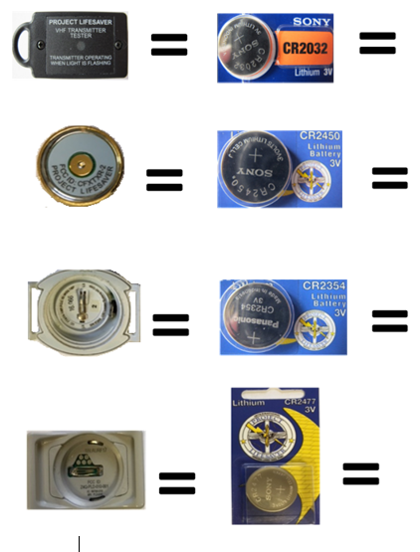  O Ring  None  O Ring  2013-& Older M60WASH  2014 & Newer M60WASH14  O Ring  LTROR-L4  O RING  CSORING.2 | PROJECT LIFESAVER INTERNATIONAL  Are you using the right battery AND “O” Ring with the appropriate transmitter and/or tester?  Using the wrong battery in your transmitter/tester may cause damage, or shorten the lifespan of the battery, and may VOID the warranty of Project Lifesaver provided equipment. Illustrated below is the right battery AND “O” Ring for each of our existing transmitter and tester.  O Ring  None  O Ring  2013-& Older M60WASH  2014 & Newer M60WASH14  O Ring  LTROR-L4  O Ring  CSORING.2

