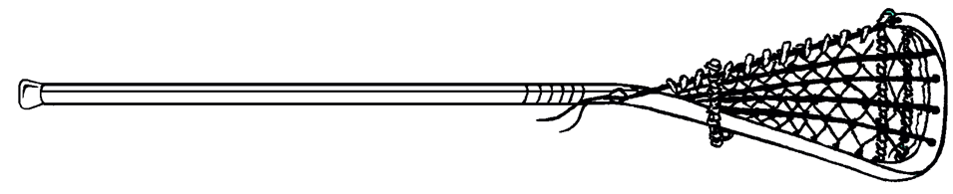

Geneva Family YMCA
Outdoor Youth Lacrosse
Parent Handbook
Spring 2020
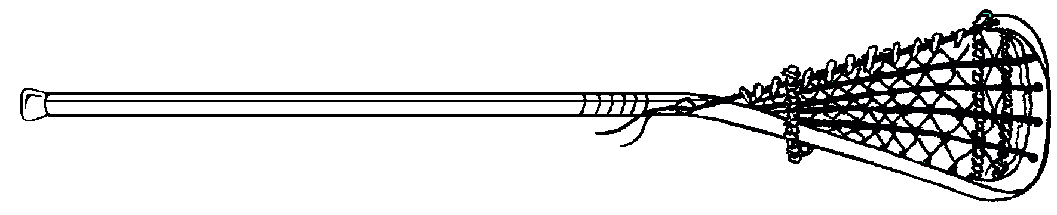
WELCOME NEW LACROSSE PARENTS!
The Geneva Family YMCA Youth Lacrosse Program welcomes you and your young player to the sport of lacrosse. Lacrosse has benefited from rapid growth in recent years. More and more people every day are learning to play America’s oldest – and fastest growing – sport.
Lacrosse is about having fun and learning a sport. As parents, part of your role is to make sure that your child is enjoying his lacrosse experience. Be positive about your child’s participation. Encourage. Support. Volunteer. Remind your child, AND yourself, that winning is not everything. You and your child will participate in many games over the years and the friendships they form and the growth they experience will certainly outweigh the win/loss record in your child’s memory.

MISSION STATEMENT
The Geneva Family YMCA is dedicated to promoting the growth and development of lacrosse within our community. The Geneva YMCA Youth Lacrosse Program strives to develop the fundamental skills of teamwork, good sportsmanship, fair play and honoring & respecting the game. Our staff, coaches, volunteers, parents and players are committed to providing a safe and rewarding environment for every player.

GENEVA YOUTH LACROSSE PROGRAM MOTTO

PLAY HARD
PLAY SMART
HONOR THE GAME

PLAY HARD - Players giving their all, every day. Practicing with the purpose of learning the skills and improving. Leaving it all on the field. Giving 100% of yourself for the team and your teammates.

PLAY SMART - Players must be prepared. Arrive to practice/games early. Pay attention during practices. Be proactive. Look ahead and follow through. Work together and communicate with your teammates to reach the team goals. Keep track of your equipment.

HONOR THE GAME - RESPECT: Rules, Opponents, Officials, Teammates, Self. Playing the game of lacrosse is about history and honor. It should be played with CLASS and INTEGRITY. Never do anything to disrespect your team, your community or yourself. Be Positive!

COMMUNICATION
Any and all concerns regarding the YMCA Youth Lacrosse Program should be addressed directly to either the Program Director or the Executive Director. The Geneva YMCA has an OPEN DOOR POLICY regarding communications with our program participants and their families. Please do not hesitate to contact us at any time with questions, concerns or issues. Remember – we cannot address issues we are unaware of.

Team communication regarding the program, i.e. practice times, locations, game information, etc. will flow through each teams Head Coach. We cannot communicate with you if we do not have your correct contact information. Please make sure that the YMCA & your coach has a valid email address and phone number for your family.

CONTACT INFORMATION

Geneva Family YMCA – 315-789-1616
YMCA Executive Director – Mary Bakogiannis – mbakogiannis@genevafamilyymca.org – 585-298-2741
YMCA Program Director – Laura Snook - tori_13820@yahoo.com – 315-719-4720

BOYS

Kindergarten
Coach: TBA

1st - 2nd

Head Coach: Chris D'Amico
Chrisdamico17@hotmail.com
(315) 521-4329

Assistant Coach: Gordy Baxter
gcbaxter84@gmail.com
(315) 945-0346

Assistant Coach: Frank Gaglianese
flg123jj@yahoo.com
(315) 719-5653

3rd - 4th

Head Coach: Dave LaVoie
lavoiecd@gmail.com
(845) 238-7999

Assistant Coach: Matt Valenti
mattkellyvalenti@gmail.com
(315) 730-3567

5th - 6th

Head Coach: Jeff Dunham
genevayouthlacrosse@gmail.com
(315) 521-7870

Assistant Coach: Tom Dunham
tdunham25@yahoo.com
(315) 719-2001

Assistant Coach: Mike Warner
mlwarner24@gmail.com
(315) 945-1110
GIRLS

Kindergarten

Coach: TBA

1st – 2nd

Head Coach: Becca Martin
rebeccam328@gmail.com
(443) 774-3193

3rd – 4th

Head Coach: Nick DeMaria
nickdemo14@hotmail.com
(315) 521-0580

Assistant Coach: Jim Devaney
mail@jdevaney.com
(315) 521-3054

5th - 6th

Head Coach: Katie Flowers
kflowers@hws.edu
(716) 983-5534

Assistant Coach: Taylor Perry
tperry@hws.edu
(315) 945-5797

Assistant Coach: Laura Dougherty
led88@cornell.edu
(315) 651-6874

Assistant Coach: Ashley McCann
ashleylax4@gmail.com
(315) 559-8678

CODE OF CONDUCT
Every player, coach and parent will be asked to sign and turn in a copy of the Geneva YMCA Youth Lacrosse Program’s following Code of Conduct.

I, as a player, coach, parent, spectator or official for the Geneva YMCA Youth Lacrosse Program pledge to conduct
myself in a manner that complies with the Geneva YMCA Youth Lacrosse “Code of Conduct” at all times.
Accordingly, I pledge to:

- “Play Hard, Play Smart and Honor the Game”
- Arrive at practices and games on time and be prepared.
- Have all of my equipment and be ready to play
- Have a coachable spirit
- Respect other players, coaches, parents, officials and spectators
- Demonstrate and encourage good sportsmanship and fair play
- Focus on fun and participation
- Understand the safety and welfare of all is our top priority
- Support the drug, alcohol, and tobacco free environment that is important for all youth sporting events.
- Absolutely NO FIGHTING. Fighting will result in immediate forfeit of a game and disqualification from the Geneva YMCA Youth Lacrosse program. It will not be tolerated
- Know and abide by the Rules of Lacrosse, the established guidelines, and all eligibility requirements
- Accept and will remain mindful that I am a representative of Geneva, NY and the Geneva YMCA
- Report to the appropriate YMCA representative any incident which may cast negative light on this great game or this program
- NOT to ever use profanity at a Geneva Youth Lacrosse event
- NOT criticize coaches, players, or game officials
- NOT ever touch an opposing player, coach, or game official in a threatening manner

I accept responsibility for my actions and understand that I may be removed from a game, practice or facility if I should behave in a manner deemed unacceptable by the coaches, game officials or spectators.

GUIDELINES FOR A HEALTHY PLAYER
This information was taken from the USLacrosse.com website to aid our parents and players in taking a positive step towards a healthier you. These are just some basic guidelines.

- A healthy diet and good eating habits are essential for a young athlete's development and performance.

- Jackie Berning, Ph.D, a registered dietician and board certified specialist in sports dietetics who serves as a
member of the US Lacrosse Sports Science & Safety Committee, notes that for athletes in season and for
those engaged in daily workouts, consuming carbohydrates within 30 minutes after exercise and again after
two hours can help muscles reload and rebuild by replacing glycogen up to 50% quicker. Berning cites
chocolate milk as an excellent source for this energy replenishment among younger athletes.

- Recovery nutrition is not as critical to athletes during offseason exercise, Berning says, because consuming
rehydration beverages and salty foods in routine meals will also help the body to replace lost fluids and
electrolytes.

- Again these are just basic guidelines. Proper hydration and healthy snacks such as a piece of fruit a half an
hour before practice would be helpful for your child in their performance at practice

PRACTICE
Practices will start on Monday April 3rd. Practice/Game schedules are attached to this handbook and are available online at: http://www.genevafamilyymca.org/youth-lacrosse.html

Practices will be held at the following locations:

Geneva Recreation Center (Turf)
Geneva High School Field #3 (The Pit) below the tennis courts
Geneva Schools Gambee Road Bus Garage West
Geneva Schools Gambee Road Bus Garage Middle Practice Field
Geneva Community Center Field
Geneva Schools Gambee Road Bus Garage East Practice Field

Individual team’s field locations for games and practices are indicated on the attached Practice/Game Schedules.

REQUIRED EQUIPMENT
Girls
- Stick
- Mouth guard
- Protective Eyewear
- Helmet (goalie only)
- Throat Protector (goalie only)
- Chest Protector (goalie only)
- Elbow Pads (goalie only)
- Gloves (goalie only)
- Goalie Pants (goalie only)
- Shin Guards (goalie only)

Boys
- Stick
- Helmet
- Mouth guard
- Gloves
- Shoulder Pads
- Arm Pads
- Rib Pads (optional but recommended)
- Throat Protector (goalie only)
- Chest Protector (required for goalie)

PRACTICE EXPECTATIONS
All players should arrive 15 minutes before practice begins. Bring a full water bottle, bring 2 if it is a hot day. Be ready to warm up and play with all gear on at the start of practice. Practice time is precious. Lacrosse has lots of elements that need to be taught. Practice will begin promptly at the time specified by the coach. Players should dress for the weather. Dress in layers for the cold and wet weather. It’s easy to peel off a layer when you get warm. Bring a dry towel or sweatshirt to change into after a cold/wet practice. Bring extra water for hot weather practices. HYDRATE before, during and after practice. Practices will be appropriately structured to the age of the player. We understand that kids learn in stages according to their age and developmental processing.

GAME DAY
Game schedules are attached to this handbook. Addresses and/or directions will be available on the Y website at:
http://www.genevayouthlacrosse.com/ & fingerlakesyouthlacrosse.leaguerepublic.com

Player Expectations:
Arrive at least 30 minutes before game time. HYDRATE/eat 2 hours before each game. Gear on, be ready to warm-up and begin pre‐game drills. Have your water near/on the bench.

Parents/Spectators Expectations:
DO: CHEER, CLAP, ENCOURAGE, SMILE, AND BE POSITIVE, LET THEM PLAY

DON’T: Yell, coach the players, question the coach/ref, or disrespect the teams on the field

GIRLS’ GAME OVERVIEW

Girls’ lacrosse is a non-contact game played by 12 players, a goalkeeper, five attackers and six defenders. Eight players may cross the restraining line into the opponent’s offensive zone and four stay behind. The object of the game is to shoot the ball into the opponent’s goal. The team scoring the most goals wins.

Draw:
Girl’s and women’s lacrosse begins with a draw, which is taken by the center position. The ball is placed between two horizontally held sticks, placed back-to-back, at the center of the field. At the sound of the whistle, the ball is flung into the air as the sticks are pulled up and away. The sticks must come up over the players’ heads. A draw is used to start each half and after each goal, and it takes place at the center of the field. Only five players from each team are permitted between restraining lines at the time of the draw. Once the signal for the draw occurs, the players behind each restraining line may cross over.
Basic Skills:
Field players may pass, catch or run with the ball in their stick. When a whistle blows, all players must stop in place. Rough checks, and contact to the body with the stick or body, are not allowed, however, incidental body contact may occur.

Rules:
The girls’ youth rules are divided by levels (A, B, and C). Levels B and C do not allow checking and do allow certain stick modification to make throwing and catching easier for the beginning or younger player. Level A rules allow for modified checking and require the use of regulation stick and pocket. Leagues, tournaments and programs with players below the 5th grade level must either use Level B or C rules. Players from the 5th grade through the 8th grade should progress from Level B or C to Level A rules

FIELD AND POSITIONS GIRLS’ LACROSSE

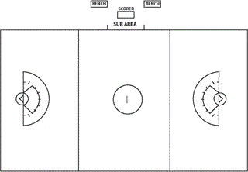

Attack (3 per team)
- Great ball handling/stick skills
- Set up and assist teammates to score
- Defend when the opposition goalie is trying to clear the ball

Midfield (5 per team)
- Speed and endurance, strong stick work and versatility
- Play both attack and defense
- Role as an attacker: Transition ball onto the offensive side, create fast-break opportunities
- Role as a defender: Stop offensive team from creating a fast break

Defense (3 per team)
- Defend the goal by “marking” opponents in the critical scoring area (the arcs)
- Strong communication skills, solid field vision, exceptional footwork
- Understand angles to be successful at seeing the ball and girl
- Create and cause turnovers and get the ground ball

Goalie (1 per team)

- Protect the goal and prevent the opposing team from scoring
- Lead the defense by directing defensemen to react
- Possess excellent hand-eye coordination and a strong voice

COMMON MINOR FOULS GIRLS’ LACROSSE
For a minor foul, the offending player is placed for a free position shot four meters off, in the direction from which she approached her opponent before committing the foul, and play is resumed. When a minor foul is committed in the 12 meter fan, the player with the ball has an indirect free position, in which case the player must pass first or be checked by an opponent before the team may shoot.

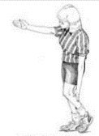Illegal Ball Off The Body: A ball that rebounds off a field player’s body to her or her team’s distinct advantage.

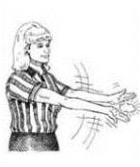Empty Crosse Check: A player may not check or hold an opponent’s stick unless the ball is in contact with the opponent’s stick

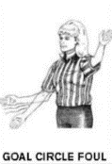 Goal Circle Foul: Occurs when any part of an offensive or defensive player’s body or stick, except that of the goalkeeper or deputy, enters the goal circle.

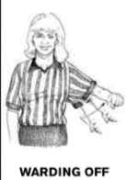Warding Off: Occurs when a player guards a ground ball with her stick, removes one hand from the stick and uses her free arm to ward off an opponent.

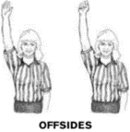Offsides: Occurs when a team has too many players over the restraining line.

COMMON MAJOR FOULS GIRLS’ LACROSSE
Fouls are categorized as major or minor, and the penalty for fouls is a “free position.” For major fouls, the offending player is placed four meters behind the player taking the free position.

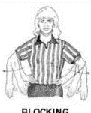Blocking: When contact is initiated by a defender who has moved into the path of an opponent with the ball without giving that player a chance to stop or change direction.

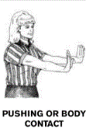Pushing or Body Contact: When a player charges, bangs, shoulders or backs into an opponent, or pushes with the hand or body.

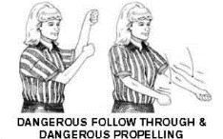Dangerous Propelling and Following Through: When a player propels the ball without control in the direction of another player. This is a mandatory card.

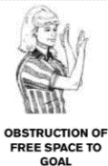 Obstruction of Free Space to Goal: When a defender is not closely marking her opponent, within a stick’s length of an opponent and is in the free space to goal of the attack player with the ball. The attack player must have the opportunity and be looking to shoot.

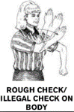Rough Check/Illegal Check on Body: When a defender swings her stick at an opponent’s stick or body with deliberate viciousness or recklessness, whether or not the opponent’s stick or body is struck. A check to the head is a mandatory card.

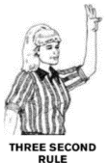Three Second Rule: A defender may not stand within the eight-meter arc for more than three seconds unless she is closely marking an opponent within a stick’s length.

GLOSSARY FOR GIRLS’ LACROSSE

Checking: Using stick-to-stick contact in an attempt to dislodge the ball.

Clear: Any action taken by a goalkeeper from within the goal circle to pass or carry the ball out of the goal circle.

Cradle: The coordinated motion of the arms and wrists that keeps the ball secure in the pocket and ready to be passed or shot when running

Critical Scoring Area: An area 15 meters in front of and to each side of the goal and 9 meters behind the goal. An 8-meter arc and 12-meter fan are marked in the area.

Draw: A technique to start or resume play by which a ball is placed in between two sticks held back to back and drawn up and away.

Eight-Meter Arcs: A semi-circular area in front of the goal used for the administration of major fouls. A defender may not remain in this area for more than three seconds unless she is within a stick’s length of her opponent.

Free Position: An opportunity awarded to one player when a major or minor foul is committed by a player from the other team. All players must move four meters away from the player with the ball. When the whistle sounds to resume play, the player may run, pass or shoot the ball.

Free Space to Goal: A cone-shaped path extending from each side of the goal circle to the attack player with the ball. A defense player may not, for safety reasons, stand alone in this area without closely marking an opponent.

Goalie Circle: The circle around the goal with a radius of 2.6 meters (8.5 feet). No player’s stick or body may ‘break’ the cylinder of the goal circle.

Indirect Free Position: An opportunity awarded to the offense when a minor foul is committed by the defense inside the 12 meter fan. When the whistle sounds to resume play, the player may run or pass, but may not shoot until a defender has checked her stick or she passes to a teammate.

Modified Checking: Checking the stick only if the entire stick is below shoulder level. The check must be in a downward direction and away from the body.

Sphere: An imaginary area, approximately 18 cm (seven inches) which surrounds a players head. No stick checks toward the head are allowed to break the sphere.

FINGER LAKES LACROSSE LEAGUE RULES

5TH & 6TH Grade Girls
- No formal score is to be kept
- Visiting Coach – please confirm date, time and location with home coach to avoid confusion
- Rain Outs – to be determined between both coaches – Rain date makeup games to be determined by coaches
- Home team supplies referees
- Goggles and Mouth Guards are mandatory
- Body Contact – None allowed
- Boundary Rule – This level will use the NCAA hard boundary rules
- 4 x 15 minute running quarters
- Modified sized field (regulation) Note: Field must be lined with an 8 and 12 meter arc
- 12 on 12
- Must complete 1 overhand pass in offensive zone, but upon the agreement of both coaches, the 1 pass rule can be dropped for the game.
- 4 players stay behind restraining line
- If player ‘stalls’ (does not shoot or pass) with ball after 5 seconds, referee will blow whistle and other team gets the ball
- Crease violation
  - No stick checks
  - No raking the ball
  - No kicking the ball
- Goalie wears – throat, leg and thigh protection
- Center draw – 5 girls on circle
- Goalie – No dumping in back net
- Coaches keep spray paint to remark crease in equipment bag

3rd & 4th Grade Girls
- No formal score is to be kept
- Visiting Coach – please confirm date, time and location with home coach to avoid confusion
- Rain Outs – to be determined between both coaches – Rain date makeup games to be determined by coaches
- Home team supplies referees
- Goggles and Mouth Guards are mandatory
- Body Contact – None allowed
- Boundary Rule – In general we will use hard boundaries at this level but it is up to the discretion of the coaches
- 4 x 15 minute running quarters
- Smaller Fields – 60 x 40 yards (approximately ½ regulation field sideways.
Note: Field must be lined with an 8 meter arc
- 7 on 7
- Goal keepers optional
- Must attempt 1 overhand pass in offensive zone.
- 2 players stay behind restraining line
- Crease violation
  - No stick checks
  - No raking the ball
  - No kicking the ball
- Goalie wears – throat, leg and thigh protection
- Center draw – 5 girls on circle
- Goalie – No dumping in back net
- Coaches keep spray paint to remark crease in equipment bag

1st and 2nd Grade Girls
- No formal score is to be kept
- Visiting Coach – please confirm date, time and location with home coach to avoid confusion
- Rain Outs – to be determined between both coaches – Rain date makeup games to be determined by coaches
- Home team supplies referees
- Goggles and Mouth Guards are mandatory
- Body Contact – None allowed
- Boundary Rule – This level will use hard boundaries at this level but it is up to the discretion of the coaches
- 4 x 15 minute running quarters
- Smaller fields – 60 x 40 yards (approximately ½ regulation field sideways.
Note: Field must be lined with an 8 meter arc
- 7 on 7 (or coaches decision)
- Goal keepers optional
- Must attempt 1 overhand pass in offensive zone
- 2 players stay behind restraining line
- Crease violation
  - No stick checks
  - No raking the ball
  - No kicking the ball
- Goalie wears – throat, leg and thigh protection
- Center draw – 5 girls on circle
- Goalie – No dumping in back net
- Coaches keep spray paint to remark crease in equipment bag

BOYS' LACROSSE - GAME OVERVIEW

Boys’ lacrosse is a contact game played by 10 players. The object of the game is to shoot the ball into the opponent’s goal and to keep the other team from scoring. The team scoring the most goals wins.

Positions:
Each team must keep at least 4 players, including the goalie, in its defensive half of the field and three in its offensive half. Three players (midfielders) may roam the entire field. Attackmen and defenders, including the goalie, can cross midfield, but another player that would normally be able to cross the line has to stay behind the line to ensure that the team has the proper number of players on each side.

Face-Off:
Boys’ lacrosse begins with a face-off. The ball is placed between the sticks of two squatting players at the center of the field. The official blows the whistle to begin play. Each face-off player tries to control the ball. The players in the wing areas can run after the ball when the whistle sounds. The other players must wait until one player has gained possession of the ball, or the ball has crossed into the offensive zone, before they can release. Face-offs are also used at the start of each quarter and after a goal is scored.

Basic Skills:
Field players must use their sticks to pass, catch and run with the ball. Only the goalkeeper may touch the ball with his hands. A player may gain possession of the ball by dislodging it from an opponent’s stick with a stick check, the controlled poking and slapping of the stick and gloved hands of the player with the ball.

FIELD & POSITIONS BOYS’ LACROSSE

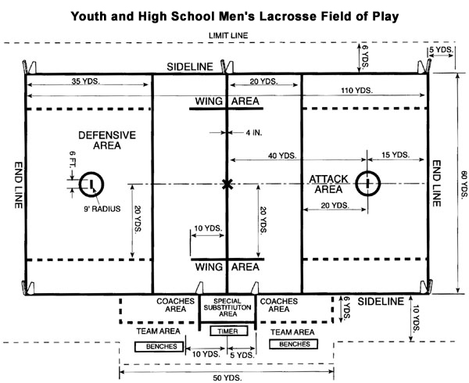

Attack (3 per team)
The attackman’s responsibility is to:
- Score goals and assist goals by passing the ball
- Stay on the offensive side of the field
- Demonstrate excellent stick work with both hands and have quick feet

Midfield (3 per team)
The midfielder’s responsibility is to:
- Cover the entire field playing offense and defense
- Clear the ball from defense to offense
- Demonstrate great stick work (throwing, catching, ground balls)
- Possess speed and stamina

Defense (3 per team)
The defenseman’s responsibility is to:
- Defend the goal
- Be agile, aggressive and possess great stick work
- Read any attackman’s play and react quickly in game situations

Goalie (1 per team)
The goalie’s responsibility is to:
- Protect the goal and prevent the opposing team from scoring
- Lead the defense by directing defensemen to react
- Possess excellent hand-eye coordination and a strong voice

PERSONAL FOULS BOYS’ LACROSSE
The penalty for a personal foul results in a one to three minute suspension from play and possession to the team that was fouled. Players with five personal fouls are ejected from the game, though this is a very rare occurrence in lacrosse.

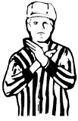Slashing: When a player’s stick viciously contacts and opponent in any area other than the stick or gloved hand on the stick.

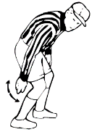Tripping: When a player obstructs his opponent at or below the waist with the stick, hands, arms, feet or legs.

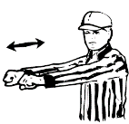 Cross Checking: When a player uses the handle of his stick between his hands to make contact with an opponent.

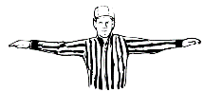Unsportsmanlike Conduct: When any player or coach acts in a way deemed by an official as unsportsmanlike conduct, including taunting, arguing or obscene language or gestures.

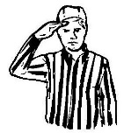Unnecessary Roughness: When a player strikes an opponent with his stick or body using excessive or violent force.

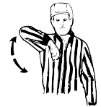Illegal Body Checking:
- Body checking an opponent who is not in possession of the ball or within five yards of a loose ball.
- Avoidable body check of an opponent after he has passed or shot the ball
- Body checking an opponent from the rear or at or below the waist
- Body checking an opponent above the shoulders. A body check must be below the shoulders and above the waist, and both hands of the player applying the body check must remain in contact with his stick.

Illegal Stick: When a player uses a stick that does not conform to required specifications. A stick may be found illegal if the pocket is too deep or if any other part of the stick was altered to gain an advantage

COMMON TECHNICAL FOULS BOYS’ LACROSSE
The penalty for a technical foul is a 30 second suspension if a team is in possession of the ball when the foul is committed, or possession of the ball to the team that was fouled if there was no possession when the foul was committed.

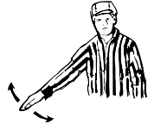Crease Violation: When an offensive player deliberately, through his own momentum, enters the opponent’s goal-crease or defensive player, including the goalkeeper, with the ball in his possession, enters from the surrounding playing field into his own goal-crease.

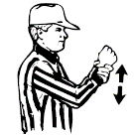Holding: Illegally impedes the movement of an opponent with the ball

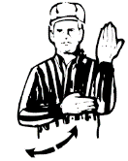Illegal Offensive Screening: When an offensive player, through moving contact of his body or equipment, blocks and defensive player from the man he is playing or impedes his normal movements of playing defense.

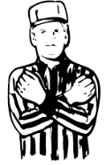 Interference: When a player interferes in any manner with the free movement of an opponent, except when that opponent has possession of the ball, the ball is inflight and within five yards of the player or both players are within five yards of a loose ball.

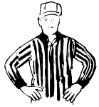Offsides: When a team does not have at least four players on its defensive side of the midfield line or at least three players on its offensive side of the midfield line.

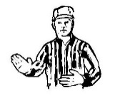Pushing: When a player thrusts or shoves another player from behind, with or without the ball, unless a player turns.

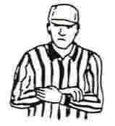Stalling: When a team intentionally holds the ball, without conducting normal offensive play, with the intent of running time off the clock.

COMMON TECHNICAL FOULS BOY’S LACROSSE Cont.

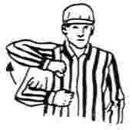Warding Off: When a player in possession of the ball uses his free hand or arm to hold, push or control the direction of an opponent’s stick check.

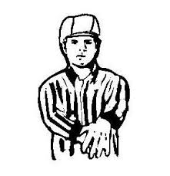Withholding the Ball from Play: When a player clamps a loose ball against the ground more than momentarily or clamps the ball against his body to prevent it from being dislodged.

GLOSSARY FOR BOYS’ LACROSSE

Checking: The act of attempting to dislodge the ball from an opponent’s stick

Clearing: Running or passing the ball from the defensive half of the field to the offensive half of the field

Cradling: The coordinated motion of the arms and wrists that keeps the ball secure in the pocket and ready to be passed or shot when running

Crease: The circle around the goal with a radius of nine feet into which only defensive players may enter. Defensive players may not take the ball into the crease-only the goalie.

Extra Man Offense (EMO): A man advantage that results from a time-serving penalty by the other team

Ground Ball: A loose ball on the playing field

Man Down Defense (MDD): The situation that results from a time-serving penalty which causes the defense to play with at least a one-man disadvantage.

On-The-Fly Substitution: A substitution made during play.

Pick: An offensive maneuver in which a stationary player attempts to block the path of a defender guarding another offensive player.

Play On: If a player commits a loose-ball technical foul or crease violation and an offended player may be disadvantaged by the immediate suspension of play, the official shall visually and verbally signal “play on” and withhold the whistle until such a time as the situation of advantage, gained or lost, has been completed.

Release: The term used by an official to notify a penalized player in the box that he may re-enter the game occurs at the conclusion of a time-serving penalty.

Riding: The act of trying to prevent a team from clearing the ball from the offensive half to the defensive half of the field.

FINGER LAKES LACROSSE LEAGUE RULES
The Spring League will use NHSA Modified Lacrosse Rules with the following exceptions:

5th and 6th Grade Boys
- Participation: Individuals on the teams in the league should currently be in 5th or 6th grade only. Younger players may play up at the discretion of their coach. No higher grades will be allowed
- Player Format: 3 attack, 3 middies, 3 defenders, and a goalie (equal playing time for each player is expected)
- Pre-game: Players and coaches should be brought to the middle of the field by the refs for a quick review of the rules and for pre-game handshakes. There should also be post-game handshakes.
- Contact Rule: No deliberate body contact may be initiated with the torso, either offensively or defensively. (Players should be instructed to play the ball). Incidental body contact is inevitable on ground balls and similar situations
- Stick Rules: Four long sticks will be allowed on the field at any time. Poke checks and slap checks are limited to the stick or glove area only. One handed checks are NOT ALLOWED. Two handed checks must be taught and used at all times.
- Field Size: Regulation fields and goals should be used in all games.
- Officials: Each town will need to supply their own officials for their home games. Certified Officials or an adult should officiate 5/6 level games whenever possible.
- Coach Rule: Only one coach will be allowed to address the officials during the game.
- Pass Rule: None, however coaches may institute this rule at any time during the game.
- Penalties: When a foul is committed it will result in either a 30 second technical foul or a one minute personal foul. The team that is man down will play with one less midfielder. The timekeeper will release the penalty. Penalized player must report and stay in the penalty area. A coach should accompany the player and explain the penalty turning it into a learning experience.
- Time Keeping: We will play 4, 15 minute running quarters. Each team will have one clock stopping time out per quarter. There is no Overtime; games will end when time expires not matter the score.
- Goal Rule: After a goal is scored, a face-off will take place at midfield. After a 5 goal differential, the team behind will be awarded the ball at midfield when scored upon. The coach of the losing team has the option to not implement this rule.
- Parental Rule: Parents should be instructed to sit on the far side of the field from where the coaches and players are located. This will allow the coaches and participants fewer distractions from game situations and reduce any possible negative situations to arise. Negative comments and remarks should be addressed immediately and not tolerated. We are expecting our players to behave like gentlemen and all parents and coaches should act as positive role models.

3rd and 4th Grade Boys
- Participation: Individuals on the teams in the league should currently be in 3rd or 4th grade only. Younger players may play up at the discretion of their coach. No higher grades will be allowed.
- Player Format: 2 attack, 3 middies, 2 defenders, and a goalie (equal playing time for each player is expected)
- Pre-game: Players and coaches should be brought to the middle of the field by the refs for a quick review of the rules and for pre-game handshakes. There should also be post-game handshakes.
- Contact Rule: No deliberate body contact may be initiated with the torso, either offensively or defensively (Players should be instructed to play the ball). Incidental body contact is inevitable on ground balls and similar situations.
- Stick Rules: Short sticks only. Poke checks and slap checks are limited to the stick or glove area only. One handed checks and slap checks are NOT ALLOWED. Engaging with hands and ‘riding’ a player out of bounds is acceptable but any arm extension will result in a penalty.
- Field Size: No full size fields. Ideal size would be 40 x 75 yards with regulation 6 x 6 goals.
- Officials: Each town will need to supply their own officials for their home games
- Coaches Rule: Only one coach will be allowed to address the officials during the game
- Pass Rule: One pass must originate and be completed in the offensive end with each new possession the team has before a shot can be taken.
- Penalties: When a foul is committed it will result in a 1 minute penalty. The player will be removed and another will take their place. No Man Down. The timekeeper will release the penalty. Penalized player must report and stay in the penalty area. A coach should accompany the player and explain the penalty turning it into a learning experience.
- Time Keeping: We will play 4, 15 minute running quarters. Each team will have one clock stopping time out per quarter. There is no Overtime; games will end when time expires no matter the score.
- Goal Rule: After a goal is scored, a face off will take place at midfield. After a 5 goal differential, the team behind will be awarded the ball at midfield when scored upon. The coach of the losing team has the option to not implement this rule.
- Parental Rule: Parents should be instructed to sit on the far side of the field from where the coaches and players are located. This will allow the coaches and participants fewer distractions from game situations and reduce any possible negative situations to arise. Negative comments and remarks should be addressed immediately and not tolerated. We are expecting our players to behave like gentlemen and all parents and coaches should act as positive role models.

Kindergarten, 1st and 2nd Grade Boys
- Participation: Individuals on the teams in the league should currently be in Kindergarten, 1st or 2nd grade only. Younger players may play up at the discretion of their coach. No higher grades will be allowed.
- Player Format: 2 attack, 3 middies, 2 defenders, and a goalie (equal playing time for each player is expected)
- Pre-game: Players and coaches should be brought to the middle of the field by the refs for a quick review of the rules and for pre-game handshakes. There should also be post-game handshakes.
- Contact Rule: No deliberate body contact may be initiated with the torso, either offensively or defensively (Players should be instructed to play the ball). Incidental body contact is inevitable on ground balls and similar situations.
- Stick Rules: Short sticks only. Poke checks are limited to the stick or glove area only. One handed checks and slap checks are NOT ALLOWED.
- Field Size: No full size fields. Ideal size would be 40 x 60 yards with regulation 4 x 4 goals.
- Officials: Each town will need to supply their own officials for their home games
- Coaches Rule: One coach will be allowed on the field anytime to be able to coach his team. His presence on the field will not affect the flow of the game. Only one coach will be allowed to address the officials during the game.
- Pass Rule: One pass must originate and be completed in the offensive end with each new possession the team has before a shot can be taken.
- Penalties: When a foul is committed it will result in a 1 minute penalty. The player will be removed and another will take their place. No Man Down. The timekeeper will release the penalty. Penalized player must report and stay in the penalty area. A coach should accompany the player and explain the penalty turning it into a learning experience.
- Time Keeping: We will play 4, 15 minute running quarters. Each team will have one clock stopping time out per quarter. There is no Overtime; games will end when time expires no matter the score.
- Goal Rule: After a goal is scored, a face off will take place at midfield. After a 5 goal differential, the team behind will be awarded the ball at midfield when scored upon. The coach of the losing team has the option to not implement this rule.
- Parental Rule: Parents should be instructed to sit on the far side of the field from where the coaches and players are located. This will allow the coaches and participants fewer distractions from game situations and reduce any possible negative situations to arise. Negative comments and remarks should be addressed immediately and not tolerated. We are expecting our players to behave like gentlemen and all parents and coaches should act as positive role models.

THE ROLE OF PARENTS

You as the parent are equally as important to your child’s positive lacrosse experience as the coach of the team. In order for your child to get the most out of playing lacrosse, it is important that you do the following:

- Be supportive of your child by giving encouragement and showing an interest in his team. Positive reinforcement encourages learning and fun.

- Attend games whenever possible. If you cannot attend, ask about your child’s experience, not whether the team won or lost.

- Be a positive role model by displaying good sportsmanship at all times to coaches, officials, opponents and your child’s teammates. “Honoring the game” is an important part of what Lacrosse represents. Help us by honoring the game in your behavior as a spectator.

- Let your child set his own goals and play the game for their self. Be your child’s “home court advantage” by giving them your unconditional support regardless of how well he performs.

- Let the coach, coach. Refrain from giving your child advice when he is playing. Also, let the coach know when they are doing a good job.

- Respect the decisions of the referees or umpires. They are the authority on the field.

- Familiarize yourself with the rules of the game. Understanding the rules will help you enjoy the game and educate others.

- Get to know those who run the program. Don’t hesitate to ask questions or voice concerns. Sometimes a quick conversation with the right parties can clear up questions and help you understand why things are done a particular way.

- Get involved – ask how you can help.

- Sit back and enjoy the game. Remember lacrosse is played for FUN.

