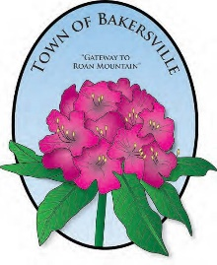
2021 CALENDAR OF EVENTS

NORTH CAROLINA RHODODENDRON FESTIVAL
FRIDAY & SATURDAY, JUNE 18-19

FOURTH OF JULY FIREWORKS
FRIDAY, JULY 2

TOWNWIDE YARDSALE
SATURDAY, JULY 3

NORTH CAROLINA MOUNTAINEER FESTIVAL
SATURDAY, SEPTEMBER 18

APPLE BUTTER FESTIVAL
SATURDAY, OCTOBER 9

HALLOWEEN SAFE CIRCLE
FRIDAY, OCT 29, 5PM-7PM

CHRISTMAS TREE LIGHTING
SATURDAY, NOVEMBER 27

CHRISTMAS PARADE
SATURDAY, DECEMBER 4

CHRISTMAS CONCERT
DATE TO BE DETERMINED

JOURNEY TO THE MANGER
DATE TO BE DETERMINED

