PRICE | Per Day | Extra Day | Weekly
CHAIRS
Brown Folding Plastic | 1.20 | .65 | 3.60
Brown Folding quantity over 150 discounted 15%
White Folding Plastic | 1.95 | .98 | 5.85
Grey Padded Banquet | 2.65 | 1.33 | 7.95
Grey Padded Arm | 2.00 | .95 | 5.70
Bistro (White Resin) | 2.10 | 1.00 | 6.30
Director | 4.75 | 2.38 | 14.25
Bar Stool (with back) | 4.75 | 2.38 | 14.25
Chair Covers |  |  | 2.50
TABLES
8’ x 30” Banquet | 7.35 | 3.67 | 22.05
8’ x 18” Lecture | 7.35 | 3.67 | 22.05
8’ quantity over 100 | 6.85 | 3.25 | 19.50
6’ x 30” Banquet | 6.90 | 3.45 | 20.70
6’ x 18” Lecture | 6.90 | 3.45 | 20.70
4’ x 30” Banquet | 5.80 | 2.90 | 17.40
4’ x 18” Lecture | 5.80 | 2.90 | 17.40
5’ Round – 60” | 8.55 | 4.27 | 25.65
4’ Round – 48” | 7.10 | 3.54 | 21.27
30” Round | 6.30 | 3.00 | 18.00
44” White Patio | 8.40 | 4.20 | 25.20
42” High Bar | 9.45 | 4.73 | 28.35
Bridge / Card | 5.25 | 2.63 | 15.75
TABLE LINEN
One time charge More sizes available upon request
Black Spandex Cover for 42” & 30” high tables |  |  |  | 8.00
90” x 90” |  |  |  | 7.00
54” x 120” (fits 6’ and 8’) |  |  |  | 8.00
108” Round |  |  |  | 11.50
120” Round |  |  |  | 12.50
18” x 18” Napkins |  |  |  | .48
TABLE PLASTIC
White Plastic has a Linen Finish One time charge
36” x 120” (fits 8’) |  |  | 5.60
36” x 96” (fits 6’) |  |  | 4.50
54” x 60” (fits Card) white or black |  |  | 4.50
54”x120” (fits 8’) white or black |  |  | 7.30
54”x96” (fits 6’) white or black |  |  | 6.20
68”x68” (fits 5’ round) white 7.85

PRICE | Per Day | Extra Day |  |  | Weekly
AUDIO VIDEO EQUIPMENT
Monitor / DVD combos
20” combo | 55.00 | 27.00 |  |  | 165.00
DVD Player | 25.00 | 12.50 |  |  | 75.00
20” Flatscreen Television | 50.00 | 25.00 |  |  | 150.00
27” Flatscreen Television 100.00 50.00 200.00
42” Flatscreen Television 225.00 112.50 450.00
17” Computer Monitor | 50.00 | 25.00 |  |  | 150.00
19” Computer Monitor | 75.00 | 37.50 |  |  | 225.00
27” Computer Monitor | 100.00 | 50.00 |  |  | 300.00
LCD Video Projector | 200.00 | 100.00 |  |  | 600.00
Overhead Projector | 30.00 | 15.00 |  |  | 90.00
Video Cart | 20.00 | 10.00 |  |  | 60.00
Video Screen (72” x 72”) | 30.00 | 15.00 |  |  | 90.00
P.A. Systems
Up to 50 people  (powered speaker, mic) | 120.00 | 60.00
From 50 to 100 people  (2 speakers, mic, stand,  mixer) | 150.00 | 75.00
Other AV equipment available upon request.
LECTERN / PODIUM
Metal Truss | 100.00 | 50.00 |  |  | 300.00
DRAPE, SKIRTING & CARPET
Per linear foot |  |  | 1-3 Days
Drape
12’ High (limited colours) |  |  |  | 5.00
10’ High (limited colours) |  |  |  | 4.00
8’ High |  |  |  | 2.50
5’ High (limited colours) |  |  |  | 2.25
3’ High |  |  |  | 1.75
Table Skirting
40” high |  |  |  | 2.00
28” high |  |  |  | 1.50
Carpet Runner (Red/Black) 4’ wide |  |  |  | 2.00

PRICE | 1-3 Days |  | Weekly
STAGING
16” high
4’ x 4’ – 16 units available |  | 30.00 | 90.00
Steps |  | 8.50 | 17.00
30” high (black carpeted top)
4’ x 4’ – 37 units available |  | 30.00 | 90.00
Steps |  | 17.50 | 35.00
Stage Skirting – per foot
16” |  | 1.25 | 2.50
28” |  | 1.50 | 3.00
TENTS
Delivery Extra (includes set-up) |  |  | Per Day
10’ x 10’ |  |  | 120.00
10’ x 20’ |  |  | 220.00
20’ x 20’ |  |  | 300.00
20’ x 30’ |  |  | 400.00
20’ x 40’ |  |  | 450.00
30’ x 30’ |  |  | 800.00
40’ x 40’ |  |  | 900.00
30’ x 60’ |  |  | 1300.00
40’ x 60’ |  |  | 1700.00
Perimeter Rope Lighting |  |  | 40.00
30’ Side Walls |  |  | 20.00
50% Deposit required for tent rentals upon booking
Tents bigger than 20’x30’ require a permit
PORTABLE DANCE FLOOR
Each unit is 1’ x 1’ Black Marble like finish
14’ x 14’ |  |  |  | 294.00
Per square foot per day up to 14’ x 14’ |  |  |  | 1.50
OUTDOOR USE MUST HAVE WOOD SUBFLOOR
STANCHION / SIGN
32” Chrome Trumpet base |  |  | Per Day  6.50
Rope - 6’ or 10’ (Burgundy Velour) |  |  | 6.50
Sign Stand (22” x 28”) |  |  | 12.00

PRICE | Per Day
DECORATING ACCESSORIES
Archway (White/Gold) | 45.00
Artificial Trees 4’ or 6’ | 14.00
Benches | 40.00
Bird Cage (White / Gold) | 45.00
Chair – Wing Back (Dusty Rose) | 50.00
Coat Rack 5’ (fits 25 coats) | 8.75
Coat Hangers | .05
Coat Tree | 5.00
Coffee & End Table set (Wood & Chrome) | 45.00
Mirror (48” x 12” floor/ silver easel style) | 8.00
Picket Fence (8’ section – White) | 16.00
Theme Props, Decorations & Costumes (call for quote)
PARTY ACCESSORIES
Popcorn Machine | 65.00
Popcorn & Bags (serves 10) | 2.65
Chafing Dish (Sterno $2.50 extra) | 12.00
Coffee Percolator (100 Cup capacity) | 12.00
Bar 18” x 48" (Grey Resin) | 45.00
Punch Bowl w/ 12 glasses | 8.00
FUN FAIR
Games | 20.00
Ball Toss, Ring Toss, Bean Bag Toss, Basketball, Darts, Golf, Tic Tack Toe
Booth (Colourful Drapery) | 30.00
MISCELLANEOUS
Draw Drum – Small | 20.00
Draw Drum – Large | 25.00
Easel | 12.00
Flipchart | 12.00
Garbage container ( 40 gallon) | 8.00
Scissors (32” Ceremonial) | 10.00
Couches Black leather/ Grey fabric sectionals | 85.00
Brown Patent Club Chairs 30” 45.00
Office Steno Chairs | 12.50
Executive Office Chairs | 25.00
4’ x 3’ Poster Panels (HP or VP) – 1-3 day | 16.50
6’ Pole with foot | 16.50

SHOW SERVICES
DRAPERY
Trade shows, booths, stages, dividers, open houses, etc. Call for quote
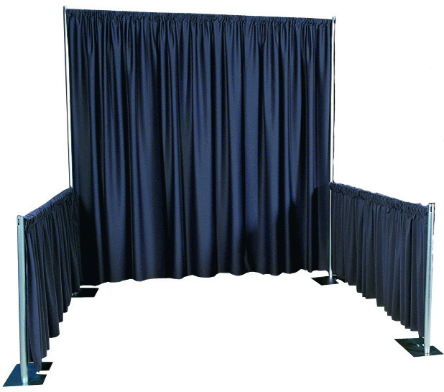
SKIRTED TABLES
All table sizes – 3 sides skirted & plastic tablecloth
42.00 per 1-3 days

CARPET
6’ wide aisle - 1.50 per running ft
Large area over 50’ x 20’ 0.50 sq ft
Booth carpeting – call for quote

DISPLAY SYSTEMS
Octanorm / Folding Stackable / Table Top
Custom Booth Design & Set-up
Call for quote
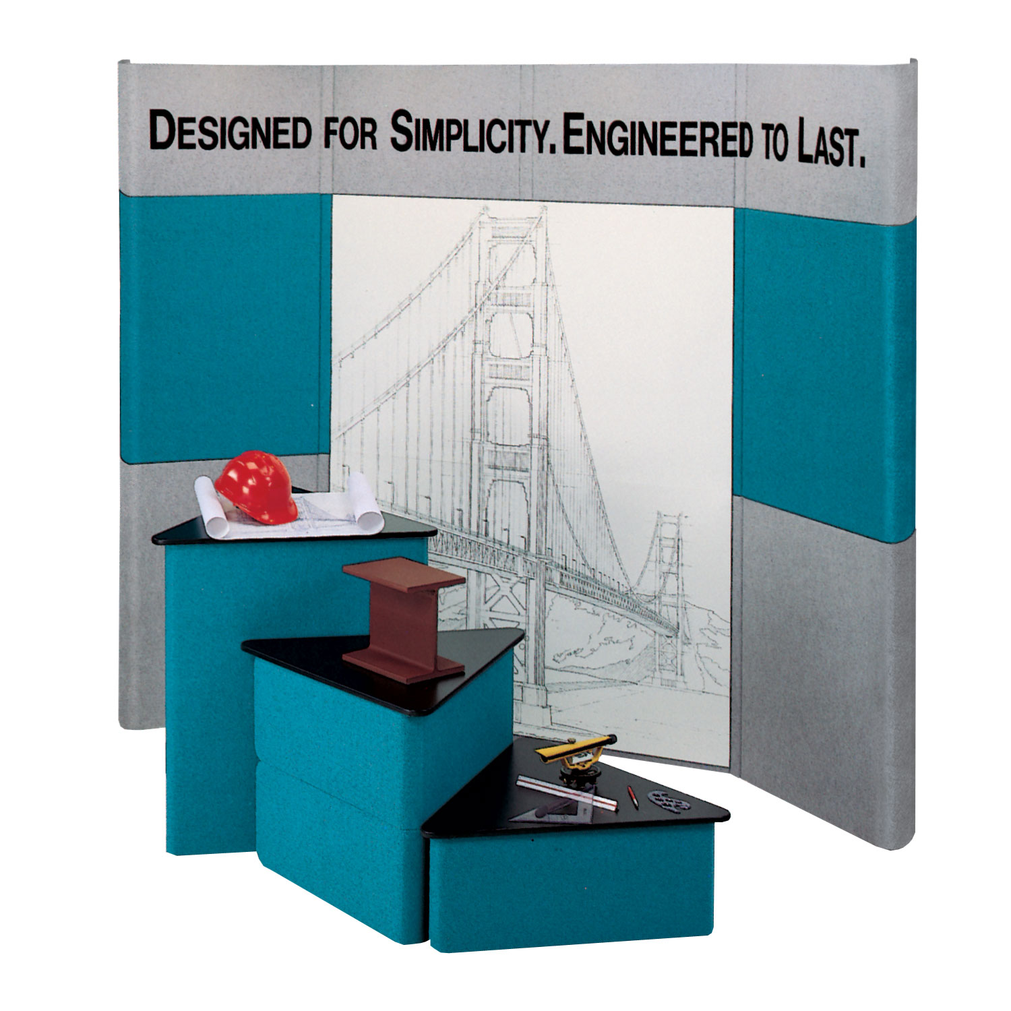
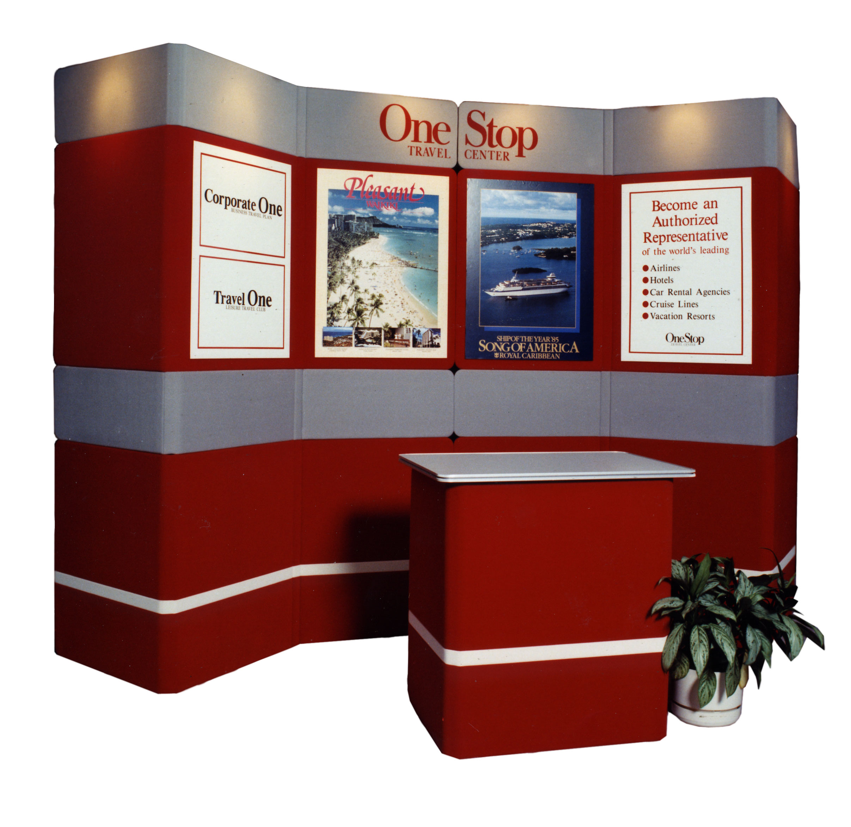
Prices subject to change without notice.
February 2016
Call or email for delivery rates

YOUR Special Event Professionals

Serving Customers for 42 years

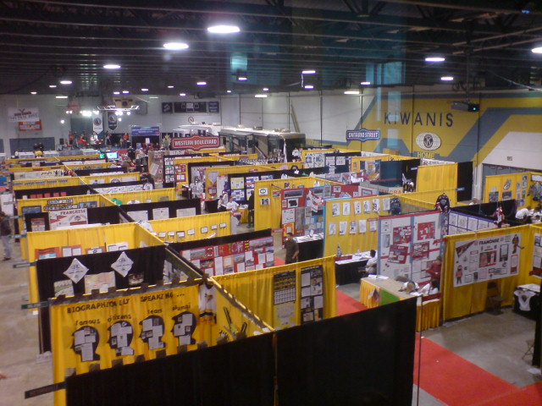

Corporate Events
Trade Shows
Displays
Tournaments
Weddings
Backyard / Indoor Parties
Fundraisers

95 Baffin Place, Waterloo, ON N2V 2C1
519-746-8955
800-563-4246
Fax
519-746-2188
info@hahnrentals.com
http://www.hahnrentals.com

