
2018
May 2018 bring you and your family good health, employment, compassion for others, time for the enjoyable things in life with family and friends and a sense of purpose. May you get to know your neighbors better and we hope you get involved in the Southwyck Community Association. The Southwyck Community Association board members.
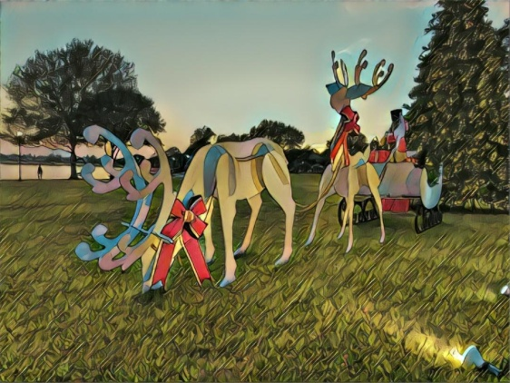
A WORD FROM THE 2017 PRESIDENT
Hello Fellow Homeowners:
So here we are in the Holiday Season once again. We had new decorations in the Southwyck Lake Park with Santa in his sleigh and reindeer ready to carry out their mission of delivering packages to all good boys and girls. We hope you were also able to get some pictures with your family or friends. We just had a great Movie Night in the Park event and we hope to be able to a have a number of other events coming in 2018.
Last year at this time we were still completing the South Manor and Lakecrest monuments. They are finished now and we also have completed the Southwyck Sunset Park monument. Both parks now have official addresses for 911 services and they have a name associated with them.
For 2018 we continue repairs and replacements of monuments and perimeter fences. It would be great to be able to fix everything at one time, but just as you cannot upgrade and/or repair everything in your house at one time, neither can we. Upkeep is always ongoing as we have amenities that are between 25 to 30 years old. We are also looking at the Lake Park Pavilion(s) as they are in need of repair or replacement and they could definitely be made more assessable to larger groups for different functions.
Hopefully you have noticed that the lake itself is showing signs of growth of vegetation which provides shelter for the small fish to grow. We stopped using harsh chemicals several years ago that killed all the vegetation. Not only does this help the environment, but it is also a cost savings for our association.
I am hoping to see you all again in person as we begin our re-election campaign and encourage all to attend our Annual Meeting January 4th.
I hope everyone has/had a Merry Christmas and a Happy New Year and beyond.
“Stronger Together”
John J Fisher - President 2017
Southwyck Community Association

SOUTHWYCK CAI – ANNUAL MEETING – RESULTS OF ELECTION
We will publish any new board members for Southwyck CAI under our website, www.SouthwyckTexas.com as soon as we can. The board members and the year their term comes up for election are always posted. At the February 1, 2018, board meeting, board members will vote on board positions. We will update our website once the positions have been determined.

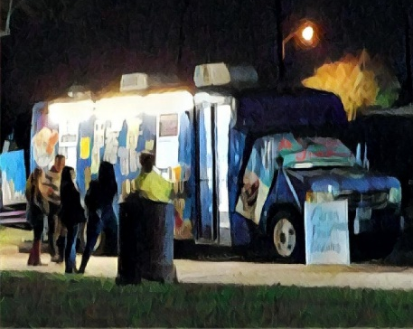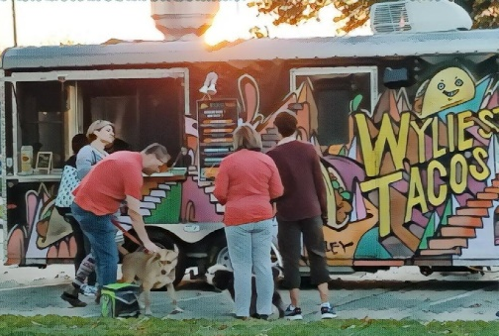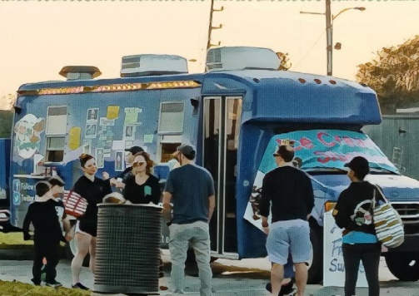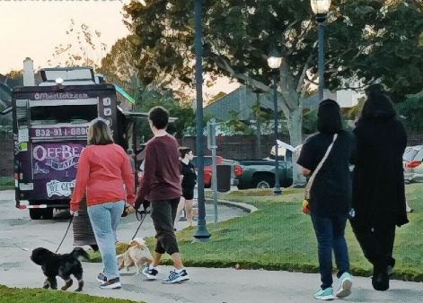
MOVIE IN THE PARK – OUR SOUTHWYCK LAKE PARK
What a wonderful evening for the event! The Southwyck Community Association decided to hold the event at our beautiful and large Southwyck Lake Park and to invite our neighboring associations as something fun to do with the entire community. We had families, teens and folks with well behaved pups attend the event at our Southwyck Lake Park. Kids played on the playground equipment before the event, folks took time to stroll around the park, friends met up, we had many donations to the Pearland Neighborhood Center donation site and lots of folks enjoyed the offerings from the 3 food trucks. The evening was the night before the supermoon and the moon was beautiful! Everyone seemed to have a fantastic time watching ‘The Game Plan’ on the large screen under the stars and catching up with each other.

DID YOU KNOW? …

that if you were unable to attend the annual meeting, the presentation will be uploaded to our website, www.SouthwyckTexas.com on the Records/Minutes/Presentations & Newsletter page.

INTERESTING PLACES TO VISIT IN AND AROUND PEARLAND
- Bat colony at Fite Road bridge - recommend parking at the Stella Roberts Recycle Center and walking across the street to the Edible Fruit Trail. From there, walk the path to the east and there is a picnic area where you can view the bats by looking north up the ditch to the bridge where the roost is located. Here is a recent article about the bats - http://www.chron.com/neighborhood/pearland/news/article/Watch-Pearland-bat-colony-emerges-for-nighttime-11304866.php
- Sri Meenakshi Temple - 17130 McLean Rd, Pearland, TX 77584 - there is an article in HoustonPress about the temple - http://www.houstonpress.com/news/texas-traveler-sri-meenakshi-temple-6733419
- Froberg’s Farm - 3601 W. Highway 6, Alvin, Texas – several times a year they have family-friendly events including a Corn Maze, Holiday Festival, a strawberry patch to name a few. Stop in and make sure you also purchase a fried pie. Depending on the season, some other homemade treats include frosted pecans, almonds, homemade pralines, pecan and peanut brittle, kettle popcorn, caramel popcorn and cinnamon popcorn. They also have homemade preserves and jellies and several kinds of pickled veggies. Greak’s Smokehouse is also located on the property with some of the best sausages around as well as homemade jerky, breakfast sausage, summer sausage, and boudin. - https://frobergsfarm.com
- Pear-Scape Art Sculpture Trail features twenty, painted pears placed throughout the City of Pearland. There are 10 locations to view the pained pears. For a map of locations and sponsors of the pears, go to http://visitpearland.com/pear-scape-locations/
- John Hargrove Environmental Complex with nature trail providing an extension of the Parks and Recreation Department Trail System. Located near the Stella Roberts Recycle Center, 5800 Magnolia Street. The complex boasts the state’s only municipal floating wetlands installation. This is a great place to do some bird watching. Pelicans, osprey, ducks, roseate spoonbill birds and more can be seen here. Fruit trees are planted along the trail as well. Citizens can pick the fruit and take it home. 1.6 miles of trail. Open dawn to dusk. A future Nature Center, called Delores Fenwick Nature Center, is currently being constructed. It is estimated that the constructions should be complete August 2018.
- Old Settler’s Cemetery – Located near Beltway 8 West off Telephone Road at the corner of Telephone Road (SH 35) and Halik Road. It is also a Texas Historical Marker. Six Civil War veterans are interred in the graveyard. Old Settler’s remained the primary community burial ground until 1936.
- Shadow Creek Ranch Nature Trail – 1801 Kingsley Drive, Pearland, Texas. Paved trails with educational signage explaining some of the local plant and animal life found in the park. There are pretty bodies of water where different birds, snakes and other animals can be observed on your walk. .91 miles of trail.
- King’s Biergarten – 1329 East Broadway, Pearland, Texas. Hans Sitter is the owner of this unique castle looking structure off Broadway on the east side of Pearland where the hostesses wear traditional dirndl style dresses at Oktoberfest. King’s holds an Oktoberfest event every year where you can enjoy lots of bier and brats, 15 different kinds of sausage to be exact, from traditional brats and Polish sausage to the exotic ones like rabbit and rattlesnake and even a vegan sausage. http://www.kingsbiergarten.com/
- Bayou Wildlife Zoo – 5050 FM 517 Road, Alvin, Texas – Open range animal zoo in Alvin where you can see and feed more than 500 different animals and birds from 60 different species from all over the world up close as they road freely across 80 acres natural habitat. The zoo also has endangered animals in their park.


HOUSE NUMBER
Please make sure your house number is visible from the street. In an emergency, you do not want the rescuers to waste precious time trying to figure out which is your house because of a hard to see number or there is no house number.


ALTERNATIVES TO BALLOON & SKY LANTERN RELEASES
While these types of releases have been done for birthdays, weddings and funerals, they impact our environment when they come down. Please be sensitive to our environment and consider these alternatives:

- Blow bubbles
- Butterfly release
- Dove release
- Planting a native tree, flower garden or butterfly garden in remembrance
- Ribbon dancers
- Kites & garden spinners
- Floating flowers
- Wildflower seed bombs
- Painted rocks
- DIY pinwheels, streamers and flags which kids could craft themselves and personalized for the occasion.
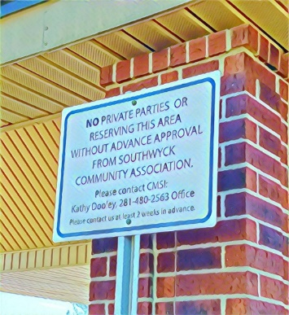
NEW SIGNS ADDED AROUND COVERED PAVILION AT SOUTHWYCK LAKE PARK
We hope you pay attention to the new signs if you wish to hold any kind of gathering at the Southwyck Lake Park. We have lots of folks using our park and we love that, but we also like to know how our parks are being used and what new equipment we should add AND we would like for your event to be as special and memorable as you hope it will be. We also have lots of projects taking place at the park so if you don’t want to have your party or gathering interrupted by sprinklers going off, large compost piles in the parking lot or us digging around during your event, you might want to plan and make sure you get permission to hold your event. We don’t currently charge anyone to reserve a spot. We simply ask that you remove your trash and leave the park looking as good as when you got there so that everyone coming to our park can enjoy it.
We do not allow political gatherings at our park. This is private land owned by the Southwyck Community Association.

ASK A PLUMBER 
John Johnson, owner - 713-885-1836 / http://www.bigjohnsplumbingllc.com

- What should every homeowner have in their plumber's box?
A plunger or a toilet auger
- What are 3-5 things you think every homeowner should know how to do or do yearly as preventative maintenance?
Change toilet flappers, flush water heater, winterize sprinkler backflow preventer,
clean aerators on faucets
- Where do you see the novice DYIer getting themselves into trouble with their own plumbing fixes?
Installation of faucets or trying to repair dripping faucets. Never fails something breaks. Trying
things they have never done and thought it's as easy as YouTube says it is. Mainly on Fridays is
our busiest DYI rescue day.
- What is the top 3-5 plumbing updates that help sell a house in your opinion?
Replacing molded caulk. Replacing water heater. New toilets (buyers love new toilets).

Replacing old kitchen sinks and kitchen faucet.

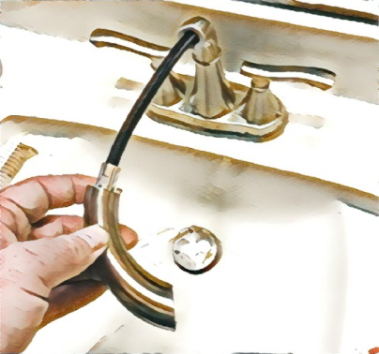

INTERESTING FACEBOOK PAGE TO FOLLOW
MOTHER DAUGHTER PROJECTS – ‘We’re homeowners sharing our DIY adventures as we learn to maintain, improve, decorate, and use tech in our homes.’ Besides their Facebook page, they also have a website: www.motherdaughterprojects.com and YouTube channel. The mother-daughter duo has a number of wonderful videos on how to use some power tools as well as simple projects to try. Scroll through their posts and I’ll bet you find something that interests you.
In a previous newsletter, we mentioned some things that you should know how to do. At the Mother Daughter Projects website there is a great video showing you how to turn off power, water, gas, etc. in a home emergency. The video is under 2-minutes and is a great review especially if you have never done any of these power shut offs - http://www.motherdaughterprojects.com/blog/a-homeowners-guide-to-emergencies.

WINTER HOME MAINTENANCE TO-DO LIST
- Kitchen Cabinets – Since you are probably stuck indoors more during the winter, you might want to take the opportunity to give your kitchen cabinets a good cleaning to remove any grease, grub and grime. You can use real orange oil polish to melt away grease, grime, polish and wax buildups and leave a fresh scent. You can also mix a 50/50 solution of vinegar and warm water in a spray bottle. Mist on cabinets, let sit for a few minutes or two and then wipe clean with a soft cloth. You can add a few drops of liquid dishwashing detergent to the vinegar and water solution to clean extremely grimy cabinets. Make sure you also clean the drawer pulls and door handles. Your cabinets will look so much better!
- Clean out the Closets – Toss out what you have not been using or give it away and reorganize your closets. Animal shelters always need old towels; Goodwill can use any clothes you no longer use or want, so making donations is an added bonus for the day. If you are cleaning out a kitchen pantry, check the expiration date of the food products…..you’ll be surprised what you have kept around for too long. Wipe down the shelves and clean the doors inside and out. Consider using baskets to help organize the contents. NOW you will be able to find what you are looking for in a short period of time instead of having stuff fall or spill out while you root around trying to find what you need.
- Bathroom Drains – There is NOTHING worse than a clogged or slow running drain. Use a drain stick to pull out any hair or other clogs. Follow this by pouring a little bleach down the drain, allow it to sit for 10-15 minutes and then flush it with water to kill any mold and mildew hanging in the pipe.
- Smoke and CO Alarms – Time to test them and replace any batteries. It’s also a good time to vacuum the devices or blowing out the dust with compressed air as well.
- Home Inventory – So you’ve got all these new, cool Christmas gifts! It might be time to compile a home inventory with any new purchases from the past year. Be sure to document it with photos, videos and receipts. All of this can be done on your cell phone and put in an email to yourself where you then move the email to a new folder you have created in your email application called ‘HOME INVENTORY’ or something. It’s available to you wherever you can get your email. You can bring it up again on your phone, laptop, tablet or PC whenever you need it by going to the folder you created and looking at the attached files of photos, videos and receipts. Remember hurricane season is just down the road….you never know when you will need this information.
We’ll leave this as a short list, so you have hopes of taking care of all of these….or at least a few. Remember, get the rest of the family involved so it goes faster and you have buy-in from the rest of the family so it stays nice….longer.

TEXAS POISONOUS SNAKES – THERE ARE ONLY 4 TO REMEMBER
We only have four poisonous snakes to remember and identify in Texas:
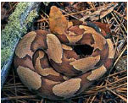 COPPERHEADS – bands of gray and/or brown with a copper-colored head. They are the most miss-identified snake in America and the most common snake in North America. They are considered a medium-sized snake and they grow to be between 2 to 3 feet long. Males have longer tails. Copperheads have brown or reddish-brown dorsal crossbands that are shaped like hourglasses, saddlebags or dumbbells. The tops of their heads have just 2 small dark dots and their bellies are either white, yellow or light brown. They have a triangular head that’s distinctive from its neck. They prefer living in the woods or forest areas and the thickets near streams and canyons, but they also can be found in rocky areas or desert oases. They are resilient and can even thrive in suburban areas. So, their habitat is very diverse. When agitated, they will vibrate their tails just like a rattlesnake. They emit a strong, nasty musk smell to send you running the other way.
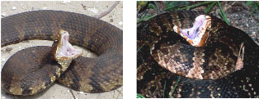 COTTONMOUTH or WATER MOCCASIN – rarely strays far from water, but does enjoy soaking up the sun on rocks and logs near the water’s edge. They do not climb trees. It can be found in marshes, swamps, ponds, lakes, ditches and canals. It will coil its body, raises its head and opens its mouth as wide as it can. The color of the skin inside the snake’s mouth is as white as cotton – hence the name Cottonmouth. A Water Moccasin may appear uniformly dark brown or black at first, but if you look closely, you can often distinguish light brown and yellowish bands encircling its heavily scaled body. The bands are somewhat similar to the markings on a rattlesnake. Cottonmouth/Water Moccasins have triangular heads and a neck that is much narrower than its triangular head and big body. These snakes usually grow to 2 to 3 feet long.

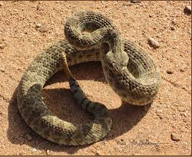 RATTLESNAKE – there are 9 kinds of rattlesnakes found in Texas. Rattlesnakes usually ‘rattle’ before striking, but if they are totally surprised, they may strike before rattling. They eat mice, rats and rabbits. These snakes can get 3 to 4 feet long and are typically colored with grey and brown diamond patterns down their back. Head is wider than its neck and somewhat triangular. These too have large bodies.

 CORAL SNAKE – red, yellow and black color bands that touch in that order. The coral snake has a small mouth and is usually not aggressive. Remember the phrase ‘if red touches yellow, you’re a dead fellow’ to help remember the difference. Coral snakes usually get to 2 feet long and they have small heads and short fangs. Coral snakes prefer wooded, marshy and loose-soiled areas and are often under debris. They also live in logs, tree stumps and rotting leaves. They eat other lizards and small snakes. Some also eat small mice and birds. They are very reclusive.
There are other similar colored snakes but their red and yellow do not touch. Milk snakes have red and black bands and are not poisonous. In the picture above, the left snake is a coral snake and the right is a milk snake and not poisonous but gets confused with the coral snake. Remember the rhyme, ‘if red touches yellow, you’re a dead fellow’.


PROJECT CALEB
On September 30th the Project Caleb group held Yoga in the Park Day at our Southwyck Lake Park in observance of Suicide Awareness month with a beginner’s yoga lesson, testimonials and closing activity. The event was attended by a number of folks from the community. Project Caleb aims to create youth-led organizations inside and outside of schools that promote kindness, love, support and hope; create forums for students to discuss their feelings anonymously or openly with young adults both online and in-person and to raise awareness of suicide and the aftermath of suicide. Project Caleb holds a number of events in our community to get their message out. If you are interested in more information, please take a look at their website: http://www.projectcaleb.org/ or their Facebook page: Project Caleb.
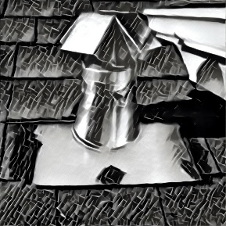
CLEAN YOUR DRYER VENT
Is it taking longer for your clothes to dry? Are your clothes and dryer extremely hot after you dry a load of laundry? Has debris appears around the outside dryer vent opening? Do you feel the excessive heat in the room where the dryer is operating? These are just a few signs that your dryer vent needs to be cleaned of dust, debris, lint and other things that can force your dryer to work extra hard and shorten it’s life and possibly yours if a fire takes place because of it. It is recommended that you clean your dryer vents once a year…<cough, cough…have you EVER cleaned it…>. Fires from clogged dryer vents is a #1 reason for house fires. Here is a video that shows you how to clean out the vent on your roof. It includes tools you will need and instructions on how to perform the task at hand. https://www.youtube.com/watch?v=XBS_v8kI8JU. There are vendors that you can call to take care of this task if you do not want to climb on your roof.
Pearland Air Duct Cleaning, www.pearlandairductcleaning.com – 832-680-1096.
Service Express, www.serviceexpress.com – 281-607-2725.
DID YOU KNOW? …

Assessments are due. Southwyck Community Association sends out invoices for assessments twice a year. The second ½ of your assessments is due January 1. We bill in arrears for all sections. Assessments should be made out to Southwyck Community Association, 2615 Bay Area Blvd., Houston, Texas 77058. If you have questions about your assessment amount, please contact Kathy Dooley, our manager at CMSI, 281-480-2563. Late fees will be assessed for all payments not received by February 1. Also, note that some sections may have increased their assessments.

DID YOU KNOW? …

Pearland has a farmer’s market. The Pearland farmer’s market is usually held the 2nd Saturday of the month. There are some exceptions from September-December. The market is open 8 AM-noon at Pearland Town Center, 11200 Broadway Street. You can find fresh produce, herbs, flowers, seedlings and baked goods to name a few.

PEARLAND EVENTS
For a list of annual events that take place in Pearland, check out the PEARLAND CONVENTION & VISITORS BUREAU - VISIT PEARLAND site at http://visitpearland.com/what-to-do-in-pearland/events-in-pearland. It is a great resource for locating what is happening in our city. We have Winterfest and TAAF (Texas Amateur Athletic Federation) Winter Games of Texas in January and Paws in the Park in March to look forward to this quarter.
You can also keep up with events that the City of Pearland offers by following the Pearland Parks and Recreation Facebook page or visit their website, https://www.pearlandtx.gov/departments/parks-recreation. They always have lots of good information to share for families to do.

NEW COLLECTION POLICY
Partial payments will not be accepted from property owners unless such owners have signed a written payment agreement with the Master Association.
Collection Schedule: The following collection schedule is to be used as a general guideline; however, the Board of Directors reserves the right to vary from this schedule as necessary.
Assessments to be collected semi-annually in arrears.

January 1 assessment: Delinquent February 1 (Collection Cost of $50.00 assessed)
Interest of 10% per annum begins to accrue February 1
Mail late notice in February
Mail certified letter in March
July 1 assessment: Delinquent August 1 (Collection Cost of $50.00 assessed)
Interest of 10% per annum begins to accrue August 1
Mail late notice in August
Mail certified letter in September

Once an account is delinquent for two consecutive payment cycles, the account will be turned over to the Association’s attorney for legal action.
Priority of Payments:
Payments received from property owners shall be applied in the following order:
- Delinquent Master Association assessments;
- Delinquent Section or Village Association assessments;
- Current Master Association assessments;
- Current Section or Village Association assessments;
- Attorney’s fees incurred by the Master Association associated solely with assessment collection;
- Collection costs incurred by the Master Association associated solely with assessment collection;
- Attorney’s fees incurred by the Village Association associated solely with deed restriction enforcement, provided the Master Association’s management company has been notified in writing of such fees at least thirty (30) days prior to the date a payment to be applied is received from the property owner;
- Any other amounts owed to the Master or Village Associations, including, but not limited to, interest and late fees, if any.
The complete document files with Brazoria County can be found at our website at http://www.southwycktexas.com/documents---forms.html under the Southwyck CAI – Master: heading.

DID YOU KNOW? …

that dumping into storm drains is not just wrong, it is illegal. That means no blowing grass clippings, motor oil or dumping your near empty pest control bottle down either to name a few. The water in our storm drain system does NOT get treated at a sewage treatment center. Any items in the storm drains get washed directly to our creeks, bayous and ultimately Galveston Bay.

YOUR 2017 BOARD OF DIRECTORS & MANAGEMENT COMPANY
SOUTHWYCK CAI – CURRENT BOARD OF DIRECTORS:
President ……………. John J. Fisher
Vice President ……. Helen Bilyeu
Treasurer …………… Vanessa Williams
Secretary …………… Tony Bowlin
Director …………….. Sangeeta Bakshi
MANAGEMENT AGENT:
Community Management Solutions, Inc. (CMSI)
2615 Bay Area Blvd.
Houston, Texas 77058
Kathy Dooley, kathy@CMSIsolutions.com
When contacting our management company, please let them know you are a Southwyck resident.
BOARD MEETINGS:
1st Thursday of the month @ 6:30 P.M.
Location:
Calvary Baptist Church
3302 County Road 89 – Pearland, Texas 77584
NEWSLETTER
Our newsletter is published quarterly – January, April, July and October. If you think you have something that we should include in our newsletter, please use the ‘Contact Information’ form on the ‘About Us’ page at http://SouthwyckTexas.com. We may include your article in our next newsletter.
Newsletter articles were provided by Helen Bilyeu and John Fisher.

