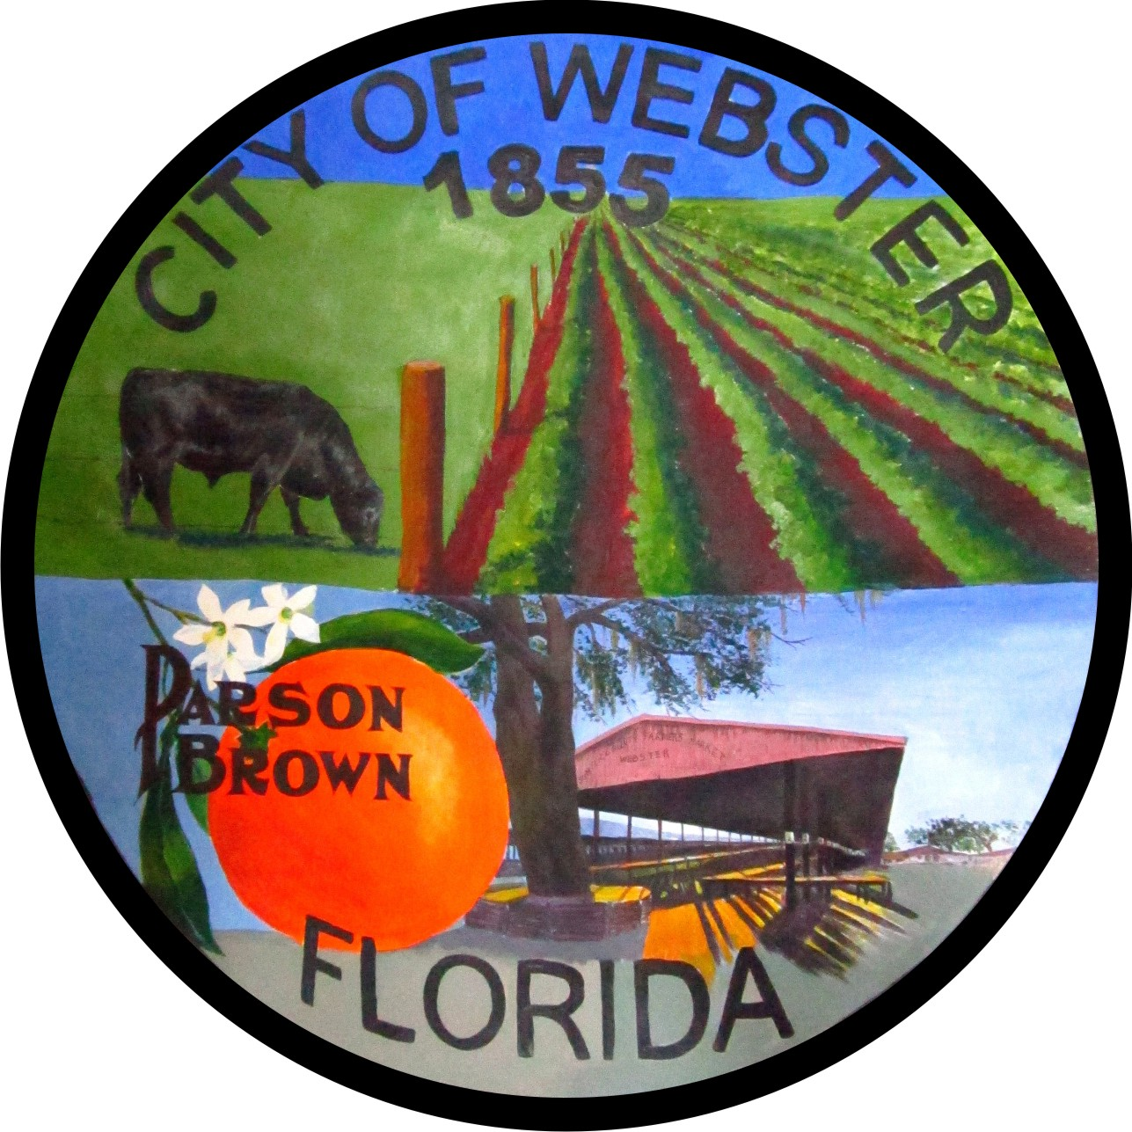

AGENDA
CITY OF WEBSTER
Regular Council Meeting
Webster City Hall, 85 E. Central Avenue
August 17, 2023 - 6:00 P.M.

I. CALL TO ORDER

Pledge of Allegiance, Invocation
Roll Call and Determination of Quorum

Note. All public comment will be limited to 3 minutes per speaker. Anyone wishing to speak during citizen’s forum or on an agenda item must fill out a speaker card and present it to the City Clerk prior to being recognized. All comments will be addressed after all speakers have spoken during citizen’s forum or on a particular agenda item.

II. APPROVAL OF MINUTES

Regular Council Meeting – July 20, 2023
M_______________S_______________ Roll Call Vote

III. CONSENT AGENDA

IV. CITIZENS FORUM

V. CORRESPONDENCE TO NOTE

Law Enforcement City Newsletter Report

VI. PUBLIC HEARINGS

Second Reading of Ordinance 2023-13 – Comp Plan Amendment-Parcel ID N25-016-Rudolfo Luisis
M_______________S_______________ Roll Call Vote to Read by Title Only

M_______________S_______________ Roll Call Vote for Approval

Second Reading of Ordinance 2023-14 – Rezoning- Parcel ID N25-016-Rudolfo Luisis
M_______________S_______________ Roll Call Vote to Read by Title Only

M_______________S_______________ Roll Call Vote for Approval

Second Reading of Ordinance 2023-15 – Comp Plan Amendment-Parcel ID Q19-086-South Sumter Self Storage, LLC
M_______________S_______________ Roll Call Vote to Read by Title Only

M_______________S_______________ Roll Call Vote for Approval

Second Reading of Ordinance 2023-16 - Rezoning-Parcel ID Q19-086-South Sumter Self Storage, LLC
M_______________S_______________ Roll Call Vote to Read by Title Only

M_______________S_______________ Roll Call Vote for Approval

First Reading of Ordinance 2023-17 –Comp Plan Amendment – Parcel ID Q19-060-Southern Properties Florida, LLC
M_______________S_______________ Roll Call Vote to Read by Title Only

M_______________S_______________ Roll Call Vote for Approval

First Reading of Ordinance 2023-18 –Rezoning – Parcel ID Q19-060-Southern Properties Florida, LLC
M_______________S_______________ Roll Call Vote to Read by Title Only

M_______________S_______________ Roll Call Vote for Approval

Second Reading of Ordinance 2023-19 –Annexation – Parcel ID N36E006-Anthony and Fely Palafox
M_______________S_______________ Roll Call Vote to Read by Title Only

M_______________S_______________ Roll Call Vote for Approval

Second Reading of Ordinance 2023-20 –Comp Plan Amendment – Parcel ID Q19-085-Florida 1 Holdings, LLC
M_______________S_______________ Roll Call Vote to Read by Title Only

M_______________S_______________ Roll Call Vote for Approval

Second Reading of Ordinance 2023-21 –Rezoning – Parcel ID Q19-085-Florida 1 Holdings, LLC M_______________S_______________ Roll Call Vote to Read by Title Only

M_______________S_______________ Roll Call Vote for Approval

VII. NEW BUSINESS

VIII. CITY ATTORNEY’S REPORT AND REQUESTS

IX. MAYOR’S AND COUNCIL MEMBER’S REPORTS AND REQUESTS

X. STAFF REPORTS

Sheriff’s Office Planning and Development Services City Manager

XI. ADJOURNMENT

M___________S_________-Roll Call Vote.

PLEASE NOTE IN ACCORDANCE WITH FLORIDA STATUTE 286.105, ANY PERSON WHO DESIRES TO APPEAL ANY DECISION AT THIS MEETING WILL NEED A RECORD OF THE PROCEEDINGS AND FOR THIS PURPOSE MAY NEED TO ENSURE THAT A VERBATIM RECORD OF THE PROCEEDINGS IS MADE WHICH INCLUDES THE TESTIMONY AND EVIDENCE UPON WHICH THE APPEAL IS BASED. ALSO, IN ACCORDANCE WITH FLORIDA STATUTE 286.26; PERSONS WITH DISABILITIES NEEDING ASSISTANCE TO PARTICIPATE IN ANY OF THE PROCEEDINGS SHOULD CONTACT THE OFFICE OF THE CITY CLERK; 85 E. CENTRAL AVENUE; WEBSTER, FLORIDA; (352) 793-2073; 48 HOURS IN ADVANCE.

