Metro Detroit, St. Clair Shores
Published March 6, 2015

Museum to host program on WWII paratrooper training

By Brian Louwers brianlouwers@candgnews.com Home
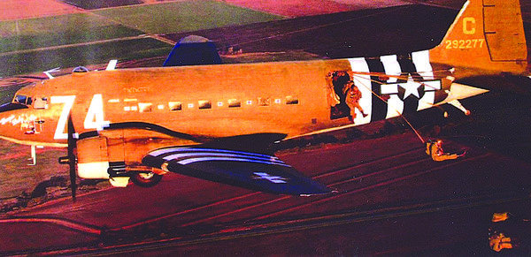
Detroit Arsenal of Democracy Museum Director John Lind jumped from the vintage C-47 “Boogie Baby” in January at the World War II Airborne Demonstration Team’s jump school in Frederick, Oklahoma. (Photo provided)
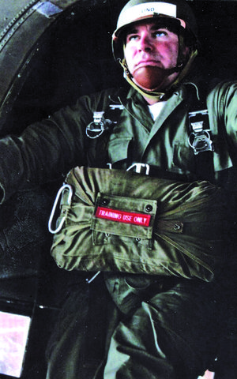
Lind, who underwent airborne training in the Marine Corps, said jumping from the vintage aircraft was a “spiritual experience.” The Detroit Arsenal of Democracy Museum will host a pre-ground school program April 11 for anyone interested in learning more about the jump school. (Photo provided)
METRO DETROIT — Do you have what it takes to be a World War II paratrooper?
Wait, back up. Let’s not even get into the fighting they encountered. That’s a separate issue, one you’re certainly not prepared for. The same goes for their basic training. Suffice it to say it was grueling, agonizing and spread over weeks. It wasn’t for the faint of heart, mind, body or spirit.
Let’s talk about walking up to the open door of a vintage C-47 military transport, part of a string of 10 jumpers, going 125 mph 1,500 feet over the drop zone when a blast of wind hits you in the face. Would you jump? And even if you did, would you know what to do if your parachute didn’t open?
There’s only one way to find out. Interested, serious participants only are invited to sign up for a one-day pre-ground school class April 11 at the Detroit Arsenal of Democracy Museum in St. Clair Shores. During the museum’s four-hour session, program participants will learn about the history of the airborne forces and will be instructed in various parachuting techniques.
“You’ll learn how to do a parachute landing/fall and safety procedures,” said John Lind, the museum’s director. “You’re going to have harness training and learn how to wear a chute.”
Lind, who attended the World War II Airborne Demonstration Team jump school in Frederick, Oklahoma in January, said the pre-ground school program at the museum would give those interested in attending the full jump school an edge even before they consider signing up for nine days of intense training.
He said the jump school in Oklahoma is the real deal; for those serious about learning the art of parachuting in a disciplined, military-style setting.
“This isn’t reenacting. This isn’t a fantasy camp. This is learning how to be a real parachutist,” Lind said. A veteran of the, U.S. Navy, Air Force and Marine Corps, where he first took military jump training, Lind said attending the full jump school class in Oklahoma was the experience of a lifetime.
“It’s a spiritual awakening,” Lind said. “Once you achieve your wings, you are born of the air.” But not everyone who signs up makes it through.
Dan Cutting, the executive officer of the World War II Airborne Demonstration Team, said the full jump school program is not for everyone.
Two sessions are held each year. Students who successfully complete the challenging, physically demanding course and make five military-style jumps successfully “earn their wings.” By doing that, they also become members of the World War II Airborne Demonstration Team.
The team is the only organization of its kind in the world. It was founded in 1996 by Richard Wolf, a former U.S. Army Special Forces soldier who sought to pass along the values of honor and courage to future generations while, at the same time, recognize those who fought in World War II.
The four-hour pre-ground school program at the Detroit Arsenal of Democracy Museum will be held at 10 a.m. April 11. The cost for the program is $20 per person and space is limited to 20 people. Registration is open to patrons 16 and older.
The museum is located at 22960 West Industrial Drive in St. Clair Shores. To register or for more information call (586) 604-5393.

