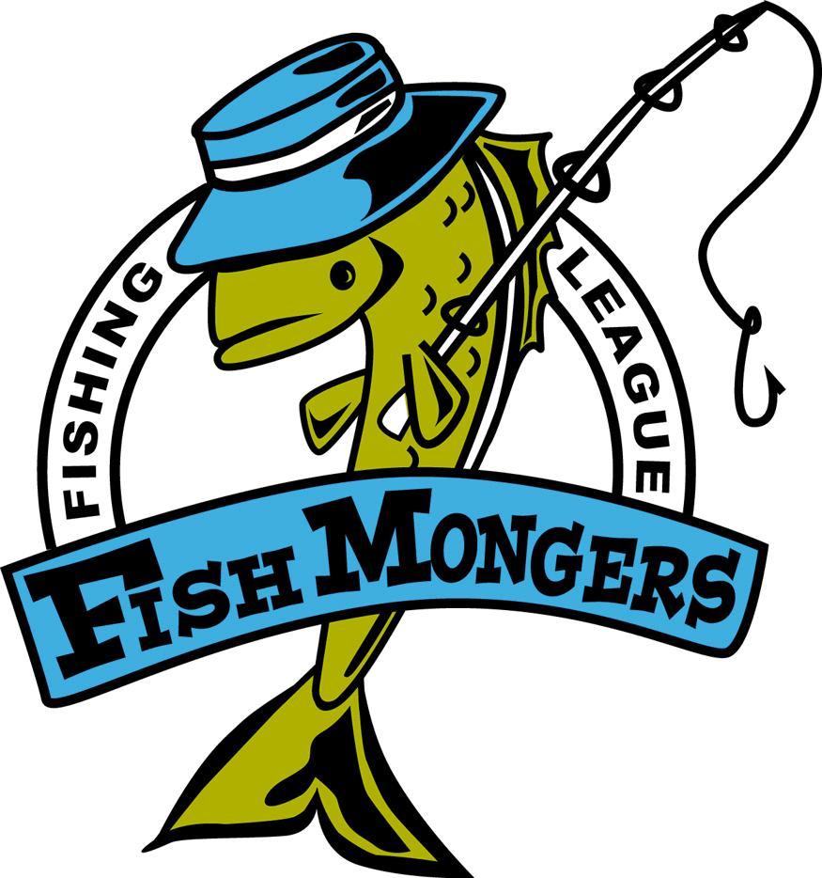
Gull 9/11/2015
Team | Skunk | Walleye  Andy 22.75 Gull | Northern  Paul 30 Pelican | Black Bass  Jeff/John Sibley 20.75 | Rock Bass  Chuck N Long 11.5 | Weekly Points  Richard 20 Round | Total Points
Chuck /  Dave |  |  | 25.5,22 | 16 |  | 8 | 63
Dan / Paul |  |  | 2 | 15,14 | 10.25 | 5 | 60
Andy/Raguse |  |  |  | 13 |  | 2 | 58
Kevin/ Richard |  |  |  | 15.5,14.5 |  | 4 | 50
Travis/JT |  |  |  |  |  | 0 | 42
Ryan /Chris | NS |  |  |  |  | 0 | 42
Jeff/John |  |  | 26 |  |  | 4 | 25
Jim/Mike | NS |  | 0 |  |  | 0 | 18

