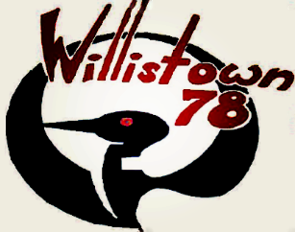

Willistown Troop 78

Media Consent Form

The Troop's web presence represents our troop to a potentially large audience.
The Troop web presence serves two purposes:
- to disseminate information to the Troop family
- as a means to promote the Troop to the community and to potential recruits.
Please note: events such as awards ceremonies, Chester County Council events, public events at Camp Horseshoe or similar events which have newsworthy aspects and are open to the public and are not intended to be covered by this consent form. These public events may be subject to media coverage by third parties and/or scout parents and material may appear on a third party’s web site or on social networking sites outside the Troop’s control.

**************

I give Willistown Troop 78 permission to publish photographs, video and/or audio and/or work product of my child for informational or publicity purposes. I understand that these photos, other media, and work product may include my child’s first and last name. Scout work may include text, (such as articles the scout has written for the Troop website or Newsletter), art work, voice, video, or other form of media. The scout’s photos, other media and work product may appear in paper publications, electronic publications and web pages including the Troop website and Facebook page.

YES

NO

I agree to have my son’s email address added to the Troop email list. This will allow my son to receive informational emails from the Troop, and from my son’s youth and adult leaders.

_______ YES

_______ NO

______________________________________________
My son’s email address

Scout's Name (Please Print) Date

Parent/Guardian Signature Date

Parent/Guardian email Address

If you have more than one child in the Troop, please fill out a permission slip for each.

