6/28/2017 The War Bow

The Rainbow, Symbol of Peace

After destroying nearly all life on earth in Noah's day with the waters of a flood, YaHuWaH Elohim placed a rainbow in the sky as a sign the He would not destroy the earth again by water.

The sign from YaHuWaH Elohim was an upward arching rainbow. When a war was over a military archer would hang his bow on the wall in similar fashion with the arch upward. The upward arch of the bow was a sign of peace.

LGBT groups have taken the rainbow, the sign of peace given by YaHuWaH Elohim, to use as the sign for the global society of sexual perverts.

There's a lesson to be learned from Daniel chapter 5. The lesson is not to take something that YaHuWaH Elohim has reserved for His own purpose and use it for one's own perverted purposes. Doing such a thing can bring Divine judgment.

Offspring of Devils

The ancient Olympic Games honored the Grecian gods. In 1896 the modern Olympic Games were restarted in Athens, Greece, with ceremonies through the years that have continued to memorialize the ancient mighty ones.

Genesis 6:3 tells us that 120 years were allotted to the Nephilim (Giants) in Noah's day, for they were also flesh, as mankind was.

The time allotted to the modern Olympic Nephilim expired 4/2016, 120 years from 4/1896. The Rio Olympics in 2016 began on 8/5/2016.

Remembering back to Noah's flood and the upward arched rainbow "hung" in peace in the sky, we note that on the opening day of the Rio Olympic Games a curious rainbow appeared in the sky near Washington, D.C.

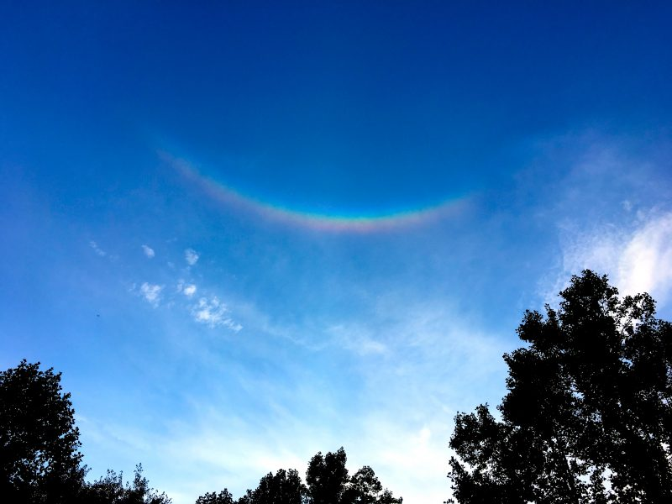
Photo courtesy Patricia Chambers, Potomac, MD.

Above: The War Bow in the sky near Washington, D.C. on 8/5/2016, the opening day of the Olympic Games in Rio de Janeiro. Although probably unaware of its meaning, this is the rainbow that the LGBT community definitely does not want to see, as it signals the death of their global society.

The message from YaHuWaH Elohim in the photo above is clear. The 120 years allotted to the modern offspring of devils are ended. The bow in the sky is no longer hanging in peace. It is inverted. War is imminent.

Sesame Street and the LGBT Agenda

The month of June is Gay Pride month each year.

As mentioned in a previous article, on 6/23/2017 a public countdown clock for the total annihilation of the State of Israel was inaugurated in Tehran, Iran.

Also on 6/23/2017, the graphic below was released by the popular children's TV program Sesame Street in support of the LGBT agenda.

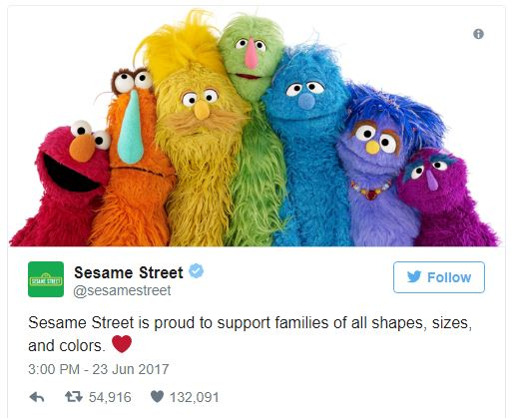

Above: The rainbow arrangement of Sesame Street characters showing support for the LGBT agenda.

Link for above information: https://prophecyinthenews.com/world_news/sesame-street-celebrates-lgbt-during-gay-pride-month/

Jude 1:6 And the angels which kept not their first estate, but left their own habitation, he hath reserved in everlasting chains under darkness unto the judgment of the great day.
7 Even as Sodom and Gomorrha, and the cities about them in like manner, giving themselves over to fornication, and going after strange flesh, are set forth for an example, suffering the vengeance of eternal fire.
8 Likewise also these filthy dreamers defile the flesh, despise dominion, and speak evil of dignities.

Lot, the Righteous Judge

In ancient times, the elders of the land would sit in the city gate to judge disputes among the inhabitants of the city.

Genesis 19:1 And there came two angels to Sodom at even; and Lot sat in the gate of Sodom: and Lot seeing them rose up to meet them; and he bowed himself with his face toward the ground;

Genesis 19:5 And they called unto Lot, and said unto him, Where are the men which came in to thee this night? bring them out unto us, that we may know them.
6 And Lot went out at the door unto them, and shut the door after him,
7 And said, I pray you, brethren, do not so wickedly.
8 Behold now, I have two daughters which have not known man; let me, I pray you, bring them out unto you, and do ye to them as is good in your eyes: only unto these men do nothing; for therefore came they under the shadow of my roof.
9 And they said, Stand back. And they said again, This one fellow came in to sojourn, and he will needs be a judge: now will we deal worse with thee, than with them. And they pressed sore upon the man, even Lot, and came near to break the door.

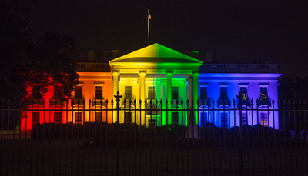

Above: The White House on 6/26/2015 when the unrighteous judges of the U.S. Supreme Court ruled in favor of homosexual marriage.

Luke 17:26 And as it was in the days of Noah, so shall it be also in the days of the Son of man.
27 They did eat, they drank, they married wives, they were given in marriage, until the day that Noah entered into the ark, and the flood came, and destroyed them all.
28 Likewise also as it was in the days of Lot; they did eat, they drank, they bought, they sold, they planted, they builded;
29 But the same day that Lot went out of Sodom it rained fire and brimstone from heaven, and destroyed them all.
30 Even thus shall it be in the day when the Son of man is revealed.

The definition of tribulation is "pressure". There's a lot of social pressure to accept Sodomy as normal socially acceptable behavior. Four years ago the Gay Pride parade in a small city nearby was attended by about 500 people. Because of continuing social pressure it was attended by 2,500 people this year.

Those who agree with YaHuWaH Elohim and consider homosexual behavior among humans as abominable are labeled as deviates from society and worthy of being attacked. Such was the position of Lot in Sodom.

John 15:18 If the world hate you, ye know that it hated Me before it hated you.
19 If ye were of the world, the world would love his own: but because ye are not of the world, but I have chosen you out of the world, therefore the world hateth you.
20 Remember the word that I said unto you, The servant is not greater than his lord. If they have persecuted Me, they will also persecute you; if they have kept My saying, they will keep yours also.
21 But all these things will they do unto you for My Name’s sake, because they know not Him that sent Me.
22 If I had not come and spoken unto them, they had not had sin: but now they have no cloke for their sin.

