Please submit completed form to:
info@rivercrestmarina.us

Credit card required with reservation
BOAT RENTAL AGREEMENT AND WAIVER OF LIABILITY
THE PARTIES TO THIS AGREEMENT ARE the Owner and the Renter
OWNER: Rivercrest Marina, 1211 Hatteras Way, Madison, IN 47250
Telephone: 812.273.9080
Dockmaster: “Shorty”
RENTER:
Name:
Address:
Telephone: (Home) (Cell)
Email:
Birthdate (Must be 21 years of age):
Driver’s License: Number State
Number of persons on boat (Maximum Capacity 10):
The above stated addresses are the parties’ physical addresses at which legal proceedings may be instituted.
RENTAL PERIOD: Owner agrees to rent the below-described boat and motor to the Renter for the following period*:
The boat must be returned with full gas tank by Renter prior to ending time or a premium gas and refill charge will incur.
The boat will be free of garbage and debris and in the same condition as it is when given to the Renter, except normal wear and tear.
Starting Date: Time: a.m. or p.m.
Ending Date: Time: a.m. or p.m.

RENTAL RATE: For the Rental Period outlined above, Renter agrees to pay the Owner the following amount:
Authorized Marina Agent

EXTENDED RENTAL: To extend rental time, a call to Marina is required. If Renter returns the boat to the physical address listed above after the above stated ending date/time, there will be an extended rental fee of $55 per hour.
WEATHER CANCELLATION: The Owner can cancel this agreement due to inclement or impending bad weather. Rental fees will be prorated.
* The Owner’s ability to provide the rental boat is contingent upon and subject to the return of the boat by a previous Renter or any other cause beyond Owner’s control.
Renter’s Initials
(Boat Rental Agreement Continued, Page 2)
ADVANCE RENTAL DEPOSIT: Full credit card payment is required in advance for boat reservation. Cancellation of advance reservation must be made 7 days prior to rental date for full refund.
Date deposit made is:
DAY OF USE SECURITY DEPOSIT: The Renter agrees to make a security deposit of $300 with the Owner, said deposit to be used in the event of loss or damage to the boat, equipment, or motor during the term of this Boat Rental Agreement, to defray fully or partially the cost of necessary repairs or replacement. In the absence of damage or loss, said deposit will be refunded.

CONDITION OF BOAT AND MOTOR:
The Owner states that to the best of his knowledge and belief that above-described boat and motor is in sound and safe condition and free of any known defects or faults which would affect its safe and reliable operation under normal use. The Owner further states that all required lifesaving and safety equipment are aboard the boat and in good order and condition at the time of delivery to the Renter for this boat rental agreement.
The Renter admits to having inspected the boat and lifesaving and safety equipment on board the boat to his satisfaction and agrees that they are in compliance with the regulations pertaining to his intended use of the boat.
If there is a breakdown, malfunction, or any other defect discovered after the Renter leaves the dock, the Renter will immediately notify the Owner.
QUALIFICATIONS:
The Renter states that he is physically and legally qualified to operate the above-described boat.
INSURANCE/LIABILITY:
The Renter agrees that he shall be held fully responsible for any and all loss of or damage to the boat or equipment or motor during the term of this Boat Rental Agreement whether caused by collision, fire, flood, vandalism, theft, or any other cause, except that which shall be determined to be caused by a fault or defect of the boat or equipment or motor.
The Owner shall retain any portion (or all) of Renter’s security deposit as necessary to cover repairs for such damages. To the extent that damages to the boat exceed the amount of the security deposit, Renter will pay Owner the full amount of damages caused by Renter during the rental period, including reasonable attorney’s fees.

COMPLETED BY MARINA:
RENTAL BOAT:
2017 Sweetwater Pontoon 90 hp Mercruiser motor
22-foot length Passenger capacity: 10
The boat being rented as part of this agreement is the boat identified with “X” below:
Color: Black Color: Navy
Boat registration # Boat registration #
Motor ID # Motor ID #
Odometer/Hours Reading at the beginning of Rental Period
LIFESAVING AND SAFETY EQUIPMENT WILL BE FURNISHED AND IS TO REMAIN ON BOAT AS FOLLOWS:
Life jackets Fire extinguisher Whistle
Throw cushion Paddle Anchor
Phone Number on Console
Renter’s Initials
(Boat Rental Agreement Continued, Page 3)
RULES & REGULATIONS:
- The boat cannot be taken through the locks.
- The boat shall not be used to carry passengers, goods, or materials in excess of the rated passenger/weight carrying capacity of the boat as stipulated.
- The boat shall not be used to push, propel, or tow another boat, barge or any other thing without the written permission of the Owner.
- The boat shall not be used to carry passengers or property for hire.
- The boat shall not be used for any race or in any competition.
- The boat shall not be used for any illegal purpose.
- The Renter shall not operate the boat or motor in a negligent manner.
- The boat shall not be operated by any other person other than the Renter stipulated above without the written permission of the Owner.
- The Renter shall not remove the motor from the boat for any use whatsoever.
- The Renter is responsible for the safety of any and all passengers in the boat.
- Grills are not permitted to be used on the boat.
- All children under the age of 13 MUST wear a life jacket at all times while in the boat.
- Smoking is not permitted while in boat.
- Renter must not operate boat under the influence of alcohol, drugs, or mind altering substances.
- Pets are not permitted in the boat.

Signature, OWNER or Dockmaster representing the Owner DATE

Signature, RENTER DATE
RENTER MUST ALSO READ AND SIGN THE DOCUMENT ON THE NEXT PAGE ENTITLED,
“WAIVER OF LIABILITY, ASSUMPTION OF RISK AND INDEMNITY AGREEMENT”

WAIVER OF LIABILITY, ASSUMPTION OF RISK & INDEMNITY AGREEMENT
I, , Renter, agree that in consideration of being permitted to use property owned by Rivercrest Marina, Owner, located at 1211 Hatteras Way, Madison, IN 47250, I do hereby release, waive, discharge and covenant not to sue Owner, its members, officers, employees, and agents from liability from any and all claims, including the negligence of Owner, resulting in personal injury, accidents or illnesses, including death, and property loss arising from the use of said property. This Waiver applies to all renters, operators, passengers, and users of said property. I am personally liable for any damages to other operators, passengers, or visitors even if such damages arise out of the negligence or fault of Owner.
Assumption and Acknowledgement of Risks: I acknowledge that there are risks associated with the use of said property. Use and control of the property, by its very nature, carries with it certain inherent risks that cannot be eliminated regardless of the care taken to avoid injuries. The specific risks vary from one activity to another, from one location to another, from one individual to another, but the risks of using said property can range from minor injuries to major and catastrophic injuries including paralysis and death.
I understand and agree that it is my responsibility to assess the hazards presented by my use of the property and further agree that I am the ultimate judge as to whether I can handle the piece of property without risk of harm to myself and others. I agree that I am renting, operating, and using the property provided by Owner at my own risk. I agree that I am voluntarily participating in all activities related to the rental, operation, or use of the rental property. I accept full responsibility for the risks of personal injury, accidents or illness and any resultant expenses from the risks and assume all risk, injury, illness, damage, or loss that might result, regardless of the cause, even if the risks arise out of the negligence or fault of Owner.
Indemnification and Hold Harmless: I agree to defend, indemnify, and hold harmless the Owner, its members, officers, employees, and agents, from and against any and all claims and demands, actions or causes of actions, for costs, attorney’s fees, expenses or damages to personal property, or personal injury or death which may result from any and all activities related to the rental, operation or use of the said property.
Severability: The undersigned further expressly agrees that the foregoing waiver and assumption/acknowledgement of risks is intended to be as broad and inclusive as is permitted by the law of the State of Indiana and that if any portion thereof is held invalid, it is agreed that the balance shall, notwithstanding, continue in full legal force and effect.
Acknowledgment of Understanding: I have read this waiver of liability, assumption of risk, and indemnity agreement, fully understand its terms, and understand that I am giving up substantial rights, including my right to sue the Owner, its members, officers, employees, and agents. I also understand that this agreement binds my heirs, executors, personal representatives, attorneys-of-law, attorneys-in-fact, administrators, and assigns, as well as myself. I acknowledge that I am signing the agreement freely and voluntarily and intend by my signature to be a complete and unconditional release of all liability to the greatest extent allowed by law. I hereby assert that my use of said property is voluntary and that I knowingly assume full responsibility for the risks of personal injury, accidents, illness or death and any resultant expenses from the foregoing risks, regardless of the cause, even if the risks arise out of the negligence or fault of Owner.

RENTER SIGNATURE DATE

BOAT RENTAL CHECKLIST

Renter Name Rental Period

Rented Boat Description

Marina Attendant
Circle missing items upon return: # LIFE JACKETS THROW CUSHION FIRE EXT
PADDLE WHISTLE ANCHOR

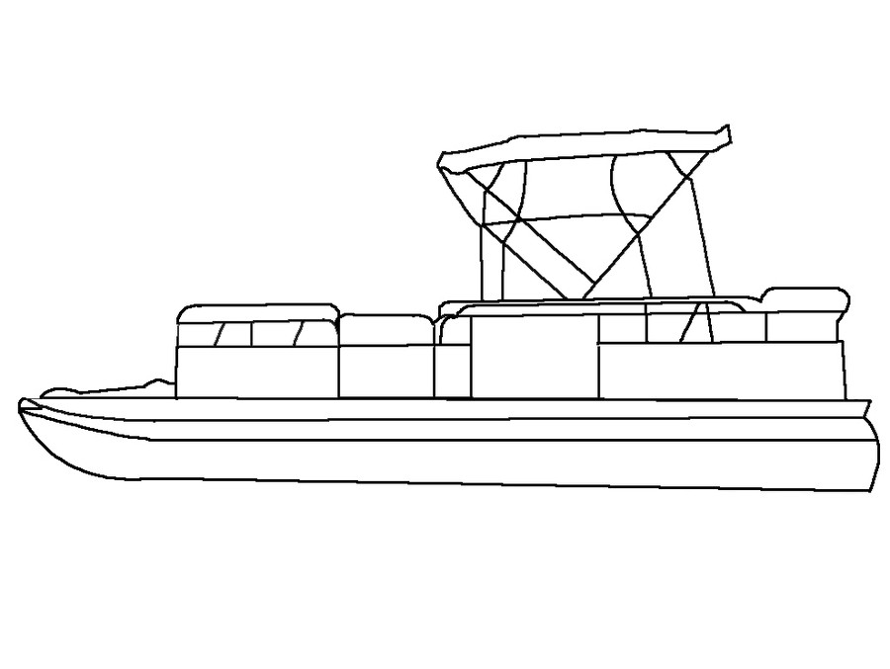
Please place an X on any area where boat damage exists prior to rental departure. Comments may be added below.

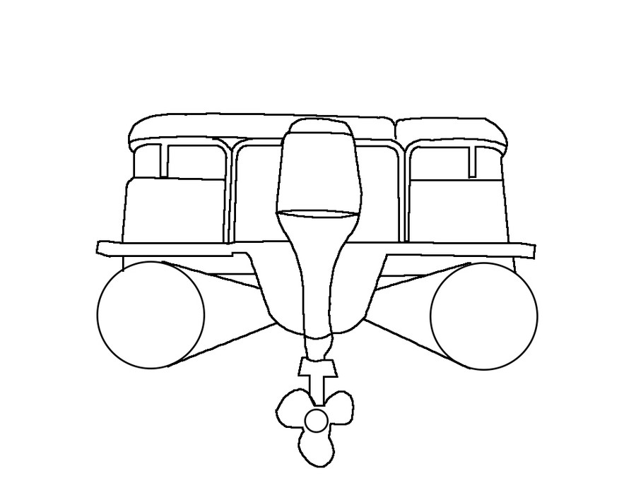
Left Side of Boat
Right Side of Boat

Acceptance / Signature of Renter Date

COMMENTS:

