3/27/2016 30 AD Calendars

I've compiled some Roman - Hebrew calendars combination to indicate the possible Passover dates from 27 AD to 33 AD. These take into account the sighting of the new moon from Jerusalem as was the practice 2000 years ago.

The Roman calendar dates on the calendars below were obtained from the astronomy program Cybersky 4, with verification from timeanddate.com. Both Cybersky and timeanddate.com take into account the missing 10 days that were skipped when the Roman calendar was adjusted in 1582 AD.

The TimeandDate.com calendars can be viewed here: http://www.timeanddate.com/calendar/monthly.html?year=30&month=4&country=34

If you visit the timeanddate.com website you will see that the Hebrew dates on my calendars will sometimes be 1 day off from theirs. I used the Cybersky program to see the actual sunset and moonset times from Jerusalem 2000 years ago to help calculate the 1st Aviv dates.

The first sliver of the new moon is generally unable to be seen if moonset is less that 40 minutes after sunset in Jerusalem. This one day difference between some of timeanddate.com's calendars and the "Karaite" visual observation method used to calculate the first day of the month wasn't really a problem. The Passover date was so far removed from the weekly Sabbath in most years as to be of no consequence.

Here are the calendars:

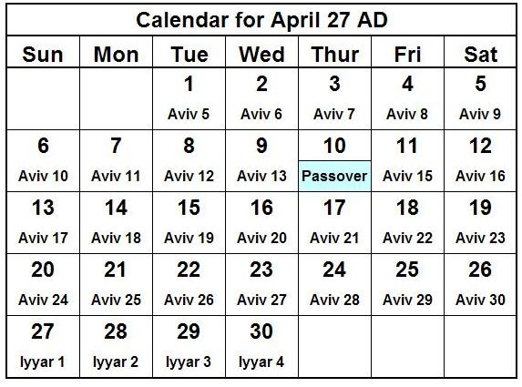
According to Luke 3:23 Messiah YAHUSHUA entered His ministry at about 30 years of age.

Because of the birth year of the Messiah probably being around 3 or 4 BC, 27 AD, above, is considered too early a year for the crucifixion after Him spending 1 to 3 years in ministry.

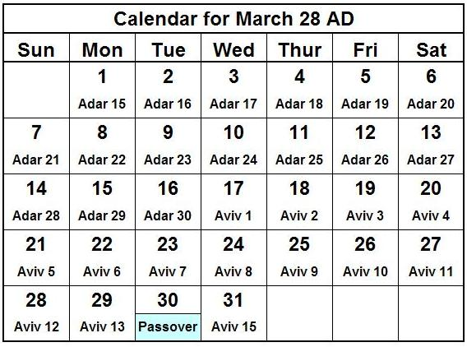

Above, in 28 AD the crucifixion would have been on a Tuesday, too early in the week for a Saturday - Sunday resurrection with 3 days and 3 nights in the grave. The calendar from timeanddate.com indicates that Monday was Passover in 28 AD. The astronomy program indicates Tuesday as Passover according to probable visual sighting of the new moon two weeks earlier.

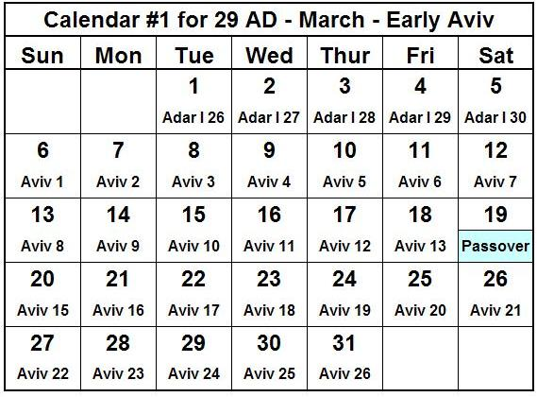

Above, the Passover in 29 AD with possible early aviv barley sighting is on a Sabbath. The Timeanddate.com calendar indicates this is an Adar II month, and that Passover is next month.

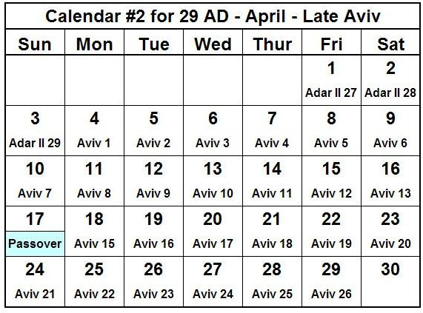

Above is calendar #2 for 29 AD with the Adar Bet included. The Passover is on a Sunday, and will not fit the 3 day in the tomb requirement.

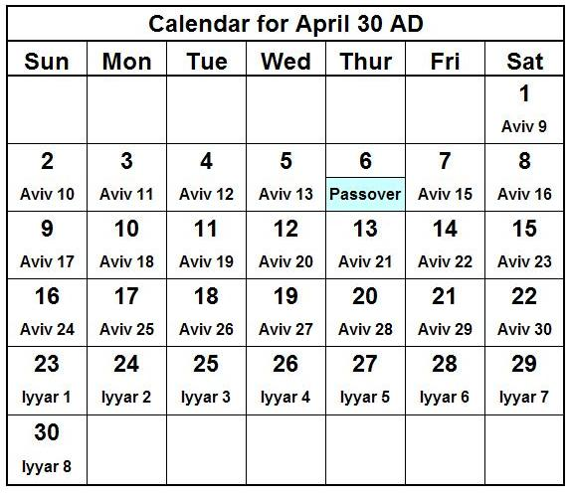

The Karaite reckoning shown above is one day off from the timeanddate.com calendar. 30 AD fits the 3 days and 3 nights in the tomb requirement according to scripture.

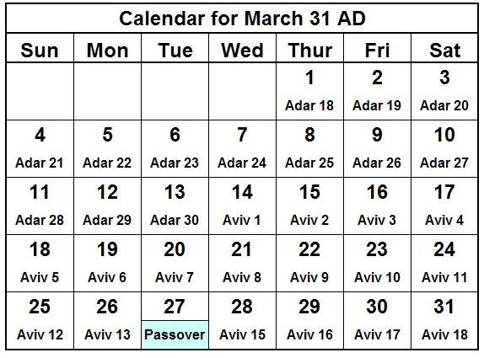

Tuesday 3/27/31 AD above doesn't work.

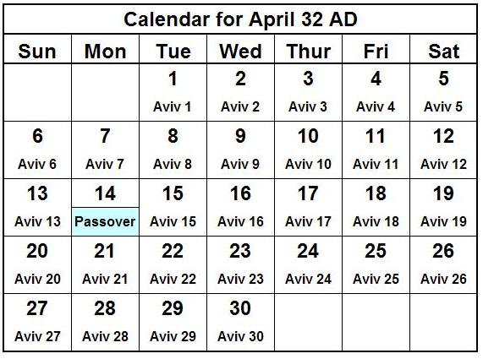

Monday 4/14/32 AD above doesn't work.

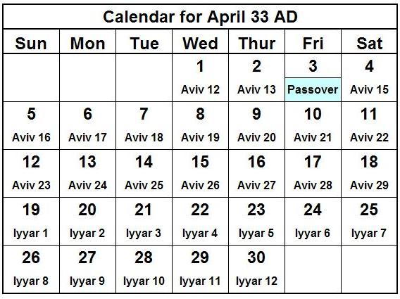

Friday 4/3/33 AD above is the same on the timeanddate.com calendar and also via Karaite reckoning. However, it allows only 2 days and 2 nights in the tomb, and should be refused.

Only two years, 27 and 30 AD, in the research above appear to yield the proper day of the week for a stay of 3 days and 3 nights in the tomb.

The year 30 AD comes out looking like it's the most acceptable possibility.

Lets look at one more item associated with the crucifixion in 30 AD.

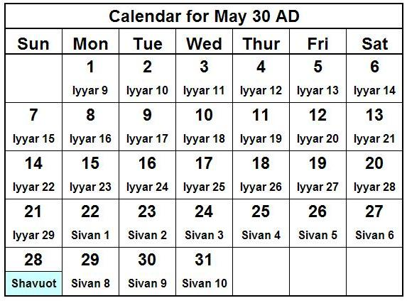

Here's the calendar above indicating the day of Pentecost (Feast of Shavuot) that would have occurred on 5/28/30 AD with the crucifixion being in 30 AD.

If we take 5/28/30 AD, The Day of Pentecost when about 3000 people were saved in Jerusalem according to Acts 2:4, and add exactly 2000 prophetic years we arrive at an ominous day in history.

You can use this calculator to add 720,000 days to May 28, 30AD if you want: http://keisan.casio.com/exec/system/1247127342

5/28/30 AD + 2000 prophetic years (2000 years x 360 days each) (720,000 days) = 9/10/2001

September 10, 2001 filled to the full exactly two - 1,000 year long prophetic days.

9/11/2001 was the very first day of the 3rd prophetic millennium from the Feast of Shavuot, the Day of Pentecost, in 30 AD, the very day mentioned in Acts 2:4.

On 5/28/30 AD about 3,000 people were saved, on 9/11/2001 about 3,000 people died.

Judgment has begun. We've entered the 3rd prophetic day when Messiah will arrive.

If anyone would like a copies of these calendars and are unable to extract them from this message, please let me know and I'll send them in a Word file.

The calendars will also soon be available here: http://www.joybysurprise.com/Graphics.html

