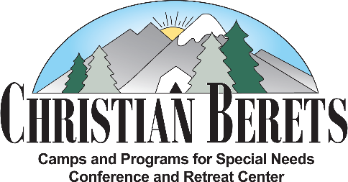
1317 Oakdale Road, Suite 340 Modesto, CA 95355
(209) 524-7993 Fax: (209) 524-7979
info@christianberets.org www.christianberets.org

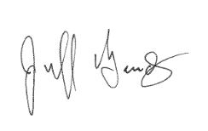
December 2017

Dear Ministry Partner,
What an awesome evening we had at our annual Inspiration Celebration. The evening was emceed by Michael Douglas who did an outstanding job. We were blessed to hear our amazing Joy Sounds Choir truly make a joyful noise unto the Lord. Thank you to Brice and Sandy Ringsby for your outstanding leadership! We then heard first hand from one of our campers, Randy Pearce, about how camp has blessed his life. Next, we heard from the leader of our kitchen staff, Kevin Williams. Our evening concluded with keynote speaker, former camper, and current board member John Saunders. Thank you for the passion that all of you have for The Lord and for our campers. A round of applause for our Office Manager Karin Hoselton, Jennifer Julian-Chambers, Debbie Rivera, and all our amazing volunteers for making our Dessert and Silent Auctions a huge success. We had two pies sell for over $200 each! Thank you to everyone who generously donated items to our auctions.
As the year draws to an end we have several projects that we could use your help to accomplish. Here are our top three priorities:
- Our water tank at the camp needs some serious attention. It needs to be evaluated for its functionality, sand blasted, and painted. $4500
- We need a new storage and maintenance building to properly store our equipment and free up valuable space in other buildings. We would like the building to be approximately 24’ by 36’ feet to properly meet our needs. $18,000
- Our recreation and medical storage sheds are both in dire need of repair especially with the winter weather already upon us at camp. $3000
So, we warmly invite you to do whatever God empowers you to do. Don’t pull up short; go to the limit of His provision for you! We think of the little boy’s loaves and fishes. Why would Jesus bother to start with such a tiny amount when God could have done it all from scratch? No, in His vast wisdom and love, He wants us all to share in the greatness of what He will do. As Proverbs 31:9 says, “Yes, speak up for the poor and helpless, and see that they get justice.”
As we enter the blessed season of Christmas and the close of another year let’s look back at how much God has blessed us. He gave us the Greatest Gift of all time when He sent His son to Earth to save us from our sins. As the Bible verse found in Luke 2:11 states “Today in the town of David a Savior has been born to you; He is Christ the Lord!” Myself, the Staff and our Board of Directors wish all of you a blessed season celebrating the birth of Jesus.
God Bless,

Executive Director
Meet our new Executive Director
My name is Jeff Goudy and God has blessed me with the opportunity to serve others as the new Executive Director for our organization. I am a retired public-school teacher who has always had a heart for serving especially when it involves kids and the ignored masses of people in the world. I taught in the trenches of some of the lowest socioeconomic areas for the past twenty-one years and God has put a passion in my heart to let these people know that He loves them and hasn’t forgotten them. My grandfather was an Evangelist and Senior Pastor and my Father was the Minister of Music in several churches. God has blessed me with my wonderful wife Carol, five children, and three grandchildren. I live in Modesto and am blessed to be a part of this community. I am truly humbled by the opportunity God has given me to help our organization become what He wants it to be.

Camp Dates:
Session 1: June 11-15
Session 2: June 18-22
Session 3: June 25-29
Session 4: July 9-13
Session 5: July 16-20
Session 6: July 23-27

Save the Date – March 10, 2018
Pancake Breakfast & Joy Sounds Choir
Parkview Christian Estates 3112 Napier Drive, Modesto
Tickets are $10 Adults $6 Kids ages 4-12

Joy Sounds Performances
December 3rd from 3-4pm at Parkview
January 7th at 3:00pm at Samaritan Village in Hughson

Interested in getting involved?
We will begin hiring counselors, RN’s, LVN’s, and CNA’s for our 2018 Summer staff in January. We need people with a heart for people with special needs. Also, we are always looking for volunteers that want to help us make our organization into what God wants it to be. If you are interested in applying, please contact the office or visit our website www.christianberets.org.
Thank You and may God richly bless you
- - - - - - - - - - - - - - - - - - - - - - - - - - - - - - - - - - - - - - - - - - - - - - - - - - - - - - - - - - - - - - - - - - - - - - - - - - - - - - - - - - - - - - - - - - - - - -

Name Phone ___________________

Address ________________________________________________________ City/Zip____________________

Email: _____________________________________________________________
I would like to donate to:
Make your check payable to:
Christian Berets, Inc.
1317 Oakdale Road, Suite 340,
Modesto, CA 95355
209-524-7993

_____ General Fund _____ Scholarship Fund _____ Building Fund
_____ I can’t donate, but I would like to volunteer for a project
_____ I would like to make a monthly commitment of $_____
Total Amount Enclosed: $________

