RSAI Legislative Update
April 14, 2022
Week Fourteen of the 2022 Session: Rank and file legislators were home most of the week, in Session sparingly as Leadership and the Governor continue to work out compromises. It is unknown when they will return to finish up the Session. Budget bills are through the House, with only one receiving action in the Senate Appropriations Committee. A constitutional amendment regarding tax policy was approved in the Senate this week. Meanwhile, in Washington, President Biden’s Education Budget is out and there are proposals to continue free school lunch for the next year. This RSAI Weekly Report from the 2022 Legislative Session includes:
- Note about SF 2369 Governor’s School Choice/Voucher Omnibus
- Appropriations Bill Status
- SJR 2006 Constitutional Amendment
- President’s FY 2023 Budget Proposal
- Advocacy Actions and Links to Advocacy Resources
SF 2369 Governor’s School Choice/Voucher Omnibus: this bill is still in the House Appropriations Committee without a subcommittee assigned. See last week’s report for all of the details, including the Parents’ Rights Provisions and Policies to Address Teacher Shortages amended onto the bill. Options for action at this point.
- Let the bill die in the Appropriations Committee. The only thing the Legislature needs to do before the adjourn is pass a budget.
- The Appropriations Committee could amend the bill to remove vouchers and move the other policies forward.
- The policies they wish to move forward could be included in the Standings Appropriations bill, typically the last bill considered as they close the Session. Of course, the Senate could put the provisions they want, such as vouchers, in their Standings Appropriations bill.
- If Legislative Leaders and the Governor come to some agreement, the bill could be amended with that agreement.
We will notify RSAI leaders as soon as we find out what the course of action will be. In the meantime, if you are at legislative forums or connecting with your Representatives and Senators, the talking points in the March 31 RSAI School Choice Call to Action are still relevant.

Status of Appropriations: the following table from the IALNS Bulletin, April 13, 2002, shows the progress of appropriations bills, all of which have been approved by the House with no action in the Senate but for the Transportation, Infrastructure and Capitals bill. The only remaining budget bill not discussed in the House is the Standings Appropriations bill, which includes state foundation aid, typically introduced as the last budget bill of the Session. See the March 31 RSAI Weekly Report for details of the Education Appropriations Bill HF 2575.
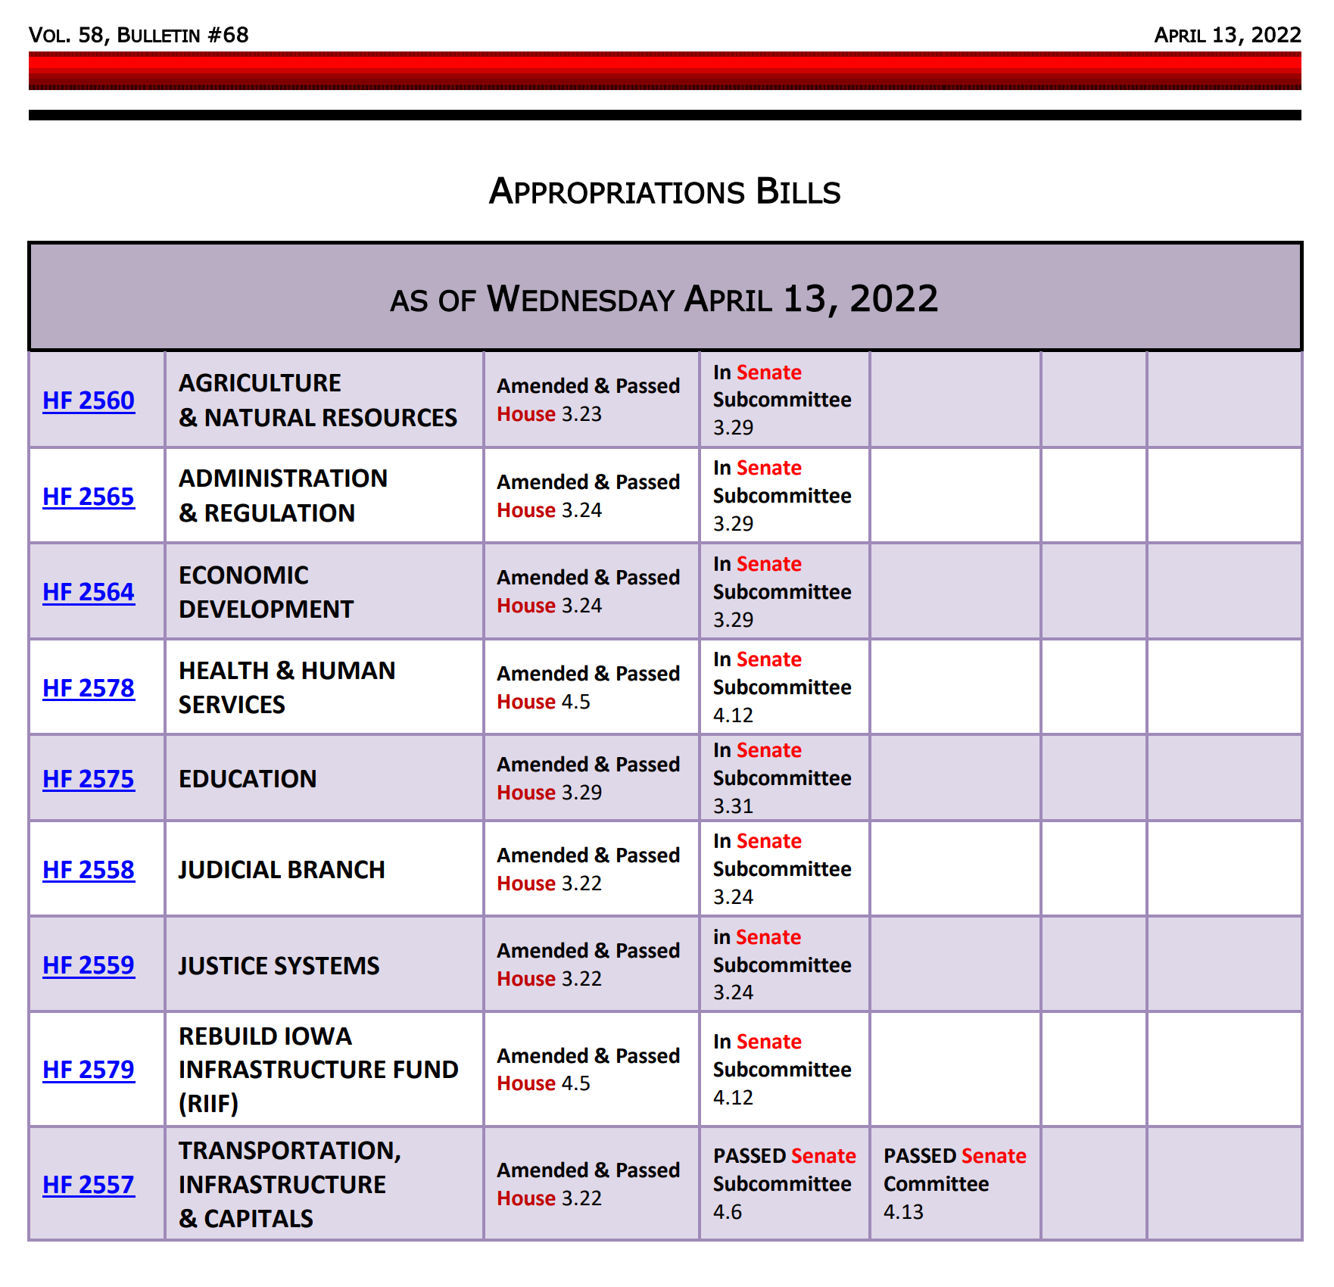
SJR 2006 Constitutional Amendment Tax Policy: this resolution proposes amending the Iowa Constitution to require that a future increase in the individual income tax rate or corporate income tax rate must be approved by 2/3rds of the Iowa Legislature. The bill was approved by the Senate, 30:18, and is now assigned to the House Ways and Means Committee. RSAI is registered opposed to the bill.
Additional background: to amend the Iowa Constitution, the proposed resolution must be approved in two consecutive Legislative biennium and then approved by the majority of Iowans voting in a general election. If this resolution is approved by the House, then it would need to be approved in the same form by both the House and Senate in one of the two Legislative Sessions following the November election (either the 2023 or the 2024 Legislative Session.) It would then be voted on the November 2024 ballot. Additionally, Colorado is the only state in the nation with a TABOR (taxpayer’s bill of rights) constitutional amendment. In the 5 states most recently putting such an amendment before their voters, all 5 ballot initiatives were defeated. See the Center for Budget and Policy Priorities, Nov. 2019 article: Policy Basics: Taxpayer Bill of Rights (TABOR) for additional information.
President Biden’s FY 2023 Education Budget Proposal: President Biden released his FY 2023 budget proposal, March 28. It includes $88.327 billion in funding for the USDOE, a $11.9 billion or 15.6% increase over FY2022. The largest increases are proposed for core programs
- $36.5 billion Title I. The request proposes $20.5 billion in discretionary funding for Title I, which is an increase of $3 billion or 17.1% above FY22 and $16 billion in mandatory funding. However, mandatory funding for Title I is unlikely to advance through the annual appropriations process.
- $16.3 billion ($3.3 billion increase) for IDEA (federal support of Special Education)
- $1 billion to increase specialist school staff including counselors, nurses, school psychologists
- Doubling the maximum Pell Grant
Congress is currently in recess until April 18 for the House and April 22 for the Senate. The updated information from AASA and the NREAC shared that neither chamber has any movement on the budget. There are rumors that Senators are working on a reconciliation package to address Democrats’ priorities that Senator Manchin will also support. No details have yet been released.
Child Nutrition Waivers—NREAC & AASA continue to advocate for an extension of the waivers. Senators Stabenow and Murkowski introduced the Support Kids Not Red-Tape Act which would extend the waivers through next school year. Reps Spanberger and Fitzpatrick introduced a similar bill back in February. This is a good sign, but we remain cautiously optimistic. Key talking point: help families with inflationary costs of food this next year until supply chain issues are resolved. We have not yet returned to a post-pandemic normal. Find contacts for your Congressional Representative and Senators Grassley and Ernst here: https://www.congress.gov/contact-us. You can always reach out to them at their Iowa offices found on their individual websites.
Advocacy Actions This Week:
- Watch your email for announcements if policies pop up that need quick outreach to legislators: As the Session winds down, we’ll keep you in the know.
- Ask House members to resist SJR 2006 Constitutional Amendment on Tax Policy.
- Send a note to your legislators: As most are home awaiting the announcement of leadership compromises, this is a good time to circle back and reinforce your local connections. Thank them for working on teacher shortage policies, improving the transparency requirements to what’s workable, and for being there to represent you and your district. If they had committed to you their opposition to vouchers, you could thank them for that as well.
Find Representatives here: https://www.legis.iowa.gov/legislators/house
Find Senators here: https://www.legis.iowa.gov/legislators/senate
- Check out your new legislative district and primary candidates for the Nov. 2022 election. Enter your address in this new map lookup tool on the legislative website to confirm your House and Senate district numbers: https://www.legis.iowa.gov/legislators/redistricting. Find names, phone numbers and home email addresses for primary candidates on the Iowa Secretary of State’s website, which publishes this information in a pdf found here: https://sos.iowa.gov/elections/pdf/Candidates/primarycandidatelist.pdf. Call them or send them a note, introduce yourself, offer to be a resource for them on education issues, and let them know what they can do to best represent and support the students, families and staff in your school district.
Connecting with Legislators at the Statehouse: To call and leave a message for a Senator, call the Senate switchboard operator number is 515.281.3371. To call and leave a message for a representative, the House switchboard operator number is 515.281-3221. You can ask if they are available or leave a message for them to call you back. You can also ask them what’s the best way to contact them during Session. They may tell you email, text message or phone call is the best way to connect with them during the Session, based on their personal preferences.
RSAI Advocacy Resources: To find Advocacy Resources such as Position Papers, RSAI Weekly Legislative Reports and video updates, RSAI Calls to Action when immediate advocacy action is required, testimony presented to the State Board of Education, the DE or any legislative committee or public hearing, and links to fiscal information that may inform your work, visit the RSAI legislative web page here: http://www.rsaia.org/legislative.html. Also, check out the newly released 2022 RSAI Advocacy Handbook, and also available on the legislative page of the RSAI website
Contact us with any questions, feedback or suggestions to better prepare your advocacy work:
*Margaret Buckton, RSAI Professional Advocate, margaret@iowaschoolfinance.com , 515.201.3755 Cell
*Dave Daughton, RSAI Grassroots Advocate, dave.daughton@rsaia.org, 641-344-5205 Cell

Thanks to our RSAI Corporate Sponsors:
Special thank you to your RSAI Corporate Sponsors for their support of RSAI programs and services. Find information about how these organizations may help your district on the Corporate Sponsor page of the RSAI website at www.rsaia.org/corporate-sponsors.html.
 | www.apptegy.com
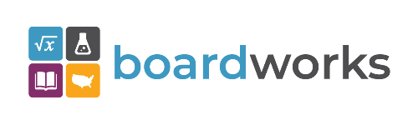 | www.boardworkseducation.com
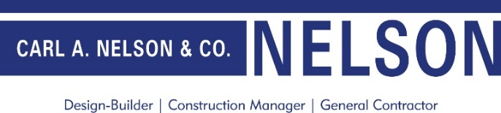 | www.carlanelsonco.com
 | www.classroomclinic.com
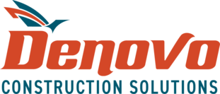 | www.teamdenovo.com
 | www.friedman-group.com
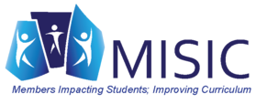 | www.misiciowa.org
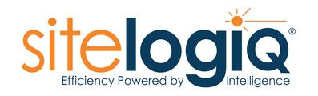 | www.sitelogiq.com
 | www.wgu.edu

