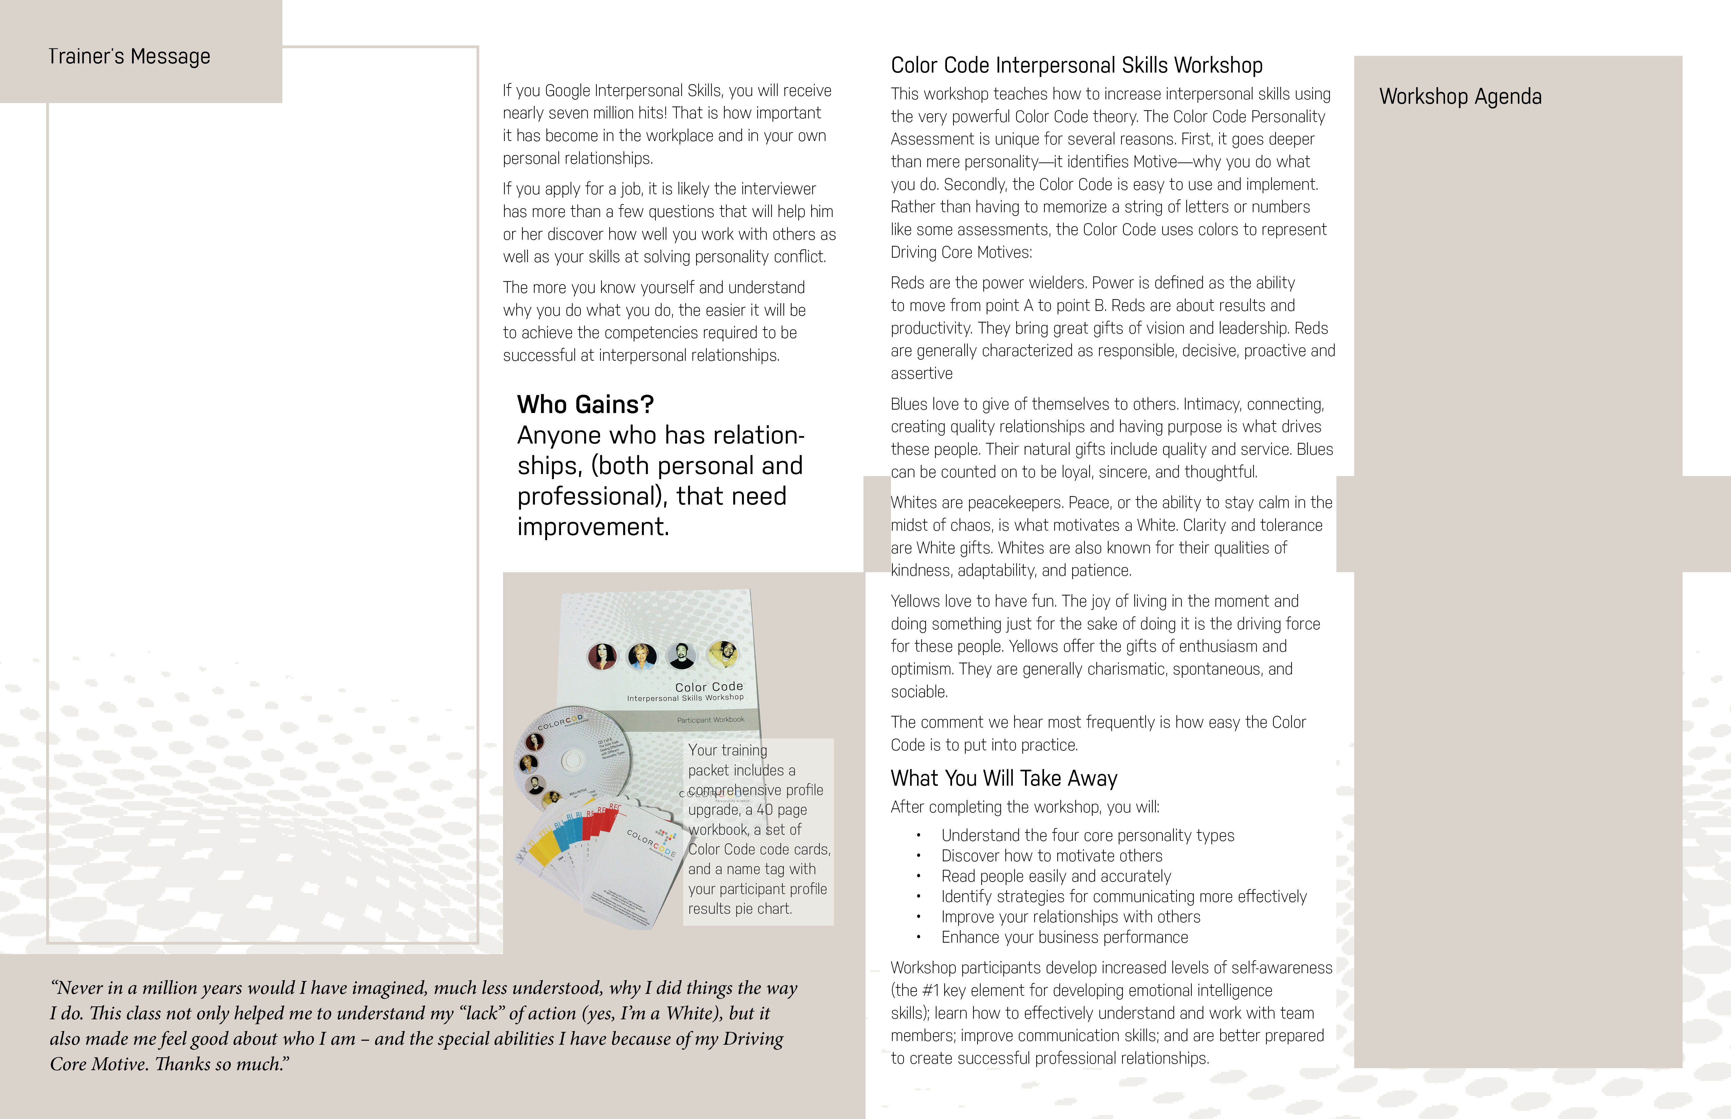

**Color Code Principles**

1. Every individual is born with an intact, innate personality that can be accurately identified by the Color Code Personality Theory.
2. Each personality emanates from a **driving core motive** (DCM).
3. No two personalities are exactly alike. Each personality is legitimate, valuable, and deserving of dignity.
4. The **driving core motive** for each personality will never change.
5. The four **driving core motives** (Power, Intimacy, Peace, and Fun) are neither good nor bad in and of themselves. However, they generate a positive or negative value according to the intent or purpose for which they are employed.

LearningGraham Ltd.

Dr. Patricia Graham

Doctorate in Management, Organizational Leadership

**Leadership, Management, Coaching, Sales and Training**

More than 30 years of progressive and comprehensive experience.

Areas of expertise include:

* Certified Negotiation Expert
* Leading and directing a team of 200 + employees to goals in sales, profit, growth, and revenue
* Identifying problems and creating systems and processes to minimize issues
* Forecasting short and long-term planning
* Developing and implementing individual and group marketing plans
* Researching analyzing, and marketing trends
* Hiring and evaluations of personnel, from entry to director level
* Coaching training in large groups to individual sessions
* Project management/general contractor residential home
* Developing, writing, and teaching curriculum in the school system from Junior High through Universities Doctoral Degrees
* Leading customer and employee meetings
* Developing, and conducting training to ensure understanding of new processes
* Training and coaching for career success
* **Contact 719-339-1111**