An Interview with Grace Smith 1976

An Interview with Grace Smith
Grace Smith is, by her own description, a colored woman. She is 83, and was born on April 12, 1895. Mrs. Smith lives in a house on Community Drive. She has lived there all her life. While the students refer to her as Mrs. Smith, census records indicate that Smith was her family’s name and that she never married.

The students from the Great Neck South High School SWAS program who interviewed Grace Smith were Amy Briamonte, Isabella Busillo, and Andrew Mattson.

ON MEETING GRACE SMITH
The house was shabby and worn and old. Its appearance gave the feeling of an old faithful blanket, colors faded, worn thin and all the more soft than when it was new.

Hearing a soft shuffling noise, we knew she was coming to the door. Anticipation growing as we stood on a new porch of naked pine planks looking absurdly hopeful against the gray washed wood of the rest of the house. Two squirrels chased each other into a hole they had gnawed through a wall where they, like the old woman, resided in this beautifully beaten house.

Opening the door in one gesture, she stood, shorter than Isabella and I by about a foot. She had not asked who it was, nor had she peered at us through the yellowed lacey curtain before opening the door, as we had expected. Instead, she just stood, eyes looking up at us with darkened lids, one twitching, "yes" she spoke in a low tone.

Isabella and I looked at this woman and then at each other, after a silence we introduced ourselves. "Oh yes, but what exactly is your purpose?" We haphazardly tried to explain Feb. proj. It was awkward, we were awkward. Tired eyes looking a bit confused, invited us in. "Sit down, sit down." And so we did on a bed covered with a maroon spread. The room was small and very warm. In front of us was a huge cast iron stove leading to a brick chimney. Quite oversized for the room it was, and so she stated, "It was once used in a barn." As she settled back into her accustomed, once overstuffed rocking chair, it gave her a welcoming sigh which she acknowledged with a sigh of her own. It seemed as if the two were more comfortable together than apart.

On the bottom, she had only one tooth, which seemed to me all too appropriate. It was a straight tooth, unstained. Like the old woman herself, the soul survivor of all its siblings. Both had managed to withstand 84 years, and now the woman and her tooth stand alone, old and strong, the last of the Mohicans, each in its own right. Each dutifully never leaving the place of birth.
She sat in her chair and tugged at her flannel stockings. She wore a cotton blue, green, and yellow paisley house coat, faded to dreamy pastels. Her hair, all gray with a few black streaks, was pulled into a knot going down the back of her head. Before she spoke, she smiled, revealing for the first time an entire set of upper teeth, straight and white, a loving smile. The kind that makes you smile back before you know. Suddenly everything became easy. We needed to ask few questions; she spoke for well over an hour.

GS: My mother’s an English woman—white woman—her father partly Spanish, and his mother real Squaw. On Island there are Shinnecock Indians. Grandpa Smith was a Mohawk. Grandmother Smith was from Africa.

SI: Do you remember what tribe she belonged to?
GS: No, you see I was so young. I was but a year old when my Grandfather Smith died, and when my Grandmother Smith died, I was only 8. Dad didn't talk too much about his family. Mostly, my aunts and uncles.

SI: How long have you been living in the town of Great Neck
GS: I was born here, born right in this little house, 82 years ago.

SI: Did your parents build this?
GS: No, when my daddy bought it, he bought it in 1891. It wasn't new then, it was cute—like a big red bam. It had a lot of flowers and morning glories. My mother and father loved flowers. They had them in the halls, porch, everywhere—lilacs, roses—my mother was crazy about fuchsia. We didn't have any porch then, a large stone in front of door--now it's steps—and we would sit out in evenings in the summers and tell stories around the fire. and we would keep them awake too. After a while, my daddy had polio and then of course he was crippled.

SI: Did they have any good doctors then?
GS: Well, we had a doctor around, a real expert. He was ?, Doctor Neslee. We had so many doctors then, because, when one said they couldn't do anything they would give it up. They told my mother that you're really doing more for that boy (guy?) than we are. So she just wouldn't let him die. She wouldn't study for nurse, but she did the best for him. So it kept us all busy. Kept us all working in order to pay the doctor bills, and get things that was needed for the crippled. So we were busy at äll times, and things like that.

SI: What kind of work did you and your family do?
GS: Laundry, huge amount of laundry.

SI: Did they have those laundry machines in that time?
GS: No, it was done by hand.

SI: I guess you hung it all out on the line.
GS: We had the place full. We had lines streaming all over the place. Daddy worked for a family called Chatman (?), but first Cox, and Dad, he was something like my mother, he never learned to be a veterinarian, but he really had the talents of a veterinarian. Of course, he learned it from his Mohican grandfather. I guess his grandfather taught him an understanding for the animals. Yes, they even taught him how to kill something. I guess she was one who was interested in that, because he taught dad how to instantly remove suffering of an animal that he was going to kill. If I do say. Dad was really an expert at it. He did the slaughtering for Phipps and the Niggs, and some of the farmers around Port Washington. In so many ways it was a white gentleman who was the greatest veterinarian around, and his name was Mr. Bone, and he wanted Dad to go train horses with him, because he had trained so many of them. He trained some that the Chatmans had. He just seemed to understand them. I remember the day so plainly, they had a team of horses, but they had several teams and carriage houses, and beautiful carriages and beautiful horses. Margaret and Black Beauty are good riding horses, and he devoted so much of his time to them. When Chatman's coachman would go away for vacation or something like that, Dad would drive for them and so they brought them at delivery and Dad was big. He rode Salty. He was 6 foot three. One time he was thrown from Salty, but when he landed, he was on his feet and he was holding the reins. He loved horses; so do I. If a horse ran past, I’d know. I would just rise to the window to see.

When Margaret came past, she slipped a little. He was just going to the station. It had hailed the night before, and Margaret slipped and Dad called Margaret and she struggled and jumped up, a beautiful animal. I don't know, he just seemed so kind and he just loved them. I always wondered how he could do the killing of those animals. He killed anything up to a cow that he was asked to do. We used to have a pig killing day here where all the neighbors would bring their pigs and things. Of course, they would come to help with the scraping of the animals and things like that. When come night, he would have 15-16 animals laying on the gallows. I remember one time, there was a young man come from Great Neck; and so Dad had one of his brother's cousins that lived next door, another cousin lived down the street, and Mrs. Walker. They all had about 3 hogs to kill at a certain part of the year, late fall. It's according to just how the moon lies in November or December. According the way the moon, some kind of thing that they killed at that time. I don't know of why was it the full or crescent. Is there such thing of the perigee moon, sounds something like that. I don't know what they meant, I really don't know what they meant.

This young man and Dad would get Dad's friends right around him. They called him Mitch and Mac. This young man said, "I bet I can beat that time in stringing that." And he did and they timed him. We had a little show that day. This young man got one on the gallows and then won. They all said, "Well now it's your turn to see how good you can do it." So Dad did (not?) say a word, he was so quiet. They used to call him "easy like." He smoked a corn cob pipe that was what he used in an informal way, except on Sundays; he was a little extra different on Sundays.

SI: Was That because of church?
GS: No, not because he was going to church, he just wanted to be a little more stylish. Well, he was smoking this com cob pipe, he didn't seem to be hurrying. Dad was getting kind of old, hé wasn't old, but he was getting along there. All the people said they never saw a man who didn’t seem to be hurrying and could accomplish so much. I don't know how many seconds or minutes that it was that he beat this young man. I'm telling you those older men threw their hats in the air, and they had a time. Dad made his own dagger and learned just how and when to use it from his father’s. It was dull when he first got it.

SI: Was there a strong community feeling among your relatives and friends in this town?
GS: We all seemed to be like one family. We really were. We were relatives except the Walkers, and they seemed like they were relatives, too. Everybody seemed to work together, life was so hard, really hard, in the way of working, but it was beautiful.

SI: Did you have an enjoyable life?
GS: This is my life staying right here in this place and I made as much money as any young woman did or any woman did, but the only thing I could do with the money that I made was to put my John Hancock on it. We needed it; we needed it badly. We raised all the vegetables we could, and chickens and geese and did the best we could. There were other people that did the same thing, but of course that's the way people lived around election time. We would have potato breads in the summer. We had a food closet, of course; we didn't have to worry about rats and things as we do now. We would build trenches. I don't know what you would call them. I knew at the time. Other families around the same time would do the same thing. We dug real deep and we put straw in the trenches, and then you put cabbage, beans, tumips. Then you put more straw on top, and then final cover of dirt. You know you would be surprised how much sweeter the vegetables tasted from being in the Earth.

SI: Did your family invent this practice?
GS: No. It was just done. It was a tradition. It was more that Dad did it; many farmers did the same thing,

SI: Did you or any of your relatives suffer any of the bondages of slavery?
GS: Well, early, they tracked down some people in the history of my family, but for me showing it. They did do a lot of tracing, when it first started.

SI: Did you feel a strong existence of segregation throughout your school days and youth in this town?
GS: When I went to school, there was a difference.

GS: … and we would fill trenches...but any way we would dig them real deep. I know more than my father done it. Other families at the same time done the same thing. We put straw in the trenches and then you would put things like cabbage, beets, and turnips, and things like that into the trench. Then you'd put straw on top of that, and dirt on top of that.

SI: Would you store this over the winter?
GS: Over the winter and you'd be surprised to find how much sweeter it was.

SI: This was tradition?
GS: It seemed to be, more than Dad done it.

SI: Were any of your ancestors slaves?
GS: Ann Early and Vicky Hershy traced down something that said they suffered some slavery, but from me knowing it, I can't really say; they did a lot of tracing you know, about when it started. I had an Uncle Berthris who owned a house right near the church. He rented it to.. . He sold it to Mrs. Mankom, and he lived in a cave right in the woods back there. (In the golf course on the west side of Community Drive.)

SI: A cave?
GS: Yup, the two would eat right under the cave. The cave would open and Berthris
would be right in it.

SI: Is the cave still there?
GS: No, you know it would not, so that was a common way of life. My sister said that
because she is the oldest in the family. She could have told you so many things, that she
really knew, many things....

SI: Was this little cave a hide-out?
GS: Huh?

SI: Was he hiding?
GS: No, no, no, he lived there.

SI: I see. Did you feel the effects of segregation in this town in the last fifty years?
GS: Well no.. .when I went to school and there was a difference of course, somewhat, but we had a little school here for the colored people, and some people said black people was colored people. I was always trained to call my people colored people. If a white person at that time would call a colored person black, he had himself a fight. It's strange to me to be called black now. (laughter)

SI: A change in times, huh?
GS: It's changing me! It's a change in something, I don't know where it come from, but that's what they want to be called.

SI: So you're a traditionalist?
GS: I live to suit myself and try, I do try, to get along with everybody. I love friends, I don't care what nationality we all are. When I was going to school as far as children were concerned, I had lots of white friends. As far as getting along bad, or different, or any trouble we really come out of.... well, my mother, until she married dad, if she didn't.. .she might to.... They all belonged to the white church over in Douglaston. They were Episcopalians, and they come up as white folks. So, I think that it's really wise that I don't feel any different, because we come right up with them. I don't think that there's any hate amongst us with the white people.

SI; I noticed a little white church here on the right, is that your church?
GS: Yes, that's my church. That's what my grandfather built with the help of others
.
SI: Has it been rebuilt in recent years?
GS: No, no. It's just been worked òver and patched up a little bit.. .and I think it needs it now.

SI: What year did your grandfather and the community build this little church?
GS: Well, they said that this church was estabhshed in 1873, but it was before that, because one night, I woke up in the middle of the night, and I heard them giving the history of the church. I heard them say that when they first started forming, they started to worship in some house near the valley pond. They said that they started this connection with the church in 1833. I did read somewhere that said it started in 1891.

SI: Is the congregation mostly black?
GS: Oh yes, yes.

SI: Were the whites welcome to come?
GS: The old oath in those times was trusting. Once in a while, some white folks floated in there and we would have a minister with hate in him and he'd stop the service. But those folks who had trust in them wouldn't stand for this. They wouldn't have them folks insulted, and when those folks went back they said to the minister that they didn't want to be hearing that because the church is not for one set of people only. It's for everybody. Everybody should be welcome into church. There should only be good feelings in there, right? That's right, and when George Tremble, he's the man who gave him the land to build that church on and the graveyard, and when George gave him this land he said he didn't want anything built on this land except a church and a graveyard, because that land is hallowed ground and should not be used for anything. He gave it to my grandfather because he trusted him and not everyone could build a church. It was not supposed to be sold or anything like that. Each generation was supposed to be trustees, so now, see my grandfather, Thurston, all his children have died except my cousin and me.

SI: Is this your only living relative?
GS: Yes, the next generation, we are the next generation of that world.

SI: Is your cousin your only living relative?
GS: No, no, she's not the only living relative, but she and I are the ones to see that nothing happens to this church, we are the trustees.

SI: The keepers.
GS: The keepers, that's right. It's got down to the generation where there's only two and I. But after us there will be my brother's children, so there'll be quite a group. But this generation, this right now, is no more.

SI: So it's been passed down, this responsibility of keeping and looking after the church?
GS: That is so.

SI: Did you conduct your church ceremonies in a very different way than white people did?
GS: Well, you see, I've never really been to any white churches, except I went to a Catholic church a couple times, but I never really been to any white churches, so I can't really say. I've only been to colored churches. I've been to a lot of different colored churches and I worked in this church. I worked as the church secretary until my sister got sick and everything.. .everything seemed to work beautifully so you know I got out of it. I'd rather get out of it then to hinder something else. Just to stay in something for a name, I can't work that way. If I can't give what I am supposed to give, I'd rather get out of it and not have it...

SI: Did the people have a strong belief in God?
GS: You know my friend that is a strange thing to say. Who knows how much belief each individual has in God? How do you know? Just by what they say? Or if they shout
it or not, Unless you can watch how a man or a woman walks. How he treats his
fellow man. I don't know how you can tell if he is a Christian.

SI: I guess it's something inside you.
GS: Yes, because I find myself at time examining myself to see if I have, if somebody
mistreats me, I have to.. .1 wonder why they do that and then I have

SI: When you say the way a man walks?
GS: I mean...

SI: The way he conducts his life?
GS: The way he conducts his life. You can talk all you want, but you may not be totally true. You may not be telling the truth, just satisfying your own self. You're just fooling yourself (laughter). ‘Cause you can't fool God, you know. So you're just fooling yourself. So that's a waste of time.

SI: You mentioned your business doing laundry. Did your family sing any songs while they worked?
GS: No, we were poor singers. My daddy tried singing, but Lou's father had a very fine voice. Now, my mother didn't sing very much, but I was in the choir. But I was only there to make a little extra noise, I done the best I could. But we had a lot of songs in the church and out of church. Then we went to school. Especially the Walker family, the Walker children and I, we didn't go in September, when we was supposed to go, we went in October, 'cause in September the beans was being picked. We stayed home and picked beans. I enjoyed myself very much. I don't regret any of it. I didn't have nobody for myself, I didn't live a life for myself. I lived it for them, because I loved them, and I don't regret it. Now I have something to be cured for. I am a relative. Once in a while I get lonely, like now after I got used to being alone, but while I had them.... I don't know we were more like brothers and sisters.

SI: So it was a very strong relationship.
GS: Very strong amongst us. So that gives me strength to know that I really tried to do the best I could, and I think that I'm just as well off as the people that went on and made a life for themselves, because I can't see anywhere anyone plainer than I am, except that I'm living poor. But all those people who do not love are all hurting themselves, because it's such a waste of time to hate.

SI: It all comes back.
GS: Yes, such a waste of time, but if you love one another it's something that strengthens you through and through, and at the end now I'm very old and I'm getting older, and now I can look back and see all of the beauty. At times I can look back and see all of the beautiful apple trees blossoming, the pear trees, and the animals, and the gardens full of vegetables, and my parents getting along together, and we all of us working together for the sick. That's a good feeling, a good warm feeling
.
SI: I guess you're very close to the earth?
GS: Yes, I do hope.. .there's two things I really wish for very much in life. I had an operation on my eyes and the operation was successful, but it takes time for my eyes to come back right, and I hope I can stay here until the end comes, and then I do hope too, that I will live and have my clear mind, as it is today, when I leave here. I hope my mind will be just as clear that day, as it is now. I would like it very much to be that way, and I hope, at least, I can see other folks.
SI: Are you able to see a little bit?
GS: Oh yes, I can see, but I have a couple of sutures that are still in my eye that have to be taken out. There are four still in there, and I didn't know when or if they'll take them out, but that seems to be my biggest problem now.

SI: You mentioned that you had a relative from Africa. Did he pass on any traditions?
GS: My grandmother's mother came from Africa.

SI: Did she bring any traditions with her?
GS: Well, I don't know her, I'm just going back. I didn't know her at all. I knew my
Grandmother, but I don't know if she was brought over from Africa or brought up here.
They had a little house right up there along the path. It was so sweet and lovely.

SI: Was there much unemployment among the colored people in this area?
GS: Anybody who wanted to work around here found work.

SI: Was it as rich a community as it is today?
GS: Oh no.

SI: Mostly farmers?
GS: Yes, all along that side, but now there's a hospital, and they'd like to get this strip if they could.

SI: I imagine you've seen a lot of change in this town. How long ago was it that these roads were different?

GS: Oh, I don't know. It seems like only yesterday. I remember when it was just one lane and dirt, but now to cross the road where my uncle used to live, he'd be sitting right in the middle of the road.

SI: I guess you feel like a proud woman being the last one in this house, after your family and relatives using it and living in it.

GS: Well, I feel that I must have been the strongest of the group, and now I'm just staying a while to finish up the work. You know, people always have a job to do that they leave undone and leave a person behind to finish up.

SI: What is it that you have to accomplish?
GS: Well, there's an awful lot to accomplish. I don't see how I can live here, my strength won't hold up. It's cold upstairs, and I have to cut wood, but I hope with the little time I have left, that I can stay here until the end.

SI: Do you still attend church?
ÇS: I haven't been to church in quite a while. There's not many members and, you see, all those houses are down. It seems they were up only yesterday, and now the Horn house is down, the house next to where my niece lives is down, the Kussel house burned, the Hughes house, where the doctor's office was, that house is torn down. They had a nice little home. Where my uncle's house was they tore all that down. So you see they're all gone now.

SI: Did your parents or grandparents build the house?
GS: Oh, no.

SI: They bought it?
GS: Yes, that's right.

SI: Was it originally a barn?
GS: Well, it looked like a bam from the outside, a big red bam. When we bought it I remember saying to Dick, he was my father's brother, you know what I'd like to do to this house after we fix it up? I'd hke to paint it red, and he said, "what are you plain crazy?" (laughter) 'Cause that's the first thing I remember, that big red barn, but then the attic wasn't finished off. We had curtains for between the girls and the boys, but we had so much fun then.

SI: They say that jazz music started among the black people...
GS: Yes, I would imagine so, but I don't know.

SI: Did people participate in jazz?
GS: I never heard of that when I was young. The music was more classic. I never really cared for jazz. I never really liked that at all. They say that man.. .what's his name.. .a trumpet player.. .Satchmo.. .they say he was a great jazz player. I couldn't stand that man. They should have paid people to listen to him. I don't like jazz. I don't care for jazz. But I do like to hear certain people sing rock.. .especially Elvis Presley. He sings nice classic music too. I like his music.

SI: Did you do a ton of things together in the community, like baseball games or softball games?
GS: Yes, yes, the boys.

SI: Where did they post the announcements?
GS: Oh, they didn't make it formal, just for the fun of it
.
SI: Just a couple of people at a time?
GS: Yes, yes, the young men and boys of the community.

SI: What sport did they like the most?
GS: Well, in the winter, sleigh riding.

SI: Where did they do it?
GS: They'd start at the top of the big hill.

SI: Over on the estate?
GS: No, not on top of this hill, Community Drive, and I remember my sister-in-law and I, they trusted their lives in our hands. We'd bring them down in the bob sleigh, and bring them right down. They trusted their lives.. ..I don't know how they could do it, but they did and we'd bring them right down on the bob, and my oldest brother, Joe, tried so hard to learn me how to skate when I was very young, but I fell down one night trying to skate, and I couldn't count all the stars I saw. So I didn't try anymore, but I would have loved to learn how to figure skate.

SI: Did you skate on the pond?
GS: Yes

SI: What pond?
GS: Oh, Woolley's Pond.

SI: Is it still there now?
GS: No, no it's all built up now. Everything has changed, it's terrible.

SI: Does it bother you to see so much change?
GS: Not really.

SI: You're able to cope with it?
GS: Yes, because it is supposed to be. Changes have to come. It really doesn't bother me.

SI: Do you miss the old farming days?
GS: Yes, I thought that was beautiful because horses are so beautiful. I like animals anyway. It would be nice if they kept up with those days. It would be very nice, but I don't really worry about the changes. I feel that everything is in God's hands, and you know that He is the beginning and the end, and I believe that everything that is happening to us right now is his will, and I believe that God does everything well. If more people would trust in God and let him have his way, he will have his way, and be satisfied. Sometimes I have come to a place where I have said, I just can't go on because there's nobody but God, and I know there's to do. I look at my life and I really do not know how I've made it up to 83. God has let me live a long time. There must be a reason. He has a reason for it. I have not finished the work that he has sent for me to do.

SI: Do you feel that God has sent you a certain goal to achieve?
GS: I feel that there is a certain amount that must be done before my day is done, and these tests, I have an awful amount of tests, when one test is over another moves right in front of it, and I believe, I don't know you're a very yoimg man, but when I lost my brother and sister in the very same year I'd didn't know how to take it, but somehow or another I got interested in the Book of Job, and Job was a very rich man and a very good man, but God let mean things happen to Job. All of his cattle on the hill were destroyed and one thing after another happened to Job, and then a woman said to him, "Foolish man you should curse God and die." But Job said, "Though he slay me, I cannot go back on him." It isn't because I haven't been true. I don't know myself how I went through. I really don't, but there's something about it that God is with me at all times.

SI: What did you find to be the most difficult test that God sent you?
GS: The saddest, it was so sad to see my brother, he had a brilliant mind, but he was so crippled he couldn't feed himself. He had polio, you know, and I had a retarded sister.

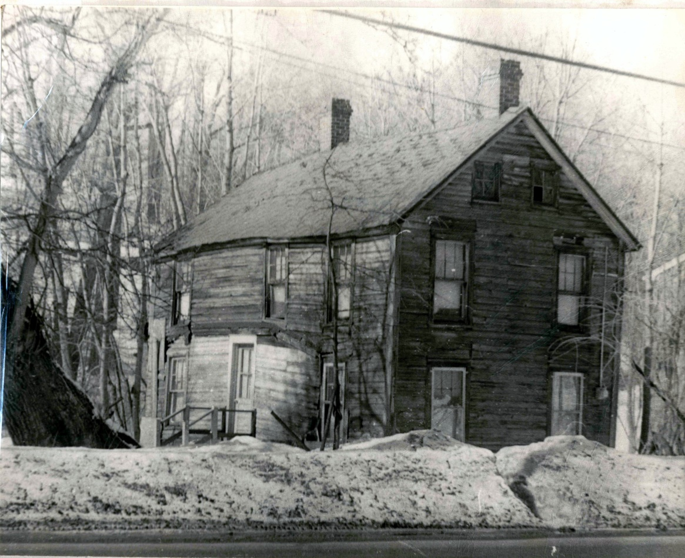

Home of Grace Smith on Community Drive

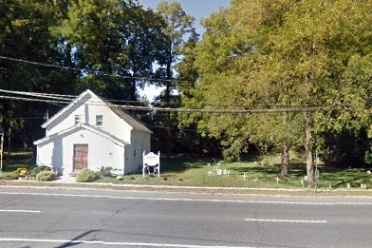
Lakeville A M E Zion Church on Community Drive

