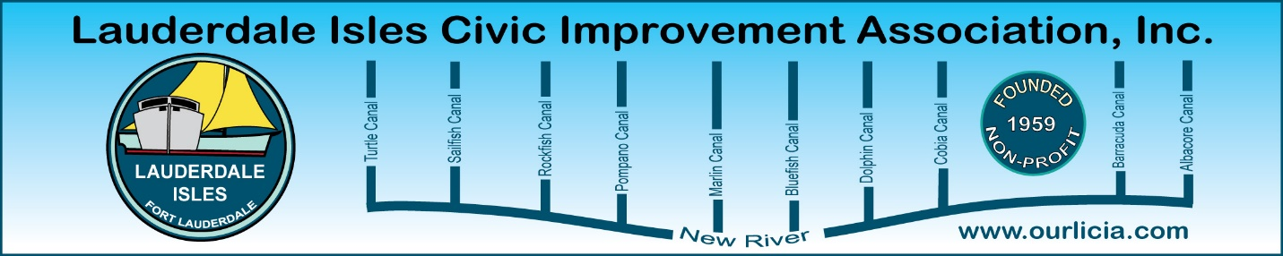

Minutes of the Lauderdale Isles Civic Improvement Association General Meeting March 20, 2025.
The meeting was called to order by Earl Prizlee at 7:10pm. Earl thanked the Pastor for the use of the Church for our General Meetings.
Earl welcomed everyone and gave an overview of the meeting agenda and displayed the Board Members and lane volunteers on the screen along with a short note about what we do to help our community. Geoff provided an update on our recent Waterway Cleanup along with photos. Geoff noted that our water quality is good and snook are being caught in the canals and at the boat ramp. The water is so clear you can see the fish. Last year the water was tested and all results under 140: November tested 59, July 89, May 112 and March 34.
FLPD report: Officer Jackson said there were 2 thefts that occurred from January 17 through today. Keys were left inside a car even though they had their Lojack on and a vessel disappeared. A case is being built to determine what happened. Questions were raised about parking including the Andros Lane construction site where cars are obstructing traffic. Officer Jackson recommended to ask for a supervisor if we are not seeing results from calling the police.
Code Compliance report: Dec 17-March 17. 25 cases were closed, 3 cases complied and ee cases pending. Cases sited include derelict vehicles, exterior lack of maintenance, debris on roof and parking on lawn.
Community Center: Earl provided an update and introduced the Joe Webb with AECOM and the members of the Parks & Recreation Department with the City. They provided their vision of the Community Center including preliminary plans, keeping the trees and an estimated timeline. Park Rangers will be checking the building when it is built.
Commissioner Sorensen, Guest Speaker: Commissioner Sorensen spoke about what he is focused on accomplishing this year and then opened up to questions.
*Traffic Calming on Riverland Road has been an issue for us for a long time and he confirmed the Acting Deputy Director of Transportation & Mobility will be sending out a package to bid end of April to be awarded to a contractor July/Aug and construction to begin Sept/Oct to add raised intersections to slow down the traffic.
*New City Manager hired and starts April 2.
*New City Attorney will be hired.
*Chief Waterway Officer will be starting soon.
*New City Hall building will be constructed and should be ready November 2025.
*Tunnel vs. bridge: Moving towards the tunnel. Commissioner Sorensen working with everyone in the County and City to finalize this decision to move forward.
*Homelessness: Working with County and City, United Way, Salvation Army and others to help provide affordable and low-cost housing, drug and alcohol addition treatment, job training and services to help those in need.
A variety of questions were asked, and we were all happy to hear Commissioner Sorensen did promise tonight that any costs incurred over and above the budget confirmed for our Community Center would be covered and he will secure the funding for our project in total.
Flanigan’s Gift card was awarded.
The meeting ended at 8:50pm. Board members not in attendance: Glo, Eric and Aynsley.
Respectfully submitted by Karen Rames, Secretary

