DispensingGuidelines.com
Eyewear Dispensing Guidelines
For Eyewear Professionals.
"All Opticianry is local."

/
Sadly, Hari Singh Bird passed away on November 16, 2018. He was a passionate advocate for hands-on adjustments and was a true friend to me and Optical Seminars. I hope you enjoy his unique perspective on opticianry in general and adjustments in particular.
(Anthony Record, January 2022)
​
Mr. Bird's career as an optician began following active duty with the U.S. Marine Corps and his subsequent employment with an American Optical Company Branch Laboratory in 1958. He spent more than two years in all phases of lab operations as a lab technician, which included hand surfacing, power generation, hand stone and automatic edging, bench work, finishing, final inspection and hands-on-the-patient, handcrafted, custom fitting of eyewear. Mr. Bird then became the manager of an AO Branch Laboratory, and later a sales rep. for American Optical lenses, frames, and ophthalmic instruments. He subsequently returned to ophthalmic dispensing with a joint ophthalmology/optometric practice. He held active dispensing optician licenses in Florida and Arizona. He was also ABO-NCLE certified. He was a member of POF (Professional Opticians of Florida), and had several years’ experience as the owner of an independent, privately operated ophthalmic dispensary, and as a dispensing optician for a retail optical chain.

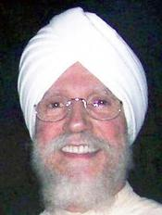

Question: Are you an Optician
or are you an eyeglass merchant?
If your answer is the latter,
it's time to shift your thinking.
It's time to get your shift together.
It's time for eyewear professionals
to become agents of change going forward;
it's time to return to the days of providing full service;
to improve your hands-on craftsmanship skills; it's time
for those who know to teach those who do not know; and
it's time for those who do not know to surrender their ego.
It's time for three-dimensional dispensing, a time honored craftsmanship that includes:
. Discovery of the real needs of the Patient by way of an in-depth Lifestyle Interview,
. An unbiased Design of frame and lenses that fulfill the Patient's real vision needs, and
. Delivery of hand-customized eyewear, which creates a multi-dimensional balance in
relation to the visual axis, the face and skull, and results in a skull conforming,
form-fitting that precisely matches the topography of the Patient's features.
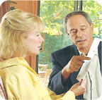 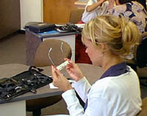 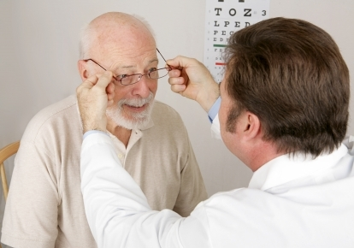
Discovery Design Delivery
. Why do we so often consider Consumers mere customers
when they present us with a doctor's prescription for eyewear?
. Why not consider consumers Patients requiring vision care?
. Wouldn't this change the way we relate in terms of time and kind of
service we render them? (Maybe this is why we relate to them merely as
customers. We want to be simply merchants. Too much responsibility, otherwise.)
. Aren't optical dispensaries supposed to be genuine healthcare facilities where we
provide Three Dimensional Dispensing, i.e., Discovery, Design, and Delivery of
prescription eyewear, and where the Patient's health and wellness needs are served?
WHAT'S THE DIFFERENCE BETWEEN
BEFORE AND AFTER DISPENSING?
BEFORE DISPENSING
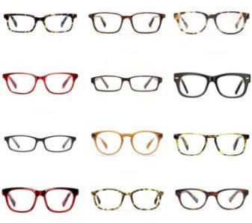
AFTER DISPENSING
DON'T SEE ANY DIFFERENCE?
This is why prescription eyewear Consumers shop online.
No difference between store-bought versus online eyewear.
POINTS TO PONDER
We can choose to learn at the hands
of the teacher, or we can learn at the
"Handcrafting prescription eyewear to fit the consumer
cannot be outsourced to virtual sources. It is an art form,
which requires actual and direct contact with the patient.
It cannot be learned or practiced in a lecture hall setting."
"For the last few decades our collective mindset has manifested as,
'Divided we stand...united we fall.' We must shift to, 'United we stand...
divided we fall,’ as our paradigm. Instead of money is the answer, what's
the question, it's time for service is the answer, what's the question?"
"More than half of all people in the United States use some type of lens
to correct their vision. How many of these have been able to acquire
handcrafted, form-fitted eyewear?" -- OpticiansForChange.com
"It's time for Opticians to receive practical form-fitting training,
an art form and craft, which cannot be taught or learned virtually.
It's time for those Opticians who know to teach those who do not know.
And it is incumbent on those who do not know to surrender their ego."
"The real challenge for any Optician is to take a symmetrically 4-point squared
device and handcraft it to fit an asymmetrically shaped surface. The answer
is hands-on training, hands-on training, hands-on training. It's time for those
Opticians who know to teach those who do not know. And it's time for those
Opticians who do not know to surrender their ego." -- Dispensing Guidelines
"When Opticians relate to Consumers as customers, it often has an adverse
impact on the relationship. When Consumers purchase prescription eyewear
they should invariably be served as 'Patients', never as 'customers'. Patients
receive healthcare. Customers receive merchandise." -- 3DDispensing.com
"If you will recall, Opticianry is ultimately defined by how well
the eyewear fits the Patient. So, the real issue for Opticians and
Consumers to consider, is not whether prescription eyewear can be
purchased in stores or online. The real issue is the current deficiency
in the delivery of eyewear due to the absence of the craftsmanship
and skills required to dispense form-fitting eyewear to the Consumer.
The real challenge for any Optician is to take a symmetrically, 4-point
square device and handcraft it to fit an asymmetrically shaped surface.
The answer is hands-on training, hands-on training, hands-on training.
It's time for those Opticians who know to teach those who do not know.
And it is time for any Opticians who do not know to surrender their egos.
It's been predicted that if Opticians fail to practice customizing eyewear to
fit the Patient, Opticianry will become irrelevant as a healthcare profession."
"Just as Hairstylists cannot practice without tactile contact with a consumer,
Opticians cannot dispense eyewear without direct contact with the Patient.
Unskilled eyeglass merchants routinely hand over prescription glasses without
hands-on assessment, nor any of the appropriate touch and feel required for
handcrafting eyewear. And when skilled Opticians dispense eyewear, they can
determine for themselves how the eyewear feels in lieu of asking the Patient."
"Today's retail optical paradigm needs to be upgraded to that of serving
Healthcare Patients, as opposed to serving retail customers. Only then can
Opticians be seen as Healthcare Professionals, instead of mere merchants."
A recent graduation class of Opticians.
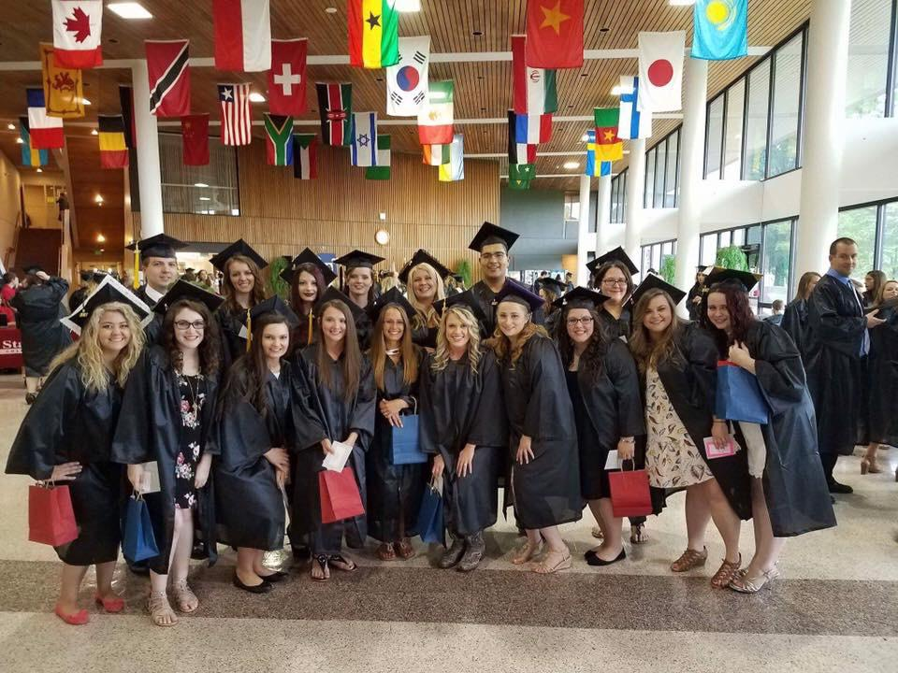
But do they have any practical hands-on frame-fitting experience?
'The Professional Ego'
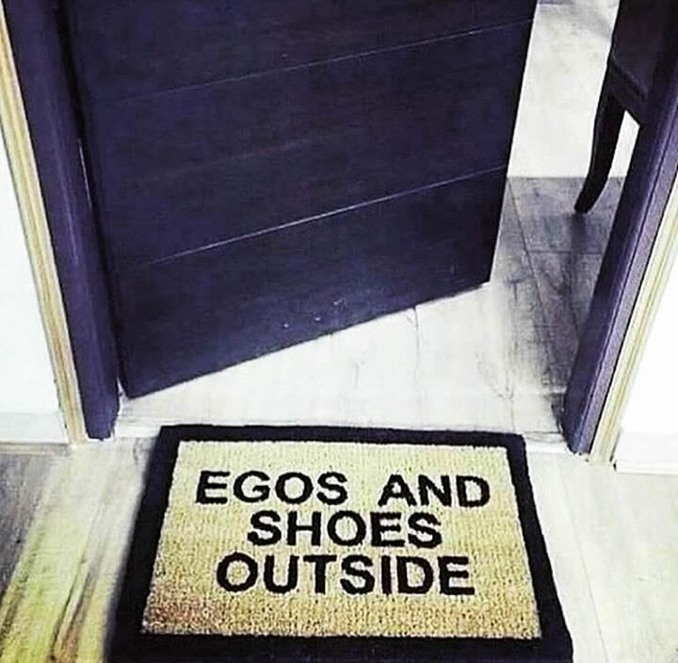
There are a number of conflicted forces at work within the ophthalmic dispensing industry, which keep us from making progress. The two biggest are:
.) We have not yet effectively dealt with the reality that the majority of current dispensers are woefully under trained and extremely challenged when it comes to handcrafting prescription eyewear. For instance, I know senior Opticians who attend Optical Workshops who are unable to adequately customize eyewear directly on a Patient. (The number one complaint by prescription eyewear consumers is they are unable to acquire well fitting eyewear.)
.) There's also a lot of what I call 'professional ego' or shaktipad*, whereby many 'Opticians' are unable to admit, either through ignorance or antipathy, that they really do not know (many only think they know and take umbrage when challenged) how to fit handcrafted eyewear. They are convinced that they need no further training, that they've been adjusting eyewear for years and see no need to change.
Regarding this 'professional ego' issue, I suggest that we ask a question of those dispensers who claim they already know how to fit eyewear and those who claim that they have been working as an Optician for several years.
"But have you had any formal training in fitting handcrafted eyewear?"
The problem is that many folks are self-taught, and most of those who came up as apprentices were taught by dispensers who have had no formalized hands-on the consumer training.
I am convinced this decades-old history is the main reason Opticianry as a profession has lost, and continues to lose market share.
Therefore it is incumbent on those who know to teach those who do not know. And it is incumbent on those who do not know to surrender their ego.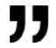 OpticalGuidelines.com
*Shaktipad: The status or mind-set of an optical dispenser who knows far less than they think they know, and who fails to acknowledge it. The worst case scenario is that the optician falls into the trap of convincing themselves and others that only they know the best way, and that the old ways need to change, going forward. Beware of the 'tiger's bite'! Shaktipad is a normal consequence of 'riding the tiger' of pride. One must ever be alert to the signs in order to take appropriate action. In the case of opticians, the remedy is to seek out practical training with the attitude of a student, i.e., one who surrenders their ego, and realizes that learning never stops, that one can always improve their skills. See Ego Eradicator.
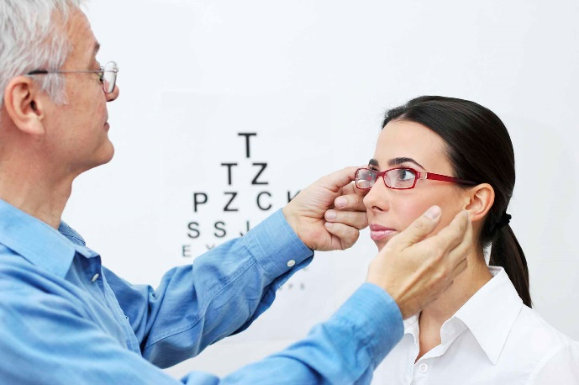
Opticianry is defined by how well the eyewear makes contact with the patient.
"While serving as an eyewear professional, I hereby pledge the following:
To conduct in-depth lifestyle interviews of my eyewear Patients;
To assist Patients with design and selection of their eyewear;
To provide eyewear Patients with form-fitting eyewear;
To serve my Patients with free lifetime eyewear
adjustments and minor repair services;
As an Optician who knows, I pledge
to teach those who do not know."
See EyewearGenie.com.
Here is where we explore
Handcrafted, Form-Fitting Eyewear
aka Old Fashioned Hands-on Opticianry and
where we teach Opticians who think they know, how
to custom fit temples to the topography of the mastoid.
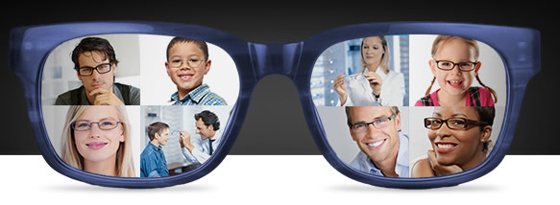
Opticianry is ultimately defined by how well the eyewear makes contact with
the Patient, not by the number of sales or customers served. Opticians are highly
skilled Eyewear Professionals. Optical Dispensaries are Health and Wellness Facilities.
"The real challenge for any Optician is to handcraft a symmetrically
4-point squared device to fit an asymmetrically shaped surface."
1ST STEP WHEN DELIVERING EYEWEAR
Make sure the eyewear is in standard 4-point alignment!
Check the 'x' plane especially before proceeding with any adjustments.
NOTE: A twisted bridge causes lenses to be out of square with the face.
When 'x' plane is not square, one lens is twisted out of plane with the other.
When one lens is out of plane, all other alignments will be adversely affected.
The x, y, z axes must be squared.
X-axis - the horizontal,
Y-axis - the vertical,
Z-axis - the optical axis of the system.
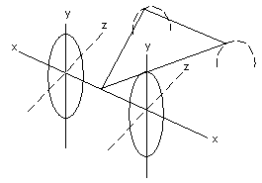
x, y, and z planes
'Four pointing' eyewear on a table is never a substitute for
custom fitting the frame directly on a person. For too many
ECPs the table has become the point of service, not the Patient.
NOTE: Once eyewear is bench-squared it is pointless to repeat this
procedure. Now it's time to person-square the frame directly on Patient.
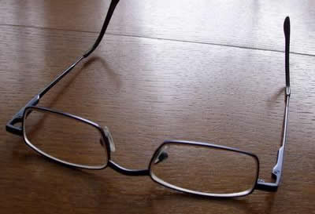
Four pointing a frame
The Optician must personally place the eyewear on the Patient’s face,
thus allowing for a mental 'snapshot' to be taken of any problem areas.
This permits both visual and tactile assessments to be made in order to
handcraft and form-fit the eyewear for the long term comfort of the Patient.
The eyewear must be placed on and off the Patient by the Optician as many
times as necessary until all form-fitting issues are resolved. Dispensing should
never be rushed. Handcrafted adjustments need as much time as necessary.
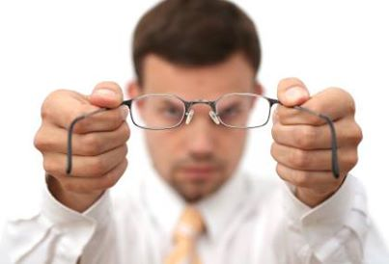
CORRECT
YOU MUST PLACE NEW EYEWEAR DIRECTLY ON THE PATIENT
DO NOT JUST HAND THE PATIENT THEIR NEW EYEWEAR
WRONG
Opticians always need to relate to Consumers as 'Patients'.
Only eyeglass merchants relate to Consumers as 'customers'.
Patients receive Healthcare. Customers receive merchandise.
2ND STEP WHEN DELIVERING EYEWEAR
Place the eyewear on the Patient yourself.
Hold spectacles by temples. Spread them slightly.
Avoid forcing the eyewear onto the Patient's head.
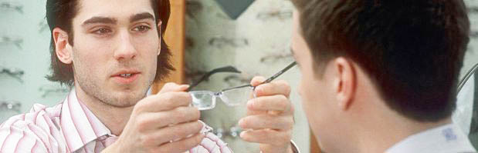
CORRECT
SPECIAL NOTE
A lot of non-verbal data is gathered and imprinted by the
Optician while placing the eyewear on a Patient. Skilled Opticians
will know how the eyewear 'feels' without even asking the Patient.
WHEN PLACING THE EYEWEAR ON THE PATIENT'S HEAD
Push temples down gently on the ears to check for fit and straightness.
NOTE: This can be done visually, but MOSTLY using Your Sense of Touch.
THE FITTING TRIANGLE
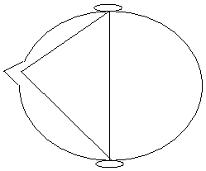
The Fitting Triangle
VISUALLY CHECK THREE POINTS
Crest of Nose (Bridge)
Above Right Ear-Crest
Above Left Ear-Crest
What bridge style will best fit these patients?
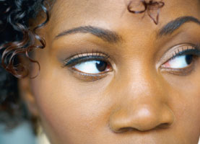
TOUCH AND FEEL THESE POINTS...
Behind each ear (the mastoid complex).
Check for gaps between the temple and skull.
Do NOT use the ears to hold the glasses in place.
The ears are to act only as a stop, not to hold glasses
NOTE: Ears are also used as a means of front alignment.
MAKE ADJUSTMENTS IN THIS ORDER
1. Temple Spread
2. Bridge of The Nose
3. Frame Front Alignment
4. Temples at Crest of Ears
5. Temple Contact With Mastoid Area
(See Mastoid-Bend and Mastoid-Wrap)
"The real challenge for any Optician is to handcraft a symmetrically
4-point squared device to fit an asymmetrically shaped surface."
TEMPLES TOUCHING THE SKULL WITH NO PRESSURE IS THE RULE
Temples must touch at ALL points behind the ears. If NO touch, there's NO hold.
Nosepiece and temples are to hold eyewear in place on the nose, and behind ears.
Do NOT adjust temples to make contact with ears in order to hold eyewear in place!
TEMPLE-SPREAD
(Using Endpiece Adjustments)
BASIC FRAME ALIGNMENT
A: When temples too tight, spread temples
B: When temples too loose, bring temples in
C: When just right, temples touch head with no pressure
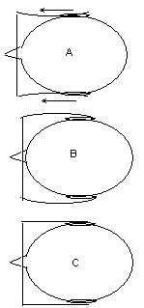
Temple-Spread
Most people have at least some subtle
facial-cranial anomalies to be reckoned with.
The Dispenser must stand up, look and feel behind
the ears, then look down over the top of the Patient's
head to acquire the above view of the fitting triangle.
Use your hands to manipulate the head, the frame, and
to feel the temple ends relative to the mastoid complex.
Temple-touch must NOT exert pressure on either side of head!
If temples press on the sides of head, the frame-front will be
pushed down the nose, and temples can cut into back of the ears!
If Patient complains of glasses slipping, DO NOT INCREASE temple-spread!
Temple-touch without any pressure is necessary at the crest (top) of the ears!
Too much temple-spread will mostly cause the eyewear to slip down the nose!
TEMPLE LENGTH
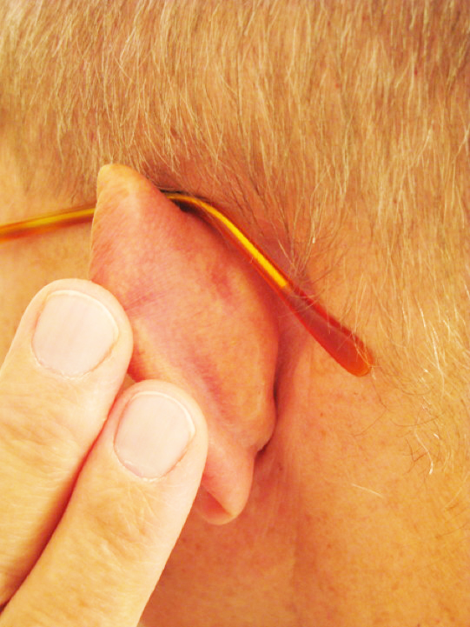
The temple is too short in the photo, left, and the temple-end, right,
makes contact with the skull only at the very tip. See form-fitted temple.
TEMPLES TOUCHING THE SKULL WITH NO PRESSURE IS THE RULE
Temples must touch NOT PRESS behind the ears. If NO touch, there's NO hold.
Nosepiece and temples are to hold eyewear in place on the nose, and behind ears.
Do NOT adjust temples to make contact with ears in order to hold eyewear in place!
UNEQUAL VERTEX DISTANCE ISSUES
Caused by unequal temple-spread or an asymmetrically shaped head.
Right temple needs to be spread if left lens is too close to face.
Left temple needs to be spread if right lens is too close to face.
'BEND TO THE PROBLEM' IS THE RULE TO REMEMBER
Right frame-front too close IN? Adjust right endpiece IN.
Left frame-front too far OUT? Adjust left endpiece OUT.
SPECIAL POINTS TO PONDER
ALLOW TIME FOR CUSTOMIZING
TAKE THE TIME TO DO THE JOB RIGHT
Oftentimes many adjustments are necessary.
Hint: Split the adjustments between the two sides.
Hint: If Patient complains of pressure on one side of the nose and
the opposite side of the head, it may be due to unequal temple spread.
PRACTICE MAKES PERFECT
Practice placing a squared frame on a partner.
Customize the frame using handcrafting techniques.
Opticians are Eyewear Professionals. Opticianry
is ultimately defined by how well the eyewear makes
contact with the Patient, not by the number of 'customers' served.
ADJUSTING THE FRAME-FRONT
When Temple-Spread is achieved,
continue adjustments in this order.
1. Pantoscopic Tilt
2. Frame Alignment on Face
3. Remaining Temple Adjustments
(See Mastoid Dip and Wrap here)
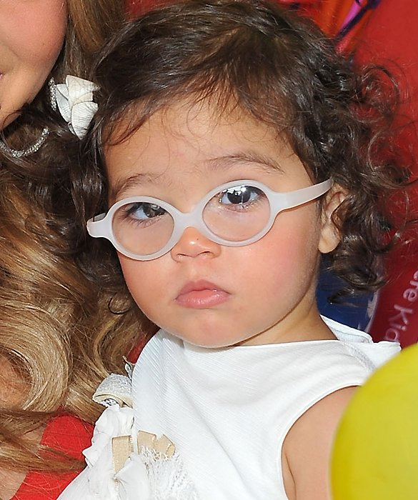
PANTOSCOPIC TILT
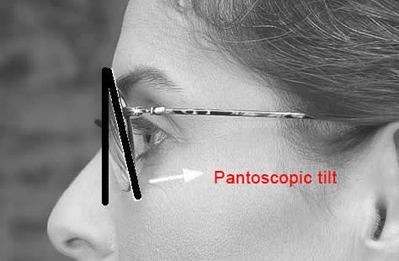
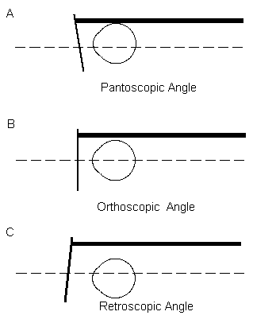
Frame-Front Tilt
Flat-Fitting Front
General Rule: For every millimeter the pupil is positioned above
the optical center of a lens, about two degrees of pantoscopic angle
should be applied to the front. The usual inclination of the front can be
from 4 to 18 degrees from the vertical, depending on the Patient’s facial
features. Lenses and-or eyewire should not touch lashes, eyebrows or cheeks!
FRAME-FRONT ALIGNMENT ON THE FACE
Frame-Front is not in alignment because...
A. One eye is higher than other
B. One ear is higher than other
C. Temples are not parallel
D. Frame Front is crooked
No two heads or faces have the same dimensions, so the delivery
of eyewear 'as is' or as if it's one-size-fits-all, is NOT an option.
"Patients deserve custom-fitted prescription eyewear.
When adjusting glasses, you're fitting a human being
for comfort, not an inanimate table for square or for pretty.
Opticians must observe and feel glasses in-place on the Patient
and then take the time to align and handcraft the eyewear to fit."
CAN YOU SPOT ASYMMETRIES IN THESE PHOTOS?*
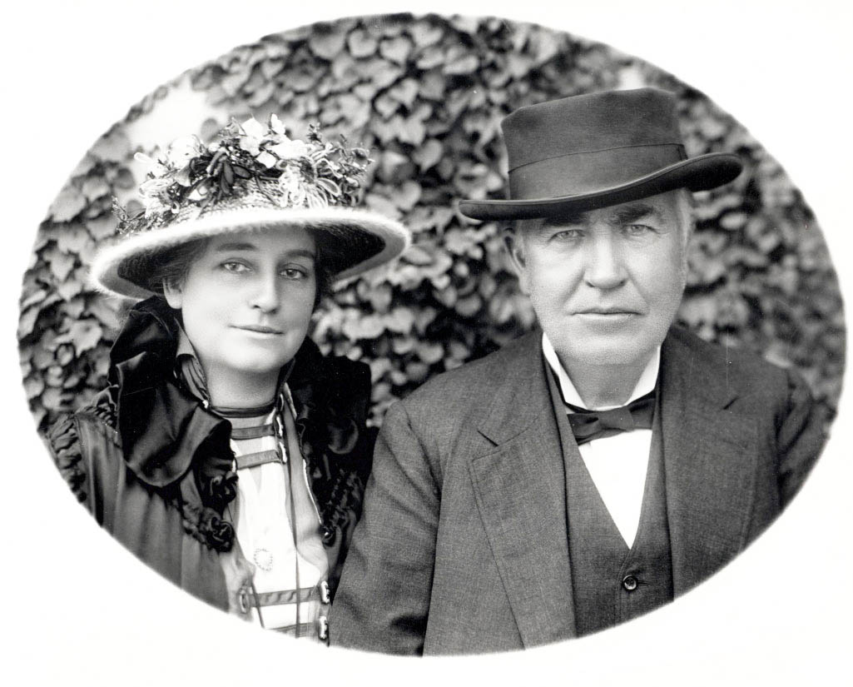
QUESTIONS NEEDING ANSWERS
How will anomalies affect the design of patient's lenses?*
Do facial asymmetries translate into ear-skull anomalies?
Can these be overcome via lens-frame design and-or adjustments?
ALWAYS FIT TO THE ANOMALY
There is no right or wrong way to fit eyewear.
There is only the Patient's way.
Be prepared to accommodate facial-cranial anomalies when
designing-fitting prescription lenses in cutting edge eyewear.
*SPECIAL NOTE: Multi-focal lenses are routinely ordered today with the reading portion placed at matching heights because vertically equal eye symmetry is assumed to be the norm and-or "it looks better" when the segments can be observed as vertically and horizontally equidistant, and because vertical eye asymmetry is not considered as a design factor, even though its consideration is important for the Patient's visual balance and comfort at the near and intermediate points. In fact, eyewear merchants don't allow for any disparate bifocal segment height or seg inset in their lens design, even in their software. Skilled Opticians however, will compensate for the Patient's structural disparities in their frame and lens design and-or hands on the face, in place frame adjustments. See My Two Sense.
EXAMPLES OF FRAME MISALIGNMENT
ISSUES
A. Right front is too high.
B. Left lens is down.
C. Left lens is up.
REMEDIES
A. Re-angle the right temple up.
B. Re-angle left temple down.
C. Re-angle left temple up.
To make sure Frame-Front is straight, use overall appearance
of the eyes, eyebrows, floor, and ceiling as reference points.
NEVER REFERENCE THE EYEBROWS ONLY!
FRAME-FRONT ISSUES AND THEIR CAUSES
Bent Endpiece
Misaligned Hinge
Unequal Temple Angle
Bent temples
Skewed Bridge
One eye higher than the other
One ear higher than the other
One ear farther back than other
Asymmetric skull, eyes, ears or nose
REMEDIES
Adjust bridge-pad angle and temple-bend.
RAISING AND LOWERING FRAME HEIGHT
FIXED-BRIDGE FRAMES
Very difficult to adjust.
Try shrinking-widening bridge.
Try using special pliers, or dowel rod.
ADJUSTABLE NOSE PAD FRAMES
Raise front: Bring pads in or lower pad arms.
Lower front: Bring pads out or raise pad arms.
VERTEX DISTANCE OF LENSES
x, y, and z planes
Lenses must be equidistant from each eye.
Make sure x, y, z planes are squared, especially the x plane.
SPREADING THE NOSE PADS OUT
Frame-front will come down and in
NARROWING DISTANCE BETWEEN PADS
Frame-front will come up and out
CHECK NOSE PAD ANGLES
Vertical
Frontal
Splay
PRACTICE MAKES PERFECT
Practice With A Partner
Open Temple Angle
Pantoscopic Tilt
Front Alignment
Height of Frame
Vertex Distance
Pad Positioning
WHEN OPEN TEMPLE-SPREAD AND FRAME-FRONT FIT ARE GOOD
It's time for temple adjustments including behind-the-ear mastoid bends.
TEMPLES TOUCHING THE SKULL WITH NO PRESSURE IS THE RULE
Temples must touch at all points behind the ears. If NO touch, there's NO hold.
Nosepiece and temples are to hold eyewear in place on the nose, and behind ears.
Never adjust the temples to make contact with the ears to hold the eyewear in place.
KNOW YOUR TEMPLE-TYPES AND THEIR CHARACTERISTICS
TEMPLES USING LATERAL TOUCH
A. Library style fits straight back
B. Skull style fits skull behind the ears
C. Comfort cable-Riding bow wraps around ears
TEMPLES TOUCHING THE SKULL WITH NO PRESSURE IS THE RULE
Temple touch-points should be at the bend, i.e., just above crest of ear,
and then just past the crest of the ear, matching the contours of skull.
(See example of form-fitting Mastoid-Bend and Mastoid-Wrap here.)
PROCEDURES FOR BEHIND-THE-EAR HANDCRAFTED
FORM-FITTING BENDS INCLUDING MASTOID SCULPTING
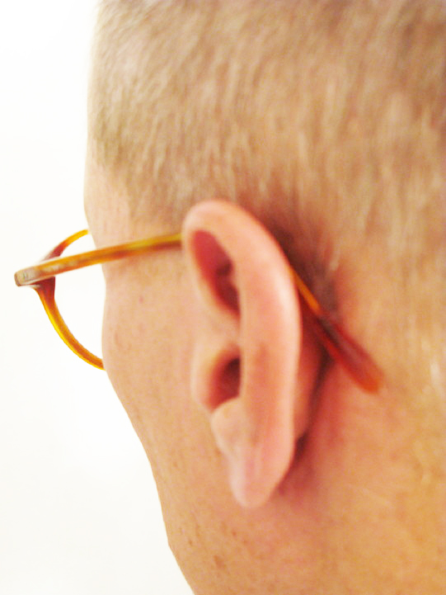
Note big gap between skull and temple-end.
"Where there's no touch, there can be no hold.
Temple-ends must fully contact the mastoid complex.
Temple-ends cannot hold eyewear in place for long-term
comfort if they do not make full contact with the mastoid.
Full contact does not mean pressure. Touch only is necessary."
1950s Optician-assisted frame selection

"Opticianry is defined by how well the eyewear makes contact with the patient.
Eyeglass consumers need and deserve the following:
a) Optician-assisted, in-depth lifestyle interview;
b) Optician-assisted, design and selection;
c) Handcrafted, form-fitting eyewear;
d) Free lifetime adjustments and
minor repair services, none of
which are available online."
See EyewearGenie.com.
Everyone deserves sufficiently handcrafted,
multi-dimensional, form-fitting frame adjustments, e.g.,
gaps and spaces are removed from between the frame's
temples and the skull behind the ears, in order to enhance
comfort, stability, and full-time wearability. Full contact with
a light touch of the skull, NOT THE EARS, is the primary means
by which the frame should be held in place for long-term comfort.
Note: If you're able to teach this skill, contact me at LinkedIn.com.
FORM-FITTING THE MASTOID COMPLEX
With Handcrafted Mastoid Dip and Mastoid Wrap
Form-fitted for an actual patient
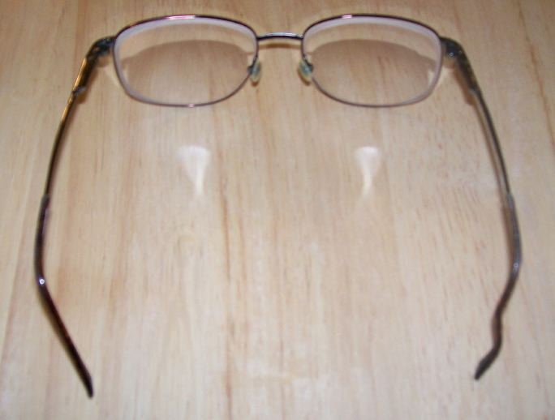
Bends are not seen when worn!
DIRECTIONS
. Note old bend position
. Estimate new bend position
. Straighten and re-bend (3 bends)
A. Make vertical bend just past ear crest
B. Bend temple-end to create mastoid-dip
C. Bend remainder to create wrap around skull
BEFORE temple-end is in out-of-the-box condition,
i.e., it doesn't make contact with the Patient's skull,
whereas the AFTER temple has been form-fitted with
an added handcrafted mastoid dip and mastoid wrap.
It now fits the mastoid bone like a glove since it has been
shaped to make full, direct contact with this Patient's skull.
Custom-fitted by hand temples become invisible when worn
and the resultant fit avoids pressure and is extremely comfortable.
NOTE: This skill cannot be learned virtually, i.e., via lecture or online.
This skill is acquired only by handcrafting the eyewear using direct, face
to face, on the Patient, tactile, touch and feel contact with the Patient. The
availability, knowledge and skilled use of related handcrafting tools is essential.
Also, keep in mind that online merchants are incapable of providing this service.
WHEN MUCH BENDING HAS BEEN DONE ESPECIALLY BEHIND THE EARS
Show the Patient the adjustments you've made and explain the necessity.
This avoids Patient returning to say that the frame doesn't lie
“straight” on the table, or "they don't look like grandma's!"
SUMMARY OF FITTING CRITERIA
VERTICAL HEIGHT OF EYEWEAR
Symmetry of Height
Pantoscopic Tilt
Vertex Distance
BEHIND-THE-EAR BENDS
No-gap skull-contoured
If no touch, no hold
NOSE PAD POSITIONING
Nose pad angles
A. Vertical
B. Frontal
C. Splay
See that pads are flat on the nose
See that temple tension is equalized
AFTER THE FRAME IS ADJUSTED
Give instructions to Patient
GENERAL INSTRUCTIONS TO PATIENTS
WRONG
Always remove your eyewear with TWO hands!
One-hand removal stretches and weakens temples.
Do not leave your eyewear on the dashboard of your car!
Glasses should be kept inside a case, preferably a hard case!
When removing your eyewear, especially with cable temples...
Lay the glasses down on table with temples open, and upside down!
ALWAYS RINSE LENSES WITH RUNNING WATER BEFORE WIPING CLEAN!
FINALLY
Compliment Patient for their decision in purchasing eyewear!
And always genuinely thank Patient for their patronage and support!
MORE POINTS TO PONDER
After many years of failing to provide the public with
Hands on Patient, handcrafted services, many Opticians
have suddenly discovered that consumers are flocking to
the Internet for eyewear purchases, where likewise, they
are unable to acquire customized frame-fitting services.
Refusing to admit culpability, these same retailers now
blame cheap online prices and unethical practices for the
erosion of market share and the steep decline of revenues.
(See AARP's 'Your Money,' December, 2011, for example.)
Consumers deserve a pleasant experience.
Consumers deserve as much time as they need.
Consumers deserve handcrafted prescription eyewear.
What do Dentists, Manicurists, Hairstylists and
Opticians all have in common? They all make direct,
tactile contact with consumers while dispensing services.
When Opticians do not touch consumers at the time
they dispense prescription eyewear, they are acting
as unskilled eyeglass merchants, not as Opticians.
Opticians must practice Three Dimensional Opticianry:
Full DISCOVERY; Masterful DESIGN; and Touch
and Feel DELIVERY of prescription eyewear.
When Opticians relate to consumers as Customers,
it often has an adverse impact on their relationship.
When consumers purchase prescription eyewear they
should invariably be served as Patients, never Customers.
Patients receive Healthcare. Customers receive merchandise.
Opticians are vision experts who serve Patients with
comprehensive vision solutions, unlike eyeglass merchants
who mostly sell their customers eyeglasses and contact lenses.
The manager of a nationwide retail optical dispensary
advised a staff member who attempted to customize a
frame as seen here that they would be fired if they tried to
fit another "customer" with such an "ugly looking" adjustment.
Never mind that the temple ends look, feel, and fit like a glove.
Pushing consumers into Progressive Addition Lenses without
full discovery and disclosure is tantamount to the over-zealous and
now criticized universal practices of circumcision and tonsillectomy.
There is no right or wrong way to handcraft eyewear.
There is only the Patient's way. Therefore, Opticians must
take as much time as needed to customize the Patient's eyewear.
The conflicted relationship between Professional Opticians and
Retail Management can be likened to the current relationship
between Medical Practitioners and Insurance Industry HMO's.
What are the chances of prescription eyeglass consumers getting
handcrafted, customized fitting of their eyewear in today's market?
If you answered this question correctly, you know why they buy online.
More and more eyewear is being purchased online.
The number one complaint of brick and mortar store patrons?
"Nobody adjusted my glasses. They just handed them to me."
So, for these consumers there's little difference between the service
they receive in many of today's dispensaries and buying glasses online.
Opticians are Eyewear Professionals. Opticianry
is ultimately defined by how well the eyewear makes
contact with the Patient, not by the number of customers served.
Therefore, a conscious, precise, and personalized process of frame
selection, lens design, and in-place, hands-on fitting is required. In too
many cases unrealistic and excessive sales goals override the Optician's
mission of providing professional Healthcare, whereby the personalized,
custom fitting of eyewear is given only the most minor consideration, if any.
Opticians must assume responsibility for loss of market share.
Our gradual drift from hands-on services over several decades is
what has contributed directly to our loss of market share, today. We
can't be any more disconnected from hands-on service than the Internet.
The consumer didn't demand or cause this outcome. Opticians abdicated
their direct connection, vis-a-vis insufficient form-fitting eyewear training.
Opticians traded away direct, personal contact as providers of health care
services to PATIENTS for marketing merchandise to CUSTOMERS. Our focus is
now more on Selling than it is on Serving. Opticians must regain the lost balance.
The future of Opticianry is quite literally and figuratively in the hands of Opticians.
It's incumbent on those skilled Opticians who know to teach those who do not know.
And it is just as equally incumbent on those who do not know to surrender their ego.
The customized fitting of eyewear involves more than just adjusting a nose
piece or bending a temple. It has to include the reshaping, bending, stretching,
twisting and artful sculpting of the frame components in order to personalize the
eyewear. Anything less will most likely compromise the Patient's visual comfort
and full-time wearability. The difference between adjusting and customizing is
what's different between today's eyewear merchants and yesterday's Opticians.
Hand crafted multi-dimensional adjustments, including tactile, hands on the Patient,
touch and feel craftsmanship such as reshaping the temple ends to make direct
and full, touching-without-pressing contact with the mastoid area behind the ears,
and simultaneously avoiding direct contact with the pressure-sensitive ears, is
the single most important considerations for long term comfort and wearability.
Many dispensers practice four-pointing eyewear on a flat surface as
a substitute for handcrafting eyewear directly on the Patient. This is a
pointless, time consuming exercise after the frame is initially squared,
usually at the lab. Once four-pointed, the eyewear must be fashioned by
skilled hands, using appropriate tools, to form-fit the contours that are unique
to each Patient's face-skull, to wit four-pointing becomes an exercise in 'fluff.'
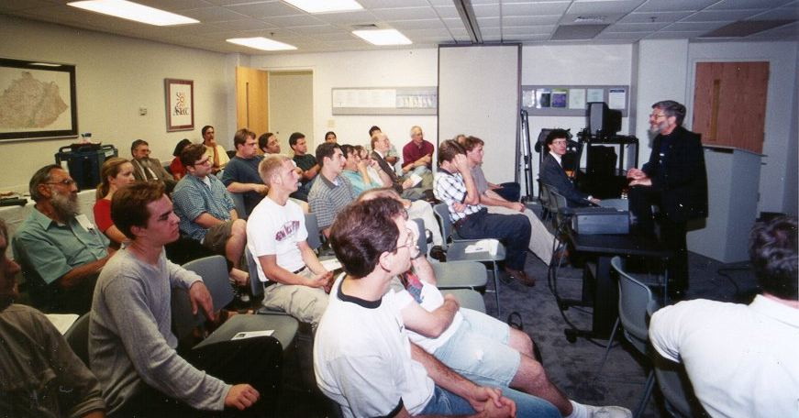
Frame-fitting skills cannot be lecture-learned,
they must be applied using direct hands-on contact.
Handcrafted frame-fitting, i.e., touch and feel, hands-on dispensing,
cannot be outsourced to text books or virtual sources. It is an art form and
craft, which requires actual and multi-dimensional contact with the Patient.
Experience is the best teacher.
Practical experience is the final teacher.
"Handcrafted frame-fitting, i.e., touch and feel, hands-on dispensing,
cannot be outsourced to lectures or virtual sources. It is an art form,
which requires actual and multi-dimensional contact with the patient."
Opticians must 'humaneyes' their dispensing procedures.
Only touch and feel, hands on the Patient training can provide an
Optician with multi-dimensional skills required to serve consumers.
**Optical Workshops is a Florida approved Continuing Education Provider #50-13776.
Please contact them here or call 855-410-2700 to acquire hands-on training.
MORE POINTS TO PONDER
Any ophthalmic dispenser who is not practicing these Basic Guidelines is a mere eyeglass merchant, not an Optician. The absence of these practices (not cheaper prices) is the reason more of today's PRESCRIPTION eyewear consumers purchase their eyewear online.
When there is NO DIFFERENCE between the offerings of a brick-and-mortar merchant and an online vendor, other than price, many consumers will understandably choose the online source. Keep in mind that 7-11 stores are successful even though their prices are high. Why? Because consumers get the Service and Quality they want. There are only three things available to consumers in the marketplace, Service, Quality and Price. But ONLY TWO of these can be had at one time from any one source. Why not choose SERVICE, i.e., Three Dimensional Dispensing, and QUALITY as your primary offerings to consumers?
Those practitioners who remain in denial over the Internet ophthalmic sales issue, which prostitutes the profession of Opticianry, must eventually accept responsibility for the success of online vendors since Opticians collectively are the major source of, and the major solution to the matter.
See TheiSites.com. See My Two Sense. See Enough With The Talking Points. See Points To Ponder Discussions for more. See The Danger Independent Opticians Face. See 50 Things On-Line Sellers Simply Cannot Do – But We Can! See Our Letter to ECPs.

Shift Happens
Letter To ECPs
The Power of Touch
Common Complaints
Touch and Feel Dispensing
Visit OpticalWorkshops.com
Customizing Prescription Eyewear
Visit Points-To-Ponder Discussions
More Hands-On-The-Patient Pointers
Hands-On-The-Patient Delivery Defined
Whatever happened to old-fashioned
Hands on the Patient Opticianry?
Contact Lens Care and Compliance
Eyewear For Hard-To-Fit Patients
NCLE No Fee CEs For Opticians
The Rap on Wrap-arounds
Sunwear Is Not An Option
About Professional Egos
Time For Craftsmanship
Hands-on Frame Fitting
Anti-Reflection Coatings
Dispensing Guidelines
For Optical Managers
The Power of Touch
Serving vs Selling
Jobs For Opticians
Get Optician Jobs
Optician's Forum
3D Dispensing
Shift Happens
Video Library
Testimonials
Resources
Books, lectures and tests can take an Optician only so far.
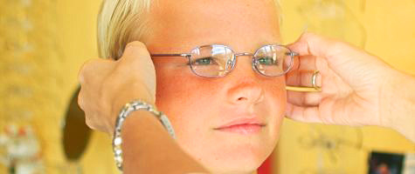
It is time for touch-and-feel, Hands on the Patient training.
Only one on one craftsmanship training provides this.
Craftsmanship cannot be learned virtually.
"Handcrafted frame-fitting, i.e., touch and feel, hands-on dispensing,
cannot be outsourced to lectures or virtual sources. It is an art form,
which requires direct and multi-dimensional contact with the patient."
HANDS ON THE PATIENT WORKSHOP TRAINING AVAILABLE HERE
"It is incumbent on those who know to teach those who do not know.
It is incumbent on those who do not know to surrender their ego."
American Board of Opticianry accredited and Florida State Board approved CE hours
for Intermediate and Advanced Level Opticians in Handcrafted Frame-Fitting are
currently offered under the sponsorship of POF, the Professional Opticians of
Florida. Click or Call 855-410-2700 to arrange for Training Session.
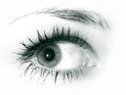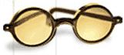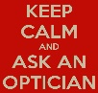
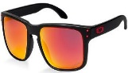
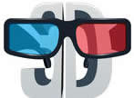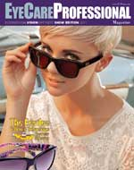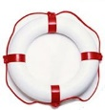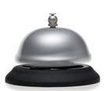
DispensingGuidelines.com
© All rights reserved.
Grateful appreciation is hereby expressed to
Ennco Display Systems and Systems of Sight for
permission to use their copyrighted images on this website.
To report website functionality issues, please contact us here.
More Web 'Sights' by
EyeWearProfessionals.com
TheiSites.com | MySixSense.com
OpticalViews.com | 2020Forsight.com
OpticalCourse.com | 3DDispensing.com
FitItAndForgetIt.com | EyewearGenie.com
OpticianryToday.com | EyewearMoodys.com
2020ForOpticians.com | OpticianryReview.com
OpticalGuidelines.com | OpticiansForChange.com
OpticalWorkshops.com | ServingVersusSelling.com
OpticalShiftHappens.com | EyewearProfessionals.com
GlassesOnlineWarning.com | EyeExaminationOnline.com
TimeForCraftsmanship.com | OpticiansForThePeople.com
TestYourKnowledgeOnline.com | ReachOutAndTouchSomebody.com

More Web sites by
KhalsaWebMasters.com
SAAAP.org | Dieterata.com
AllIsOne.guru | HariSingh.com
TheISites.com | SikhTribes.com
SopaSeca.com | SikhSongs.com
UbuntuAge.com | WaheGuru.guru
UntoInfinity.com | NarayanOil.com
LeftOfMaya.com | SikhsShine.com
LivtarSingh.com | 3HOHistory.com
EyesOnPies.com | Turbanators.com
SikhAnthem.com | IsolatedSeer.com
BroadPoints.com | 13EkOngKar.com
Obama43To1.com | SoothingSpa.com
HariKaurBird.com | ChardeeKala.com
OpticalViews.com | 2020ForEyes.com
KhalsaVision.com | SPIRITofGRD.com
GuruRamDas.com | LakeKillarney.com
DualityOptics.com | HariSinghBird.com
MySikhSense.com | RamDasSingh.com
BigotDetector.com | BeYourAllness.com
3DDispensing.com | LandOfAwwws.com
Interior-Guard.com | SatKartarSingh.com
OpticalCourse.com | DrRamonIbarra.com
MiriPiriWarrior.com | FitItAndForgetIt.com
1IsTheAnswer.com | OpticianryToday.com
SatNamMeans.com | WordPhysiology.com
KaliYugaSigns.com | JustAddedWater.com
SiriSinghSahib.com | EyewearMoodys.com
1And1Equals11.com | PreetKaurKhalsa.com
CloseOrderDrill.com | WhiteTantraYoga.com
RamDhanSingh.com | 3HOLegacyLinks.com
2020ForWomen.com | TheMahanTantric.com
HangupsByHari.com | SiriMantraForLife.com
DownWithCarbs.com | WhoAreTheSikhs.com
ACTForDiversity.com | OpticianryReview.com
AdiShaktiMantra.com | 2020ForOpticians.com
ScienceOfMudra.com | OpticalGuidelines.com
OneIsTheAnswer.com | GuruGobindSingh.com
ScienceOfMantra.com | OpticalWorkshops.com
GuruGaitriMantra.com | KirpalSinghKhalsa.com
OohRahMemorial.com | SimranKaurKhalsa.com
WeProcessLoans.com | SatpalSinghKhalsa.com
AkalCommittee13.com | SadhanaGuidelines.com
GurdwaraSecurity.com | YouAreTheEssence.com
AmarSinghKhalsa.com | KundaliniYogapedia.com
DiversityDialogues.org | StFrancisOfficePark.com
SensitivitySummit.com | ToTheSweetestMom.com
AwtarSinghKhalsa.com | YogiBhajansTeacher.com
SurvivalCampUSA.com | OpticalShiftHappens.com
KhalsaWebMasters.com | AllForOneWonForAll.com
MasculineMoments.com | DrinkingDrivingDead.com
AhaMomentOfTruth.com | MyInterviewWithGod.com
HairInLaysTheTruth.com | SaTaNaMaMeditation.com
PartnersNotParents.com | FaceBlindnessIsReal.com
ToTheSweetestWife.com | ToServeIsToSucceed.com
EachMomentIsAGift.com | ServingVersusSelling.com
SikhAndYeShallFind.com | SukhmaniKaurKhalsa.com
OpticiansForChange.com | LakesideManorOnline.com
HappinessIsTheRule.com | EyeWearProfessionals.com
AtTheFeetOfTheYogi.com | SecurityAdvisoryTeam.com
SiriGuruGranthSahib.guru | ReligionDemographics.com
RaMaDaSaMeditation.com | TimeForCraftsmanship.com
UniversityOfDiversity.com | FirstSikhOfSikhDharma.com
YogiTeaByYogiBhajan.com | AkalCommitteeThirteen.com
DispensingGuidelines.com | HealthEqualsHappiness.com
CourageousDialogues.com | GoodGuysWearTurbans.com
SatKriyaByYogiBhajan.com | AquarianAgeBeganHere.com
IfYouKnowWhoYouAre.com | ButterflyEffectExplained.com
EyeExaminationOnline.com | FirstTeachersAreWomen.com
GlassesOnlineWarning.com | SugarIsAFourLetterWord.com
IDoNotEatDeadAnimals.com | SikhWomenWearTurbans.com
MoreThanYouCanKnow.com | WomenWimpsOrWarriors.com
OpticiansForThePeople.com | CosmicCyclesAndCircles.com
OnsiteFamilyHealthcare.com | TheAfterDeathExperience.com
SantSipahiAdvisoryTeam.com | IAmABornAgainAmerican.com
KirtanKriyaByYogiBhajan.com | TestYourKnowledgeOnline.com
SatHanumanSinghKhalsa.com | LifeAccordingToYogiBhajan.com
TextingAndDrivingIsCrazy.com | NowYouKnowThatYouKnow.com
ItsAllAboutMeNotAboutYou.com | KundaliniYogaByYogiBhajan.com
WordsOfWisdomAndHumor.com | IfYourDadDoesntHaveABeard.com
CrucifixionByAnEyewitness.com | EndOfPrideAndPrejudiceIsNigh.com
GodAndMeMeAndGodAreOne.com | EkOngKarSatNamSiriWaheGuru.com
ReachOutAndTouchSomebody.com | TheTechnologyOfConsciousness.com
ConsciousCommunicationGuidelines.com | OneIsTheAnswerWhatIsTheQuestion.com

