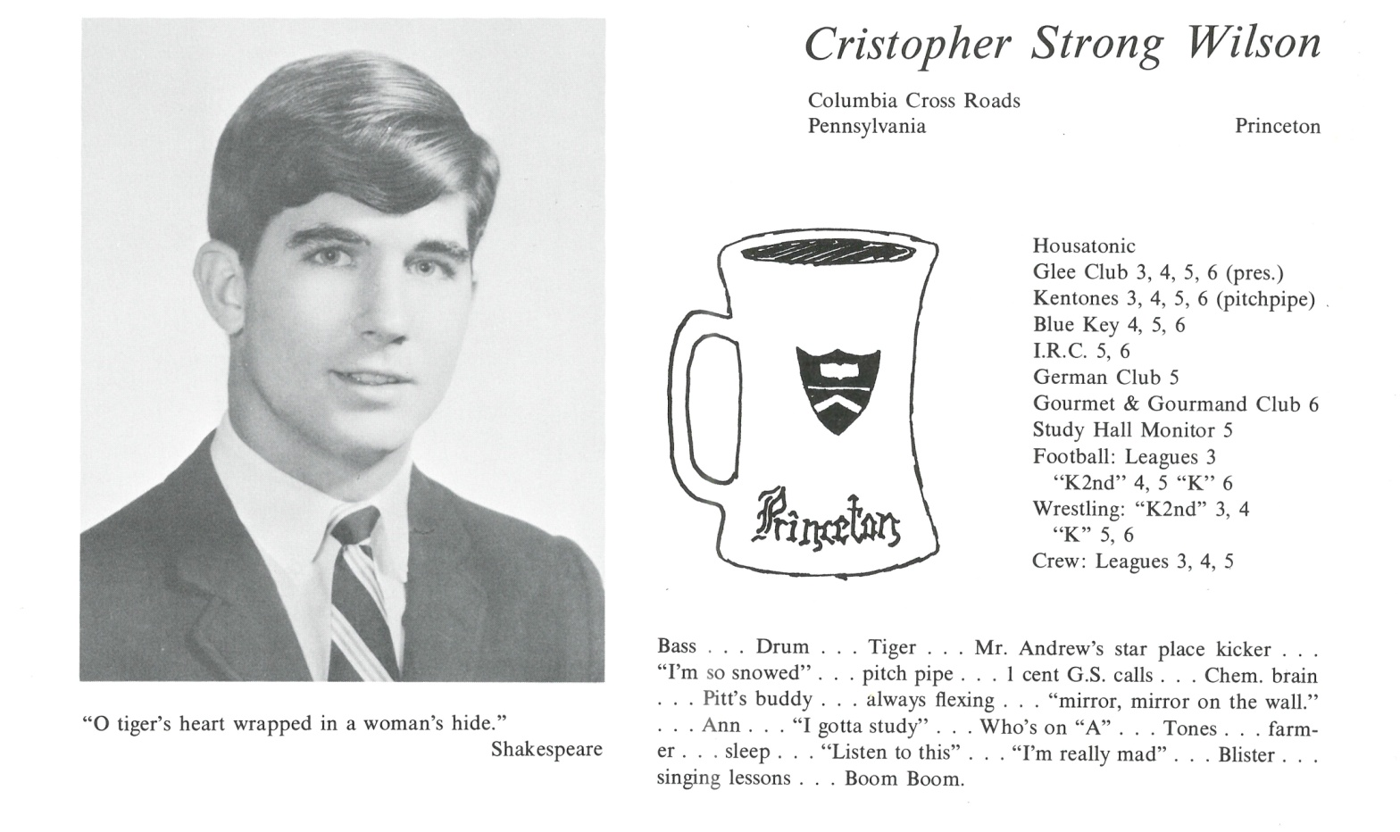

Christopher S. Wilson

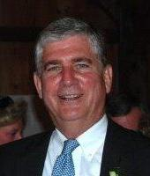After leaving Kent, I spent my Princeton years as an NROTC scholarship student and member of the Princeton Nassoons, an acapella singing group. I majored in history and foreign affairs and was commissioned a Marine infantry officer in 1971 where I served during the remainder of the Vietnam War. I married a California girl in 1973 and together had three children over the next eight years while launching my business career. We lived in a variety of places including Riyadh, Saudi Arabia, Sanaa, Yemen, SF, LA and New York before settling in Concord, MA in 1981.

Unfortunately, the marriage didn’t survive so I lived as a bachelor for a few years before meeting a wonderful woman, Carol Finigan, and her five daughters ranging in age from two to fifteen. We married in 1996 and set out trying to raise this eclectic group of eight loveable souls. Our life has been immersed in that effort and keeping up with the still-growing family. All have completed their educations and been successfully launched. Five of the seven girls have been married and all eight are engaged in their own careers. We are enjoying our six grandchildren with a new arrival expected in late June.

Professionally, I spent the first 15 years of my career as a banking executive; the next 10 as a consultant to manufacturing companies; and the last ten with Chase Corporation, an advanced materials manufacturer, first as Director of Sales and Marketing and now as Director of Business Development, focusing primarily on M&A. Carol owns and operates a thriving property and casualty insurance business.

As I slide into “maturity” phase of my life, I’m loving travel, time at our Cape get-away, golf and playing the banjo.



______________________________________________________________

______________________________________________________________ ______________________________________________________________ ______________________________________________________________ ______________________________________________________________ ______________________________________________________________ ______________________________________________________________ ______________________________________________________________ ______________________________________________________________

Attach Picture in .jpg Format

______________________________________________________________

______________________________________________________________

___________________________________________________________________________________ _________________________________________________________________________________________________________________________________________________________________________________________________________________________________________________________________________________________________________________________________________________________________________________________________________________________________________________________________________________________________________________________________________________________________________________________________________________________________________________________________________________________________________________________________________________________________________________________________________________________________________________________________________________________________________________________________________________________________________________________________________________________________________________________________________________________________________________________________________________________________________________________________________________________________________________________________________________________________________________________________________________________________________________________________________________________________________________________________________________________________________________________________________________________________________________________________________________________________________

___________________________________________________________________________________