# 

***Vance County***

***Child Well-Being Landscape Analysis***

***February 2025***

# **EXECUTIVE SUMMARY**

Children in Vance County face significantly greater challenges than those confronting the average child in North Carolina.  This disparity can be significantly reduced by increasing collaboration among the agencies and organizations that serve the most vulnerable families and children in Vance County.

The North Carolina Public School Forum’s 2023 The Roadmap of Need: A Whole Child Needs Assessment for North Carolina Youth ranked Vance County an overall 93 among the State’s 100 counties with 100 being the lowest or worst ranking. This annual report presents county-level data and rankings on 20 indicators of wellness across five domains: economic development, physical health, mental health and safety, education inputs, and education outcomes. Vance ranked in the 4th quartile (worst) in the domains of economic development (86), physical health (76), and education outcomes (97) and in 12 of the 20 indicators. Among those indicators, Vance ranked in the worst 10 county rankings in unemployment rate (98), child fatality (92), juvenile detention (93), local expenditure per pupil (94), teacher vacancy rate (97), 3rd grade reading proficiency (98), and graduation rate (97). Vance ranked in the 1st quartile (best) in suicide (2), student/counselor ratio (16), state expenditure per pupil (24), and federal expenditure per pupil (22). Vance Roadmap ratings and rankings for Vance County are summarized in Appendix E to this study.

The Roadmap cautions that “the nature of county-wide indicators can mask the significant variation occurring within counties….” This is certainly true in Vance County. Looking below the county level to underlying Census Tracts that comprise each county in its five-county service area, the “Social Vulnerability Sector” section of the Vulnerability Assessment for the Kerr-Tar Regional Council of Governments (August, 2022) states that “Vance County residents, specifically near the county seat of Henderson, should be considered the most vulnerable group in the region.” (p. 112).

Four Census Tracts surround the intersection of Garnett Street and Montgomery Street that was historically designated as the center of Henderson. These are CT9607 (east), CT9605 (north) CT9608 (south) and CT9604 (west). Adverse socio-economic and other vulnerability factors tracked in the Vulnerability Assessment are least prevalent in West Henderson, while population density in East Henderson and North Henderson combined with adverse socio-economic and other vulnerability factors establish those two tracts as the maximum vulnerability area (MVA) within Vance County.  Approximately 2,100 (21.4%) of the 9,795 children residing in Vance County live in the MVA.

One vulnerability factor in the MVA is of particular significance in assessing the well-being of children who live in those two census tracts.  More than fifty-eight percent (58.56%) of the households with children in the MVA are single parent households compared to 40% for Vance County as a whole and 36% for North Carolina.  Assuming many of those households include more than one child (average family size in Vance County is 3.31), then the percentage of children in single parent families probably exceeds 60%.    This fact not only has a direct adverse effect on those children, but also makes it difficult for the custodial parent to access programs and services available for their children.

A host of government-funded, non-profit and faith-based resources are available in Vance County to meet the needs of children for sufficient food, housing, day-care or out-of-school care, physical and mental health, recreation and education. However, the delivery of government-funded resources to children is restricted by a lack of required personnel.  For example, the Vance County School District has a teacher vacancy rate of 12.76% compared to the state rate of 3.43%.  Personnel shortages similarly restrict child services through DSS, law enforcement and mental health services.  As an example, for over a decade, the Vance County Department of Social Services has experienced extreme staffing shortages that limit their effectiveness in supporting families.

The participants in this study identified crisis mental health services and family mental health needs as two of the top sixteen community needs affecting children in Vance County.  These concerns reflect the fact that North Carolina, as a whole, is experiencing a behavioral health service crisis. The need for services to prevent and treat mental health and substance use disorders has surged in the wake of the COVID-19 pandemic. Across multiple demographic and age groups, depression, anxiety, and opioid use disorders increased since the onset of the pandemic. Meanwhile, the chronic shortage of trained behavioral health practitioners who can meet the needs of diverse communities of North Carolina has left many without the help they need. Vance County is designated as a mental health professional shortage area by the Rural Health Information Hub. More than 50% of both children and adults who want to access behavioral health care are unable to do so.

Further, resources for children provided by government-funded agencies, and by non-profits and faith-based organizations are made effectively inaccessible by their parents’ lack of access to transportation and by parental inexperience or reluctance in accessing available resources. For example, school bus transportation is available to take children from school to after-school and out-of-school programs but not to transport children home after the programs end each day.  These programs are accordingly only available to children if their parents have access to transportation and have work schedules that conform to the program end time.

Since beginning grantmaking in 2013, Triangle North Healthcare Foundation (TNHF) has invested over $5.7 million in funding for programs to improve health in the four-county region, which includes Vance, Granville, Franklin, and Warren counties.  Child well-being is one of the Foundation’s primary funding priorities.  In recent years, grant applications for all health purposes have greatly exceeded the Foundation’s available funding.

This Vance County Child Well-Being Landscape Analysis (VCCWLA) was commissioned by TNHF with generous support from The John William Pope Foundation to assist TNHF in making decisions that will direct funding available for child well-being in Vance County to the most strategic advantage.  Information developed in the VCCWLA should also assist other interested organizations, public and private, in their decisions affecting child well-being in Vance County.

This VCVCCWLA concludes with recommendations for (i) regular collaboration by local child resource agencies, (ii) engagement of parents and youth in the collaboration, and (iii) creation of a shared database of services and programs that is kept up to date.

# **INTRODUCTION**

This Vance County Child Well-Being Landscape Analysis (VCCWLA) summarizes and analyzes:

1. The general community environment in which Vance County children are living.
2. Data and risks which are particularly relevant to children in Vance County.
3. Programs and services available for children in Vance County & the agencies and organizations that offer them.
4. Gaps in services and obstacles to providing the programs and services; and
5. Collaboration among the relevant agencies and organizations to maximize benefits to children.

A concluding section offers recommendations to improve services and benefits to children in Vance County.

The VCCWLA was commissioned by Triangle North Healthcare Foundation with financial support from The John William Pope Foundation. It was conducted by Positive Childhood Alliance North Carolina (PCANC), a statewide nonprofit organization that works to ensure the prevention of child maltreatment is a priority in North Carolina. PCANC collaborates with partners and communities to increase the knowledge, skills, and resources needed to build safe, stable, nurturing families for all children in North Carolina. PCANC provided a project team for the study and worked in partnership with Cara Gill, Executive Director of Strength and Mending Child Advocacy Center which is based in Henderson.

The goal of this analysis is to assess the current data on child and family well-being in Vance County, elicit feedback on risk and service gaps from trusted community partners, and jointly prioritize risks that children and families face in Vance County, and to support the community in development of interventions to meet these needs.

The Vance County Child Well-Being Landscape analysis project team conducted **sixteen** structured interviews with key community partners who agreed to participate in the study. A list of the participating partners is provided in Appendix C to this report. The goal of these interviews was to better understand current programs and services available to children and families across Vance County, to gather individual feedback as to the most pressing issues presently facing Vance County children, and to obtain their perspectives on risk and protective factors impacting child well-being, and opportunities for shared community intervention.

# **1 - THE GENERAL COMMUNITY ENVIRONMENT**

**Population - Density and Projected Growth**. Vance County encompasses 270 square miles; and with a total population of more than forty-thousand residents, has a higher population density than the neighboring counties. (Community Health Assessment , 2021). From 2010 to 2022, the population of Vance County decreased by 7%. It is estimated that by the year 2030 the population will continue to decrease by between 5 and 7% with a projection of a total population of 40,046.

**Population - Ethnic and Racial Diversity.** The population of Vance County is ethnically and racially diverse, with a significant representation of African American, White, Hispanic, and Native American communities. This diversity adds richness to the cultural tapestry of the county, influencing various aspects of community life, including education, healthcare, and social services.

Ninety-five percent (95%) of the total population in Vance County are US Citizens having been born in the United States. 75% of residents were born in North Carolina and 20% were born in another state. Of the 5% of the resident population born outside of the United States, 21.8% are naturalized US citizens and 78.2% are not US citizens. Citizenship status may impact access to family support programs and services.

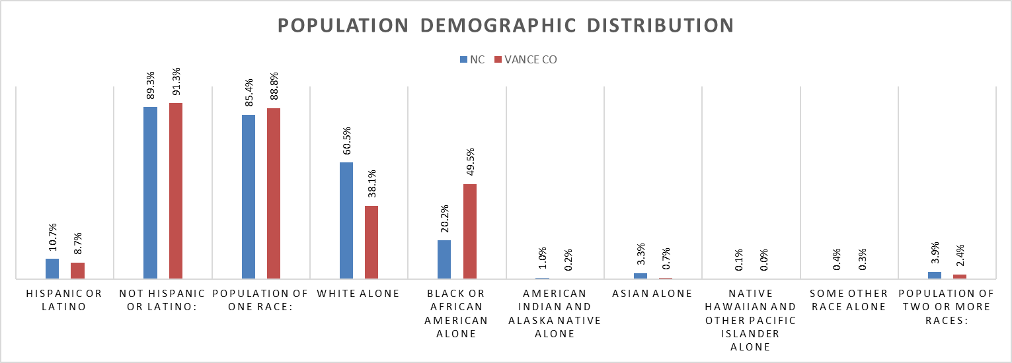

**Economic Opportunity and Security.** Recently released data from the NC Budget and Tax Center illustrates the struggle many families in Vance County are facing related to economic opportunity and security. Vance County is designated as a *Tier One County* based on the three-level system used to designate county development tiers in North Carolina. Tier One designation represents the forty (40) most distressed counties based on four ranking factors: average unemployment rate, median household income, percentage growth in population, and adjusted property tax base per capita. In the most recent tier designation, Vance County ranked 6 in designated Tier One counties (where #1 is the most distressed). For comparison, both Franklin County and Granville County were ranked in Tier 2 with overall distress rating of 67 and 73 respectively, and Warren County was ranked in Tier 1 with an overall distress rating of 26. A report in the July 18, 2024 edition of The Daily Dispatch stated that Vance County is classified as a persistent poverty county, meaning more than a fifth of residents have lived in poverty for over 30 years.

The NC Budget and Tax Center 2024 County Economic Snapshot data also shows opportunities for economic intervention. The snapshot is focused on how well county residents can meet their basic needs, access good jobs, and engage in an economy that works for everyone. It shows that rent is unaffordable for 52% of renters in Vance County and that there was a 12% overall reduction in people working in December 2023 as compared to those working in December of 2007 (pre-Great Recession). Current unemployment rates in Vance County are 4.7% as compared to 3.2% at the state level with an almost 15% reduction in unemployed persons actively seeking work since the COVID-19 pandemic began in early 2020. When looking specifically at young adults ages 16-24, 19.8% were neither in school nor working full or part time as measured from 2015 to 2019. This does include incarcerated youth who are not enrolled in school. This rate places Vance County at 89 out of 100 counties when ranked from lowest concentration to highest concentration (Commissioners, 2023). Further, forty-four percent (44%) of Vance County residents are considered low-income with total incomes less than $59,900 for a family of 4.

The NC Budget and Tax Center further reports that when examining income and the ability to afford the basics, the Living Income Standard annual income in Vance County (for 1 adult and 2 children) would be $52,300 and the median worker earnings from 2018-2022 in Vance County was only $33,800 (median household income of $48,300). In fact, according to the North Carolina Housing Coalition, the hourly wage needed to afford a Fair Market Rent apartment in Vance County is $17.48 per hour and rental rates have increased 13% in the last year and 34% in the last five years. These increases have resulted in almost 1,500 families facing eviction filings in the last year representing almost half (48.99%) of all cost-burdened renters.

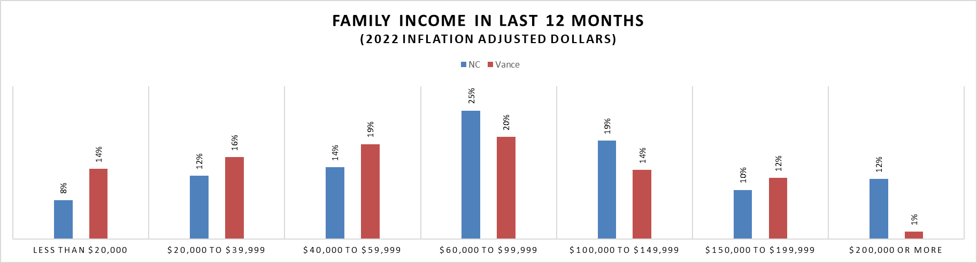

**Educational Resources & Attainment.** Overall educational attainment rates for the Vance County population are shown below. The most recent NC DPI data show that 70.1% of Vance County Schools enrolled youth graduate within 4 years or less after enrolling in the 9th grade. This is compared to 79.3% in Granville County, 83.3% in Franklin County, 79.3% in Warren County and 86.5% for the State of North Carolina. It is important to highlight that overall, more Vance County residents go on to achieve their high school graduation / or equivalency through the Vance Granville Community College or may achieve this graduation in greater than 4 years as is evidenced in the chart below.

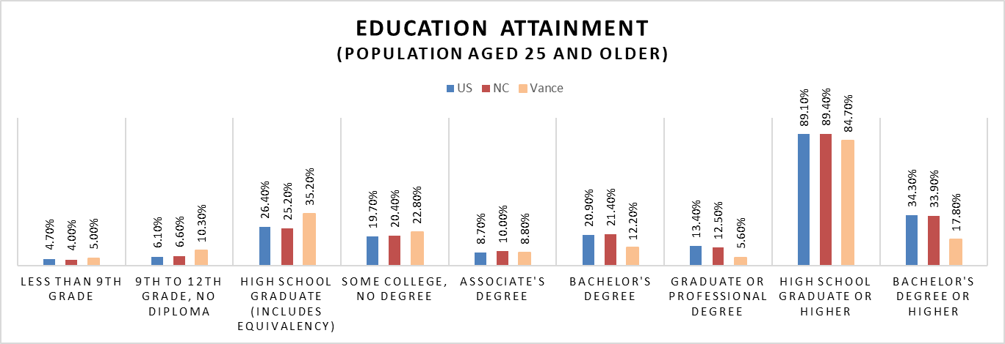

**Access to primary care and mental health.** In 2019 the North Carolina Institute of Medicine published data related to access to care showing that for every 10,000 residents, Vance County had 5.9 primary care physicians, 3.5 dentists, 0.2 psychiatrists & psychologists, and 3.2 birth attendants. The chart below represents a comparison with North Carolina data from the same reporting period. (North Carolina Health Profile: Vance County, 2019)

According to the 2021 Granville Vance Public Health Community Health Assessment, the primary care provider to population ratio in Vance County was 1 per 1,000 which exceeds the goal of 1 per 1,500 set by the NC Institute of Medicine. Of note, and as in many rural communities in North Carolina, access to mental health services is limited, resulting in a reliance on providers in adjacent counties or the use of telehealth services for primary mental health needs. Additionally, it is estimated that up to 14% of the total county population is uninsured (County Health Rankings and Road Maps, 2024).

**Access to Healthy Food.** Approximately 14.3% of all households in Vance County experienced food insecurity at some time during 2021. This is defined as a household reporting not having access to enough food for an active, healthy lifestyle for all household members or access to nutritionally adequate food is limited or insecure (Commissioners, 2023). In 2021, the Margolis Center published a report on food insecurity projecting that in 2021 almost 75% of children would experience very low food security rates defined as “at times during the year, eating patterns of one or more household members were disrupted and food intake reduced because the household lacked money or other resources for food. (Childhood Food Insecurity in North Carolina: Policy Recomendations for NC Integrated Care for Kids (NC InCK), November 2021)”

According to data from the state Department of Health and Human Services, approximately 26% of households in Vance County receive SNAP benefits and/or WIC benefits. By comparison, approximately 22% of households in Franklin County, 24% of households in Granville County, and 20.3% of households in Warren County receive these benefits.

**Parks and Recreation**. Through the Henderson-Vance Recreation and Parks Department, children and their families have access to quality facilities and programs that promote leisure, recreation and social engagement.  Indoor facilities at the Aycock Recreation Center include an indoor pool, gymnasium, fitness room and indoor track.  Fox Pond Park offers tennis courts, pickleball courts, softball/baseball, playground, picnic areas, nature trails, and concessions.  Henderson is the smallest community in North Carolina offering a full-service YMCA.  A Boys and Girls Club is located in the center of the county’s largest low-income residential area. Finally, Kerr Lake State Recreation Area offers opportunities for swimming, boating, picnic shelters, walking trails and campgrounds.

**Substance Misuse & Treatment.** As detailed in the 2021 Granville Vance Public Health Community Needs Assessment, Vance County had a rate of 40.1 medication and drug overdose deaths per 100,000 population. The 2023 County Map Book cites a slightly higher rate of 44.9 deaths per 100,000 population in Vance County as compared to a rate of 38.5 per 100,000 at the state level (Commissioners, 2023). Opioid use treatment rates are actually much higher in comparison to state-level rates at 1,141 per 100,000 vs. 484 per 100,000. The total number of residents engaged in Local Management Entity / Manage Care Organization (LME/MCO) treatment programs in Vance County was 508.

**Community & Neighborhood Safety.** Crime rates for both violent crime and property crimes in Vance County are higher than state rates and those in Granville County (Community Health Assessment , 2021). More recent data shows the number of reported violent crimes in Vance County to be 581 per 100,000 population compared to 351 per 100,000 population at the state level. From this same data source, the homicide rate increased 6.82 per 100,000 population to a rate of 21.8 per 100,000 from 2014-2022 as compared to a state rate of 6.6 per 100,000 population (Data USA, 2024). Deaths due to firearms was reported at 29.2 per 100,000 population in Vance County and 14.2 per 100,000 population in North Carolina.

**Transportation.** As with many rural communities, access to reliable and affordable transportation can be a limitation for families with children in Vance County.

**Internet and Computing Device Access.** Families with children often rely on access to reliable internet and computing resources to access online services and connect with their children’s educational home and other social services. In 2021 75.4% of households reported access to at least one desktop, laptop or tablet computer that could be used to access the internet. This compared to 78.2% of households in Frankin County, 83.0% of households in Granville County, 66.9% in Warren County and 82.6% of household in North Carolina.

Additionally, the percentage of fully served broadband serviceable locations (BSLs) in Vance County was 80.6% compared to 73.8% fully served BSLs in Franklin County, 67.3% fully served BSLs in Granville County, 36.5% in Warren County and 88.2% fully served BSLs throughout North Carolina (Commissioners, 2023).

Finally, the percentage of households that are eligible for the federal Affordable Connectively Program which provides $30 per month to access high-speed internet was 46.2% in Vance County as compared to 32.6% in Franklin County, 33.5% in Granville County, 45.4% in Warren County, and 32.3% state-wide (Commissioners, 2023).

# **2-CHILD DATA AND RISKS**

**Child Population and Projected Growth.** Based on estimates from the US Census Bureau, in 2022 Vance County had a total child population of approximately 9,795 with approximately 3,200 children under age six and 509 total births. Accordingly, children represented 22% of the total population.

It is estimated that by the year 2030 the total child population for the county will decrease to 9,432 including approximately 3,329 children under age six. With these projections, children will represent 23.5%of the total population by the year 2030.

**Household Data.** The most recent data on living arrangements in Vance County shows that there are approximately 16,063 households, with approximately 5,145 households (32%) having at least one child under the age of 18. The average household size is 2.62 individuals with the average family size of 3.31 family members. Per the US Census Bureau, a *household* is defined as all people living in a housing unit, while family household if defined as where the householder and at least one other person are related by birth, marriage or adoption.

Approximately 40% of family households in Vance County are headed by a single parent. Data from the US Census Bureau 2021 American Community Survey reflect a great disparity in single parent family households between white and non-white families. In fact, 56% of black and 52% of Native American family households in Vance County are single parent households with 48% of black family households having a female single parent designated as the “householder”.

It is also important to note that almost 1,400 grandparents report living with their own grandchildren under 18 years of age and 626 of these grandparents report being solely responsible for their grandchildren with 411 (66%) having been solely responsible for their grandchildren for 5 years or more.

**Average Family Size**

North Carolina: 3.00

Vance County: 3.31

**Child welfare investigations and foster care.** The most recent data from NC DHSS shows that as of January 31, 2024, there were 68 children in DSS custody / in foster care in Vance County. 33 of these children were aged 0-5 and 35 were aged 6 -12. Twenty-two percent (22%) of these children were being cared for in a kinship or relative placement, 38.24% were in a licensed foster home placement, 8.82% were housed in a group home and 4.41% were in their own home. Over the past four years, the number of children in custody over time has been rising.

However, it is still lower than the all-time high rate of almost 190 children in January of 2005.

In the fiscal year beginning July 1, 2023 there were a total of 62 reports of child abuse and neglect investigated by the Vance County Department of Social Services. Of these, 32 were found to be unsubstantiated and a further 15 were decided as services not recommended. Of the remaining 15 cases where the finding was reported, 2 were substantiated as abuse and neglect, 9 substantiated as neglect, 3 were closed with services provided and no longer needed, and 1 had a finding of dependency. The same data set showed a similar pattern in the fiscal year of 2022. In that time, there were a total of 221 investigated reports of abuse and neglect. Nineteen (19) were found to be unsubstantiated and 114 were closed with services not recommended (60% closed with no findings). Of the cases investigated in the previous fiscal year, 62 were closed with services recommended and 20 were closed with services needed (37%) and four cases were closed as substantiated abuse and neglect or neglect only (two per category or approximately 2% of the investigations).

**Education Environment and Attainment.** Vance County offers several educational opportunities for children including public, charter and private schools.

Vance County Public Schools is comprised of 16 public schools serving approximately 5,098 children in grades K-12 with an additional 292 Pre-K enrollees. Vance County District Schools are designated as “high poverty” schools with ninety-six percent (96%) of students qualifying for free or reduced lunch based on national eligibility requirements.

|  |  |  |  |  |  |  |
| --- | --- | --- | --- | --- | --- | --- |
| School | Grades | Enrollment | Race / Ethnicity | Economically Disadvantaged | Graduation Rate | Performance Grade |
| Vance County Schools | K-12 | 5,098 | 64.8% Black  10.1% White  19.3% Hispanic | 76% | 70.1% | D (avg.) |
| Henderson Collegiate | K-12 | 1,326 | 61.0% Black  3.9% White  28.4% Hispanic  6.7% Other | 86% | 84% (4 year)  90.1% (5 year) | B (84) |
| Vance Charter School | K-12 | 941 | Not available | 34.9% | 95% | B (78) |
| North Carolina | K-12 | 1,503,647 | 24.8% Black  45.5% White  29.0% Hispanic | 51.6% | 86.5% | C (avg.) |

*NOTE: There are two additional schools for which data was not available.*

The Vance County School District employs approximately 721 teaching staff with approximately 78.8% of teachers being designated as experienced and overall, 81.7% of educators in the district being designated as effective (63.1%) or highly effective (18.6%) by the NC Department of Public Instruction. According to data from the National Center for Education Statistics, in the 2022-2023 school year, there were 15 FTEs of staff identified as “school counselors” and just under 49 FTEs identified as “student support services staff.”

Related to school environment and facilities, and as reported to NC DPI in the 2022-2023 school year, approximately 41.6% of all enrolled children met the definition for “chronic absenteeism”. A student is defined as chronically absent when they are enrolled in a North Carolina public school for at least 10 school days at any time during the school year, and whose total number of absences is equal to or greater than 10 percent of the total number of days that the student has been enrolled at any school during a given school year. Further, when assessing disciplinary action across the entire student population, 509.90 per 1000 students experienced a short-term suspension during the 2022-2023 school year. Male students experienced short-term suspension rates of 659.11/1,000 and female students experienced short-term suspension rates of 334.99/1,000. In-school suspension rates show a similar distribution with the entire student population experiencing a rate of in-school suspension of 146.01/1,000, male students had a rate of 182.96/1,000 and female students had a rate of 102.15/1,000.

Data related to educational success for the child population was gathered from various sources. This included data related to enrollment in high quality childcare and pre-K programs, third grade reading proficiency, on-time high school graduation rates and education attainment for the adult population aged twenty-five and older.

**rollment in Pre-K**

***(eligible 4 year olds)***

North Carolina : 53%

Vance County: 66%

**On-time High School Graduation**

North Carolina : 86%

Vance County: 76.2%

**Reading Proficiency**

***(Third grade children reading at grade level)***

North Carolina : 46.4%

Vance County: 24.6%

Per the Child Care Services Association (CCSA) of NC, in 2022, 845 children ages birth to five were enrolled in licensed childcare centers. Of these 79% were enrolled in 4- or 5-Star centers.

According to data from the North Carolina Department of Public Instruction, the NC End of Grade (EOG) tests are designed to measure student performance on the goals, objectives, and grade-level competencies specified in the North Carolina Standard Course of Study. EOGs are given at the following intervals:

* Mathematics (Grades 3-8)
* Reading (Grades 3-8)
* Science (Grades 5 and 8)

DPI publishes district report cards that describe student performance in various test subject areas. Student test performance is reported as one of four achievement levels. Not Proficient is below grade level. Level 3 is grade level proficient. Levels 4 and 5 indicate students are on track for career and college readiness.

Students scoring at Not Proficient will likely need additional help in the next year to succeed in that subject area. Students scoring at Level 3 are considered proficient for that grade level or course but may still need some targeted help in the next grade or course. Students scoring at Levels 4 and 5 are ready for the next grade or course and are also on a path to be prepared for a career or college by the time they graduate.

Proficiency data from the most recent district level profiles [(2023-24)](https://bi.nc.gov/t/DPIAccountabilityandTesting/views/FACT_DPITestScores2024_State/TestingState?%3Aembed=y) is below:

|  |  |  |  |  |  |  |  |  |  |  |  |  |
| --- | --- | --- | --- | --- | --- | --- | --- | --- | --- | --- | --- | --- |
|  | Math Performance | | | | Reading Performance | | | | Science Performance | | | |
|  | Not Proficient | Level 3 | Level 4 | Level 5 | Not Proficient | Level 3 | Level 4 | Level 5 | Not Proficient | Level 3 | Level 4 | Level 5 |
| Vance County | 67% | 20% | 12% | < 5% | 68% | 18% | 11% | < 5% | 49% | 14% | 30% | 8% |
| Granville County | 59% | 19% | 18% | < 5% | 62% | 19% | 15% | < 5% | 43% | 12% | 36% | 10% |
| Franklin County | 50% | 19% | 23% | 8% | 55% | 22% | 18% | 6% | 36% | 13% | 37% | 14% |
| Warren County | 74% | 18% | 7% | < 5% | 76% | 13% | 8% | < 5% | 59% | 13% | 27% | < 5% |
| North Carolina | 45% | 18% | 25% | 12% | 50% | 20% | 21% | 10% | 32% | 10% | 37% | 21% |

**Health & Wellness.** Based on estimates from the US Census Bureau, in 2022 Vance County had a total child population of approximately 9,795 with approximately 3,200 children under age six and 509 total births. Various indicators of health and wellness were examined including access to prenatal care, incidence of pre-term delivery, babies born at a low birth weight, health insurance coverage, access to health care providers, and child infant mortality. Despite the fact that only 3.7% of children in Vance County report being uninsured, as compared to 5% for North Carolina, health statistics for Vance County children on the whole compare adversely to the state statistics.

**Early**

**Prenatal Care**

***(first trimester care)***

North Carolina : 73.8%

Vance County: 61.2

**Infant Mortality**

***(per 1,000 live births)***

North Carolina : 6.9%

Vance County: 10%

**Children Without Health Insurance**

North Carolina: 5.0%

Vance County: 3.7%

**Babies born**

**pre-term**

North Carolina: 10.8%

Vance County: 11.0%

**Babies born at**

**low birth weight**

North Carolina : 9.5%

Vance County: 12.8%

# 

# **3-AVAILABLE PROGRAMS AND SERVICES**

A large array of programs and support services is available for families with children in Vance County. Through structured interviews as well as exploration of online resource finders (NC Care 360 and FindHelp.org), PCANC staff captured contact information, program/service descriptions, and eligibility for services and programs that fall into the following categories:

• Basic Needs (financial supports, housing supports, material goods and transportation)

• Food / Nutrition Services

• Health / Mental Health Services and Crisis Intervention

• Education, Recreation and Enrichment

• Parenting Support & Education

A directory of the programs and services is provided in Appendix A to this report.

The services include not only services that are legally mandated, but also community, non-profit and faith-based programs in the categories listed above.

**Basic Needs**. Government-funded programs and services are available in Vance County to meet basic family needs for low-income rental housing, rent, utilities, weatherization and home improvements, home ownership counseling and training, employment training, and transportation. In addition, local non-profit and faith-based organizations provide financial assistance with rent, utilities, household furnishings, supportive services for victims of domestic violence, and homeless shelters.

**Food and Nutrition Services**. Government- funded food purchase assistance is available to low income households and specifically for eligible women, infants and children through the SNAP and WIC programs. Hot meals and snacks are provided to children in all public and charter schools (including pre-school programs and K-12), and in after-school and out-of-school programs. Local non-profit organizations and churches provide cooked meals, operate food pantries and distribution services, and provide nutrition education.

**Health and Mental Health Services and Crisis Intervention**. A broad range of health services is available in Henderson through Granville Vance Public Health, through Maria Parham Medical Center, a private, full-service regional hospital that is part of Duke LifePoint, and through medical and dental clinics, private practices and urgent care facilities.

Proximity to Durham provides access to sophisticated medical specialties and technologies in driving or life-flight times comparable to or better than those in major metropolitan areas. In addition, pop-up clinics provide indigent children and others with free medical, dental, vision, pharmaceutical and other services and products on an annual basis.

State funded services for mental health conditions, intellectual/ developmental disabilities, substance use disorders and traumatic brain injuries are available through government-contracted managed care organizations (MCOs) and non-profit organizations.

Crisis intervention services for children, including foster care, are available through the Vance County Department of Social Services and S.a.M. Child Advocacy Center.

**Education, Recreation and Enrichment**. In addition to federally funded Head Start pre-school and NC Pre-K programs serving approximately 244 students, and public schools serving approximately 5,000 students Pre-K through 13, Vance County has two K-12 charter schools serving a total of 2,253 students.

After-school and/or out-of-school programs and/or recreational activities are offered at all ten public elementary schools, the county middle school, Henderson Collegiate and also through the local full-service YMCA, Boys & Girls Club, Edmonds Tennis and Education Foundation, Henderson-Vance Recreation and Parks Department, the Salvation Army and Turning Point CDC.

Cultural enrichment programs and resources are available to children through Perry Memorial Library, McGregor Hall Performing Arts Center, three local historical museums and annual community events.

**Parenting Education and Support.** Case management, support and educational services are available through Granville Vance Public Health and/or Smart Start for mothers and their newborn babies, teen parents, and parents of children with specific behavioral conditions and chronic physical developmental issues.

# **4-GAPS IN SERVICES & OBSTACLES TO PROVIDING PROGRAMS/SERVICES**

PCNAC sought to understand more about the alignment of services and programs as well as to uncover any pervasive obstacles to providing services and programs for children in Vance County. To ensure that policy makers and funders were able to hear directly from service providers and family support programs throughout the county to support their decision making, PCANC staff conducted structured interviews with key community stakeholders.

Invitations to participate in the interview process were distributed via email and direct mail to key partners in Henderson and throughout Vance County. Questions were shared in advance with the interviewee agency and scheduled directly with PCANC staff. Interviews were conducted by PCANC staff via Zoom with recording and transcription provided as requested. Staff members used qualitative research methods to review and aggregate findings from these interviews as outlined below.

**Agency Assessment of Needs.** Interviewed local agencies generally agreed in their assessment of issues facing children and their families in Vance County. The table below illustrates the 16 top issues identified in the agency interviews. These agencies also stressed that all challenges and disparities are amplified among children with special health care needs or intense / pervasive mental and behavioral health needs.

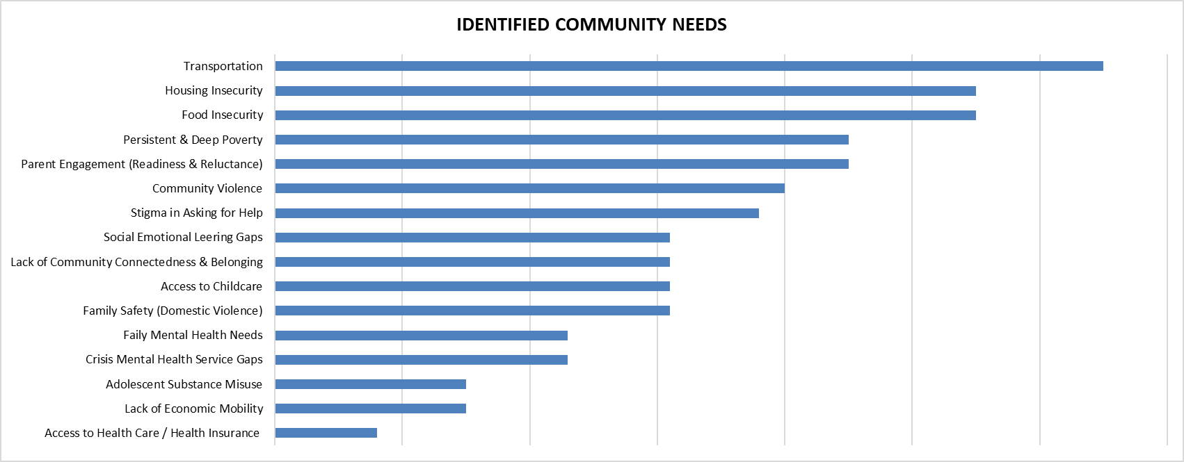

Additional needs not represented above include services and supports for children diagnosed with autism spectrum disorder, social-emotional learning in schools, parenting support programs for older children (school-aged and teens), fatherhood support programs, and enhanced mental health crisis intervention services. Finally, it was noted that for children with higher level mental / behavioral health needs there are no services within the county. Children are placed out of county which limits parent/caregiver engagement and overall readiness to support the child when they return home.

**Barriers to Service Delivery.** Most interviewees noted that additional funding would allow them to better sustain, or expand, their service delivery in Vance County. However, when asked to identify the biggest barriers to initiating / sustaining services, the group was almost unanimous in identifying staff recruitment and sustainment as their primary barrier. It was recommended that agency partners come together to assess current staff shortages and work together to find solutions to staff recruitment or staff development opportunities. Members of the community also pointed to the potential to work with workforce development resources such as NC WORKS or CTE education programs in the schools to build and retain a highly qualified workforce in Vance County.

In addition, interviewees identified that parent engagement with programs and services is a barrier. This was identified as both parent apprehension to ask for or engage in services and supports as well as parents’ lack of understanding how to engage and advocate for their child in education, child welfare, and juvenile justice settings. Language accessibility was identified as a barrier for direct engagement of parents in their children’s education as resources from the schools are not always translated. Additionally, there is a need to provide parent literacy in any language to ensure that parents can fully engage with their children’s educators and other social services in the community.

Multiple participants noted that parents have many concrete barriers to engagement (work schedules, lack of transportation, etc.). However, many noted that parents often do not have the necessary understanding or competencies in social emotional skills and may have their own histories of trauma (individual, family, or community based) that limit engagement due to long-term mental health and substance misuse issues. The overall stigma associated with accessing and engaging in many of the available services and programs means that parents / caregivers are reluctant to, or unable to, seek support that they need.

Finally, the interviewees noted that many policies and procedures are out of sync with the rural nature of the Vance County population. For example, caseloads (or per member per month engagement requirements) for health-related service providers are often based on experience in more urban or suburban settings. As such, they fail to be responsive to the realities of a population and array of service providers who are dealing with limited transportation, broadband access, and lack of general connectedness. Additionally, policies set at the state or national level are not always trauma informed. For example, in prior years, NC Medicaid reimbursement rates for trauma-focused mental health services were based on the time required for providing that service and the organizational time needed to provide the full service (e.g., clinical supervision, clinical assessment, etc.). With Medicaid expansion and other system changes, this policy has shifted back to only allowing for a certain number of sessions and not necessarily reimbursing providers for the additional time it takes to manage complex cases of trauma. The result is that highly qualified mental health providers that want to provide these trauma-focused services are less likely to accept Medicaid (or any insurance) further limiting access to an already limited resource in the community. Finally, it was brought forward that there is a need to better understand the needs of families in the Henderson municipality versus the more rural parts of the county. Special attention should be given to undocumented families so that we can better understand their needs as well as any additional barriers to accessing services brought forward based on their immigration status.

**Context of Children’s Risks and Needs.** In the years spanning 2020 to 2022, due to the COVID pandemic in the US, many economic supports were made available to families. In Vance County, as throughout NC and the US, these supports were time limited and are now being phased out or otherwise constrained. Even for families that remain eligible for benefits, in-person requirements for application or assessment that were relaxed during the pandemic have been reintroduced. Families with limited transportation, or whose work schedule does not support the time to attend an application meeting or other assessment, are further marginalized and at increased risk of losing necessary services and support. Ensuring eligible families have continued access to these services should be a priority.

In Vance County, it was noted that with the large number of grandparents that are the primary caregiver(s) for their grandchildren, challenges faced by the grandparents carry over to the grandchildren they are raising. A recent survey of senior citizens in Vance County identified the following primary concerns: housing, community safety, food insecurity, and access to health care.

Participants noted that while there are many family-focused activities and services in the County there is a lack of connectedness, or sense of community *belonging*. Simply put, many families do not feel accepted and included in the community. This feeling of being “outside” of the community can lead to feelings of stigma and a reluctance to engage in programs and services that are available to help.

As noted by the US Surgeon General, and seen in the 2021 Capita Social Solidarity Survey, loneliness is a public health issue. These studies note that the first years of a child’s life are a critical time of development that sets the stage for health and well-being throughout the lifespan. Children’s first and most important relationships are with their parents or caregivers, and as such their health and well-being are critical to that of their child. Creating and maintaining trust with parents and caregivers means that they will be more likely to ask for help and advice when they need it and shift social norms to ensure that parents see community programs and service providers as trusted resources to help nurturing positive childhoods. When parents experience social isolation, they are less able to provide this crucial early support. Therefore, supporting child wellbeing means being able to support caregiver wellbeing as well.

**Community Collaboration.** A key takeaway from the structured interviews was that there is a great deal of interest and experience in collaborating among the stakeholders that participated in the interview process. While competition for scarce resources is a real concern, various interviewees noted monthly, ongoing collaborations between community partners. Examples of this collaboration include monthly meetings of the Tri-County Collaborative (L. Cozart), Stepping-Up Initiative, Vance County DSS Collaborative, and the Juvenile Attendance Council. Participants expressed great interest in identifying opportunities to align and streamline these connections and collaborations.

Interviewees also noted that while many organizations maintain their own “events” section of online sites or printed materials, there is no centralized mechanism to locate services or events in the county. This can be perceived as a lack of cohesiveness by parents and caregivers.

# **5-RECOMMENDATIONS**

**Intentional Collaboration and Community Goal Setting.** While there are various small group convenings throughout the county, there is not a centralized collaboration space for child-serving programs and services. Therefore, building on the collaboration opportunities identified through the structured interview process, it is recommended that quarterly programs and services round tables are convened. Within these meetings, participation is expected across service domains (e.g. basic needs, food, health, etc.) and include any agency (governmental, non-profit, faith-based, etc.) that is providing services and or supports for families in Vance County. This venue would provide the opportunity to meet face-to-face and build relationships as well as to identify gaps in the current service array for families and children.

The immediate goal of a centralized collaboration effort would be to achieve a collective impact approach to the needs of children in Vance County. The concept of collective impact hinges on the idea that in order for organizations to create lasting solutions to social problems on a large-scale, they need to coordinate their efforts and work together around a clearly defined goal. The approach of collective impact is placed in contrast to “isolated impact,” where organizations primarily work alone to solve social problems.

It is recommended to use a collective impact approach, whereby a local agency will take ownership of this broad collaborative effort (and be funded to do so). This will ensure accountability to achieve full participation across the service system. Utilizing a collective impact approach will allow for greater sharing about current strengths and obstacles that partners are facing. It is expected that, through this process, community collaboration goals, strategies, and opportunities for shared evaluation (see systems recommendations below) will be established.

**Parent & Youth Engagement in Community Collaboration.** The engagement of both parent and youth voices in community planning processes is essential for fostering inclusivity, representation, and effectiveness. To begin the process for family and youth engagements, it is recommended that an online community survey be conducted, and families be invited to participate in listening sessions that will provide insight on their unique experiences as well as highlight their recommendations for improvement and expansion of services that will meet the needs of families in the community. Ongoing connection and engagement with families should be a goal of the community collaborative with final structure of this engagement being set with caregivers, youth, and service providers.

**Centralized Family Navigation Services.** Family Navigation is an evidence-informed practice designed to reduce disparities in access to services by providing families with individually tailored support and care coordination. This type of tailored support allows families to access information related to health and wellness as well as access information about local services and supports and be referred to these services in the local area. The process allows families to work with the family navigator to assess and prioritize their needs and provides the family with one-to-one support as they engage with programs and services to ensure that the family receives what they need. In the absence of such services, families are left on their own to navigate through what can be an overwhelming and confusing array of services and supports. Often, this means that families miss out on services for which they are eligible simply because they are not aware that the services exist. Similarly, without a central repository for data related to what services are available, service providers are often limited in their understanding of available services and support in the community. This can lead to them overly relying on known partners for limited services (e.g., always referring to one provider because they are unaware of others providing the service) leading to longer waitlists and frustration for families and providers alike.

Through the structured interview process it was learned that two key partners in the community are investing in opportunities to provide families with “family navigation services”. The Masonic Home for Children in Oxford has recently established a Community Support Center on their campus. This will enable service providers, such as mental health, to have a local presence with office space, services and use of other campus facilities. This centralized base will facilitate access to services and eliminate stigma often associated with facilities that primarily provide mental health services. Similarly, the Franklin-Granville-Vance Partnership for Children has hired an “Early Childhood Network Manager”. This position works with parents and caregivers directly to ensure that they are equipped to engage in their child’s education and advocate for their child’s academic, social and emotional needs. It is recommended to create additional “one stop shop” opportunities for families to assess their needs and, in turn, access the available community resources and services.

**Shared Technology / Communication Platforms.** Throughout the interviews, partners brought forward the need to ensure that there is a coordinated listing of services and support that is kept up to date and is available to service providers as well as the general public. While it is acknowledged that this type of database or listing requires a high degree of effort to initiate and maintain, the collective feedback was that it would be time and effort well spent. Such a system would allow funders to easily assess gaps in the service array or identify areas of support that need additional capacity to meet the needs of the community. It would also provide a way to see collaboration and communication patterns between and among system partners.

There are many technology platforms that could meet this need (e.g., NC Care 360, Findhelp.org, etc.). It is recommended that community partners come together to define their overall goals for this type of system as well as available funding and then engage with vendors to find a system that will meet the community’s needs.

## **Appendix A:**

## **DIRECTORY OF AVAILABLE PROGRAMS & SERVICES: VANCE COUNTY**

The information included in this Directory is derived from news, online or other sources and is provided for informational purposes only.  TNHF has made no independent investigation of the listed agencies or services.  No material in this Directory is intended to be a substitute for professional medical referral, advice, diagnosis or treatment or other professional advice.  Always seek the advice of a medical professional or other qualified health care, education or other relevant provider with any questions you may have regarding such agencies or services offered.

**TABLE OF CONTENTS**

|  |  |
| --- | --- |
| Basic Needs (financial supports, housing supports, material goods & transportation) | Page 21 |
| Food / Nutrition Services | Page 26 |
| Health / Mental Health | Page 30 |
| Education | Page 34 |
| After-School and Youth Enrichment Services | Page 37 |
| Parenting Education & Support | Page 39 |

## Basic Needs (financial supports, housing supports, material goods & transportation)

|  |  |  |
| --- | --- | --- |
| Agency / Service Contact Information | Description | Eligibility Requirements |
| *Emergency Help*  (Salvation Army – Henderson)  2292 Ross Mill Road  Henderson, NC 27536  (252) 438-7107 (Main)  <http://southernusa.salvationarmy.org/henderson-nc/> | Offers financial help with rent, electric utilities, and water utilities when funds are available. Not able to help with deposits. | Meet income limits and be in a crisis situation. Available once every 24 months. |
| *Family Store (Salvation Army – Henderson)*  218 Raleigh Road  Henderson, NC 27536  (252) 598-1050 (Main)  <http://www.facebook.com/HendersonSalvationArmyFamilyStore> | Sells household items like bedding, appliances, furniture and more. | Open to all. |
| *General Assistance (Vance County Department of Social Services)*  500 North Beckford Drive  Henderson, NC 27536  (252) 492-5001 (Main)  <http://www.vancecounty.org/departments/social-services/work-first-services-2/> | Offers temporary help for people in crisis. Crisis Intervention Program (CIP) offers financial help with utility bills for heating or cooling emergencies. Payments are made to the utility provider. Help is not available more than once every 12 months. Other financial help may be available for rent, utilities, life-saving medication, or other cases based on individual circumstances. Limited funds available. | Meet income limits and be at risk of a health-related emergency if utilities are shut off. May require a utility cut-off notice to be eligible. Requirements for other financial help may vary. |

## Basic Needs (financial supports, housing supports, material goods & transportation)

|  |  |  |
| --- | --- | --- |
| Agency / Service Contact Information | Description | Eligibility Requirements |
| *Homeownership (Franklin-Vance-Warren Opportunity)*  180 South Beckford Drive  Henderson, NC 27536  (252) 492-0161 (Main)  <http://www.fvwopp.com/adult-services-1> | Offers group and individual coaching, counseling, and training classes to adults who want to purchase a home for their family. | Adults who meet income limits and want to purchase a home for their family. |
| *Housing Choice Voucher Program (Franklin-Vance-Warren Opportunity)*  180 South Beckford Drive  Henderson, NC 27536  (252) 492-0161 (Main)  <http://www.fvwopp.com/housing> | Offers vouchers for approved Section 8 properties. Vouchers offer financial help with rent. | Meet income limits and complete a background check. |
| *KARTS (Kerr Area Transportation Authority)*  1575 Ross Mill Road  Henderson, NC 27537  (252) 438-2573 (Main)  <http://www.kartsnc.com/how-to-ride-karts/> | Offers door-to-door bus services. Also offers non-emergency medical transportation to major medical facilities in Wake Forest, Raleigh, Durham and Chapel Hill. | Open to all. Fees vary depending on service and route. Discounted passes may be available. |

## Basic Needs (financial supports, housing supports, material goods & transportation)

|  |  |  |
| --- | --- | --- |
| Agency / Service Contact Information | Description | Eligibility Requirements |
| *Kearah’s Place*  946 West Andrews Avenue Henderson, NC 27536  (252) 598-2025 (Main)  <http://www.kearahsplace.org/programs_and_services> | Offers a transitional housing program with case management and supportive services for victims of domestic violence, sexual violence, stalking, and/or dating violence. Also offers a crisis hotline. | Call or visit or apply online for eligibility determination. |
| *Life Line Outreach, Inc.*  2014 Raleigh Road  Henderson NC 27536  (252) 425-0346  <https://lifelineoutreach.weebly.com/> | Life Line Outreach, Inc is a shelter and a safe haven for women and children who are homeless. The shelter provides emergency housing, food, clothing, counseling and supportive services.  Thrift store is open Mon - Fri 10am - 4pm and Sat 9 am - 3 pm. Food pantry Mon-Wed-Fri 10-1. | Open to all |
| *Low Income Energy Assistance Program (Vance County Department of Social Services)*  500 North Beckford Drive  Henderson, NC  (252)492-5001 (Main)  <http://www.vancecounty.org/crisis-intervention-program> | Offers financial help with heating bills once every 12 months. Payments are based on household size, income, and heating source. Payments are made to the utility provider. People do not need to be in crisis to get help. | Must meet income limits and resource guidelines. Each household is only eligible once per month, even if multiple members apply. |

## Basic Needs (Financial supports, housing supports, material goods & transportation)

|  |  |  |
| --- | --- | --- |
| Agency / Service Contact Information | Description | Eligibility Requirements |
| *North Carolina Housing Coalition*  3608 University Drive  Durham, NC 27707  (919) 881-0707  <https://nchousing.org/> | The mission of the North Carolina Housing Coalition is to lead a movement to ensure that every North Carolinian has a home in which to live with dignity and opportunity. The Coalition meets its mission by convening, resourcing, and mobilizing affordable housing professionals, communities impacted by a lack of affordability, and the broader public to pursue policies at the local, state, and federal levels that improve the supply, quality, and access of affordable housing in North Carolina. | A public facing website with core data on local supports is available to all.  [Click here](https://nchousing.org/wp-content/uploads/2016/12/Vance-County-Housing-Resources.pdf) for a list of Vance County resources. |
| *The Oasis Community Resource Center*  2495 N. Garnett Street  Henderson, NC 27536  [info@turningpointcdc.org](mailto:info@turningpointcdc.org)  252-621-5190 ext. 106 | A resource hub for people in need.  Staff will research, access, and connect individuals in need to services and resources. | Monday, Wednesday, and Fridays at 12:00 - 5:00 p.m. |
| *Public Housing (Vance County Housing Authority)*  224 Lincoln Street  Henderson, NC 27536  (252) 438-6127 | Offers rental properties with rent based on income. | Meet income limits and complete a background check. (current waitlist) |

## Basic Needs (Financial supports, housing supports, material goods & transportation)

|  |  |  |
| --- | --- | --- |
| Agency / Service Contact Information | Description | Eligibility Requirements |
| *Weatherization Assistance Program (Frankin-Vance-Warren Opportunity)*  180 South Beckford Drive  Henderson, NC 27536  (252) 492-0161 (Main)  <http://www.fvwopp.com/housing> | Offers education and home improvements to reduce energy requirements. Improvement may include sealing air ducts, adding insulation and more. | Homeowners or renters with landlord permission who meet income limits. |
| *Work First (Cash Assistance Applications, Reviews and Employment Services)*  Vance County Department of Social Services  500 North Beckford Drive  Henderson, NC 27536  (252) 438-5997  <https://www.vancecounty.org/departments/social-services/> | Work First is North Carolina’s Temporary Assistance for the Needy Families (TANF) program. This program helps parents support themselves and their families by offering short-term training and other services to increase the chances of employment.  - A one-time lump-sum payment equal to a maximum of three months of Work First Family Assistance benefits - Medicaid and Food and Nutrition Services - Referrals to child care and other community and agency resources - Employment services | Work First applicants are required to register for the First Stop Employment Assistance Program with the Employment Security Commission (ESC). Failure to register results in the family's ineligibility for Work First Family Assistance. Apply at your local Departments of Social Services. |

## 

## Food / Nutrition Services

|  |  |  |
| --- | --- | --- |
| Agency / Service Contact Information | Description | Eligibility Requirements |
| *ACTS of Vance County*  201 South William Street  Henderson, NC 27536  (252) 492-8231 (Main)  <http://www.facebook.com/ACTSofHenderson> | Offers a lunchtime soup kitchen and food pantry Monday through Friday. | Food Pantry assistance is available once every 90 days. |
| *Food Pantry (Anathoth House, Inc.)*  315 Dabney Drive  Henderson, NC 27565  (301) 751-4870 | The food pantry provides quality food items to households experiencing food insecurity. This program supplies critical nutrition to hungry individuals and families.  Services are available by appointment only. Offered on the 3rd and 4th Thursday of each month. | Anyone can access this program. |
| *Food Pantry (Cotton Memorial Presbyterian Church)*  511 North Chestnut Street  Henderson, NC 27536  (252) 492-3478 | The food pantry provides quality food items to households experiencing food insecurity. This program supplies critical nutrition to hungry individuals and families.  Services are available the 2nd and 4th Saturdays of each month. | Anyone can access this program. |
| *Food Pantry (Greater Ransom Way of the Cross Temple)*  90 South Lake Lodge Road  Henderson, NC 27537  (252) 492-1824 | The Harvest of Love Food Pantry provides food for people at risk of hunger. Provides basic provisions and non-perishable items free of charge.  Services are available the first and third Saturdays from 9am – 12 pm. | Anyone can access this program. |

## Food / Nutrition Services

|  |  |  |
| --- | --- | --- |
| Agency / Service Contact Information | Description | Eligibility Requirements |
| *Food Pantry (Help Center NC)*  415 Raleigh Road  Henderson, NC 27536  (919) 391-7300  <http://www.thehelpcenternc.com/community-resources> | Offers a food pantry, mobile food pantry, diaper distribution and older adult information and referral. | Families and older adults age 55 an over who meet income limits. |
| *Food Pantry (Life Line Outreach, Inc.)*  2014 Raleigh Road  Henderson, NC 27536  (252)-438-2098  [*https://lifelineoutreach.weebly.com/*](https://lifelineoutreach.weebly.com/) | The food pantry distributes food those who are in need of a helping hand providing fresh vegetables, fruits, eggs, milk, bakery goods and meats.  Services are available Tuesdays and Fridays from 10:30a – 2:00pm. | Anyone can access this program. |
| *Food Pantry (Salvation Army – Henderson)*  2292 Ross Mill Road  Henderson, NC 27537  (252) 438-7107 (Main)  <http://southernusa.salvationarmy.org/henderson-nc/> | The food pantry provides quality food items to households experiencing food insecurity. This program supplies critical nutrition to hungry individuals and families. | Available once every 90 days. |
| *Food Pantry (Shiloh Baptist Church)*  635 South College Street  Henderson, NC 27536  (252) 438-8987 | Shiloh Baptist Church’s food pantry provides food to meet basic nutritional needs for individuals and families in need. Clients are children, adults or senior citizens with limited or no income, who simply have fallen on hard times or recently unemployed and simply need assistance to make ends meet.  Services are available by appointment only. Offered on Thursday and Saturday mornings. | Anyone can access this program. |

## Food / Nutrition Services

|  |  |  |
| --- | --- | --- |
| Agency / Service Contact Information | Description | Eligibility Requirements |
| *Food Pantry (Young Memorial United Holy Church)*  1379 Brookston Road  Henderson, NC 27537  (252) 492-1610 | The food pantry serves everyone from low income families, single parents, senior citizens, unemployed individuals, disabled veterans, working poor, and anyone else that comes to the pantry.  Services offered second and fourth Wednesdays from 6:00pm-7:00pm. | Anyone can access this program. |
| *Oasis of Hope Food Pantry and Distribution Center*  2495 N. Garnett Street  Henderson, NC 27536  Phone number: 252-621-5190 ext. 104  [info@turningpointcdc.org](mailto:info@turningpointcdc.org) | Provides access to resources, opportunities, and experiences that improve health outcomes through healthy food, nutrition education, and community engagement. Provides food to unserved individuals with priority given to those with chronic illnesses (diabetes, high blood pressure, or heart disease.) | There are no eligibility requirements.  Hours of Operation: Mondays - 1:30 p.m. - 5:30 p.m. Wednesdays - 1:30 p.m. - 5:30 p.m. 1st Tuesdays - 3:00 p.m. - 5:30 p.m. 1st and 3rd Fridays - 12:00 p.m. - 5:30 p.m. |
| *Supplemental Nutrition Assistance Program (SNAP)*  Vance County Department of Social Services  500 North Beckford Drive  Henderson, NC 27536  (252) 492-5001  <https://www.ncdhhs.gov/assistance/low-income-services/food-nutrition-services-food-stamps> | The Supplemental Nutrition Assistance Program (SNAP), formerly known as Food Stamp Program, provides food assistance to eligible households to cover a portion of a household's food budget. Benefits are distributed through an Electronic Benefits Transfer (EBT) card. SNAP benefits can be used to purchase eligible food items for home consumption including seeds and plants which produce food for consumption by SNAP households. | Must be a U.S. Citizen(s) or immigrant(s) admitted to the United States under a specific immigration status. You must meet income guidelines to receive benefits.  This program helps people with income at or below 165% of federal poverty guidelines. |

## Food / Nutrition Services

|  |  |  |
| --- | --- | --- |
| Agency / Service Contact Information | Description | Eligibility Requirements |
| *Women, Infants and Children (WIC)*  Granville Vance Public Health  115 Charles Rollins Road  Henderson, NC 27537  (252) 492-3147  <https://www.gvph.org/> | The Women, Infants and Children Supplemental Food Program (WIC) is designed to promote healthy food habits to low-income pregnant, postpartum, and breastfeeding women and infants and children birth to five years of age. | Must be pregnant or parenting children ages 0-5 with income at or below the 185% of the federal poverty level. A person receiving Medicaid, NC Temporary Assistance to Needy Families (TANF or Work First) or assistance from the NC Food and Nutrition Services automatically meets the income eligibility requirement. |

## 

## Health / Mental Health

|  |  |  |
| --- | --- | --- |
| Agency / Service Contact Information | Description | Eligibility Requirements |
| *Granville Vance Public Health*  115 Charles Rollins Road  Henderson, NC 27537  (252) 492-7915  <https://www.gvph.org/> | Granville Vance Public Health provides many resources including health care clinics (primary care, child health, family planning, maternal health and vaccine clinics) as well as nutritional services, care management services for high risk pregnancies and at risk children (CMHRP and CMARC) and health programs focused on chronic health issues (e.g., diabetes) as well as behavioral health resources including Centering Pregnancy and Positive Parenting Program: Triple P. | Open to All |
| *The Bridge Consulting Group LLC (TBCG)*  222 Young Street, Suite B  Henderson, NC 27536  (252) 572 4486/(252) 452 7346  https://thebridgeconsultinggroupllc.org/bridge-therapeutic-academy | TBCG is a community-based entity that offers a core set of evidence-based clinical and behavioral services as well as consultancy, training, and demonstration programs to meet the needs of individuals who suffer with Autism Spectrum Disorder, Pervasive Developmental Disorders, Emotional/Behavioral Disorders from ages 24 months to 15 years (years 1-4), 15 years to 22 years (year 5) along with their caregivers, providers, and educators who live in Franklin, Vance, Warren, Granville, Person, Durham & Orange Counties along with the border counties of Danville, VA. |  |

## Health / Mental Health

|  |  |  |
| --- | --- | --- |
| Agency / Service Contact Information | Description | Eligibility Requirements |
| *Fast Braiin*  1415 College Street  Oxford, NC 27565  [*https://www.fastbraiin.com/*](https://www.fastbraiin.com/) | Provides ADHD diagnosis and ADHD treatment in a professional, medical environment and from a integrative approach, including an in-house line of natural ADHD supplements. | Contact information is available on the website regarding how to set up an appointment / account with this agency. |
| *First in Families*  3109 University Dr #100  Durham, NC 27707  (919)251-8368  <https://fifnc.org> | First In Families of North Carolina (FIFNC) is a state-wide not-for-profit supporting individuals with Developmental Disabilities and/or Traumatic Brain Injuries and their families. Families in Vance County are supported through the Durham office. | A family member must have developmental delay or disability. |
| *Grace Ministries*  215 Crozier Street  Henderson, NC 27536  <https://www.graceofhenderson.org/> | Faith-based ministry to those struggling with addiction and their families or anyone in need. | Open to all |
| *S.a.M. Child Advocacy Center*  704 S. Garnett Street  Henderson, NC 27536  (252) 572-4112  <https://www.samchildadvocacycenter.com/> | Strength and Mending Child Advocacy Center is a non-profit 501(c)(3), neutral organization that serves children who are victims of physical abuse, sexual abuse and/or witnesses to violent crimes in Vance and surrounding counties.  S.a.M. CAC engages multiple agencies such as law enforcement, mental health, DSS, prosecution, medical, and child advocates to collaborate and create a child-focused approach to reduce the overall trauma to the child and family in cases of child abuse or trauma. | All services provided at the center are provided at no cost to the child or their families. |

## Health / Mental Health

|  |  |  |
| --- | --- | --- |
| Agency / Service Contact Information | Description | Eligibility Requirements |
| *Trillium Health Resources*  *Member Services: 877-685-2415*  *https://www.trilliumhealthresources.org/* | Trillium Health Resources helps people with serious mental health conditions, intellectual/developmental disabilities (I/DD), substance use disorders and traumatic brain injuries (TBI) to get the healthcare services they need | Services provided for people who receive Medicaid through the Behavioral Health and Intellectual/Developmental Disabilities Tailored Plan, NC Medicaid Direct, or the uninsured. |
| *Vaya Health*  134 South Garnett Street  Henderson, NC 27536  (800) 849-6127 (Crisis Line)  (800) 962-9003 (Main)  <http://www.vayahealth.com>  Find locations here: <https://www.vayahealth.com/get-help/walk-crisis-centers/>. | Coordinates prevention, treatment, and support services for people with intellectual/developmental disabilities, mental health issues, or substance use needs. Offers drop-in services at each county center. Offers supported employment services for people with intellectual/developmental disabilities to help find competitive integrated employment or self-employment. Offers a 24-hour Crisis Line for people looking for services or in a mental health crisis. | Crisis Services: Anyone having a mental health, substance use, or developmental disability crisis, regardless of insurance. Non-crisis Services: Uninsured people and people with Medicaid. |
| *Vance County Juvenile Crime Prevention Council*  Vance County Schools Central Office  1724 Graham Avenue  Henderson, NC 27536  <https://www.ncdps.gov/our-organization/juvenile-justice/community-programs/juvenile-crime-prevention-councils> | The Division of Juvenile Justice and Delinquency Prevention partners with Juvenile Crime Prevention Councils in each county to galvanize community leaders, locally and statewide, to reduce and prevent juvenile crime. JCPC board members are appointed by the county Board of Commissioners and meet monthly in each county. The meetings are open to the public, and all business is considered public information. DJJDP allocates approximately $28 million to these councils annually. Funding is used to subsidize local programs and services. | Vance County meetings are held the third Thursday of each month except for July. Meetings begin at 9a.m. and are open to the public |

## Health / Mental Health

|  |  |  |
| --- | --- | --- |
| Agency / Service Contact Information | Description | Eligibility Requirements |
| *Women and Children Family Counseling Services*  704 South Garnett Street  Henderson, NC 27536  252-395-5158  <https://www.wcfcs.com/> | Mental Health Clinicians addressing the sources of specific behaviors and emotional patterns | Contact directly for more information about starting treatment. |
| *All Things Are Possible 4 Autism*  ATAP4AUTISM INC  120 East Belle Street  Henderson, NC 27536  Phone: 252-592-2933  Fax: 252-572-4745  <https://atap4autism.com/> | Provides Applied Behavior Analysis (ABA) Therapy Services to individuals diagnosed with Autism Spectrum Disorders (ASD) serving children ages 3-17 and adults 18-21. | Contact this program directly for more information on setting up an appointment. |

## 

## Education

|  |  |  |
| --- | --- | --- |
| Agency / Service Contact Information | Description | Eligibility Requirements |
| *Head Start (Franklin-Vance-Warren Opportunity)*  180 South Beckford Drive  Henderson, Nc 27536  (252) 492-0161  <http://www.fvwopp.com/head-start-center-locations> | A preschool education program to help children prepare for school success. Offers health and mental health services as well as parenting education, nutrition education and services for children with disabilities. | Children ages 3-5 whose parents meet income limits. Children in foster care, homeless children and children from families receiving TANF or SSI are eligible regardless of income. |
| *Henderson Collegiate*  1071 Old Epsom Rd  Henderson, NC 27536  (252) 598-1038  <https://hendersoncollegiate.org> | Charter school serving grades K-12 since 2010; Elementary School (K-4), Middle School (5-8), High School (9-12); current enrollment 1,326; student demographics, 96% students of color; 86% qualified for free or reduced-price lunch; focus on college success; provides free breakfast and lunch to 100% of students as well as free bus transportation before and after school within Vance County. | Open to all; blind lottery if applications exceed available openings. |
| *Homeless Liaison (Vance County School District)*  1724 Graham Avenue  Henderson, NC 27536  (252) 492-2127 (Main)  <http://www.vcs.k12.nc.us/Page/393> | Offers services for homeless youth and their families. Helps students enroll or stay in school. Connects families to community resources for health, transportation, food and more. | Youth without a fixed, regular place to stay. Examples: staying in a shelter, motel, vehicle, campground, street, abandoned building, trailer, someone else’s home or other similar situation. |
| *Migrant Education Program (Vance County School District)*  1724 Graham Avenue  Henderson, NC 27536  (252) 492-2127 (Main)  (800) 234-8848 (Hotline)  <http://www.vcs.k12.nc.us/Page/4462> | Offers services for migrant youth and their families. Helps youth enroll in school and offers support to help them overcome language barriers and isolation. | Youth, ages 3-21, without a high school diploma, who have moved into the school district in the last 36 months, and whose parent or guardian is currently working or seeking work in agriculture or fishing. |

## Education

|  |  |  |
| --- | --- | --- |
| Agency / Service Contact Information | Description | Eligibility Requirements |
| *NC Pre-K (Smart Start Franklin, Granville, and Vance Counties & Vance County Public Schools)*  125 Charles Rollins Road  Henderson, NC 27536  (252) 433-9110 ext. 237  <http://fgvsmartstart.org/nc-pre-k> | Preschool education program that helps children prepare for school success. Program offerings include Kindergarten Transitions, NC Pre K, Adolescent Parenting, Dolly Parton Imagination Library, Fatherhood, and Parents as Teachers. | Children must be age 4 on or before August 31 of the program year and parents must meet income limits. Income limits may not apply for children with one or more of the following: developmental disabilities, limited English Proficiency, certain educational needs, or chronic health conditions. |
| *Vance Charter School*  2090 Ross Mill Road  Henderson, NC 27537  (252) 431-0440  <https://www.vancecharter.org/en-US> | K-12 public, independent charter school; SACS (now Cognia) accredited; current enrollment 953 students; demographics – 74% white, 17% African American or Hispanic. | Open to all; blind lottery if applications exceed available openings. |
| *Vance County Public Schools*  1724 Graham Avenue  Henderson, NC 27536  (252) 492-2127 (Main)  <http://www.vcs.k12.nc.us> | PreK-13 public school; current enrollment appx. 5,000; district comprised of 9 traditional elementary schools (serving grades PreK-5), 1 year-round elementary school (serving grades PreK-5), 1 traditional middle school (serving grades 6-8), 1 early high school (serving grades 6-8), 1 non-traditional school (serving grades 6-12), 1 traditional high school (serving grades 9-12), 1 early college high school (serving grades 9-13), 1 virtual school (serving grades K-12) | Open to all. |

## Education

|  |  |  |
| --- | --- | --- |
| Agency / Service Contact Information | Description | Eligibility Requirements |
| *Vance-Granville Community College*  200 Community College Road  Henderson, NC 27537  (252) 492-2061 (Main Campus)  <http://www.vgcc.edu> | Offers continuing education opportunities. Offers classes on adult education, GED preparation, and English and Second Language. Associate degrees, diplomas and certificates are available in a variety of fields. | Open to all. Application process for specific areas of study can be reviewed via their website. |
| *Youth Build*  *Franklin Vance Warren Opportunity Inc.*  180 South Beckford Drive  Henderson, NC 27536  252-492-0161  <https://www.fvwopp.com/copy-of-youthbuild-2> | Franklin-Vance-Warren Opp., Inc., is one of two grantees in North Carolina to receive funding for Youth Build. Youth Build is a national program designed to support individuals who have stopped or dropped out of school to acquire their high school diploma and certification in a trade, human services or technology. |  |

# After-School and Youth Enrichment Services

|  |  |  |
| --- | --- | --- |
| Agency / Service Contact Information | Description | Eligibility Requirements |
| *Boys and Girls Club of Vance County*  212 N Clark Street  Henderson, NC 27536  (252) 430-1871 | Provides after-school activities and summer programming. Provides food services within afterschool and camp activities. | Children in grades K-12. Fees are based on program with financial assistance and sliding-scale fees available after completing and applying. |
| *Creating Success Education Center (Turning Point Community Development Corporation)*  2495 US 1/158 Highway  Henderson, NC 27537  (252) 621-5190 (Main)  <http://www.turningpointcdc.org/creating-success-education-center> | Offers afterschool and summer tutoring programs. Offers meals, academic support and more. | Students in grades K-12. Fees vary by program. |
| *Henderson Family YMCA*  380 Ruin Creek Road  Henderson, NC 27536  (252) 438-2144 (Main)  <https://www.hendersonymca.org/> | Provides afterschool activities, day camps (school breaks and summer), Teen Mental Health, Youth Sports and health and wellness classes. Provides food services within afterschool and camp activities. | Services provided to members and non-members. Fees are based on program with financial assistance and sliding-scale fees available upon application. |
| *Henderson-Vance Recreation & Parks Department*  375 Vicksboro Road  Henderson, NC 27536  (252) 431-6095  <https://henderson.nc.gov/departments/recreation_and_parks/index.php> | The Henderson-Vance Recreation & Parks Department provides indoor and outdoor facilities, quality services and programs that are affordable, open and friendly to enrich the quality of life for residents. Programs include youth sports, clubs, teen court, and service projects. | All youth are welcome to participate. Fees may vary by program with sliding scale and/or financial assistance available for most programming. |
| *NC Cooperative Extension Center- Vance County*  305 Young Street  Henderson, NC 27536  (252) 438-8188 (Main)  <http://vance.ces.ncsu.edu/> | Offers youth programs such as 4-H activities and clubs. | Eligibility: Open to all. Youth programs available for children and adolescents, ages 5-19. Other programs may have more specific eligibility requirements. |

After-School and Youth Enrichment Services

|  |  |  |
| --- | --- | --- |
| Agency / Service Contact Information | Description | Eligibility Requirements |
| *Perry Memorial Library (PML)*  205 Breckenridge St  Henderson, NC 27536  (252)438-3316  <https://www.perrylibrary.org/> | PML includes a Youth Services Department, a Youth Services Librarian and posts a monthly Youth Services Newsletter on its website. The Youth Services Department has dedicated children’s computers and a story-telling and events theater. | Open to all |
| *Red Shield Club and Community Center (Salvation Army – Henderson)*  292 Ross Mill Road  Henderson, NC 27537  (252) 438-7107 (Main)  <http://southernusa.salvationarmy.org/Henderson/corps-how-we-help> | Offers afterschool care and youth summer camps. | Ages 6-15. Fees vary, depending on service. |

# Parenting Education and Support

|  |  |  |
| --- | --- | --- |
| Agency / Service Contact Information | Description | Eligibility Requirements |
| *Adolescent Parenting Program (Smart Start – Franklin-Granville-Vance Partnership for Children)*  125 Charles Rollins Road  Henderson, NC 27536  (252) 433-9110 x 232 (Main)  <http://fgvsmartstart.org/adolescent-parenting-program> | Offers case management and support services for teen parents. Offers help to avoid second pregnancy, remain in high school, find medical care and more. | Teen parents and their children aged 0-5. |
| *Care Management for At-Risk Children (Granville Vance Public Health)*  115 Charles Rollins Road  Henderson, NC 27537  (202) 492-7915 (Main)  <http://www.gvph.org/health-programs/cmarc> | Offers care management services for children with special healthcare needs who require extra support. Offers medical support, health education and information, and referrals to other community resources. | Children ages 0-5 with chronic physical developmental, behavioral, or emotional conditions who have been exposed to severe stress in early childhood and who have been in the neonatal intensive care unit. |
| *Newborn and Postpartum Home Visits (Granville Vance Public Health)*  115 Charles Rollins Road  Henderson, NC 27537  (252) 492-7915  <http://www.gvph.org/health-programs/newborn-postpartum-home-visit> | Nurses are available to visit mothers and newborn babies at home and teach new moms about infant feeding, parenting and more. | Postpartum women and newborns. Fees are on a sliding scale based on income. The program accepts Medicaid, Medicare, and most private insurance. |
| *Supporting Father Involvement*  NC Cooperative Extension, Vance County  305 Young Street  Henderson, NC  252-438-8188  https://vance.ces.ncsu.edu/ | A program designed for fathers from diverse backgrounds, including those facing challenges such as low income, low education, single parenthood, or involvement with the child welfare system. | Contact Jamon Glover ([jamon.glover@gmail.com](mailto:jamon.glover@gmail.com)) for more information. |
| *Triple P Program (Smart Start – Franklin-Granville-Vance)*  125 Charles Rollins Road, Henderson, NC 27536  (252) 433-9110 x 232 (Main) | Offers individual or group counseling with parents to address specific behavioral problems or parenting issues. | Open to all parents. Call for more information and to apply for services. |

## **APPENDIX B:**

## **ADVERSE CHILDHOOD EXPERIENCES AND CONSEQUENCES**

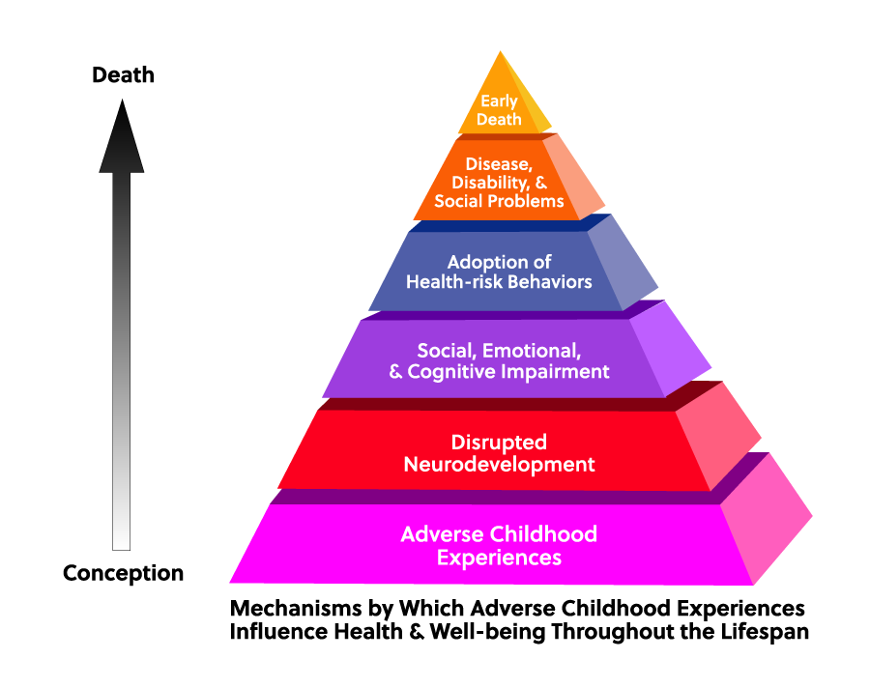**Early adversity and life expectancy.** According to the 2021 Community Health Assessment published by Granville Vance Public Health, Vance County residents have a lower life expectancy than Granville County, peer counties and the state at 74 years old.

The relationship between early childhood adversity and lower life expectancy is complex and multifaceted, with various factors contributing to this correlation. Adverse childhood experiences (ACEs) refer to traumatic events or circumstances occurring before the age of 18 that can have long-term negative effects on physical and mental health outcomes. Some common ACEs include abuse, neglect, household dysfunction (such as substance abuse or domestic violence), and socioeconomic adversity (such as poverty or food insecurity).

Several ways in which early childhood adversity can impact life expectancy include:

Physical Health Effects: Adverse childhood experiences can lead to long-term physical health problems, including chronic diseases such as heart disease, diabetes, and obesity. Childhood trauma can also weaken the immune system and increase susceptibility to infections and diseases throughout life, ultimately affecting life expectancy.

Mental Health Impacts: Early adversity is strongly associated with mental health disorders such as depression, anxiety, and post-traumatic stress disorder (PTSD). These conditions can lead to unhealthy coping mechanisms, substance abuse, and self-destructive behaviors, all of which contribute to lower life expectancy.

Health-Risk Behaviors: Individuals who experience early adversity are more likely to engage in health-risk behaviors such as smoking, excessive alcohol consumption, and drug abuse. These behaviors can have detrimental effects on physical health and contribute to premature mortality.

Social and Economic Disadvantages: Childhood adversity can perpetuate a cycle of poverty and social disadvantage, limiting access to education, employment opportunities, and healthcare. Socioeconomic factors such as income inequality and lack of access to quality healthcare services can further exacerbate health disparities and decrease life expectancy.

Biological Mechanisms: Chronic stress experienced during childhood can dysregulate biological systems such as the hypothalamic-pituitary-adrenal (HPA) axis and the autonomic nervous system. Prolonged activation of stress response pathways can lead to inflammation, oxidative stress, and accelerated cellular aging, contributing to the development of age-related diseases and ultimately lowering life expectancy.

Interpersonal Relationships: Early adversity can impact the development of interpersonal relationships and social support networks, which are important protective factors for health and longevity. Lack of positive social connections and supportive relationships can increase vulnerability to poor health outcomes and premature mortality.

Overall, the cumulative impact of early childhood adversity on physical health, mental health, health behaviors, socioeconomic status, and biological processes can significantly contribute to lower life expectancy. Addressing and mitigating the effects of childhood adversity through early intervention, trauma-informed care, and supportive interventions can help improve health outcomes and promote longevity.

# **APPENDIX C:**

# **ORGANIZATIONS PARTICIPATING IN INTERVIEWS FOR VANCE COUNTY CHILD WELL-BEING LANDSCAPE ANALYSIS**

Boys & Girls Clubs of NCNC

Franklin-Granville-Vance Partnership for Children (Smart Start)

Granville-Vance Public Health

Guardian Ad Litem

Henderson Family YMCA

Henderson Police Department

Masonic Home for Children – Oxford

Salvation Army

S.a.M. Child Advocacy Center

Turning Point CDC

Vance County Commissioners

Vance County Cooperative Extension

Vance County DSS

Vance County Schools

Vaya Health

**Appendix D:**

**2020 Census Tract Data for Henderson NC**

|  |  |  |  |  |
| --- | --- | --- | --- | --- |
| **Variable** | **9607 (East)** | **9605 (North)** | **9608 (South)** | **9604 (West)** |
|  |  |  |  |  |
| Total Population | 3770 | 4650 | 1898 | 4226 |
| Square Miles | 1.3 | 2.4 | 3.5 | 3.7 |
| Population per square mile | 2980 | 1946 | 540 | 1150 |
|  |  |  |  |  |
| Black | 3069 (81.4%) | 3381 (72.7%) | 1010 (53.2%) | 1681 (39.8%) |
| White | 377 (10.0%) | 836 (18.0%) | 415 (21.9%) | 2132 (50.4%) |
| Hispanic / other | 324 (08.6%) | 433 (0.93%) | 473 (24.9%) | 413 (09.8%) |
| Total | 3770 (100%) | 4650 (100%) | 1898 (100%) | 4226 (100%) |
|  |  |  |  |  |
| Children under 5 | 249 (06.6%) | 311 (0.67%) | 120 (0.63%) | 220 (05.2%) |
| Children 5-17 | 758 (20.1%) | 766 (16.5%) | 344 (17.6%) | 623 (14.7%) |
| Total | 1007 (26.7%) | 1077 (23.2%) | 454 (23.9%) | 843 (19.9%) |
|  |  |  |  |  |
| Housing Units | 1699 | 2205 | 850 | 1944 |
| Unoccupied | 255 (15.0%) | 274 (12.4) | 98 (11.5%) | 115 (05.9%) |
| Occupied | 1444 (85.0%) | 1931 (87.6%) | 752 (88.5%) | 1826 (94.1%) |
| Owner occupied | 467 (32.3%) | 529 (27.4%) | 356 (47.3%) | 1100 (60.1%) |
|  |  |  |  |  |
| Households | 1444 | 1931 | 752 | 1829 |
| Married coup 2/ children | 100 | 111 | 72 | 195 |
| Cohabitating couple w/ children | 53 | 51 | 28 | 40 |
| Single parent male | 21 | 30 | 22 | 13 |
| Single parent female | 215 | 278 | 74 |  |
| Total Households w/ children | 389 | 470 | 196 | 151 |
| total single parent w/children | 236 (60.7%) | 308 (65.5%) | 96 (49.0%) | 164 (41.1%) |
|  |  |  |  |  |
| Children in single parent households | 611 (60.7%) | 705 (65.5%) | 222 (49.0%) | 346 (41.1%) |

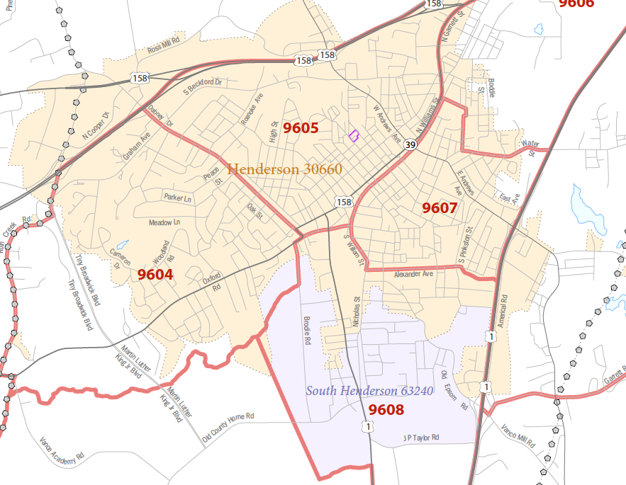

**Appendix E:**

**Roadmap of Need**

|  |  |  |  |  |  |  |
| --- | --- | --- | --- | --- | --- | --- |
| **COUNTY** | **OVERALL** | **ECONOMIC DEVELOPMENT** | **PHYSICAL HEALTH** | **MENTAL HEALTH & SAFETY** | **EDUCATION INPUTS** | **EDUCATION OUTCOMES** |
| **Franklin** | 49 | 26 | 49 | 35 | 58 | 71 |
| **Granville** | 44 | 24 | 12 | 18 | 87 | 89 |
| **Vance** | **93** | 86 | 76 | 35 | 65 | 97 |
| **Warren** | 74 | 87 | 59 | 14 | 11 | 99 |

## Appendix F:

**Gun Fatalities**

