12/24/2016 Follow the Star to the Man Child

According to Matthew chapter 2, an entourage of wealthy and wise men arrived in Jerusalem from a foreign country about 2021 years ago and asked directions to Israel's new born King. They said that they had seen a star that indicated the Anointed One's birth. Everyone in Jerusalem was taken by surprise. The Temple priests found in the scriptures that their King was to be born in Bethlehem.

There will be a very rare sign in the sky on 9/23/2017 indicating the birth of the Man Child mentioned in Revelation chapter 12.

The sign in the heavens of the Woman clothed with the sun with the moon at her feet travailing in birth on 9/23/2017:

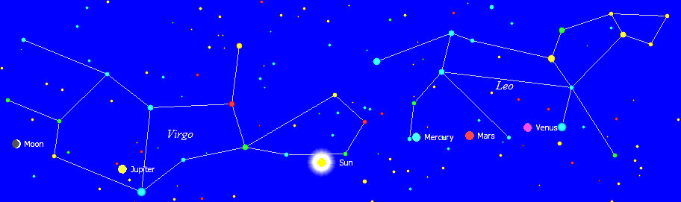

About a month earlier, on 8/21/2017, a total solar eclipse will cross the United States. The eclipse of 8/21/2017 will be the 1st part of a special 2,422 day eclipse sequence that will place an ancient Paleo Hebrew Tav on the United States.

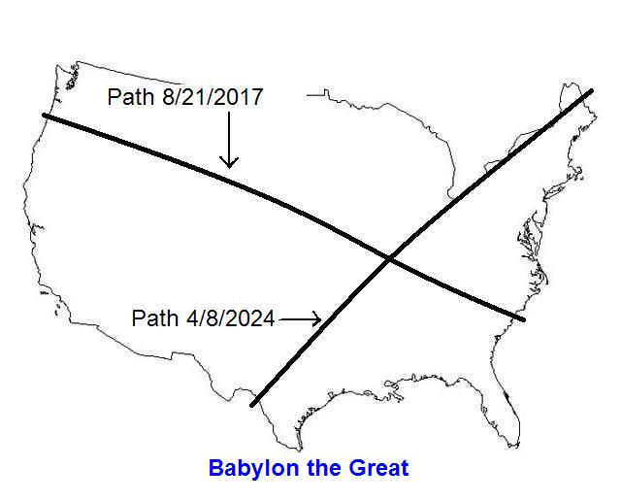

During the total solar eclipse of 8/21/2017 the King Star Regulus, a sign of Israel's Messiah, will appear in the middle of the day right next to the eclipsed sun to viewers in the United States.

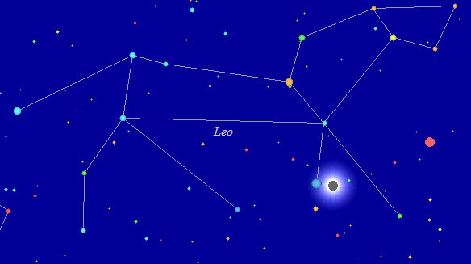
Regulus is the large blue star next to the eclipsed sun above.

Here's a photo of Regulus, symbolic of Israel's Messiah:

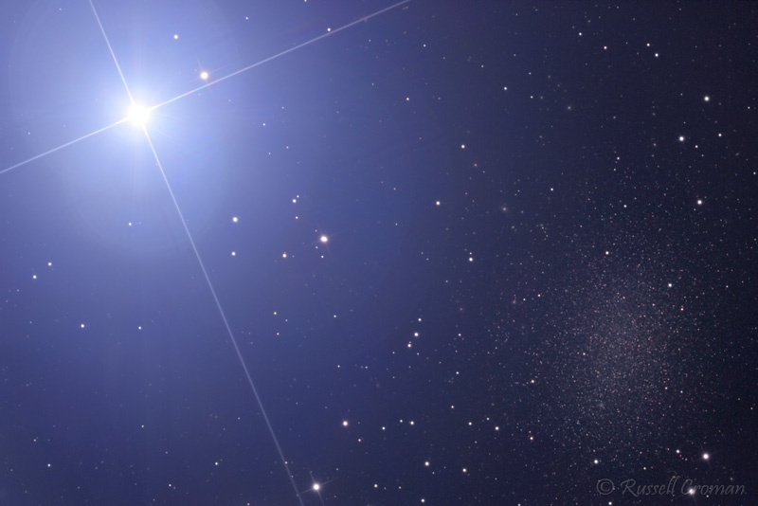
Photo courtesy astronomer Russell Croman

Below is a graphic indicating the time relationship between the revealing of the King Star Regulus at midday on 8/21/2017 and the birth of the Man Child about a month later.

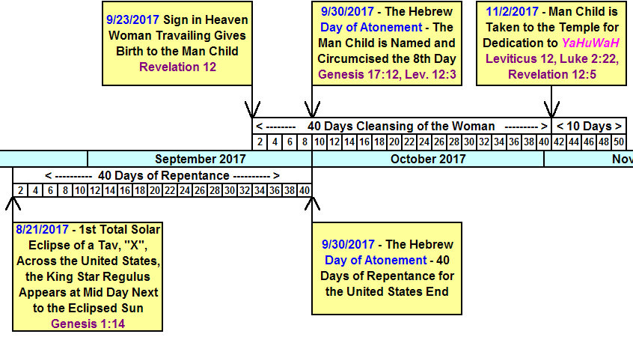

Please note that the symbolic Man Child born on 9/23/2017 is to be circumcised on the 8th day from His birth, which will be on the Hebrew Day of Atonement, 9/30/2017.

Also note that a 40 day period before the Day of Atonement is allotted each year for repentance of sins according to Hebrew teachings. That 40 day period also ends on the Day of Atonement, 9/30/2017. http://free.messianicbible.com/holiday/elul-and-the-days-of-awe-the-season-of-judgment-mercy-repentance-and-the-return-of-yeshua/

9/30/2017 minus 40 days is 8/21/2017, the very day the Paleo Hebrew Tav, "X", an "end mark" begins to be placed on the United States by our Creator, YaHuWaH Elohim.

Summary

On 8/21/2017 we can "follow the King star Regulus", symbol of Messiah, in the constellation Leo, symbol of the Lion of Judah, to the symbolic birth of Israel's Messiah King and Ruler of the World on 9/23/2017.

