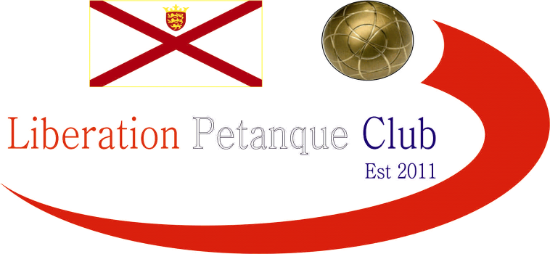

WINTER 2025/26 SEASON
WEEK 9 – 27th December 2025
CHARITY DOUBLES CUP

This year s competition saw 7 teams playing for their own charities.

Split into two groups with the top teams playing in the final and runners up playing for third place.

In Group 1 2024 Winner Callum Stewart was playing with Geoffroy Buffetrille this year and they started off amazingly well beating Graham Toudic and Keith White 13 – 0 whilst Andrew Bellamy-Burt and Jake Romeril lost to Katrina & Trevour Holden.

In Group 2 Gary Cowburn & Wendy Ritzema beat Daniel and James Villalard 13 – 1 with Laurent Pellaton & Toby Northern getting a bye.

In Round 2 Callum & Geoffroy just beat Andrew & Jake 11-10 which ended the latters chances of a final appearence. Graham & Keith though ggot off the mark beating Trevor & Katrina.

Laurent & Toby survived a scare against Daniel & James winning 12 – 10! Gary & Wendy with a bye.

In the final Round Callum & Geoffroy handed out another 13 – 0, this time to Katrina & Trevor whilst Andrew & Jake win on the final end over Graham & Keith got them the runners up spot.

Laurent & Toby played extremely well to beat Gary & Wendy 13 – 4 to make the final with Gary & Wendy going to the third place play off.

In the third place play off Gary & Wendy were 8 – 0 up against Andrew & Jake before losing 13 – 9!

A very close final between Callum & Geoffroy and Laurent & Toby in the end went the formers way meaning Callum has won it three years running (previous two with Ross Payne).

WINNERS - Callum & Geoffroy



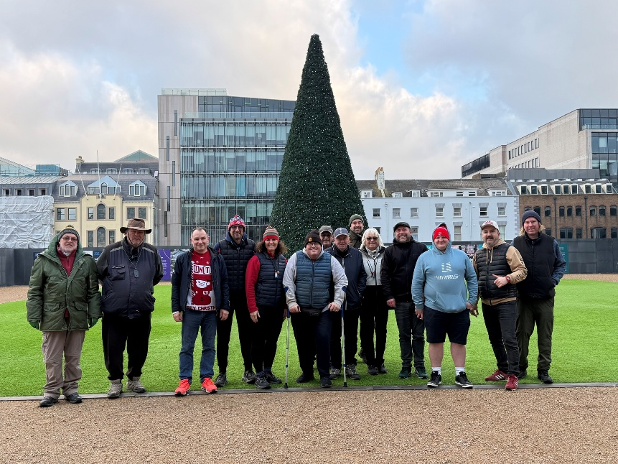

NEXT WEEK - DOUBLES LEAGUE

Club email address - liberationpc@gmail.com

Club Website - www.liberationpetanque.co.uk

Kind Regards

Toby Northern

Chairman

Liberation Petanque Club

