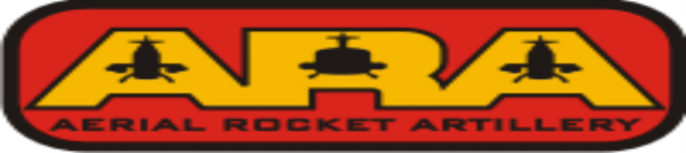

ARA - SAVANNAH - REUNION
23nd ARA REUNION, SAVANNAH, GA, AUGUST 31, - SEPTEMBER 4, 2020
Reunion Registration Form
Send form and check(s) made payable to ARA ASSOCIATION to:
ARA ASSOCIATION
c/o Herbert L. Hirst
P.O. Box 220
North Plains, OR 97133-0220
Information
Name/Membership #
Wife/Guest name(s)
Additional Guest(s)
Street Address
City, State, Zip Code
Telephone Number
Email Address
Any special assistance/
needs required

Please list name(s) as you would like for them to appear on NAME TAG(S) | Where From
Member
Spouse/Guest
ARA Units(s)
Dates

REGISTRATION/EVENT FEES | Details | Price | # In party | Total
Registration Fee | Per member in party over 18 | $40.00
Annual Membership Dues (N/A for Life Member) | If not already paid for 2020 | $25.00
Monday – Dinner & Bus | Per member in party | $36.00
Tuesday - Historic District Trolley Tour | Per member in party | $28.00
Wednesday – Lunch & Bus to Hunter AAF | Per member in party | $25.00
Thursday – Farewell Banquet | Per member in party | $45.50
Total for Reunion | ---------------------------------- | --------- | ------
Please complete and return by July 31, 2020 so that we may finalize all plans and secure set prices for events. Registration forms will be numbered upon receipt in order to secure seats on bus.
Please send confirmation of attendance e-mail to host for head counts. E-mail address for host is jthipp@aol.com: Telephone # 912-598-8785

