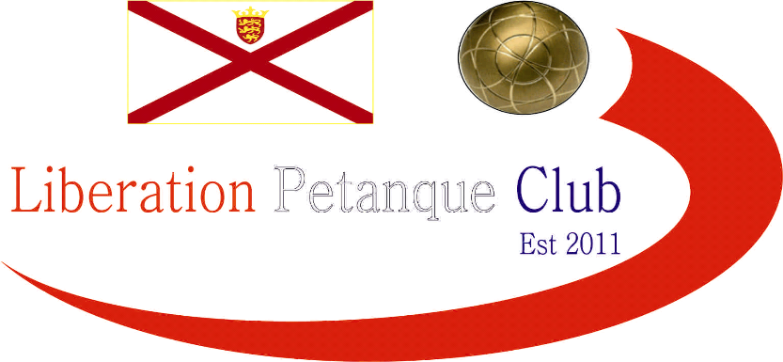

2016
Liberation Cup

Another fantastic competition last night with 16 teams participating in the 6th Annual Liberation Cup.

Last years winner Toby & Matt were looking to become the first team to retain the cup and face tough opponents in David Ibitson & Ian Foster, but quickly went 12-0 up for a spirited fight back resulted in a more respectable scoreline for David & Ian 13 – 8.

The quickest match was Ross & Antony winning 13 – 0 against Andy & Lorna and a big win for Callum & Jake.

Round 2 saw Alan & Craig move to 12 – 5 up against Toby & Matt only for the sound to end during the next end upon which Toby & Matt got 4 points so with one end left just needed to concede less than 3 points. But is was 3 points to Toby & Matt to tie 12 – 12 and the final end. Toby nailed the coche with his first boule, but an excellent fire by Craig left the coche on the terrain althoughToby placed close, Alan placed even closer with Matt missing his firing Alan & Craig won 13 - 12.

Round 3

Alan & Craig went 11 – 0 up against Ross & Antony before blowing their hopes of a top 4 finish with a 13 – 12 loss. Toby & Matt went to the very last end again this time against Geoffroy & James who won 7 – 6. This mean’t their title defence was over.

Round 4

Matt Buesnel & Ellis Turmel won their last match and were holding a top 4 place until Geoffroy & James pulled off another low scoring win to take 4th place. Callum & Jake topped the rankings beating Ross & Antony who finished 2nd. Another good perfomace in this competition saw Joey, this time with his league partner Jonny finish 3rd.

RANKINGS

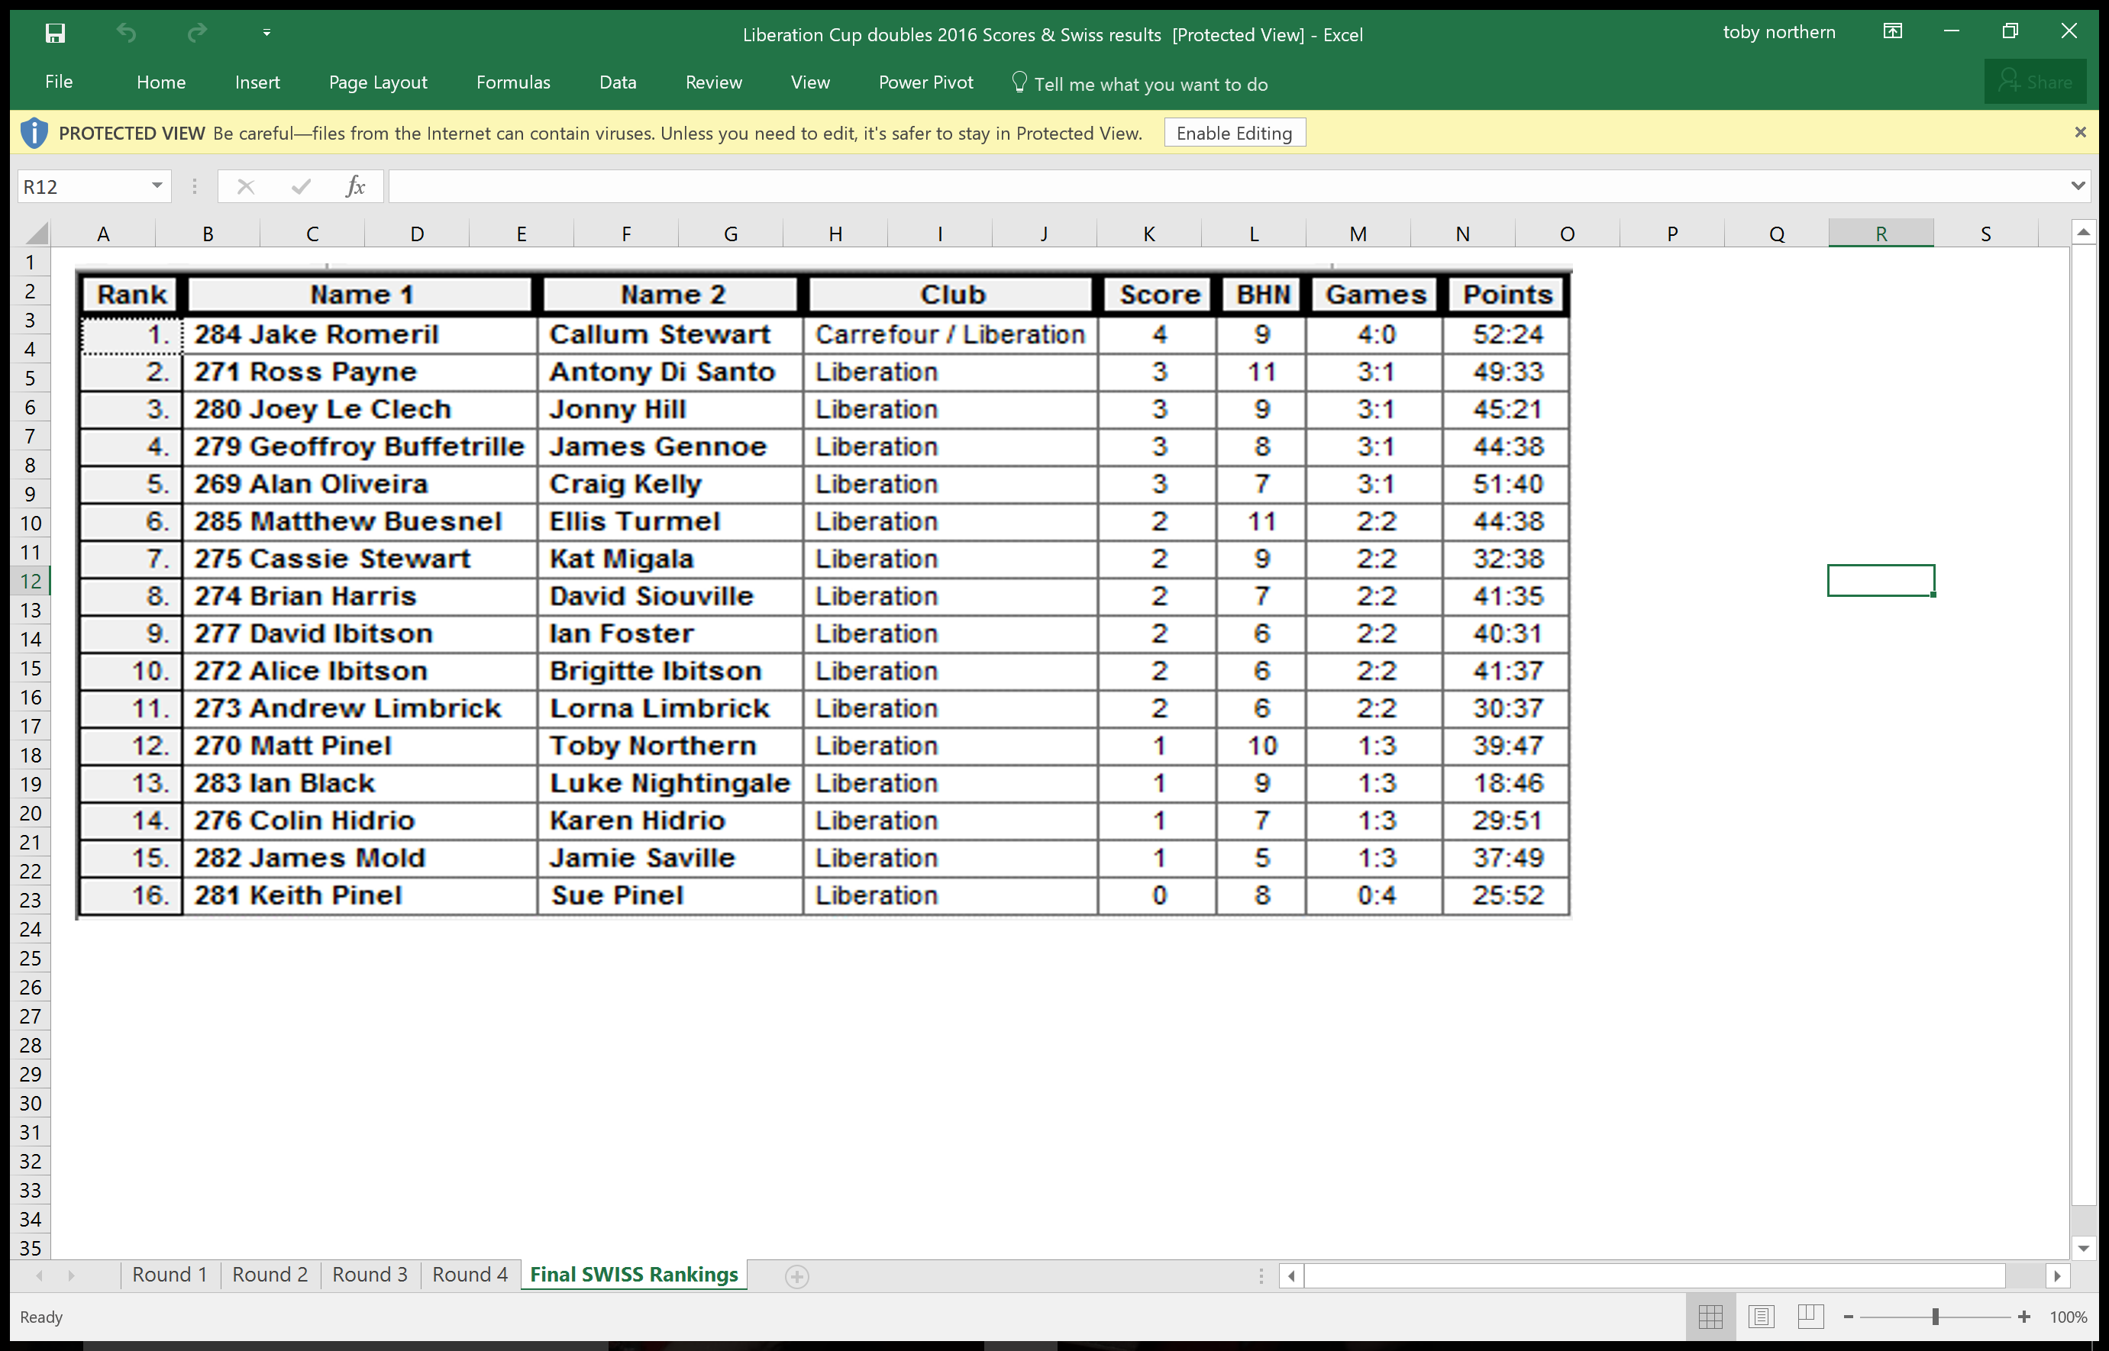

Semi - Finals

With no quarter finals this year Ross & Antony finishing 2nd in the Swiss rankings played Joey & Jonny, it was Joey with Luke who knocked out Ross & Antony at the quarter final stage last year. Ross & Antony though got revenge with an emphatic 13 – 0 win.

Top ranked team Callum & Jake played Geoffroy & James who just scrapped through in 4th on BHN over Alan & Craig who finished 5th for the second year in a row. With Callum taking up the unusual role of placing with Jake firing. Callum though was placing exceptionally well but this only proved to be cannon fodder for Geoffroy who end after end fired Callum’s boules out of the way as Geoffroy & James made the final.

Callum & Jake recovered to beat Joey & Jonny to 3rd place.

The final saw Ross & Antony pick up a 5 on the first end, before Geoffroy & James got back to 7 – 6. Ross & Antony then won the next 2 ends to lead 12 – 6 but Geoffroy & James got 4 points to make it 12 – 10, but that was it as Geoffroy lost his 3rd final this year and gave Ross & Antony their first Liberation Cup win. The only question now is, who will stop them from winning their 4th successive Summer League title and therefore the league and cup double.

Many thanks to James, Toby and everyone else who helped out on the evening, another great job. I hope you all enjoyed the evening.

Club email address - liberationpc@gmail.com

Club Website - www.liberationpetanque.co.uk

Kind Regards

Ross Payne

Chairman

Liberation Petanque Club

SPONSORED BY

