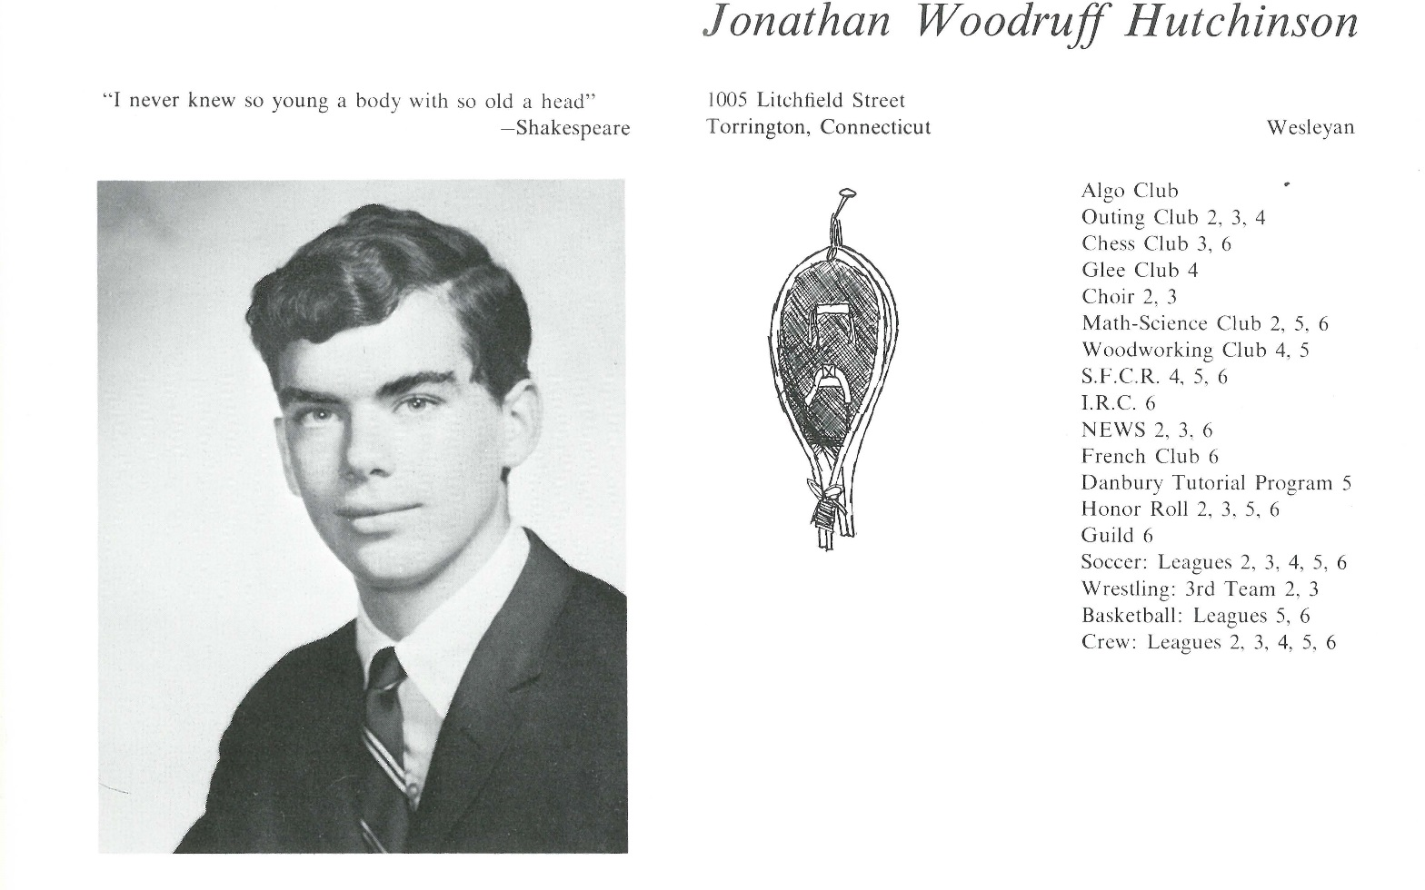

Jonathan W. Hutchinson

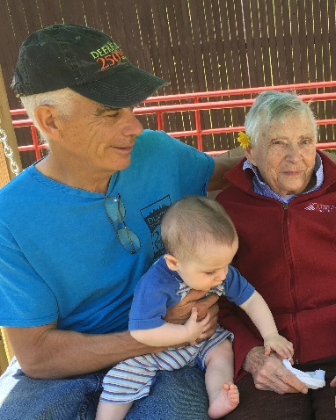Married for 43 years to Rebecca; both retired; two daughters, both married; two grandsons; settled into New Hampshire small town life where we're active on many levels. I care for my aging mother, garden, bicycle and we get ourselves to Merlefest each year.

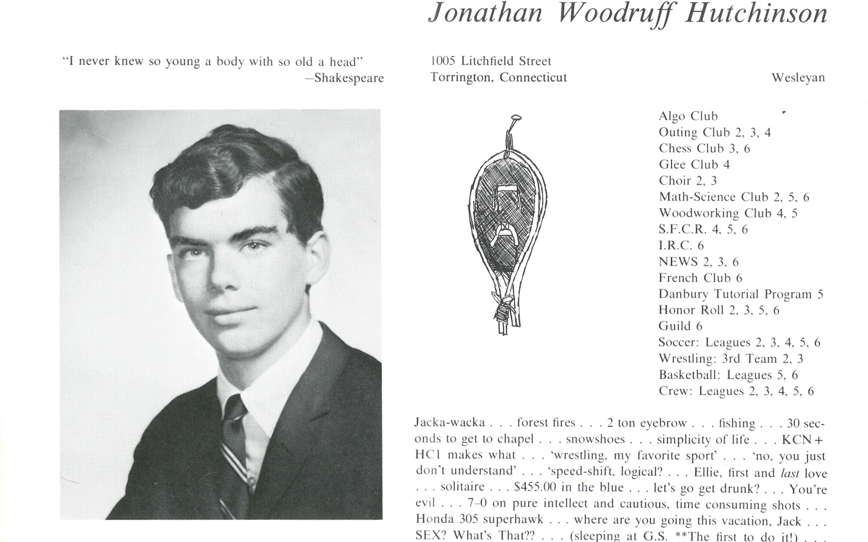

______________________________________________________________

______________________________________________________________ ______________________________________________________________ ______________________________________________________________ ______________________________________________________________ ______________________________________________________________ ______________________________________________________________ ______________________________________________________________ ______________________________________________________________

Attach Picture in .jpg Format

______________________________________________________________

______________________________________________________________

___________________________________________________________________________________ _________________________________________________________________________________________________________________________________________________________________________________________________________________________________________________________________________________________________________________________________________________________________________________________________________________________________________________________________________________________________________________________________________________________________________________________________________________________________________________________________________________________________________________________________________________________________________________________________________________________________________________________________________________________________________________________________________________________________________________________________________________________________________________________________________________________________________________________________________________________________________________________________________________________________________________________________________________________________________________________________________________________________________________________________________________________________________________________________________________________________________________________________________________________________________________________________________________________________________