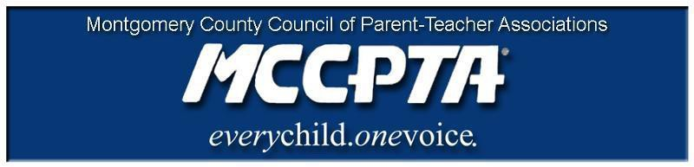
DELEGATES’ ASSEMBLY MEETING AGENDA
Tuesday, February 26, 2019
7:30 PM Thomas Edison HS of Technology – 12501 Dalewood Drive

Welcome and Introduction of Officers

MISSION OF PTA
To make every child's potential a reality by engaging and empowering families and communities to advocate for all children.
Hacer una realidad el potencial de cada niño al comprometer y apoderar las
familias
y comunidades para que intercedan por todos los niños.

Approval of Agenda and Minutes

MCCPTA Minute
- Student Minute – SMOB finalists (postponed)
- Community Minute – PEP
- Community Minute – Junior Achievement

New Business
● Family Justice Center – Choose Respect/Expect Respect programs
● Physical, Social, Psychological (PSP) Framework – Dr. Brice on the new initiative
● Legislative Update – bills and events – Laura Stewart
- Safe Stops and Safe Routes to School – committee update – Alison Gillespie
- School Safety and Security Update – Community Conversations
- Enrollment Projection methodologies – MCCPTA Member concerns – Katya Marin
- LGBTQ subcommittee work– legislative alerts and LGBTQ Forum with Dr. Smith – Mark Eckstein
- PTA/Admin Best Practices- MCAAP/MCCPTA joint recommendations for powerful PTA/School partnerships – Carrie Palsson
- “Racism 101”, Bias, Intolerance, Cultural Sensitivity – programs available for PT(S)As

Officer Reports-
- Cynthia Simonson – “Honors for All”, MISA testing, MPIA request

Committee Updates

Announcements - Education Budget Forums, Restorative Justice workshops, Quadrennial Cluster meetings with BOE

Adjourn

