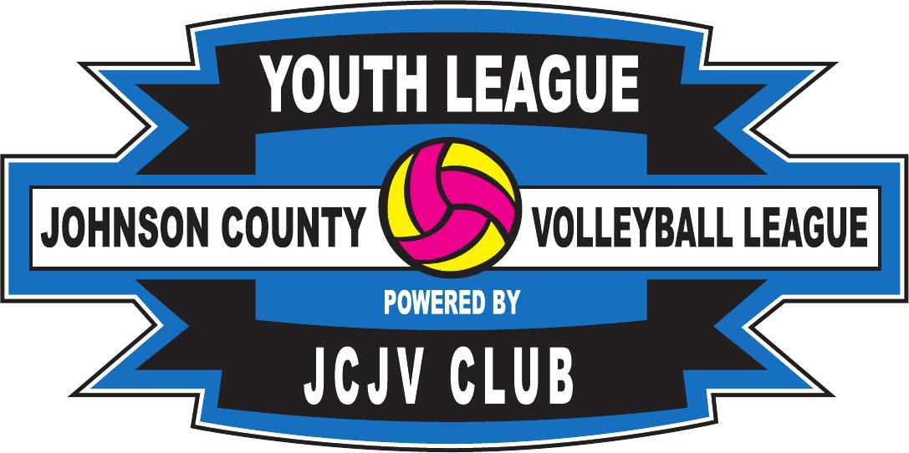

Player Name | Player Age | Player Grade
Parent Name | Parent Email | Parent Phone

I, the undersigned give permission for my child to participate in Johnson County Volleyball League . This authorization shall waive, release and resolve Johnson County Volleyball League and its staff from any and all liability from injury and or illness incurred. I give the staff permission to act on my behalf, according to their best judgment, in any emergency. I also certify that the above applicant has no physical problems or disabilities which would impede her from participating in Johnson County Volleyball League .

Parent Signature : _______________________________________________ Date : ______________

Player Name | Player Age | Player Grade
Parent Name | Parent Email | Parent Phone

I, the undersigned give permission for my child to participate in Johnson County Volleyball League . This authorization shall waive, release and resolve Johnson County Volleyball League and its staff from any and all liability from injury and or illness incurred. I give the staff permission to act on my behalf, according to their best judgment, in any emergency. I also certify that the above applicant has no physical problems or disabilities which would impede her from participating in Johnson County Volleyball League .

Parent Signature : _______________________________________________ Date : ______________

Player Name | Player Age | Player Grade
Parent Name | Parent Email | Parent Phone

I, the undersigned give permission for my child to participate in Johnson County Volleyball League . This authorization shall waive, release and resolve Johnson County Volleyball League and its staff from any and all liability from injury and or illness incurred. I give the staff permission to act on my behalf, according to their best judgment, in any emergency. I also certify that the above applicant has no physical problems or disabilities which would impede her from participating in Johnson County Volleyball League .

Parent Signature : _______________________________________________ Date : ______________

Player Name | Player Age | Player Grade
Parent Name | Parent Email | Parent Phone

I, the undersigned give permission for my child to participate in Johnson County Volleyball League . This authorization shall waive, release and resolve Johnson County Volleyball League and its staff from any and all liability from injury and or illness incurred. I give the staff permission to act on my behalf, according to their best judgment, in any emergency. I also certify that the above applicant has no physical problems or disabilities which would impede her from participating in Johnson County Volleyball League .

Parent Signature : _______________________________________________ Date : ______________

Player Name | Player Age | Player Grade
Parent Name | Parent Email | Parent Phone

I, the undersigned give permission for my child to participate in Johnson County Volleyball League . This authorization shall waive, release and resolve Johnson County Volleyball League and its staff from any and all liability from injury and or illness incurred. I give the staff permission to act on my behalf, according to their best judgment, in any emergency. I also certify that the above applicant has no physical problems or disabilities which would impede her from participating in Johnson County Volleyball League .

Parent Signature : _______________________________________________ Date : ______________

Player Name | Player Age | Player Grade
Parent Name | Parent Email | Parent Phone

I, the undersigned give permission for my child to participate in Johnson County Volleyball League . This authorization shall waive, release and resolve Johnson County Volleyball League and its staff from any and all liability from injury and or illness incurred. I give the staff permission to act on my behalf, according to their best judgment, in any emergency. I also certify that the above applicant has no physical problems or disabilities which would impede her from participating in Johnson County Volleyball League .

Parent Signature : _______________________________________________ Date : ______________

Player Name | Player Age | Player Grade
Parent Name | Parent Email | Parent Phone

I, the undersigned give permission for my child to participate in Johnson County Volleyball League . This authorization shall waive, release and resolve Johnson County Volleyball League and its staff from any and all liability from injury and or illness incurred. I give the staff permission to act on my behalf, according to their best judgment, in any emergency. I also certify that the above applicant has no physical problems or disabilities which would impede her from participating in Johnson County Volleyball League .

Parent Signature : _______________________________________________ Date : ______________

Player Name | Player Age | Player Grade
Parent Name | Parent Email | Parent Phone

I, the undersigned give permission for my child to participate in Johnson County Volleyball League . This authorization shall waive, release and resolve Johnson County Volleyball League and its staff from any and all liability from injury and or illness incurred. I give the staff permission to act on my behalf, according to their best judgment, in any emergency. I also certify that the above applicant has no physical problems or disabilities which would impede her from participating in Johnson County Volleyball League .

Parent Signature : _______________________________________________ Date : ______________

Player Name | Player Age | Player Grade
Parent Name | Parent Email | Parent Phone

I, the undersigned give permission for my child to participate in Johnson County Volleyball League . This authorization shall waive, release and resolve Johnson County Volleyball League and its staff from any and all liability from injury and or illness incurred. I give the staff permission to act on my behalf, according to their best judgment, in any emergency. I also certify that the above applicant has no physical problems or disabilities which would impede her from participating in Johnson County Volleyball League .

Parent Signature : _______________________________________________ Date : ______________

Player Name | Player Age | Player Grade
Parent Name | Parent Email | Parent Phone

I, the undersigned give permission for my child to participate in Johnson County Volleyball League . This authorization shall waive, release and resolve Johnson County Volleyball League and its staff from any and all liability from injury and or illness incurred. I give the staff permission to act on my behalf, according to their best judgment, in any emergency. I also certify that the above applicant has no physical problems or disabilities which would impede her from participating in Johnson County Volleyball League .

Parent Signature : _______________________________________________ Date : ______________

Player Name | Player Age | Player Grade
Parent Name | Parent Email | Parent Phone

I, the undersigned give permission for my child to participate in Johnson County Volleyball League . This authorization shall waive, release and resolve Johnson County Volleyball League and its staff from any and all liability from injury and or illness incurred. I give the staff permission to act on my behalf, according to their best judgment, in any emergency. I also certify that the above applicant has no physical problems or disabilities which would impede her from participating in Johnson County Volleyball League .

Parent Signature : _______________________________________________ Date : ______________

Player Name | Player Age | Player Grade
Parent Name | Parent Email | Parent Phone

I, the undersigned give permission for my child to participate in Johnson County Volleyball League . This authorization shall waive, release and resolve Johnson County Volleyball League and its staff from any and all liability from injury and or illness incurred. I give the staff permission to act on my behalf, according to their best judgment, in any emergency. I also certify that the above applicant has no physical problems or disabilities which would impede her from participating in Johnson County Volleyball League .

Parent Signature : _______________________________________________ Date : ______________

Coaches Info:

Team Name | Grade Level

Coaches Name
Coaches Email
Coaches Phone
Directors Name
Directors Email
Directors Phone

All Communication from JCVL will done between Coaches of teams , Volleyball Association directors only. No communications will be done to the parents of teams. All Schedules will be given to Coaches and directors and will be on line on the jcjvclub.org website.
JCVL schedule.

Cost for league. $500.00 per team
Pay with Check or pay on line at jcjvclub.org click on JCVL scroll down to team payment menu.
Not accepting payments from parents individually. Must be from Team Coach or Association.
Mail and make payments to J.R. Martinez
JCJV 817-915-2059
219 4th St
Joshua,Tx 76058

