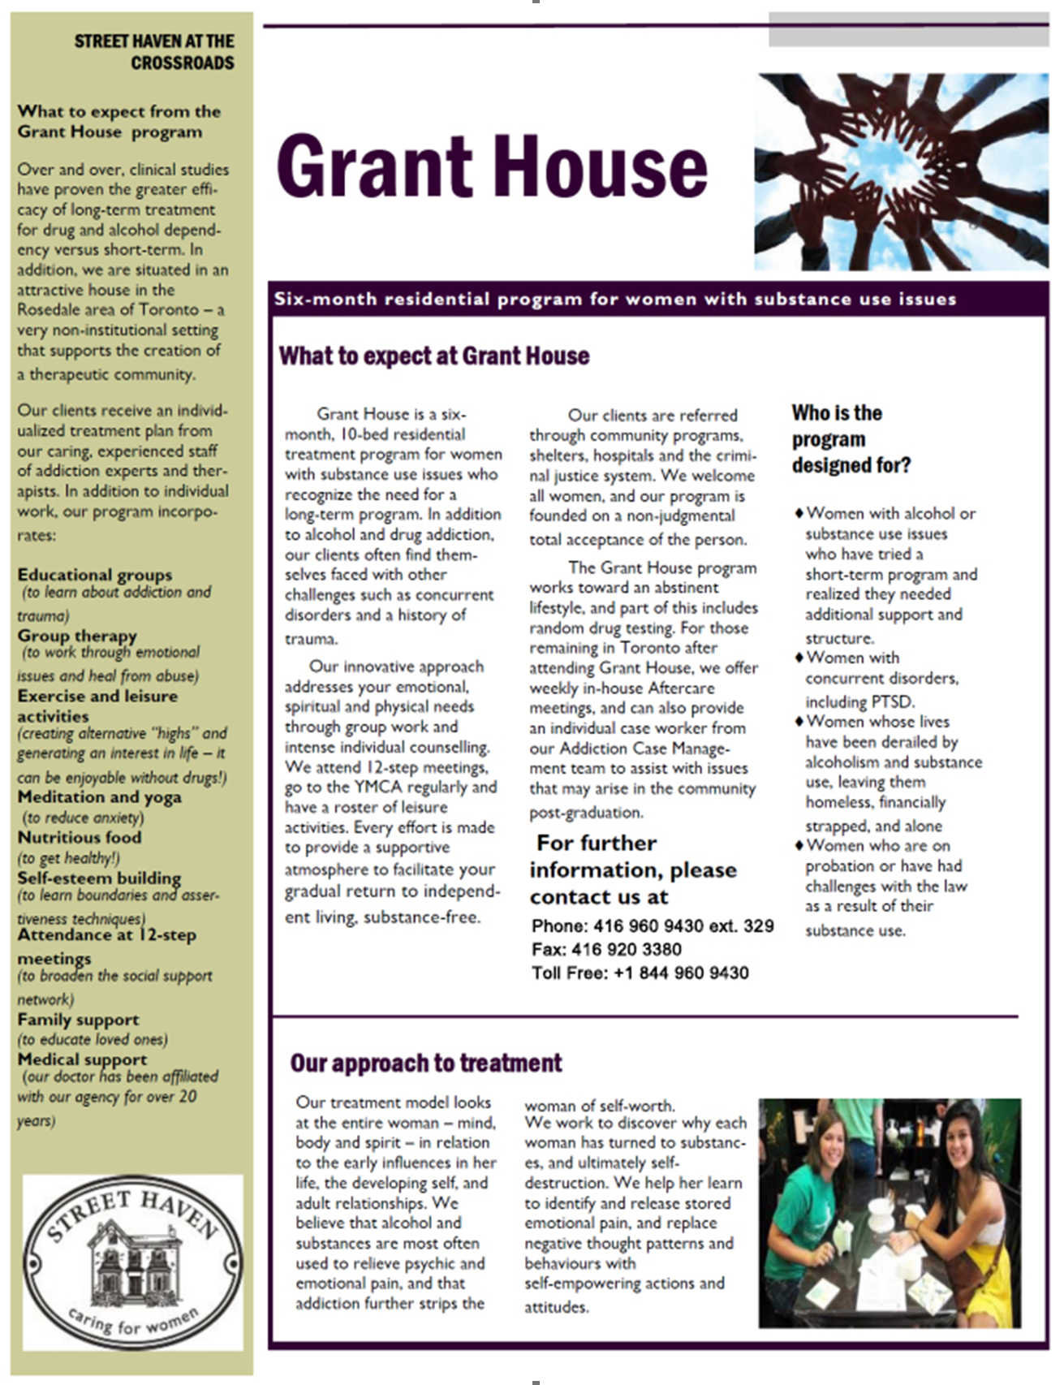
 Street Haven Addiction Services

Grant House APPLICATION

Dear applicant,
We are pleased you are considering Grant House for treatment and hope in this package to provide more information about our program.
Grant House offers a six-month residential stay for 10 women recovering from substance abuse. We have two groups daily to address the physical, emotional, mental, spiritual and social aspects of recovery, and provide individual counselling as well. We attend 12-step meetings, go to the YMCA, and pursue leisure activities as part of our abstinence-based program.
The length of residence allows for increased amounts of freedom to assist with your integration back into the community. After you complete the program, we offer additional support from our team of outreach counsellors, as well as an Aftercare group at Grant House.
If you are interested in our program, the next step is to fill in the accompanying forms and return them to us:
❑ the Application
❑ the Consent Form for Disclosing Personal Health Information
When I receive your application, I will get in touch with you to talk further and keep you updated.
Once I have received your application I would like you to do a weekly phone check-in - and remember; you are welcome to call at any time if you have any questions or concerns.
Yours,
Program Supervisor
Phone: 416 960 9430 ext. 329 Fax: 416 920 3380
Toll Free: +1 844 960 9430
Street Haven Addiction Services

Grant House
Grant House is a six-month, 10-bed residential treatment program for women with substance use issues who recognize the need for a long-term program. In addition to alcohol and drug addiction, our clients often find themselves faced with other challenges such as concurrent disorders and a history of trauma.
Our innovative approach addresses your emotional, spiritual and physical needs through group work and intense individual counselling. We attend 12-step meetings, go to the YMCA regularly and have a roster of leisure activities. Every effort is made to provide a supportive atmosphere to facilitate your gradual return to independent living, substance-free.
Our clients are referred through community programs, shelters, hospitals and the criminal justice system. We welcome all women, and our program is founded on a non-judgmental total acceptance of the person.
Our program includes:
- Cognitive living skills
- Making connections between trauma and addictions
- Relapse prevention
- Cognitive-Behavioural skill building
- Behavioural therapy
- Nutrition for recovery
- Relaxation and exercise
- Preparing for the future [parenting, school preparation, house hunting, etc.]
- Self-help for recovery [12-step meetings]
- Leisure therapy
- Cultural connections
- Individual counselling
- Aftercare
The Grant House program works toward an abstinent lifestyle, and part of this includes random drug testing.
For those remaining in Toronto after attending Grant House, we offer weekly in-house Aftercare meetings, and can also provide an individual case worker from our Addiction Case Management team to assist with issues that may arise in the community post-graduation.
For further information, please contact us at 416-960 9430 ext. 329

Street Haven Addiction Services

Grant House APPLICATION

Name: __________________________________ Date: _____________

Date of birth: (dd/mm/yy) _____________________

Age:____
Health card number: ___________________
Have you ever changed your name:  yes  no Social insurance number:
If so, what were your initials at birth? ___ ___________________

Contact information:

Address: ________________________________

________________________________

Phone: ________________________________ Okay to call?  yes  no

In case of emergency, who should we call?

Name: ___________________________________ Relationship: ____________

Address: __________________________________

__________________________________

Phone: __________________________________

Please describe your current living arrangements. Are you living on your own, with friends, with family? ___________________________________________________________
_________________________________________________________________
_________________________________________________________________

Are you currently in a relationship?_______________________________________
_________________________________________________________________

Family background 2

Where were you born? ________________________________

Please fill in the following chart with information about your family, not including your own children (should you have any):

Family member’s name | Relationship | Age | Do you have contact with them? | Do they support your plans? | Do they abuse drugs/alcohol

If any of your family members are deceased please fill in the follow chart:

Name | Relationship | Year of death

What was it like growing up in your family? _________________________________

_________________________________________________________________

_________________________________________________________________

How would you describe yourself as a child? ________________________________

_________________________________________________________________

_________________________________________________________________

Marital status:

❑ Married/Common law  Single (never married)
❑ Widow  Divorced/Separated
Do you have children?  yes  no 3

If you have had children, please fill in the following chart:

Name | boy /girl | age | Where and with whom are they living? | Do you have contact with them?

Has there been C/CAS or Native Child and Family Services involvement?

❑ yes  no Which children? __________________________________________

Do you need to arrange childcare while you are in treatment?  yes  no

Education/Employment

What languages do you speak? ______________________________________

Please check highest level of schooling achieved:

❑ no formal schooling  some high school  completed college
❑ some primary school  completed high school  some university
❑ completed primary  some college/technical school  completed university

Do you have plans for further education? ____________________________________

Are you employed? ____________________________________________________

Do you have a source of income?__________________________________________

Can we assist you in applying for Ontario Works? ______________________________

Do you have a family doctor?  yes  no

Name: _________________________________________

Address: _______________________________________

DRUG AND ALCOHOL HISTORY 4

When did you first start drinking or taking drugs? _________________________________

When did your substance use start becoming a problem? ____________________________

_______________________________________________________________________

Have you had periods of clean time? ____________________________________________

_______________________________________________________________________

What are your drugs of choice? How often did you use in the past
30 days?
MAJOR: __________________
❑ did not use
2nd: ______________________  1 to 3 times a week
❑ 3 to 6 times a week
3rd: ______________________  daily

Please indicate any substances you have used in the past year:

❑ Alcohol | ❑ Heroin | ❑ Hallucinogens (K)
❑ Crack | ❑ Opium | ❑ Ecstasy
❑ Cannabis | ❑ Amphetamines  (Ritalin) | ❑ Prescription opioids (oxys, percocets, Fentanyl, Dilaudid)
❑ Cocaine | ❑ Barbiturates | ❑ Crystal meth
❑ Glue/Inhalants | ❑ Benzodiazapines (Valium) | ❑ GHB

Injection drug use:

- Never injected
- Injected more than one year ago
- Injected in the past 12 months

What are you like when you are drinking or using? How would you describe your personality changes? ________________________________________________________________

_______________________________________________________________________

What are you like when you are withdrawing?_____________________________________

_______________________________________________________________________

5

Have you ever experienced withdrawal seizures? __________________________________

_______________________________________________________________________

Have you ever had problems with an eating disorder? _______________________________

_______________________________________________________________________

Would you say you still struggle with an eating disorder?_____________________________

_______________________________________________________________________

Have you ever attempted suicide? _____________________________________________

_______________________________________________________________________

Have you ever overdosed? ___________________________________________________

Have you ever been to treatment before? If so, please fill in the following chart:

Name of treatment program | Year attended | Program length | Clean time following completion of treatment

What steps are you taking at the present time to assist in your recovery? (Addictions counsellor, 12-step meetings…) _______________________________________________

_______________________________________________________________________

______________________________________________________________________________

6

TRAUMATIC LIFE EXPERIENCE

Many women who develop problematic addictions have histories of abuse of some kind or other. We would like to get a picture of some of your past experiences.

Have you had traumatic or abusive experiences in your life? ____________________

Have you experienced sexual abuse between the ages of:

❑ 1 and 6 years old  16 to 20 years old  30 + years old

❑ 6 to 10 years old  21 to 26 years old  40 + years old

❑ 11 to 15 years old  26 to 30 years old  50 + years old

Was your abuser a family member, a friend, a stranger? __________________________
___________________________________________________________________

Have you ever been physically abused? If so, how old were you, and who was the person responsible?
__________________________________________________________________
__________________________________________________________________

Have you ever suffered from abuse of an emotional, psychological or criminal nature?
__________________________________________________________________
__________________________________________________________________

Thank you for sharing this sensitive information with us. It will play an important part in your recovery at Grant House.

How did you hear about our program at Grant House?
❑ Detox  Doctor  Family
❑ Friend  Internet  Nurse
❑ P.O. officer  Self-help group (AA CA)  Community worker
❑ Corrections social worker
❑ Addictions day program
❑ Other _______________________

LEGAL ISSUES (if applicable) 7
Do you have any charges, fines or warrants outstanding or pending?
_______________________________________________________________________
Do you have any upcoming court dates?
_______________________________________________________________________
Are you currently on probation? When did it start and when will it end?
_______________________________________________________________________
If you are on probation, who is your probation officer, and at what office?
_______________________________________________________________________
If you are incarcerated, what were the charges for your most recent incarceration?
_______________________________________________________________________
When were you arrested?
_______________________________________________________________________
When is your release date?
_______________________________________________________________________
Do you have a lawyer? If so, what is his or her name?
_______________________________________________________________________
Are you out, and awaiting trial or sentencing? Do you know your court date?
_______________________________________________________________________
Please list most recent prior convictions:
Type | Year | Sentence | Juvenile | Adult
Do you have conditions attached to treatment?
❑ No Conditions  Choice of treatment or jail
❑ To regain children  Condition of Probation/Parole Other___________

HEALTH INFORMATION

Do you have any significant health concerns at the moment?
_______________________________________________________________________
_______________________________________________________________________
_______________________________________________________________________

Have you been hospitalized in the past year?  yes  no
If yes, please provide more information:
_______________________________________________________________________
_______________________________________________________________________

Have you ever had a psychiatric diagnosis? If so, what was it? And when was it made?
_______________________________________________________________________
_______________________________________________________________________

Please provide a list of your current medications:

Medication | Daily dose | Why are you taking this? | Months on this med | Side effects?

NOTE: At this time, we are unable to accept clients on methadone or suboxone; benzodiazepines (valium, clonazapam etc.); or on opiates for pain control, even if these medications are prescribed by a physician.

Do you have any allergies?
_______________________________________________________________________
_______________________________________________________________________

Do you have any dietary restrictions?
_______________________________________________________________________
_______________________________________________________________________

Are you capable of walking up and down stairs several times a day?  yes  no
Are you capable of daily outings in the community?  yes  no
Are you capable of performing regular household duties?  yes  no

Are you pregnant, or think you might be?  yes  no

Are there any other medical conditions of which Grant House should be aware?
q Epilepsy/history of seizures q Liver disease
q Musculo-skeletal injuries q Heart disease
q Fibromyalgia q (other_____________________

We require a TB test performed in the past three months. Please provide a form saying you have had this test done, along with the results.

Is there anything else concerning your health that you would like to share with us?
_______________________________________________________________________
_______________________________________________________________________
_______________________________________________________________________

Street Haven Addiction Services

While it’s up to you whether you complete the following questions or not, it might help us get a better idea of why you are interested in coming to Grant House, and why, at this moment, recovery is important to you.

Can you remember how you were first introduced to drugs and/or alcohol and why you took up the offer?

____________________________________________________________________

____________________________________________________________________

____________________________________________________________________

What was your pattern of using just before you decided to come to Grant House (what drugs
were you using, how much, how often)?

_____________________________________________________________________

_____________________________________________________________________

_____________________________________________________________________

What did drugs or alcohol do for you? List as many reasons as possible.

_____________________________________________________________________

_____________________________________________________________________

_____________________________________________________________________

_____________________________________________________________________

_____________________________________________________________________

What were the factors that made you realize you had to overcome your addictions?

_____________________________________________________________________

_____________________________________________________________________
_____________________________________________________________________

_____________________________________________________________________
Please describe any periods of time when you stopped using (clean time) or when you were
able to use a lot less (what was going on in your life then)?
_____________________________________________________________________
_____________________________________________________________________
_____________________________________________________________________
What is your experience with getting help in the past? What was helpful and what was
not so helpful?

_____________________________________________________________________
_____________________________________________________________________
_____________________________________________________________________
_____________________________________________________________________
_____________________________________________________________________

What will help you to feel safe and focused on recovery at Grant House. What can you do?
How can other people help?

___________________________________________________________________
___________________________________________________________________
___________________________________________________________________
___________________________________________________________________
___________________________________________________________________
___________________________________________________________________
How do you honestly see yourself today? Which of your strengths will help you do
this program?

___________________________________________________________________
___________________________________________________________________
___________________________________________________________________
___________________________________________________________________
___________________________________________________________________
___________________________________________________________________

What obstacles do you see before you?

___________________________________________________________________
___________________________________________________________________
___________________________________________________________________

Is there anything else you would like to say?

___________________________________________________________________

___________________________________________________________________

___________________________________________________________________

Thank you!

Street Haven Addiction Services

Consent to Disclose Personal Health Information
Pursuant to the Personal Health Information Protection Act, 2004 (PHIPA)

I, ___________________________________________,
(Print your name)

authorize ______________________________________________
(Print name of health information provider, psychiatrist, treatment provider etc.)

To disclose my personal health information consisting of:

❑ clinical records  psychological evaluation  discharge summary
❑ physical health information  master treatment plan  psychiatric evaluation
❑ mental health information  Drug/alcohol tests and results  drug/alcohol diagnosis,
treatment, referrals

To: ___________________________Grant House program counsellor.
(Print name of staff member)

The information is needed for the purpose of adopting a more comprehensive and integrated approach to my health care and maintaining a continuity of care for this purpose only unless otherwise permitted or required by law.
This authorization may be revoked at any time by the client. Revoking of this authorization shall not cancel any prior action that has already transpired. If not revoked, it shall terminate the last day of clinical treatment.

I understand the purpose for disclosing this personal health information to Grant House staff. I understand I can refuse to sign this consent form.

Print name: ______________________________________

Signature: _____________________________ Date: __________

Witness name: __________________________________

Signature: ______________________________ Date:______________

Street Haven Addiction Services
Phone: 416 960 9430 Fax: 416 920 3380
Street Haven Addiction Services

Consent to Disclose Personal Information

I, ___________________________________________,
(Print your name)

Authorize _________________________________________________
(Ministry of Community Safety and Correctional Services – Social Worker)

To disclose information consisting of:

probation details legal information
❑ mental health information, behavioar  Drug/alcohol tests and results
❑ drug/alcohol diagnosis, treatment, referrals

To Street Haven Addiction Services staff – Grant House

The information is needed for the purpose of adopting a more comprehensive and integrated approach to my care and maintaining a continuity of care for this purpose only unless otherwise permitted or required by law.
This authorization may be revoked at any time by the client. Revoking of this authorization shall not cancel any prior action that has already transpired. If not revoked, it shall terminate the last day of clinical treatment.

I understand the purpose for disclosing this information to Grant House staff. I understand I can refuse to sign this consent form.

Print name: ______________________________________

Signature: _____________________________ Date: __________

Witness name: __________________________________

Signature: ______________________________ Date:______________

Street Haven Addiction Services
Phone: 416 960 9430 Fax: 416 920 3380

Street Haven Addiction Services

Consent to Disclose Personal Information
(Legal issues)

I, ___________________________________________,
(Print your name)

Authorize _________________________________________________
(Lawyers Name and phone number)

To disclose information consisting of:

X probation details X legal information
❑ mental health information  Drug/alcohol tests and results
❑ drug/alcohol diagnosis, treatment, referrals

To Street Haven Addiction Services staff – Grant House

The information is needed for the purpose of adopting a more comprehensive and integrated approach to my care and maintaining a continuity of care for this purpose only unless otherwise permitted or required by law.
This authorization may be revoked at any time by the client. Revoking of this authorization shall not cancel any prior action that has already transpired. If not revoked, it shall terminate the last day of clinical treatment.

I understand the purpose for disclosing this information to Grant House staff. I understand I can refuse to sign this consent form.

Print name: ______________________________________

Signature: _____________________________ Date: __________

Witness name: __________________________________

Signature: ______________________________ Date:______________

Street Haven Addiction Services
Phone: 416 960 9430 Fax: 416 920 3380

Street Haven Addiction Services

Consent to Disclose Personal Information
(Legal issues)

I, ___________________________________________,
(Print your name)

Authorize Marissa Levene, Probation and Parole Officer, 920 Yonge St.

To disclose information consisting of:

X probation details X legal information
❑ mental health information  Drug/alcohol tests and results
❑ drug/alcohol diagnosis, treatment, referrals

To Street Haven Addiction Services staff – Grant House

The information is needed for the purpose of adopting a more comprehensive and integrated approach to my care and maintaining a continuity of care for this purpose only unless otherwise permitted or required by law.
This authorization may be revoked at any time by the client. Revoking of this authorization shall not cancel any prior action that has already transpired. If not revoked, it shall terminate the last day of clinical treatment.

I understand the purpose for disclosing this information to Grant House staff. I understand I can refuse to sign this consent form.

Print name: ______________________________________

Signature: _____________________________ Date: __________

Witness name: __________________________________

Signature: ______________________________ Date:______________

Street Haven Addiction Services
Phone: 416 960 9430 Fax: 416 920 3380

What Happens Next?
