

Summer 25 Season

Pre – Season Report

Welcome to the Summer 2025 season.

Current Summer league champion Geoffroy Buffetrille is back to defend his title as he aims to prove he is still the best in the Summer.

Toby who finished runners up will be back to push Geoffroy all the way as will newly crowned Singles Winter League Champion Brian Harris.

Andrew Bellamy Burt, the Singles Cup legend will be hoping to get back to the top after a few years absence with top players like Callum Stewart, Ross Payne and Laurent Pellaton all likely to be in the mix come the end of the season.

Gaining promotion from last Summer with the Division 1 title was Wendy Ritzema. How will Wendy fair in the Premier League? John McGaw, Jim Waddell and Keith White joining the top flight, who will fare the best of these three players?

Joey Le Clech and Alex & Jean Stewart all went down, who will be most likely challenge for the title and promotion?

Daniel and James Villalard, Lorna Limbrick, Colin Floyd, Mo De Gruchy, Francis Corbally, Branden De La Haye and Cassie Stewart-Le Gallais all looking to take points off each other.

Let us know on Facebook who your top three will be.

Doubles Premier League Champions Geoffroy & Matt Buesnel are not together this season as Matt takes a break with new family on the horizon.

Andrew & Callum will be looking to make it two this Summer after winning their first ever Summer title in 2023, with Neil & Ross aiming to take the final leap to the top.

Laurent will be playing with Jean again and could be ones to watch, whilst Daniel & Toby who took third last Summer will be looking to break into that top three again but will be tough going.

Alan & Mike, thee only promoted team actually playing together this summer so Brian & Colin also playing in the Premier League.

Alan & Joey and Graeme & Keith looking to push teams all the way.

Let us know on Facebook who your top three will be.

In Division 1 relegated team, Gary & Wendy will be looking to bounce back to the Premier League and should be the favourites but will find it tough going with some good teams in an open league.

John & Nick finished third in the Winter Premier League and always hard to beat could also be ones to challenge this season.

All good experienced teams in Colin & Jim, Cassie & Chris, Daniel & James and Keith & M will be joined by new teams Alex & Dawn, Lorna & Tommy.

Brand new members Gary & Sue Boschat and Lisa Hiller & Blaise Nobrega. Here’s hoping you enjoy your first season at the club.

Let us know on Facebook who your top three will be.

Good Luck to everyone.

Please like and follow us on Facebook.

League tables will be posted on Facebook each week (Thursday) as well as on the club website which will have all the scores and reports as well, each week.

WEBSITE www.liberationpetanque.co.uk
EMAIL liberationpc@gmail.com

SUMMER 2025 SEASON
WEEK 1 – 2nd April 2025
SINGLES LEAGUE

The new season and new terrains playing indoors for the first time ever. Only for a little while though.

Champion Geoffroy had a week off with his match re arranged, this meant that last years runner up, Toby had the chance to put early pressure on if he could beat Keith White who was playing his first ever Premier League game. A big win in the first game 13 – 5 but toby had to come back from 10 – 5 down to win 13 – 10 to start with a good win.

The big match of the week though was Andrew B v Laurent, Laurent having never beaten Andrew was so close but lost a 10-6 lead in game two losing 13 – 11 for a draw.

Another big match as Brian, the newly crowned Winter League champion fought for a good draw against Ross, whilst Wendy first Premier League match ended in a defeat to Neil who returns to action after a Winter break.

In Division 1 Colin Floyd tops the league early on after a big win over Lorna and both Alex and Jean Stewart won their singles matches, with Jean beating James Gennoe and Alex beating new member Keith.

Mo De Gruchy also won over Brandon, whilst Damiel and James Villalard drew against each other as did Cassie and Joey.

NEXT WEEK - DOUBLES LEAGUE

Club email address - liberationpc@gmail.com

Club Website - www.liberationpetanque.co.uk

Kind Regards

Toby Northern

Chairman - Liberation Petanque Club

SUMMER 2025 SEASON
WEEK 2 – 9th April 2025
DOUBLES LEAGUE

Great to see so many people enjoying the first scheduled doubles league fixtures and what a start it was with not one, not two but three 13 – 0 handed out!

With one of last year’s Doubles league champions not playing Geoffroy joined up again with James Gennoe whom he won the Island Doubles with last year and they won the Doubles Premier league in Winter 2017/18 season.

They played Andrew & Callum in week 1, could one of these teams make a huge start to the season. Well it was the latter as Andrew & Callum top the league after week one with a big win. This ended Geoffroy & James 14 match unbeaten run.

Last year’s third place Neil & Ross, lost their first game to Gary & Wendy before turning it around winning 13 – 0 in the second for a valuable draw. Jean & Laurent also turned it around winning 13 – 1 in the second game against Brian & Colin also for a draw.

In Division 1 it was wins all around. New team joining us this summer in Gary & Sue beat a newly formed team in Lorna & Tommy for a great start to their first season at the club and handing out a 13 – 0 in the process. Also new members Blaise & Lisa playing their first ever pétanque match managed to score some points but lost to a very experience team in Keith & Mo.

An unusual defeat for John & Nick but a great start also for Colin & Jim and also for Alex & Dawn coming back in the first game before sealing two 13 – 10 wins over Daniel & James.

NEXT WEEK - SINGLES LEAGUE

Club email address - liberationpc@gmail.com

Club Website - www.liberationpetanque.co.uk

Kind Regards

Toby Northern, Chairman - Liberation Petanque Club

SUMMER 2025 SEASON

WEEK 3 – 16th April 2025

SINGLES LEAGUE

A big double fixture week for some players, with six possible points up for grabs for most a chance to take an advantage.

Winter champion Brian Harris picked up four points with a win over Jim and a draw with Geoffroy to remain unbeaten with two draws and a win so far.

Neil made it two wins with a close 13 – 11, 13 – 10 win over Laurent who drops down the table with only one point so far, his first loss in 14 matches!.

However a different story against Toby who lead 7 – 0 in the first game before Neil level and went ahead 10-9 before Toby got the win. Toby again 5 – 0 up in the first game but Neil drew level at 6-6 before a three and two points ends saw Toby lead 11 – 6 before closing out a big win 13 – 8, Neil’s first loss in six matches.

Toby first match was against Andrew, with Toby winning comfortably 13 – 3 and look on for a win 6 – 0 up in the second game but Andrew form turned around as he managed to gain a valuable draw.

Wendy had two matches and a chance to get her first ever Premier League campaign up and running. Wendy played John first and then Daniel Deveau but could only draw both matches and just against Daniel taking the second game 13 – 12.

Keith White could also get off the mark as could his opponent Jim and they both did with a draw.

A few matches un-played though due to a trip away for a few players.

In Division 1

Colin played Branden making it two wins but very close matches before drawing with James Villalard and then James Villalard drew with Lorna for three straight draws.

Keith McGonigle got his first ever league point with a 13 – 1 win over Mo in game two and followed that up with a draw against Branden. Mo though got a shock win over Joey to sit joint first in the league with Colin and Jean.

Jean played Daniel Villalard getting a big win and then won the first game against Lorna but ended in a draw. Jean now top of the league.

Francis played James Gennoe with the latter getting an expected win and then Daniel Villalard winning the second game 13 – 12 for a great point.

Outstanding Matches

Callum Stewart v Daniel Deveau

Callum Stewart v John McGaw

John McGaw v Laurent Pellaton

Keith White v Ross Payne

Ross Payne v Andrew Bellamy-Burt

Joey Le Clech v Alex Stewart

Tommy Walsh v Alex Stewart

Tommy Walsh v Cassie Stewart Le Gallais

James Gennoe v Cassie Stewart Le Gallais

NEXT WEEK - DOUBLES LEAGUE

Club email address - liberationpc@gmail.com

Club Website - www.liberationpetanque.co.uk

Kind Regards

Toby Northern

Chairman - Liberation Petanque Club

SUMMER 2025 SEASON
WEEK 4 – 23rd April 2025
DOUBLES LEAGUE

Another Jersey Development Company issue, with the terrains being unavailable so matches played at Millennium Park.

Andrew & Callum were looking to push on after a big win in week 1, could they beat Alan & Mike? Yes and so top the league after week 2.

Gary & Wendy would have been hoping also get a win after a disappointing second game against Neil & Ross in week 1 but they lost to Alan & Joey.

In Division1 Keith & Mo, Colin & Jim all looking for back to back wins in week 2, which they both did. Keith & Mo beat Cassie & Chris whilst Colin & Jim beat Blaise & Lisa

NEXT WEEK - SINGLES LEAGUE

Club email address - liberationpc@gmail.com

Club Website - www.liberationpetanque.co.uk

Kind Regards

Toby Northern

Chairman - Liberation Petanque Club

SUMMER 2025 SEASON
WEEK 5 – 30th April 2025
SINGLES LEAGUE

Well were on the move for the last fixture before a break from league matches in May.

At Millennium Park this week with the singles league. In the Premier league Laurent come back well in the second game from 11 – 7 down to seal a valuable three points against Daniel Deveau.

Andrew finally got his first win of the season over Jim but only just taking the first game 13 – 12!

In division 1 Mo was the only top three player in action this week, she played Tommy with a draw meaning she is top of the league but could be two valuable points lost.

Francis played Lorna, with both players hoping for a win to move them up the table. It was Lorna that got a big win moving up several places in the league a s a result.

NEXT WEEK - Total Precision Petanque

Club email address - liberationpc@gmail.com

Club Website - www.liberationpetanque.co.uk

Kind Regards

Toby Northern

Chairman - Liberation Petanque Club

SUMMER 2025 SEASON
WEEK 6 – 7th May 2025
FREE WEEK

.

NEXT WEEK - FREE WEEK

Club email address - liberationpc@gmail.com

Club Website - www.liberationpetanque.co.uk

Kind Regards

Toby Northern

Chairman - Liberation Petanque Club

SUMMER 2025 SEASON
WEEK 7 – 14th May 2025
FREE WEEK

.

NEXT WEEK - FREE WEEK

Club email address - liberationpc@gmail.com

Club Website - www.liberationpetanque.co.uk

Kind Regards

Toby Northern

Chairman - Liberation Petanque Club

SUMMER 2025 SEASON
WEEK 8 – 21st May 2025
FREE WEEK

.

NEXT WEEK - FREE WEEK

Club email address - liberationpc@gmail.com

Club Website - www.liberationpetanque.co.uk

Kind Regards

Toby Northern

Chairman - Liberation Petanque Club

SUMMER 2025 SEASON
WEEK 9 – 28th May 2025
FREE WEEK

.

NEXT WEEK - DOUBLES LEAGUE

Club email address - liberationpc@gmail.com

Club Website - www.liberationpetanque.co.uk

Kind Regards

Toby Northern

Chairman - Liberation Petanque Club

SUMMER 2025 SEASON
WEEK 10 – 4th June 2025
DOUBLES LEAGUE

Where back at the Weighbridge for the re start to the leagues.

Andrew & Callum made it three straight wins as they picked up where they left off before the break to give Graeme & Keith their first loss.

Neil & Ross extended their unbeaten run to 18 matches with a win over Brian & Colin and will likely be challenging Andrew & Callum again this season.

Island Doubles champions, Geoffroy & James got off the mark with a win over Jean & Laurent to move up the table.

No matches played in Division 1.

NEXT WEEK - CLUB DOUBLES CUP

Club email address - liberationpc@gmail.com

Club Website - www.liberationpetanque.co.uk

Kind Regards

Toby Northern

Chairman

Liberation Petanque Club

The new season and new terrains playing indoors, well at least for a little while.

Round one saw big wins for champions Neil & Ross over Daniel & James, whilst Andrew & Callum made light work of Brian & Colin.

A low scoring 8 – 4 win for Geoffroy & James over Keith & Mo and a carreaux for game for Toby with Laurent against Gary & Wendy.

Round 2 - Neil & Ross went one better with a 13 – 1 win over Andrew & Callum whilst Geoffroy & James beat Laurent & Toby 13 – 3.

Brian & Colin just beat Daniel & James 9 – 7 and Gary & Wendy beat Keith & Mo 10 – 6.

Round 3 - Two close 10 – 8 wins saw Neil & Ross beat Geoffroy & James and Andrew & Callum beat Laurent & Toby.

Keith & Mo got to 13 against Daniel & James winning to 8 and Gary & Wendy also did winning 13 – 3 over Brian & Colin.

In the final round Gary & Wendy 12 – 5 win over Neil & Ross their first defeat saw Gary & Wendy finish second with Neil & Ross third.

Geoffroy & James second defeat in a row saw them drop to third and just qualify by one BHN over Laurent & Toby with Andrew & Callum finishing top.

FINAL SWISS RANKINGS

. 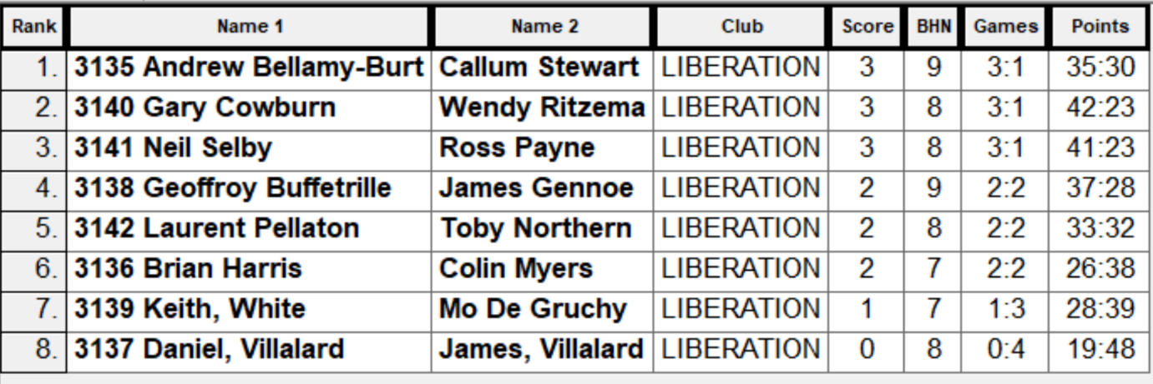

SEMI-FINALS

Ranked 1st Andrew & Callum v Geoffroy & James Ranked 4th

Ranked 2nd Gary & Wendy v Neil & Ross Ranked 3rd

In a strange twist the semi finals were the same matches as the final swiss rounds but with the opposite results as Neil & Ross helped by Gary moving the jack in their favour twice won 9 – 2 whilst Geoffroy & James made light work of Andrew & Callum winning 13 – 2.

Andrew & Callum took third, the fifth top three finish for the pair.

Well the score doesn’t represent the match as some excellent pointing by Neil & Ross was met with superb shooting from Geoffroy in fading light and with James pointing well ran out 13 – 1 winners.

Thanks to everyone who helped out.

NEXT WEEK - SINGLES LEAGUE

Club email address - liberationpc@gmail.com

Club Website - www.liberationpetanque.co.uk

Kind Regards

Toby Northern

Chairman - Liberation Petanque Club

Singles Leagues back in action with a double header this week.

Week five fixtures saw the match of the week as Andrew played Geoffroy, whilst a draw would be good for both players, a win would be huge at this stage of the season. It was a win for Geoffroy who handed Andrew his first defeat of the season. This keeps Geoffroy in the hunt for his third successive Summer League title after also beating Neil.

A big match also with Callum, sitting near the top played Laurent, again three points at this stage of the season against a fellow title rival would be huge. Callum maintained his good form with a win, but then lost his first match of the season to Toby who also beat Daniel Deveau to top the table.

Jim played Neil losing heavily against the much more experienced player and John lost to Ross who won both is matches and hand out a certificate beating Daniel Deveau 13 – 0 in game two.

A good chance for Jim and John to pick up a win against each other, Jim was the one to do it making it very close at the bottom part of the table.

In Division 1, Colin played Francis hoping to maintain his top spot, which he did, but just on points difference as James Gennoe joined him at the top with a win over Keith McGonigle and Mo.

Joey was expected to pick up six points in his matches against Branden and Tommy, but drew with Tommy.

Branden also played Jean, getting his first win of the season, handing Jean a big blow in her promotion chances. Jean did beat James Villalard though, but one game 13-12. James Villalard then played Francis getting a draw and this time on the right side of a 13-12 win. Mo also played Daniel with a big 13 – 2, 13 – 1 win!! Daniel also losing heavily to Alex.

NEXT WEEK - DOUBLES LEAGUE

Club email address - liberationpc@gmail.com

Club Website - www.liberationpetanque.co.uk

Kind Regards

Toby Northern

Chairman

Liberation Petanque Club

SUMMER 2025 SEASON
WEEK 13 – 25th June 2025
DOUBLES LEAGUE

With the beautiful summer weather holding out for another week, great to see people enjoying their matches.

In a catch up match Laurent hit the shot of the year, taking a shot on two of Neil and Ross boules when tied at eight each. Laurent split them perfectly for five points and the game and match, their first win of the season and Neil & Ross first loss in 18 matches!

.

Geoffroy & James had beaten Laurent & Jean earlier on to move up the table but could only draw against Neil & Ross.

Gary & Wendy were struggling this season, so would have been hoping for a win against Alan & Mike but it wasn’t to be as the points were shared.

In Division one Keith & Mo had the chance to put some space between themselves and Colin & Jim this week if they could beat Alex & Dawn, with Colin & Jim on a bye, but could only draw

John & Nick would have been hoping to get off the mark against Lorna & Tommy which they did with a big win. Lorna & Tommy also lost to Alex & Dawn.

NEXT WEEK - CANCELLED

Club email address - liberationpc@gmail.com

Club Website - www.liberationpetanque.co.uk

Kind Regards

Toby Northern

Chairman

Liberation Petanque Club

The season was hotting up, especially the weather. A fair few matches in the Premier League off this week.

Toby had the chance to put more space between himself and Geoffroy but was lucky to get a draw against a superb Wendy. Toby now five points above Geoffroy who has three matches in hand!

Neil win over Keith moves him into the top three after Ross could also only draw with Wendy. This was Wnedy sixth draw in seven matches, only two points off the drop zone.

Andrew beat Keith but then drew with Brian who also drew with Neil. Several outstanding matches now in the Premier League which could have significant changes to the league table.

Outstanding Matches

Brian Harris v Keith White

Callum Stewart v Ross Payne

Geoffroy Buffetrille v John McGaw

Daniel Deveau v Jim Waddell

John McGaw v Brian Harris

Jim Waddell v Callum Stewart

Daniel Deveau v Geoffroy Buffetrille

Division One is getting close at the top, but despite James Gennoe losing to Joey, James win over Tommy keeps him top as Colin could only draw his two matches against Alex and Mo.

Francis caused a big shock beating Jean seriously affecting her chance of promotion. Cassie though handed out a certificate to James Villalard on her way to a big win. Cassie could move top if she wins her match in hand over Jean.

Keith McConigle had a great week picking up not just his first win but also his second win of his Liberation career! Well Done Keith.

Alex sits just outside the top three after beating James Villalard and Joey just two points off the top three after two wins, his second over Daniel and winning one of those games 13 – 0.

Lorna beat Mo to move out of the relegation spaces.

SUMMER 2025 SEASON
9th July 2025
PRECISION SHOOTING CUP

15 Players took part this year, with some new players taking part which is good to see.
Five separate disciplines are undertaken in the Precision Shooting with a maximum available score of 100 points, although the world record is 67 achieved by Christophe Sevilla in July 2011.
After Round 1 the scores were as follows:
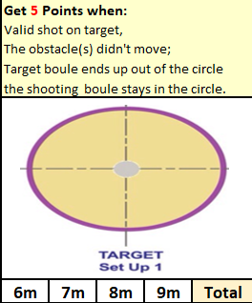
Alan Oliveira | 0
Andrew Bellamy-Burt | 6
Branden De La Haye | 0
Brian Harris | 3
Callum Stewart | 1
Daniel Deveau | 3
Gary Cowburn | 0
James Gennoe | 0
Jean Stewart | 0
Keith White | 0
Ross Churchill | 4
Ross Payne | 6
Toby Northern | 1
Tommy Walsh | 0
Wendy Ritzema | 0

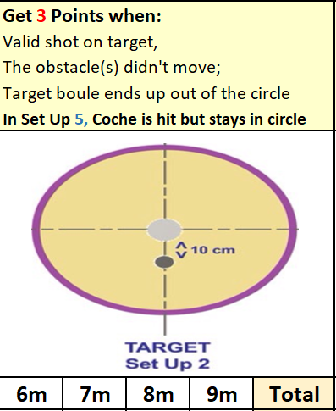
The best starts for Andrew and Ross with 6 points, but shows the importance of starting off well with several players failing to score.

Alan Oliveira | 1
Andrew Bellamy-Burt | 1
Branden De La Haye | 0
Brian Harris | 0
Callum Stewart | 3
Daniel Deveau | 0
Gary Cowburn | 7
James Gennoe | 9
Jean Stewart | 0
Keith White | 0
Ross Churchill | 5
Ross Payne | 1
Toby Northern | 3
Tommy Walsh | 0
Wendy Ritzema | 3

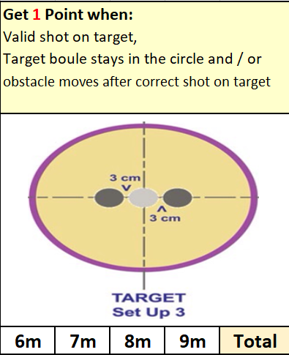
Some good scores from Gary and James in this round helping move them into contention with a much more difficult shot required.

Alan Oliveira | 0
Andrew Bellamy-Burt | 3
Branden De La Haye | 0
Brian Harris | 1
Callum Stewart | 0
Daniel Deveau | 3
Gary Cowburn | 0
James Gennoe | 3
Jean Stewart | 0
Keith White | 0
Ross Churchill | 3
Ross Payne | 0
Toby Northern | 1
Tommy Walsh | 0
Wendy Ritzema | 0

After three rounds Ross Churchill, James Gennoe lead the way.

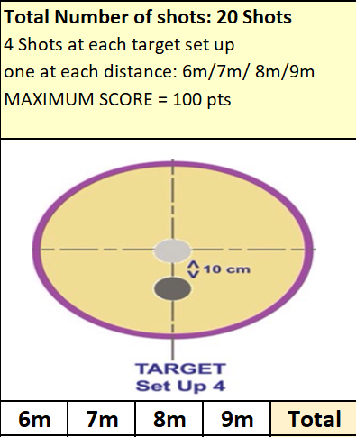
Alan Oliveira | 3
Andrew Bellamy-Burt | 3
Branden De La Haye | 0
Brian Harris | 0
Callum Stewart | 0
Daniel Deveau | 0
Gary Cowburn | 3
James Gennoe | 3
Jean Stewart | 0
Keith White | 1
Ross Churchill | 3
Ross Payne | 3
Toby Northern | 3
Tommy Walsh | 0
Wendy Ritzema | 0

Probably the most difficult one of the five disciplines saw low scores.

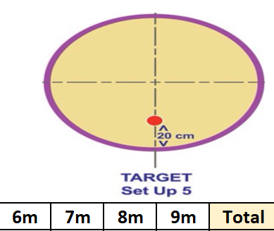
 | Round 5 Score | Total
Alan Oliveira | 0 | 4
Andrew Bellamy-Burt | 3 | 13
Branden De La Haye | 0 | 3
Brian Harris | 3 | 7
Callum Stewart | 0 | 4
Daniel Deveau | 5 | 11
Gary Cowburn | 0 | 10
James Gennoe | 0 | 15
Jean Stewart | 0 | 0
Keith White | 3 | 4
Ross Churchill | 3 | 18
Ross Payne | 10 | 20
Toby Northern | 5 | 13
Tommy Walsh | 0 | 0
Wendy Ritzema | 0 | 3

Ross Payne was the Jack master hitting 10 points to score very well in this round and go through. Ross Churchill’s three points put him through to play Ross Payne in the final as the only players scoring 16 points or more.
Some disappointing scores though with 13 players all surprisingly failing to get the minimum required. Several players one hit away from getting through though.

In the final Ross Payne took the lead 9 – 6 after round 1. This remained unchanged after Round 2.
Mr Payne extended the lead to 12 – 8 after Round three and that unfortunately was the final score with neither player scoring in the final two rounds.

Winner – Ross Payne

Huge thank you to Gary Cowburn and Wendy Ritzema for helping run the event, very much appreciated by all those taking part.

NEXT WEEK - SINGLES LEAGUE

Club email address - liberationpc@gmail.com

Club Website - www.liberationpetanque.co.uk

Kind Regards

Toby Northern

Chairman

Liberation Petanque Club

SUMMER 2025 SEASON
WEEK 16 – 16th July 2025
DOUBLES LEAGUE

With all to play for in the leagues with Brian & Colin making light work of Alan & Joey 13 – 2, 13 – 1! To move them up the table.

Big clash between Neil & Ross v Geoffroy & James ended in a draw with the latter losing the first game 13 – 12! A first win for Gary & Wendy over Graeme & Keith helped them up the table also and a nice win for Jean & Laurent over Alan & Mike.

In Division 1 just one match played with a draw between Keith & Mo and Colin & Jim.

NEXT WEEK - SINGLES LEAGUE

Club email address - liberationpc@gmail.com

Club Website - www.liberationpetanque.co.uk

Kind Regards

Toby Northern

Chairman

Liberation Petanque Club

SUMMER 2025 SEASON
WEEK 17 – 23rd July 2025
SINGLES LEAGUE

With top of the table Toby having a bye could Geoffroy take advantage against Callum? Well not this time as Callum secured a draw.

Two 13 – 12 wins for Brian over Daniel Deveau for a crucial three points and still undefeated. Ross 13 – 12 loss to Laurent in game one meant he also drew, with Laurent closer to the bottom than top!

Crucial three points for Wendy over Jim.

In division 1 James Gennoe and Cassie both got wins as they fight for the title. Whilst Joey and James Villalard also won in their quest for at least a top three finish.

Draws for Daniel Villalard against Tommy and Colin against Keith McGonigle and Alex v Jean.

NEXT WEEK - DOUBLES LEAGUE

Club email address - liberationpc@gmail.com

Club Website - www.liberationpetanque.co.uk

Kind Regards

Toby Northern

Chairman - Liberation Petanque Club

SUMMER 2025 SEASON
WEEK 18 – 30th July 2025
DOUBLES LEAGUE

Wow, huge wins for James & Geoffroy over Alan & Joey also handing out a 13 – 0 certificate, but they were not the only ones as Jean & Laurent hand out one to Graeme & Keith with their second win in a row.

League leaders Andrew & Callum dropped points against Gary & Wendy.

Two draws in Division 1 as Garry & Sue took points off Keith & Mo whilst a 13 – 12 defeat in game one meant Colin & Jim could only get a draw against Alex & Dawn.

NEXT WEEK - SINGLES LEAGUE

Club email address - liberationpc@gmail.com

Club Website - www.liberationpetanque.co.uk

Kind Regards

Toby Northern

Chairman - Liberation Petanque Club

SUMMER 2025 SEASON
WEEK 19 – 6th August 2025
SINGLES LEAGUE

Toby stays top of the Premier league after a big win over Ross, his first in three seasons. Geoffroy matched this over Wendy to keep his advantage with matches in hand.

Andrew close second game win 13 – 11 over John gave him all three points as he moves up the table. Whilst Daniel Deveau beat Keith White to help his quest to stay up, moving above Keith who drops to the relegation zone.

A big win also for Brian over Callum to remain unbeaten and hopes of back to back titles after taking the Winter Premier League.

Branden got a big draw against Cassie, in Division 1, ending her five match winning streak which meant James win over Daniel Villalard put him back on top.

Good wins for Tommy over Lorna, Jean over Mo and James Villalard over Keith McGonigle. Colin & Joey draw kept Joey just above colin for third place on just a few points on points difference.

NEXT WEEK - CLUB SINGLES CUP

Club email address - liberationpc@gmail.com

Club Website - www.liberationpetanque.co.uk

Kind Regards

Toby Northern

Chairman - Liberation Petanque Club

18 Players took part this year on a beautiful evening.

Round 1 saw champion Andrew Bellamy lose to Jim Waddell 13 – 9 for a big shock in round 1.

Jean Stewart beat Brian Harris is another shock as two Premier League players lost but that was it with wins as expected for Geoffroy over Keith, Callum over Lorna, Ross over James Villalard, Toby over Daniel Villalard as well as Neil, Ross Churchill and Alan Oliveira.

Round 2 saw Geoffroy lose 12 – 10 to Brian and Ross Churchill just beat Ross Payne 13 – 12. With Toby beating Alan and Neil beating Jim.

Good wins for Branden, Lorna and Mo.

In round 3 Callum just beat Neil 11 – 10, with Ross Churchill beating Toby 13 – 10. A great come back for ross Payne against Brian, 10-0 down coming back to win 13 – 11.

A huge win for Jim 13 – 0 over Lorna with wins for Daniel and Tommy.

In the final Round of the Swiss qualifiers Callum Stewarts 13 – 12 win over ross Churchill put him in first place with Ross finishing second.

Toby win over Neil gave him third with Neil still qualifying with two wins with the highest BHN of 12!

Geoffroy beat Jean to finish sixth with Jean taking the last spot in eighth. Ross Payne 13 – 8 win over Andrew Bellamy put him fourth and ended Andrew run of finishing in the top 3 and the holder going out.

Despite wins for Brian, Alan and Tommy who all finished on two wins it wasn’t enough and James Villard 13 – 12 win over Keith White meant Keith finished bottom.

Swiss Rankings

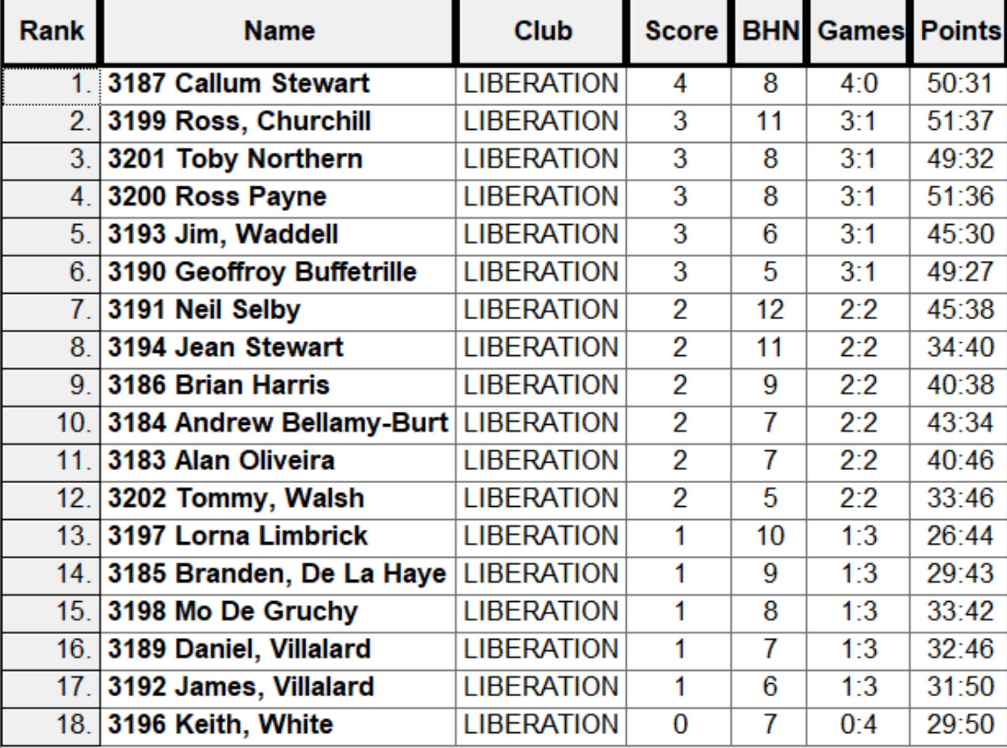

Quarter Finals

Ranked 1st Callum Stewart v Jean Stewart Ranked 8th

Ranked 2nd Ross Churchill v Neil Selby Ranked 7th

Ranked 3rd Toby Northern v Geoffroy Buffetrille Ranked 6th

Ranked 4th Ross Payne v Jim Waddell Ranked 5th

Despite having a big lead early on Callum won eventually 13 – 8 over Jean, the second win over Jean in the tournament.

Ross Churchill was on top form as he beat Neil 13 – 8 to make the semi finals. Whilst Ross Payne was too good for Jim who had a great tournament.

The last quarter final saw Geoffroy pull clear to lead 11 – 7 with two ends to go, but a decision not shoot gave Toby the chance to get three points and make it 11 – 10 and again Geoffroy decision not to shoot cost him the match with Toby pointing superbly to win 12 – 11 with a boule to spare.

Semi Finals

Ranked 1st Callum Stewart v Ross Payne Ranked 4th

Ranked 2nd Ross Churchill v Toby Northern Ranked 3rd

Toby blew a good lead at the start of his semi final against Ross Churchill who then lead 8 – 5 before Toby turned it around to gain revenge for his third round loss to Ross, winning by the same score. Callum continued his winning form to make the final winning 13 – 8 against Ross Payne.

In the Final Callum lead 4 – 1 before Toby made it 4 – 4, it was then alternate leads up to 8 – 8 and a bad end from Callum gave toby the opportunity for three points which he took. Credi though to Callum who placed and shot well to get it back to 11 – 11. A great point on the next end was out done by Toby who sat on the jack with Callum missing his shot placed another good boule. Toby though had two to play for the title but only needed one for an excellent finish to a great final.

Ross Payne took third place over ross Churchill.

2025 Winner

Toby Northern
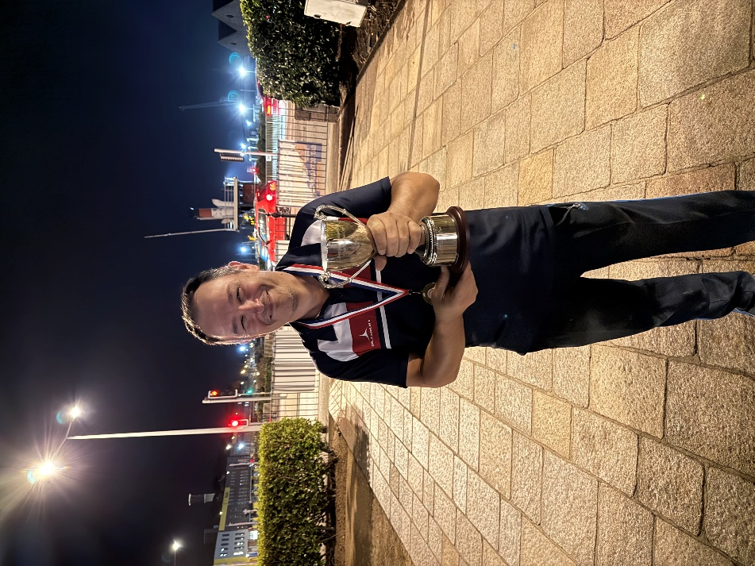

Singles Leagues with a crucial double header this week as Geoffroy played both Laurent first, followed by a top of the table clash against Toby.

Laurent needed points against Geoffroy just to stay up, so would have been fighting all the way for those valuable points. He started off well leading big in game one, but was fortunate to get over the line 13 – 12, but an important 13 – 6 win for Geoffroy in Game 2 with crucial points difference.

With Toby beating Jim it set up nicely for his match against Geoffroy. Toby was superb in game one winning 13 – 5 but a change of terrain and a better performance from Geoffroy in game two got him the draw 13 – 8. Toby getting important points difference though.

Brian needed a win over Laurent in his only match this week to keep his slim hopes of a title intact but lost his first match of the season and his 15 match unbeaten run ended. Very important win for Laurent.

Ross won his only match this week against Jim who sits bottom of the league as a result. Neil needed two wins for any chance of a top three finish, he first played John and then Daniel Deveau winning both but lost a catch up match to Andrew.

Daniel played Andrew first hoping to halt his rise up the table. Andrew then played doubles teammate Callum who had been on top form, Andrew winning both and taking nine points after also beating Neil to move up to third. Callum also played Keith who was in the relegation zone, and remains there after his loss to Callum.

In Division 1 Top of the table James Gennoe, couldn’t play as couldn’t Cassie.

Joey played Jean with both hoping to make the top three and gain promotion. It was Joey taking the points, Joey having won against James Villalard whilst Jean lost against Keith McGonigle.

A big match for Branden v Daniel in the relegation zone going Daniel way before Daniel played Lorna getting a draw and Branden lost to Alex.

Colin Floyd on the edge of a top three finish played Tommy, getting all three points with Tommy also playing James Villalard, gaining a draw after a big comeback. Francis lost to Mo and Keith.

SUMMER 2025 SEASON
WEEK 22 – 27th August 2025
DOUBLES LEAGUE

Jean & Laurent were sitting top of the league going into this week after conceding just 15 points in two matches. Andrew and Callum though have a match in hand so a big match between the two this week.

A resounding win in game one for Andrew & Callum 13 – 1 but will be rueing two points dropped after losing game two 13 – 12 for a draw.

Neil & Ross, had to win against Graeme & Keith who were bottom of the league to keep their slim hopes of a title intact. They did so, but in a close match 13 – 11, 13 – 9 to go joint top.

Geoffroy & James keep their hopes alive just one point off the top after a win over Brian & Colin.

In Division 1 Alex & Dawn were some way ahead but were not in action this week. Second and third were tied on six points, who would fair the best? Keith & Mo played Daniel & James with a big win for an impressive points difference with John & Nick also winning as both teams move into the top three.

NEXT WEEK - DOUBLES LEAGUE

Club email address - liberationpc@gmail.com

Club Website - www.liberationpetanque.co.uk

Kind Regards

Toby Northern

Chairman

Liberation Petanque Club

10 Players took part this year on an unusual Tuesday evening.

Round 1 saw several close matches with Callum beating Brian 7-6, Jean beating Keith 6-5 Geoffroy beating Trevor 5-4.

Katrina started off well beating Jim 8 – 2 in the biggest win of the round and Alex beat Toby 6-5.

Round 2 saw Brian beat Geoffroy 6-4 and big wins for Keith 9-2 over Alex. Toby 7-4 over Jim and 8-4 win for Jean over Trevor.

Round 3 saw Callum lose -4 to Jean who made it three straight wins., Alex was the first player to reach double figures winning 10-3 over Trevor.

Round 4 saw Jean beat Geoffroy 7-3 whilst Toby matches that score over Callum. Trevor got his first win over Jim and Katrina beat Keith.

Round 5 saw Toby beat Keith for four straight wins Geoffroy beat Alex and Jim got his first win over Brian 5-4.

Round 6 saw Jean make it six from six winning 9-5 over Alex whilst Toby slipped up against Trevor giving Geoffroy a chance as he won against Jim.

Round 7 saw Jean make it a clean sweep this time 7-6 over Jim, to become only the second player to make it seven from seven.

Geoffroy massive 10 -0 win over Katrina put him on 5 wins +10 but toby 9 – 1 win over Brian saw him make the final against Jean with 5 wins + 13. Keith White took fourth on points difference over Alex and Katrina.

The this place play-off saw Keith take the honours over Geoffroy 6-5. In the final Jean placing was superb as she took her maiden title winning 5-4 over Toby.

Rankings

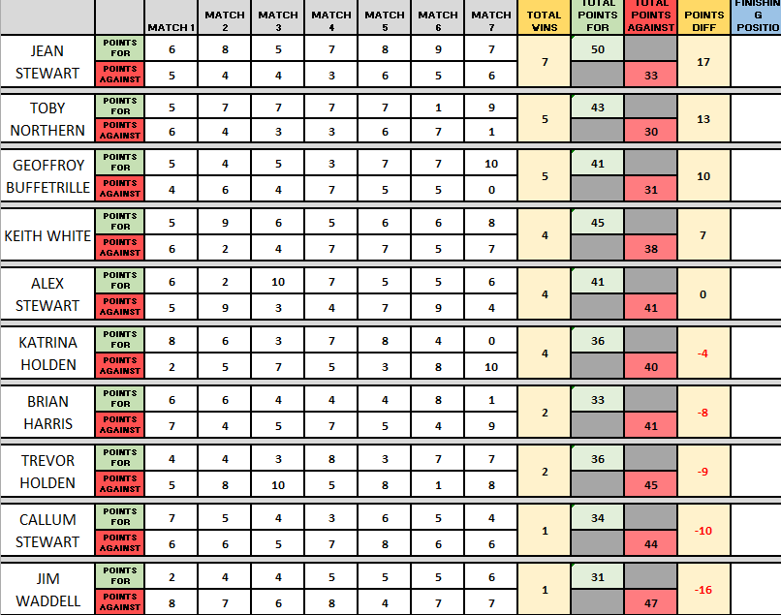

2025 Winner

Jean Stewart


Thanks to Toby again for running the competition anyone who helped Toby tidy at the end.

NEXT WEEK - SINGLES LEAGUE

Club email address - liberationpc@gmail.com

Club Website - www.liberationpetanque.co.uk

Toby Northern

Chairman - Liberation Petanque Club

Well the final scheduled Singles league matches were played this week bringing an end to the Summer season for those in the Singles League.

In the second successive season Toby needed to match Geoffroy result but out score him on points difference.

Geoffroy played Ross who couldn’t make the top three so little to play for. Geoffroy ran out a comfortable winner as expected winning to 6 and 4 meaning that despite a 13 – 5 win for Toby in game one, an impossible task against Brian in game two ultimately losing 13 – 12 to see him finish Runners up again.

Andrew had been on fire in the second half of the season and his win against Wendy sealed third place with six straight wins in the second half of the season.

Neil beat Callum for a fourth place finish with Callum’s great start to the season falling away towards the end. Daniel lost against John, but the result having no impact on either player with John relegated.

Laurent disappointing season ended with a another loss, this time to against Keith, commiserations to John and Jim who were relegated.

In Division 1

James Gennoe six match run to the end of the season saw him take the title as Cassie failed to win hers. James with a huge points difference of over 100 winning ten of the thirteen matches, well Done to James Gennoe.

Joey played Francis for a top three finish, only drawing but enough for third..

Colin Floyds draw against Daniel ended his hopes of taking third place. Jean win over Tommy helped her finish in the top half of the table. Alex beat Mo but not enough for a top three finish.

Branden played Lorna with Lorna taking the win to move her out of the relegation zone with her doubles partner Tommy taking her place in the bottom three.

Commiserations to Branden, Francis and Tommy.

SUMMER 2025 SEASON
WEEK 25 – 17th September 2025
DOUBLES LEAGUE

In a rearranged week three huge results in the Premier League with Gary & Wendy taking a big win over Jean & Laurent ending their title aspirations whilst Geoffroy & James were done in double quick time winning 13 -3, 13-2.

Andrew & Callum also won 13-6, 13-6 to maintain top spot going into the final week of the season.

Alex & Dawn win over Cassie & Chris put them on the edge of the title as Keith & Mo could only draw with John & Nick.

Colin & Jim though with the better points difference beat Lorna & Tommy for a chance of the title. Whilst Garry & Sue drew with Daniel & James.

NEXT WEEK - DOUBLES LEAGUE

Club email address - liberationpc@gmail.com

Club Website - www.liberationpetanque.co.uk

Kind Regards

Toby Northern

Chairman

Liberation Petanque Club

SUMMER 2025 SEASON
WEEK 26 – 24th September 2025
DOUBLES LEAGUE

The question in the final week of the season was could Andrew & Callum make it three titles in a row.

They had a tough task against Neil & Ross and lost the first match 13 – 1! And despite maintaining their unbeaten season winning 13 – 1 in the second game they knew a win for Geoffroy & James over Alan & Mike would give them the title.

They did so in style 13-4, 13-1 to win the league and cup double, the first time since 2011! Neil & Ross taking third.

Alex & Dawn draw over Garry & Sue was enough to give them the Division 1 title, congratulations to them. Whilst colin & Jim win over Daniel & James helped them take third with Keith & Mo taking the runners up spot.

Garry & Sue first season finishing a respectable fifth place. Whilst Lorna & Tommy finished last.

NEXT WEEK - END OF SEASON

Club email address - liberationpc@gmail.com

Club Website - www.liberationpetanque.co.uk

Kind Regards

Toby Northern

Chairman

Liberation Petanque Club

