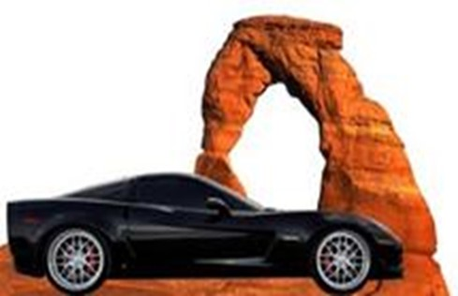

Color Country Corvette Club
Presents
Valley of Fire Corvette Run & Picnic

Hosted by Paul & Karen Styka

Tuesday, May 18, 2021

We will depart Terrible’s Gas Station at Exit 2 on I-15 no later than 11am

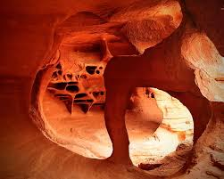
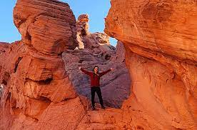
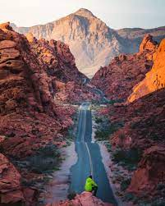
World-renowned for its 40,000 acres of bright red Aztec sandstone outcrops nestled in gray and tan limestone, Valley of Fire State Park contains ancient, petrified trees and petroglyphs dating back more than 2,000 years. The Visitor Center provides exhibits on the geology, ecology, prehistory and history of the park and nearby region. The park has numerous campsites equipped with shaded tables, grilles and water. We will picnic at one of these spots, and there are restrooms located at these areas. It’s about a one-hour drive to the park.

Park entrance fee: $10.00 per vehicle (Non-NV $15.00 per vehicle)

Pack your favorite picnic food and camera and join us for this fun adventure.

Be sure to RSVP to Paul Styka at p.styka@sbcglobal.net

