For a change of pace the club voted to go on a fee dig to one of our local tourmaline mines, the Oceanview Mine in Pala on 10/28/17. The folks at the mine did us a tremendous favor by knocking $10 off of the dig fees which brought the cost down to $60/person, still a good chunk of change, but operating a mine is not cheap. It was a bit hot, in the mid to high 80s, and even under the Easy Ups and shade umbrellas we all felt the heat. The mine folks were as friendly and helpful as they could be helping us to get the most of the material we lugged back to our screening table from the pile.
The pile and screens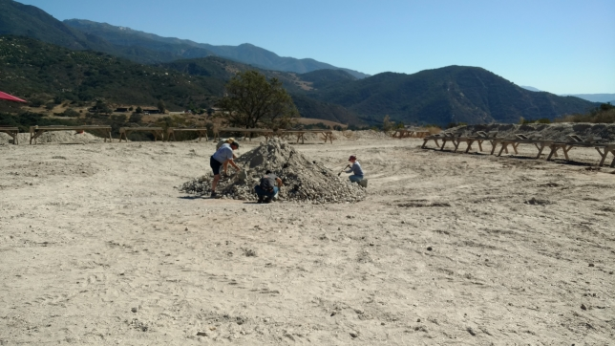
In a nutshell you go to the pile, fill up a bucket with material and bring it back to your screening table. Once there you dump your bucket into the set of screens. You shake the screens back and forth and different sized rocks get caught on the progressively smaller sets of screens. You look at the big rocks caught on the top screen and mostly throw them away because they are not interesting. The stuff caught on the second screen usually has the gem pieces. Next you wash off the rocks in the second screen in the water tub and hopefully pick out the good pieces. The overall opinion is that we had a good time, but we did not go home with $60 worth of gemstones. Going to a mine is always a hit or miss proposition. There is no telling how much (if any) good stuff is in the load of rock that they blasted out of the mine that week. You are also competing with the other folks at the dig to find the good stuff in the pile. Getting good stuff from the pile has a certain element of luck to it. One thing we did accomplish was to collect quite a number of pieces of feldspar with black tourmaline and small garnet crystals in them for our grab bags and kid’s wheel gifts for our show.

Bud, Bill and Bo hard at work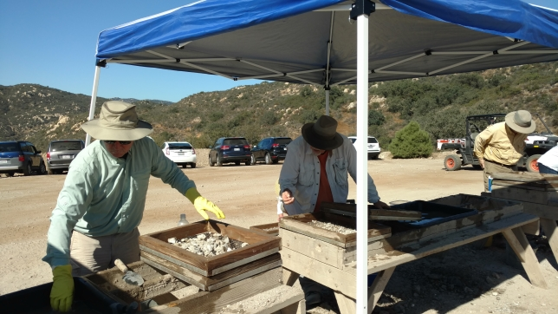
Bo, Malinda and Teri digging for treasures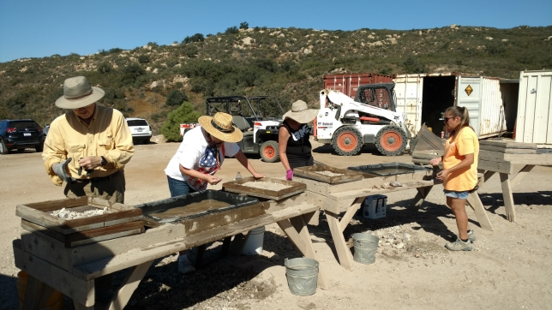

Steve and Pam working hard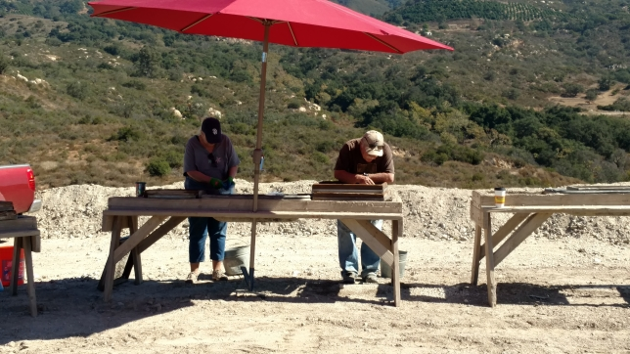
Bud’s treasures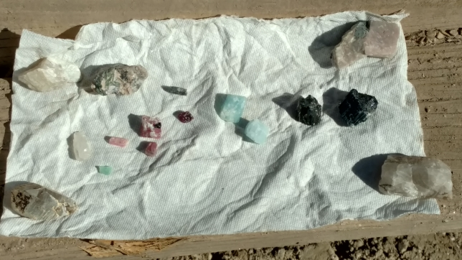
Bud found a couple pieces of pink tourmaline (rubellite), some quartz, some black tourmaline (schorl) and a couple of blue pieces. The blue pieces could be aquamarine, blue tourmaline (indicolite) or possibly some of the blue spodumene that the miners told us they have been finding lately.
Steve’s goodies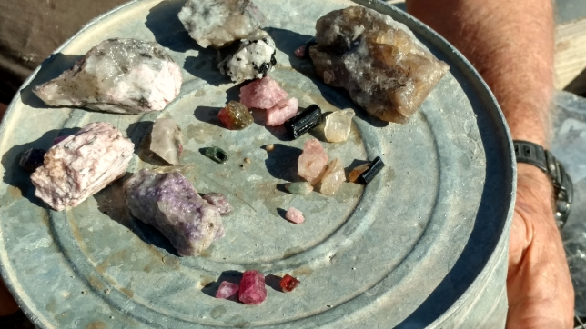
Steve got some nice pieces of tourmaline and lepidolite.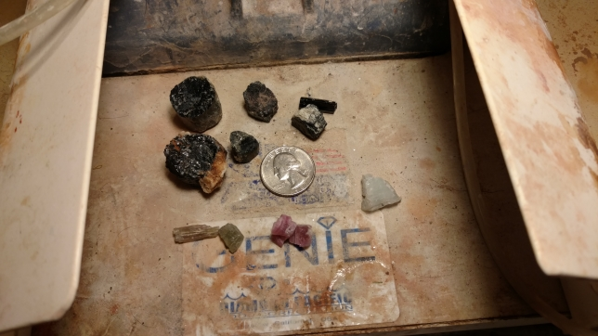
I got some schorl (top) some pieces of green tourmaline (verdilite), two small rubelites and one piece of mystery blue stone. I will bring it to our show where the Gem ID lady can tell me what it is.

Large smoky quartz crystal with a tourmaline crystal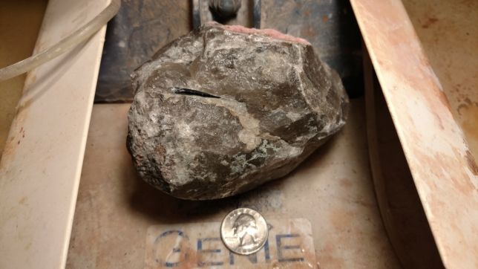
Indicolite crystals in feldspar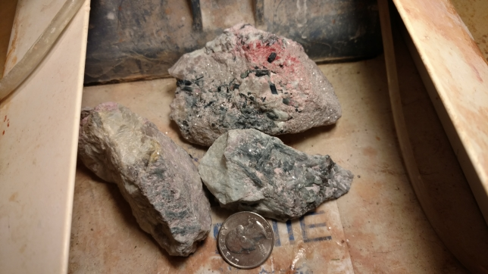

Feldspar crystals and lepidolite (purple)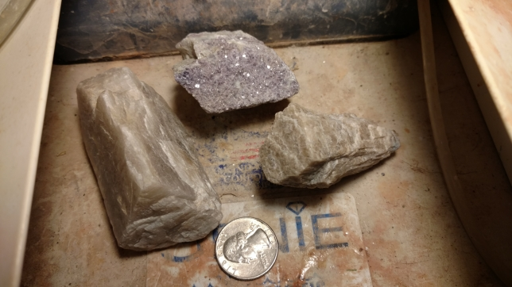
Large schorl in quartz/feldspar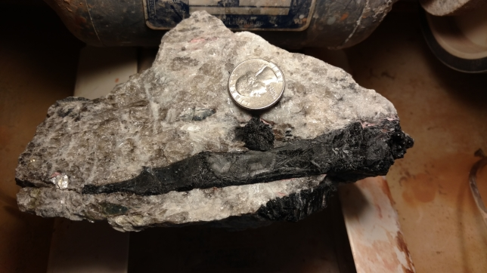
The End

