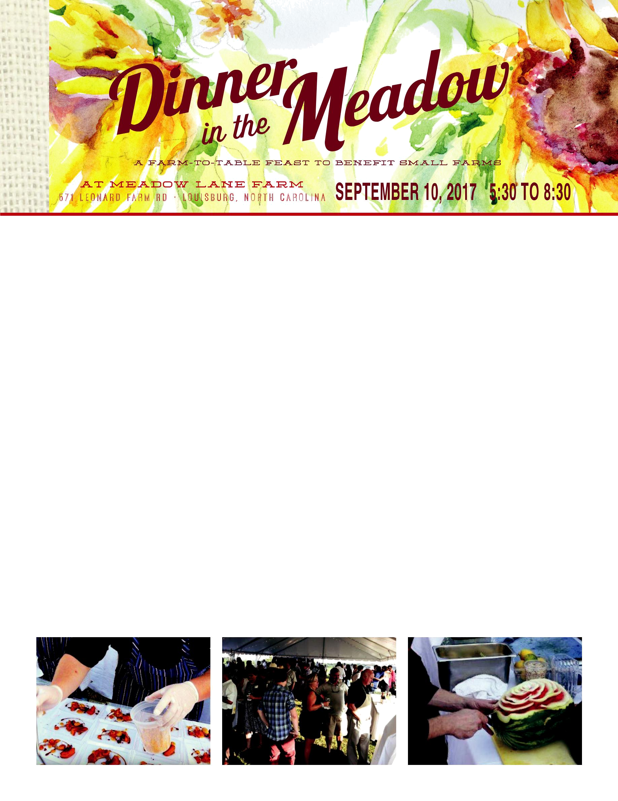
LEONARD-MOBLEY SMALL FARMS FUND

PRESENTS THE 4th ANNUAL

Dear Leonard-Mobley Small Farms Fund Supporter,

Dinner in the Meadow is an annual event to raise money for the nonprofit Leonard-Mobley Small Farms Fund (LMSFF). Through this annual fundraiser, LMSFF is able to award grants to small farms, encouraging and supporting their growth. For three consecutive years, monies raised at Dinner in the Meadow by LMSFF has allowed farmers to invest in the tools they need to grow their businesses, be it new equipment, adding new and different products, continuing education, or growing their electronic footprint. These grants are allowing them access to opportunities for growth and resources that they might not otherwise see.

This year we celebrate our fourth year of Dinner in the Meadow. This ticketed event showcases local food products, and is prepared by celebrated local chefs, and features North Carolina products for auction. Although ticket sales and auction items contribute to our efforts, we still need the support of donors if we want to expand our efforts. Your sponsorship of Dinner in the Meadow can help us do that. All sponsorship proceeds will go directly to the support of Dinner in the Meadow, LMSFF, and its grants.

Where our food comes from is important, and farming impacts everyone. We feel that by helping the small, local farmer, we can make a direct impact in their efforts, and in return, in the community they serve. We hope you will support our efforts and join us in this celebration!

For more information visit our website at DinnerInTheMeadow.org or find and like us on Facebook, via email at info@dinnerinthemeadow.org or by phone at 919.495.1305.

Sincerely,

Martha L. Mobley

Board Member, Leonard-Mobley Small Farms Fund

Meadow Lane Beef, LLC

Sunflower $5000

Rose

$2500

Zinnia

$1000

Marigold $500

Cosmo

$250

8 Tickets - 1 Table
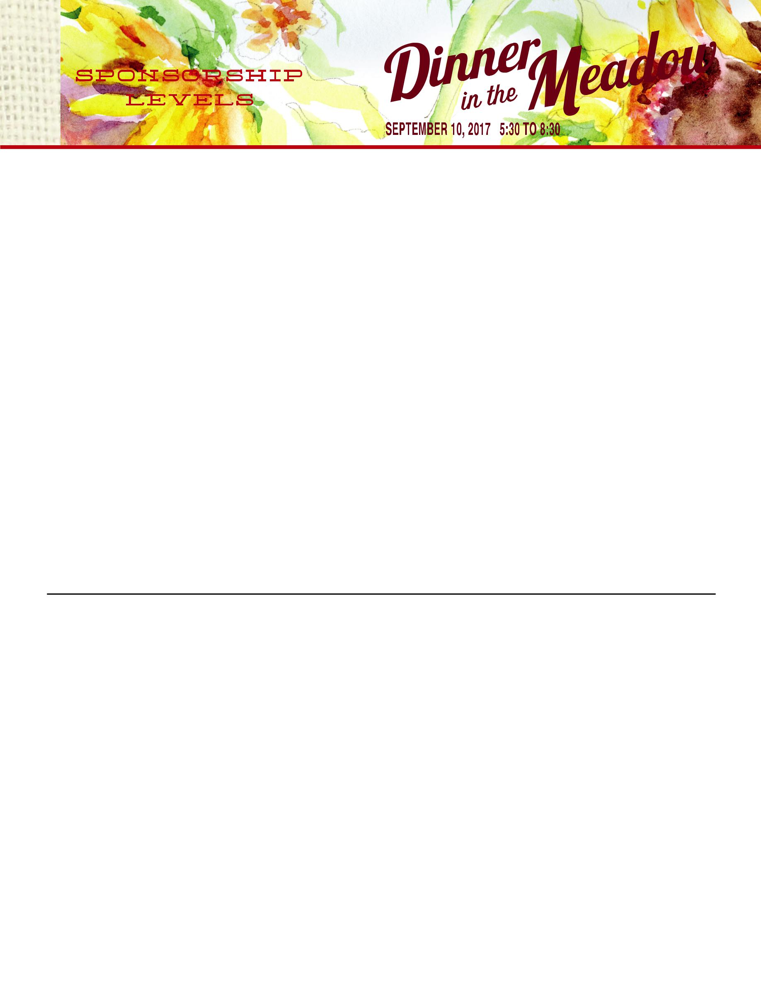
Table Top Signage

Logo In The Program

Recognition on Social Media & At the Event 8 Tickets - 1 Table

Table Top Signage

Logo In The Program

Recognition on Social Media

8 Tickets - 1 Table

Table Top Signage

Logo In The Program

4 Tickets

Name In The Program

2 Tickets

Name In The Program

ALL DONATIONS HELP COVER THE COST OF THE EVENT AND SUPPORT THE WORK OF LMSFF.

PLEASE MAKE CHECKS PAYABLE TO: THE LEONARD-MOBLEY SMALL FARM FUND AND MAIL WITH

THIS COMPLETED FORM TO

571 LEONARD FARM RD. | LOUISBURG, NC 27596

FOR QUESTIONS CONTACT MARTHA MOBLEY AT 919.495.1305

ORGANIZATION NAME ___________________________________________________________________

WEBSITE ________________________________________________________________________________

SPONSORSHIP CONTACT NAME ____________________________________________________________

ADDRESS ________________________________________________________________________________

PHONE __________________________________________________________________________________

EMAIL __________________________________________________________________________________

