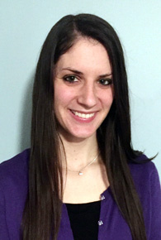
Tracey has a master’s degree in social work from Rutgers University and holds a clinical social work license. She has experience working in therapeutic settings with those suffering from addiction as well as a variety of other mental health conditions including anxiety, depression, mood and adjustment disorders. She works with a diverse population of clients in various stages of life from adolescents to seniors from different cultural and economic backgrounds.
Although Tracey’s approach to counseling is primarily Cognitive Behavior, she is also able to utilize different treatment methods to fit individual client’s specific needs. Tracey enjoys incorporating mindfulness and other holistic practices to help clients develop positive self-care and learn healthy coping skills. She strives to provide an atmosphere that is compassionate and accepting, in order to build a positive, honest connection with each client. Her goal is to help to empower people to take an active role in their own well-being and helping equip them with the skills necessary to improve their quality of life.
New Jersey State Board of Marriage and Family Therapy Examiners.
- Practicing Licensed Clinical Social Worker

108 North Union Avenue
Cranford, NJ 07016
Entrance A-Suite 6

Tracey@centerforcognitivepsychotherapy.com
908-966-6927

