When the BIG ONE Hits:

- Check on the safety of my family and animals & turn off propane

- If there is phone service, activate our community PHONE TREE

- Conduct Group check-ins on GMRS Radios
Call 911 for medical emergencies; dispatch medical & CERT Teams or transport injured to medical facility at Skyline Field Office.
- Activate HAM Radio Emergency Services (ARES). If no phone service - use Ham Radio to request services. Use the GMRS Radios to relay information to Group Coordinators.

- Physically check on all residents. Once the neighborhood is stabilized, request that medical personnel, CERT members and Ham radio operators report to Skyline Field Office.

- Call my emergency contact person out of state to advise them of my status.

- Maintain radio communication. Go to the MROSD Skyline Field Station to assist with medical and communications.
> Ham Radio - ARES
Emergency Coordinator SSA
> Neighborhood
Coordinator
Portola Heights / Castanea Ridge

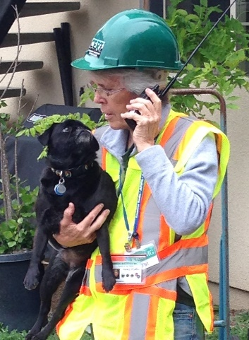
Pat O’Coffey

