December 2022 Holiday Meeting

WHAT: RMGA MEMBERSHIP MEETING –
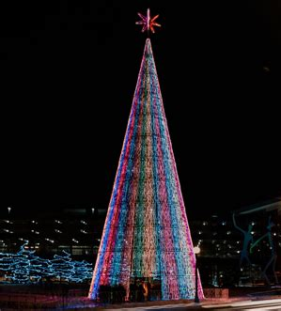
WHEN: DATE - 6:00P December 12th
PROGRAM NAME: Tis the Season….For Holiday Lights!!!
PROGRAM: Join the RMGA on Monday evening December 12th for a celebration of Denver’s holiday light tradition.
The December Member Meeting will be an in-person event! We will be meeting at the Fire Lounge in the Art Hotel at 6PM and then wander as group to Civic Center to explore the Christkindl Market and take in the bright lights of the City and County building and the Mile High Tree!!
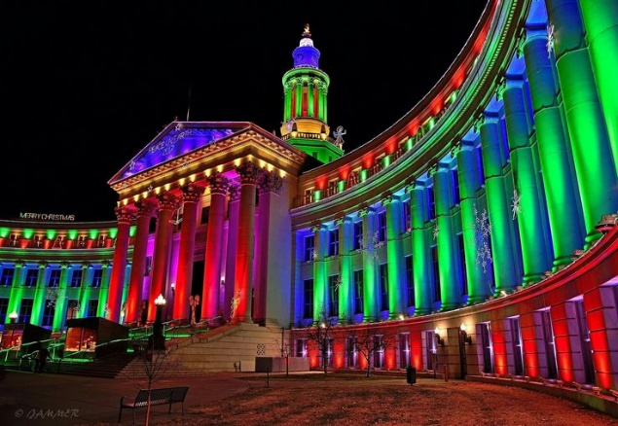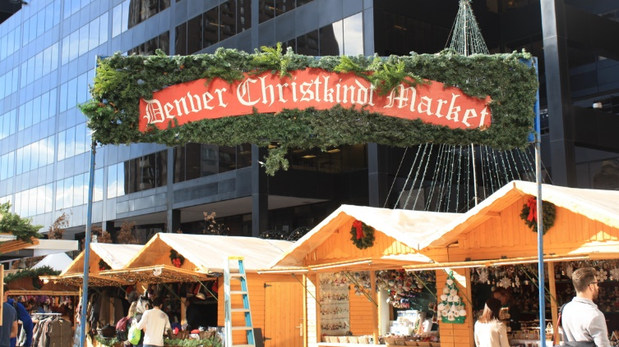
WHERE: Bring your layers for comfort to the Art Hotel 1201 Broadway 80203, head to the fourth floor and the Fire Lounge to enjoy a beverage or snack with fellow members of the RMGA before exploring the Holiday Wonder of Denver’s Civic Center.
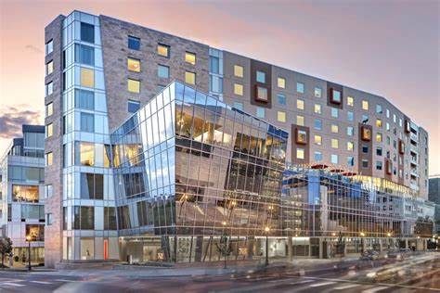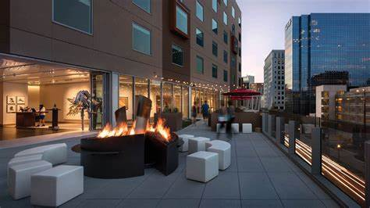
FOOD: Food and Drink available at the Art Hotel
PARKING: Public Parking available next door to the Art is accessible from 12th Ave.

GUESTS: Members are encouraged to invite potential members as guests to meeting.

GUEST FEES: 1st and 2nd Time Guest: Free, Third thru Fifth Time, Same Guest Visit is $10 each time. Succeeding Times, Same Guest Must Join RMGA.

MEETING NIGHT CONTACT: Mark Blaising. Contact Blaising303@gmail.com or by text 303-263-8647

